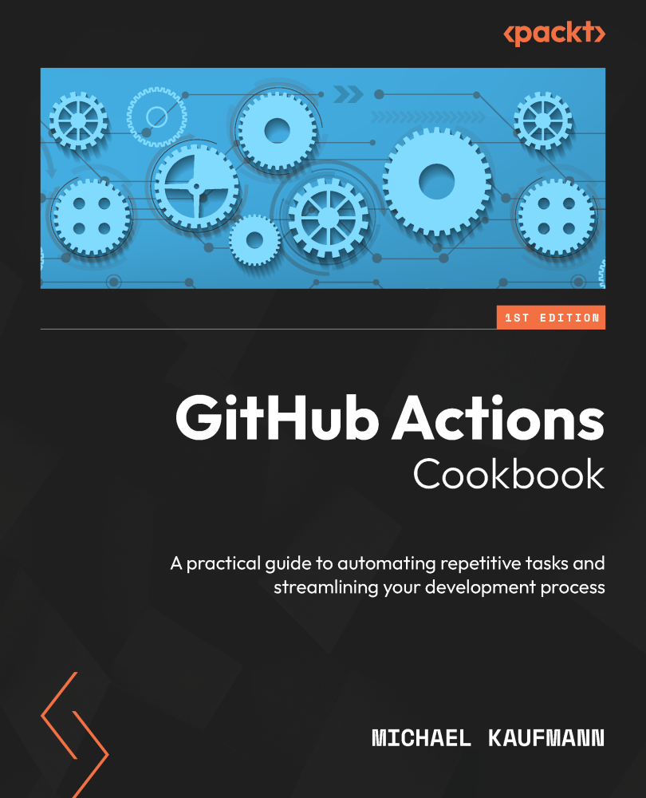

Table of Contents
GitHub Actions Cookbook
Contributors
About the author
About the reviewers
Preface
Who this book is for
What this book covers
To get the most out of this book
Download the example code files
Conventions used
Sections
Getting ready
How to do it…
How it works…
There’s more…
Get in touch
Share your thoughts
Download a free PDF copy of this book
Chapter 1: GitHub Actions Workflows
Technical requirements
The GitHub ecosystem
Hosting and pricing for GitHub
Pricing for GitHub Actions
GitHub Marketplace
Using the workflow editor for writing workflows
Getting ready
How to do it…
How it works…
There’s more…
Using secrets and variables
Getting ready
How to do it…
There’s more…
Creating and using environments
Getting ready
How to do it…
There’s more…
Chapter 2: Authoring and Debugging Workflows
Using Visual Studio Code for authoring workflows
Getting ready…
How to do it…
How it works…
There’s more…
Developing workflows in branches
Getting ready…
How to do it…
How it works…
There’s more…
Linting workflows
Getting ready…
How to do it…
How it works…
There’s more…
Writing messages to the log
Getting ready…
How to do it…
How it works…
Enabling debug logging
How to do it…
There’s more…
Running your workflows locally
Getting ready…
How to do it…
How it works…
There’s more…
Chapter 3: Building GitHub Actions
Technical requirements
Creating a Docker container action
Getting ready…
How to do it…
How it works…
There’s more…
Adding output parameters and using job summaries
Getting ready…
How to do it…
How it works…
There’s more…
Creating a TypeScript action
Getting ready…
How to do it…
How it works…
There’s more…
Creating a composite action
Getting ready…
How to do it…
How it works…
There’s more…
Using github-script in a composite action to add a comment to an issue
How to do it…
How it works…
There’s more…
Sharing actions to the marketplace
Getting ready…
How to do it…
How it works…
There’s more…
Chapter 4: The Workflow Runtime
Technical requirements
Setting up a self-hosted runner
Getting ready…
How to do it…
How it works…
There’s more…
Auto-scaling self-hosted runners
Getting ready…
How to do it…
How it works…
There’s more…
Scaling self-hosted runners with Kubernetes using ARC
Getting ready…
How to do it…
How it works…
There’s more…
Runners and runner groups
Getting ready…
How to do it…
GitHub-hosted runners
Getting ready…
How to do it…
How it works…
Chapter 5: Automate Tasks in GitHub with GitHub Actions
Technical requirements
Creating an issue template
Getting ready…
How to do it…
How it works…
There is more…
Using the GitHub CLI and GITHUB_TOKEN to access resources
Getting ready…
How to do it…
How it works…
Using environments for approvals and checks
Getting ready…
How to do it…
How it works…
There is more…
Reusable workflows and composite actions
Getting ready…
How to do it…
How it works…
There is more…
Chapter 6: Build and Validate Your Code
Technical requirements
Building and testing your code
Getting ready
How to do it…
How it works…
There’s more…
Building different versions using a matrix
Getting ready
How to do it…
How it works…
There’s more…
Informing the user on details of your build and test results
Getting ready
How to do it…
How it works…
There’s more…
Finding security vulnerabilities with CodeQL
Getting ready
How to do it…
How it works…
There’s more…
Creating a release and publishing the package
Getting ready
How to do it…
How it works…
There’s more…
Versioning your packages
Getting ready
How to do it…
How it works…
There’s more…
Generating and using SBOMs
Getting ready
How to do it…
How it works…
There’s more…
Using caching in workflows
Getting ready
How to do it…
How it works…
There’s more…
Chapter 7: Release Your Software with GitHub Actions
Technical requirements
Building and publishing a container
Getting ready…
How to do it…
How it works…
There’s more…
Using OIDC to securely deploy to any cloud
Getting ready…
How to do it…
How it works…
Environment approval checks
Getting ready…
How to do it…
How it works…
Releasing the container application to AKS
Getting ready…
How to do it…
How it works…
There’s more…
Automating the update of your dependencies
Getting ready…
How to do it…
How it works…
There’s more…
Clean up
Summary
Index
Why subscribe?
Other Books You May Enjoy
Packt is searching for authors like you
Share your thoughts
Download a free PDF copy of this book



GitHub Actions Cookbook
Copyright © 2024 Packt Publishing
All rights reserved. No part of this book may be reproduced, stored in a retrieval system, or transmitted in any form or by any means, without the prior written permission of the publisher, except in the case of brief quotations embedded in critical articles or reviews.
Every effort has been made in the preparation of this book to ensure the accuracy of the information presented. However, the information contained in this book is sold without warranty, either express or implied. Neither the author, nor Packt Publishing or its dealers and distributors, will be held liable for any damages caused or alleged to have been caused directly or indirectly by this book.
Packt Publishing has endeavored to provide trademark information about all of the companies and products mentioned in this book by the appropriate use of capitals. However, Packt Publishing cannot guarantee the accuracy of this information.
Group Product Manager: Preet Ahuja
Publishing Product Manager: Prachi Rana
Book Project Manager: Srinidhi Ram
Senior Editor: Sayali Pingale
Technical Editor: Rajat Sharma
Copy Editor: Safis Editing
Indexer: Tejal Soni
Production Designer: Joshua Misquitta
Developer Relations Marketing Executive: Rohan Dobhal
First published: April 2024
Production reference: 1050424
Published by Packt Publishing Ltd.
Grosvenor House
11 St Paul’s Square
Birmingham
B3 1RB, UK
ISBN 978-1-83546-894-4
www.packtpub.com
To my family, who had to spend many weekends and nights without me. To my colleagues from Xebia and the DevOps community for giving me feedback, challenging my ideas, and giving me the opportunity to learn.
– Michael Kaufmann

Contributors

About the author
Michael Kaufmann believes that developers and engineers can be happy and productive at work. He loves DevOps, GitHub, Azure, and modern work.
Microsoft has awarded him with the title Microsoft Regional Director (RD) and Microsoft Most Valuable Professional (MVP) – the latter in the category of DevOps and GitHub.
Michael is also the founder and managing director of Xebia Microsoft Services, Germany – a consulting company that helps its customers become digital leaders by supporting them in their cloud, DevOps, and digital transformation.
Michael shares his knowledge in books, training, and as a frequent speaker at international conferences.

About the reviewers
Mickey Gousset is a staff DevOps architect at GitHub. He is passionate about DevOps and helping developers achieve their goals. Mickey speaks on DevOps and cloud topics at various user groups, code camps, and conferences around the world.
Jamie O’Meara is a passionate technical and business leader with a strong emphasis on software development and data. He is currently a principal solution engineer at GitHub helping customers establish their GitHub solutions and adopt them at scale. GitHub Copilot has piqued his interest in learning more about the use of generative AI. He has been a speaker at various international conferences (VMworld, SpringOne, Cloud Foundry Summit, and more). He is also very interested in the VC community and an avid follower of the start-up ecosystem.

Table of Contents
Preface
1
GitHub Actions Workflows

Technical requirements

The GitHub ecosystem

Hosting and pricing for GitHub

Pricing for GitHub Actions

GitHub Marketplace

Using the workflow editor for writing workflows

Getting ready

How to do it…

How it works…

There’s more…

Using secrets and variables

Getting ready

How to do it…

There’s more…

Creating and using environments

Getting ready

How to do it…

There’s more…
2
Authoring and Debugging Workflows

Using Visual Studio Code for authoring workflows

Getting ready…

How to do it…

How it works…

There’s more…

Developing workflows in branches

Getting ready…

How to do it…

How it works…

There’s more…

Linting workflows

Getting ready…

How to do it…

How it works…

There’s more…

Writing messages to the log

Getting ready…

How to do it…

How it works…

Enabling debug logging

How to do it…

There’s more…

Running your workflows locally

Getting ready…

How to do it…

How it works…

There’s more…
3
Building GitHub Actions

Technical requirements

Creating a Docker container action

Getting ready…

How to do it…

How it works…

There’s more…

Adding output parameters and using job summaries

Getting ready…

How to do it…

How it works…

There’s more…

Creating a TypeScript action

Getting ready…

How to do it…

How it works…

There’s more…

Creating a composite action

Getting ready…

How to do it…

How it works…

There’s more…

Using github-script in a composite action to add a comment to an issue

How to do it…

How it works…

There’s more…

Sharing actions to the marketplace

Getting ready…

How to do it…

How it works…

There’s more…
4
The Workflow Runtime

Technical requirements

Setting up a self-hosted runner

Getting ready…

How to do it…

How it works…

There’s more…

Auto-scaling self-hosted runners

Getting ready…

How to do it…

How it works…

There’s more…

Scaling self-hosted runners with Kubernetes using ARC

Getting ready…

How to do it…

How it works…

There’s more…

Runners and runner groups

Getting ready…

How to do it…

GitHub-hosted runners

Getting ready…

How to do it…

How it works…
5
Automate Tasks in GitHub with GitHub Actions

Technical requirements

Creating an issue template

Getting ready…

How to do it…

How it works…

There is more…

Using the GitHub CLI and GITHUB_TOKEN to access resources

Getting ready…

How to do it…

How it works…

Using environments for approvals and checks

Getting ready…

How to do it…

How it works…

There is more…

Reusable workflows and composite actions

Getting ready…

How to do it…

How it works…

There is more…
6
Build and Validate Your Code

Technical requirements

Building and testing your code

Getting ready

How to do it…

How it works…

There’s more…

Building different versions using a matrix

Getting ready

How to do it…

How it works…

There’s more…

Informing the user on details of your build and test results

Getting ready

How to do it…

How it works…

There’s more…

Finding security vulnerabilities with CodeQL

Getting ready

How to do it…

How it works…

There’s more…

Creating a release and publishing the package

Getting ready

How to do it…

How it works…

There’s more…

Versioning your packages

Getting ready

How to do it…

How it works…

There’s more…

Generating and using SBOMs

Getting ready

How to do it…

How it works…

There’s more…

Using caching in workflows

Getting ready

How to do it…

How it works…

There’s more…
7
Release Your Software with GitHub Actions

Technical requirements

Building and publishing a container

Getting ready…

How to do it…

How it works…

There’s more…

Using OIDC to securely deploy to any cloud

Getting ready…

How to do it…

How it works…

Environment approval checks

Getting ready…

How to do it…

How it works…

Releasing the container application to AKS

Getting ready…

How to do it…

How it works…

There’s more…

Automating the update of your dependencies

Getting ready…

How to do it…

How it works…

There’s more…

Clean up

Summary
Index
Other Books You May Enjoy

Preface
GitHub is more than just a platform for hosting and sharing code. With millions of developers from all over the world collaborating on projects of every type and size, it has become the beating heart of the open source community. With GitHub Actions, GitHub now has its own workflow platform that allows engineers and developers to automate all kinds of repetitive engineering tasks – from Continuous Integration (CI) and Continuous Deployment (CD) to IssueOps, automatic issue triaging, and ChatOps.
This book will show you how to make the most of GitHub Actions in your day-to-day life. It is a practical book – so we will have you do as much as possible and explain the theory alongside the individual recipes.

Who this book is for
If you are looking for a practical approach to learning GitHub Actions, this book is for you, whether you are a software developer or a DevOps engineer. If you have already played around with Actions on your own but want to learn more; you have experience with other CI/CD tools, such as Jenkins or Azure Pipelines; or you are completely new to the topic – it doesn’t matter, you’ll find this book helpful.
In order to learn from this book, you should have a basic understanding of at least one programming or script language, Git as a version control system, and infrastructure topics such as Docker, the Linux and Windows filesystems, and authentication.

What this book covers
Chapter 1, GitHub Actions Workflows, will introduce you to GitHub Actions workflows and what you can do with them. You will learn about YAML basics, events that trigger workflows, and expressions, as well as how to use GitHub Actions from the marketplace to automate all kinds of tasks.
Chapter 2, Authoring and Debugging Workflows, will teach you best practices for authoring workflows: how to use Visual Studio Code and GitHub Codespaces and various add-ins to efficiently create, edit, and run workflows, check them for errors with powerful linters, develop them in branches, and run them locally. You will also learn how you can debug them and turn on advanced logging.
Chapter 3, Building GitHub Actions, explains the different types of GitHub actions, and you will learn how to use input and output. You will write your own Docker container action, a TypeScript action, and a composite action.
Chapter 4, The Workflow Runtime, is about the different runtime options for your workflows. You will learn how to use different GitHub-hosted runners and how to set up and scale ephemeral, self-hosted runners in Docker containers and Kubernetes with GitHub Actions Controller (GHAC).
Chapter 5, Automate Tasks in GitHub with GitHub Actions, will show you how to use Issue-Ops to automate common tasks within GitHub. You will learn how to authenticate with GitHub Apps, use GITHUB_TOKEN and workflow permissions, use the GitHub CLI to automate tasks, use environments for approvals and checks, and use reusable workflows and composite actions to share logic across workflows and repositories.
Chapter 6, Build and Validate Your Code, is about CI. You will learn how to build and test different versions of your code with the same workflow, find security vulnerabilities in your code with CodeQL, attach a Software Bill of Materials (SBOM) to your release, automate the versioning of your software, and use caching to speed up your workflows.
Chapter 7, Release Your Software with GitHub Actions, covers continuous delivery and continuous deployment. You will learn how to securely deploy to the cloud using OpenID Connect (OIDC) and how to deploy containers to Kubernetes – whether it is Microsoft Azure Kubernetes Service (AKS), Google Kubernetes Engine (GKE), or Elastic Container Services (ECS). You will also learn how to use Dependabot together with GitHub Actions to completely automate the update of your dependencies.

To get the most out of this book
You will need the following:
Software/hardware covered in the book | OS requirements
GitHub | All operating systems are compatible. You will need an account on https://github.com.
Visual Studio Code | All operating systems are compatible. If you want, you can use GitHub Codespaces for all recipes. In this case, you don’t have to install anything locally. If you want to work locally, then you’ll need Visual Studio Code (https://code.visualstudio.com/download) and the subsequent tools.
Git | Only required if you work locally. All operating systems are compatible. You should have an up-to-date version of Git installed (at least version 2.23).
GitHub CLI | Only required if you work locally. Install the GitHub CLI (https://cli.github.com/).
Node.js | Only required if you work locally. You’ll need an up-to-date version of Node.js (I’m using 21 at the time of writing). All operating systems are compatible. Download the latest version here: https://nodejs.org/en/download/current.
Docker | Only required if you work locally. Get Docker for all operating systems here: https://docs.docker.com/get-docker/.
Azure and the Azure CLI | For some chapters, you’ll need an Azure account and the Azure CLI. A free test version will be sufficient (https://azure.microsoft.com/en-us/free). If you want to work locally, you’ll also need the Azure CLI.
All recipes can be done with a free GitHub account in public repositories. You can use GitHub Codespaces to do anything in a virtual environment. This will use up your 120 free hours per month (180 with GitHub Pro). Be aware of that. Once the free hours are used, you’ll have to pay per minute for Codespaces.
If you are using the digital version of this book, we advise you to type the code yourself or access the code via the GitHub repository (link available in the next section). Doing so will help you avoid any potential errors related to the copying and pasting of code.

Download the example code files
You can download the example code files for this book from GitHub at https://github.com/PacktPublishing/GitHub-Actions-Cookbook. If there’s an update to the code, it will be updated in the GitHub repository.
We also have other code bundles from our rich catalog of books and videos available at https://github.com/PacktPublishing/. Check them out!

Conventions used
There are a number of text conventions used throughout this book.
Code in text: Indicates code words in text, database table names, folder names, filenames, file extensions, pathnames, dummy URLs, user input, and Twitter handles. Here is an example: “We can do this, for example, using the sed 's/./&/g' command.”
A block of code is set as follows:
jobs:
build-and-push-image:
runs-on: ubuntu-latest
permissions:
packages: write
When we wish to draw your attention to a particular part of a code block, the relevant lines or items are set in bold:
"dependencies": {
"@
wulfland
/package-recipe": "^
2.0.5
",
"express": "^4.18.2"
}
Any command-line input or output is written as follows:
$ npm start
> release-recipe@1.0.0 start
> node src/index.js
Server running at http://localhost:3000
Bold: Indicates a new term, an important word, or words that you see onscreen. For example, words in menus or dialog boxes appear in the text like this. Here is an example: “In your repository, navigate to Settings | Secrets and Variables | Actions.”
Tips or important notes
Appear like this.

Sections
In this book, you will find several headings that appear frequently (Getting ready, How to do it..., How it works..., and There’s more...).
To give clear instructions on how to complete a recipe, use these sections as follows:

Getting ready
This section tells you what to expect in the recipe and describes how to set up any software or any preliminary settings required for the recipe.

How to do it…
This section contains the steps required to follow the recipe.

How it works…
This section usually consists of a detailed explanation of what happened in the previous section.

There’s more…
This section consists of additional information about the recipe in order to make you more knowledgeable about the recipe.

Get in touch
Feedback from our readers is always welcome.
General feedback: If you have questions about any aspect of this book, mention the book title in the subject of your message and email us at customercare@packtpub.com.
Errata: Although we have taken every care to ensure the accuracy of our content, mistakes do happen. If you have found a mistake in this book, we would be grateful if you would report this to us. Please visit www.packtpub.com/support/errata, selecting your book, clicking on the Errata Submission Form link, and entering the details.
Piracy: If you come across any illegal copies of our works in any form on the Internet, we would be grateful if you would provide us with the location address or website name. Please contact us at copyright@packt.com with a link to the material.
If you are interested in becoming an author: If there is a topic that you have expertise in and you are interested in either writing or contributing to a book, please visit authors.packtpub.com.

Share your thoughts
Once you’ve read GitHub Actions Cookbook, we’d love to hear your thoughts! Please click here to go straight to the Amazon review page for this book and share your feedback.
Your review is important to us and the tech community and will help us make sure we’re delivering excellent quality content.

Download a free PDF copy of this book
Thanks for purchasing this book!
Do you like to read on the go but are unable to carry your print books everywhere?
Is your eBook purchase not compatible with the device of your choice?
Don’t worry, now with every Packt book you get a DRM-free PDF version of that book at no cost.
Read anywhere, any place, on any device. Search, copy, and paste code from your favorite technical books directly into your application.
The perks don’t stop there, you can get exclusive access to discounts, newsletters, and great free content in your inbox daily
Follow these simple steps to get the benefits:
- Scan the QR code or visit the link below


https://packt.link/free-ebook/9781835468944
- Submit your proof of purchase
- That’s it! We’ll send your free PDF and other benefits to your email directly
1

GitHub Actions Workflows
GitHub is more than just a platform for hosting and sharing code. With millions of developers from all over the world collaborating on projects of every type and size, it has become the beating heart of the open source community. Since its foundation in 2008, GitHub has grown to host over 200 million repositories and 100 million users, with a staggering 3.5 billion contributions made in the last year alone. With GitHub Actions, engineers and developers can now automate all kinds of workflows and repetitive engineering tasks – from Continuous Integration (CI) and Continuous Deployment (CD) to IssueOps, automatic issue triaging, and ChatOps. GitHub Actions is much more than just a CI/CD tool – it’s a comprehensive automation platform that can help streamline your entire development workflow.
This book will show you how to make the most of GitHub Actions in your day-to-day life. It is a practical book – so you will do as much as possible, and I will explain the theory alongside the individual recipes.
In this chapter, you will learn the basics of workflows in GitHub: workflow files, the workflow and YAML syntax, events that trigger workflows, expressions, secrets, and environments, and you will write your first workflows.
We’re going to cover the following main topics in this chapter:
- The GitHub ecosystem
- Hosting and pricing for GitHub
- Pricing for GitHub Actions
- GitHub Marketplace
- Using the workflow editor for writing workflows
- Using secrets and variables
- Creating and using environments

Technical requirements
For this chapter, you will need a free GitHub account and a browser. Just sign up under https://github.com/signup if you do not have an account yet.
You will find all the recipes and example code in the repository at https://github.com/wulfland/GitHubActionsCookbook.

The GitHub ecosystem
GitHub is built around the decentralized git version control system (VCS), which has played a significant role in transforming the way in which software is developed. But GitHub is more than just hosting of git repositories – it has evolved into a holistic DevOps platform with capabilities in the following areas:
- Collaborative coding
- Planning and tracking
- Workflows and CI/CD
- Developer productivity
- Client applications
- Security
From the very beginning, GitHub has prioritized a developer-centric approach, resulting in a platform that places utmost importance on webhooks and APIs. Developers can leverage either the REST or the GraphQL API to manipulate all aspects of the GitHub platform. In addition to that, developers can use GitHub as an identity provider (IdP) to access their applications. This approach facilitates seamless integration with other tools and platforms, making GitHub what it is today: the place where the world builds software.
To understand the power of GitHub Actions, one must take into account that you can use it to automate all kinds of tasks in the entire ecosystem – not just code. This includes the following:
- Planning and tracking: GitHub offers issues and milestones, GitHub Discussions, and GitHub Projects for planning and tracking. It also integrates seamlessly with other popular planning and tracking solutions such as Jira, Trello, or Azure Boards.
- Client applications: GitHub provides Visual Studio Code as a code editor that can be accessed directly in the browser (https://github.dev), mobile applications for both iOS and Android platforms, to collaborate from anywhere, a cross-platform desktop application, and has an extensible CLI available.
It also integrates with all the common IDEs such as Visual Studio, Visual Studio Code, and Eclipse, and with popular chat platforms such as Slack and Teams.
- Security: GitHub Advanced Security provides software supply-chain security with Dependabot, Secret Scanning, and code scanning with CodeQL. It also supports integrations with tools such as Snyk, Veracode, or Checkmarx, and it can be integrated into Microsoft’s Defender for DevOps.
- Developer productivity: GitHub offers a virtual containerized development environment – GitHub Codespaces – and GitHub Copilot, an AI-powered assistant that can help you write and understand code. GitHub also offers code search, a command palette, and other features that can further enhance developer productivity.
- Workflows and CI/CD: Beyond GitHub Actions, GitHub supports most CI/CD tools in the market. Furthermore, GitHub provides secure integration with all the major cloud providers for CI/CD workflows using Open ID Connect (OIDC). GitHub Packages provides a package registry that supports a wide range of package formats and native npm support – but all the other major package registries also integrate with GitHub.
GitHub Actions can be used to automate tasks and build solutions across the entire GitHub ecosystem (see Figure 1.1):
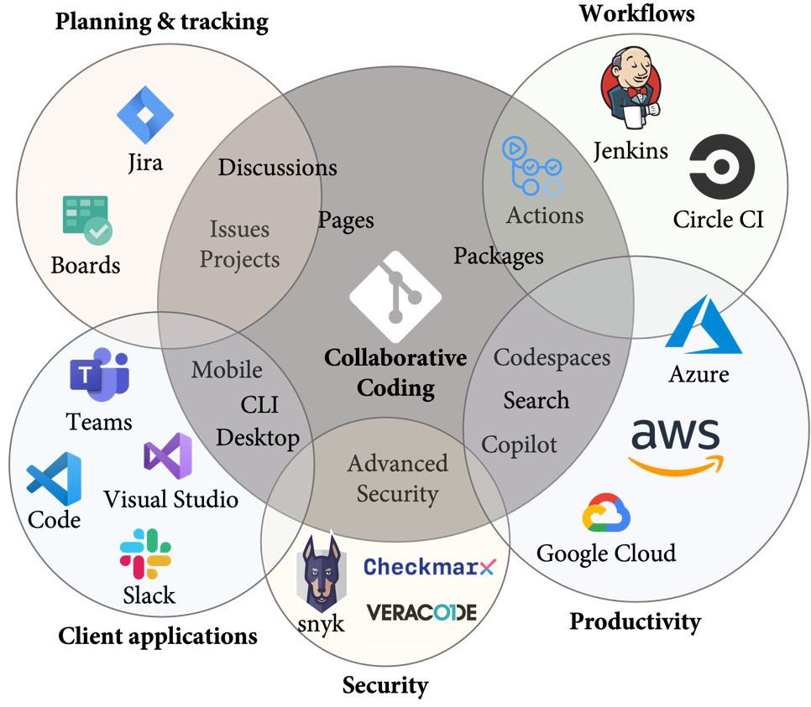
Figure 1.1 – The GitHub ecosystem and its integrations
In this book, I will provide practical recipes for workflows across all the major areas so that you will be able to automate all kinds of real-world development tasks.

Hosting and pricing for GitHub
All the examples in this book are done on https://github.com – the Software-as-a-Service (SaaS) offering from GitHub. Signing up for GitHub is free and provides users with unlimited private and public repositories. Nearly all features on GitHub are available free for open source projects (public repositories), but they may require a paid license for private repositories. In public repos, you have unlimited minutes for actions. That’s why it is important to do all the recipes in public repos – if not, you will burn rapidly through your 2,000 minutes per month.
GitHub’s pricing model is based on a monthly per-user billing system and consists of three tiers: Free, Team, and Enterprise (see Figure 1.2):
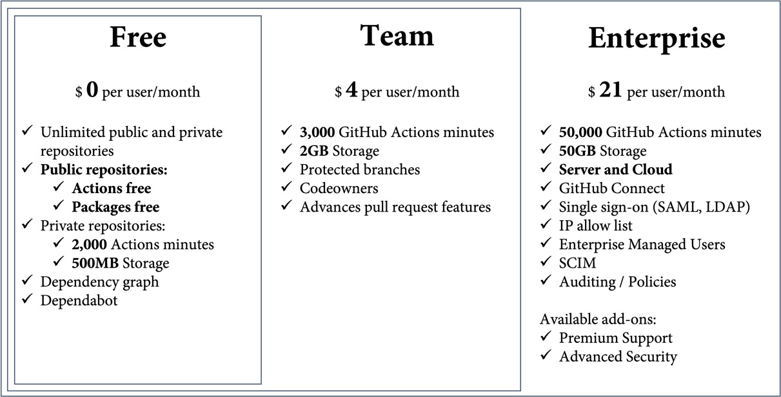
Figure 1.2 – GitHub pricing tiers
As mentioned earlier, public repos are entirely free – including GitHub Actions, Packages, and security features such as Dependabot and Secret Scanning. Private repos are also free, but only with limited functionality for collaboration. It does not include protected branches, Codeowners, and some advanced pull request features. For private repos, you have 2,000 free minutes in the free tier. To unlock the collaboration features, you’ll need to acquire a Team license for $4 per user per month. The Team plan then also includes 3,000 minutes for GitHub Actions.
The GitHub Enterprise plan brings all the Enterprise features – such as single sign-on (SSO) with Security Assertion Markup Language (SAML) and System for Cross-domain Identity Management (SCIM), Enterprise Managed Users, and the IP allow list. It also comes equipped with 50,000 minutes for GitHub Actions – but it also costs $21 per user per month.
In addition to the SaaS offering, GitHub also provides an appliance for self-hosting – GitHub Enterprise Server (GHES). It is available for AWS, GCP, Azure, or on-premises on Hyper-V, OpenStack KVM, or VMware ESXi. GHES is only available with the Enterprise plan. You can also combine GHES with GitHub Enterprise Cloud (GHEC) and share the same license for both hosting options.
GHES and GitHub Actions
Keep in mind that you cannot use GitHub-hosted runners for your workflow if you run GHES. You will have to provide your own runners for your workflows and ensure that they are secure and clean up their workflow artifacts. Typically, this is done on Kubernetes with Actions Runner Controller (ARC – https://github.com/actions/actions-runner-controller). You will learn more about this in Chapter 4, The Workflow Runtime.

Pricing for GitHub Actions
Running your workflows on self-hosted runners is completely free as you bring your own compute. Running workflows in public repositories is also free – even on the powerful runners provided by GitHub. GitHub-hosted runners are available on Linux, Windows, and macOS and in different sizes. If you want to leverage these runners in private repositories, you’ll be charged per minute. The different runners use different minute multipliers (see Table 1.1). Running a workflow on Linux will reduce 1 of your free minutes per minute – and you will be charged $0.008 if you exceed your free minutes. Windows will burn twice as fast through your free minutes and costs $0.08 per minute after that. And macOS will burn 10 times faster through your minutes and charges $0.016 per minute when you have reached the limit of your included minutes:
Operating system | Minute multiplier | Price per minute
Linux | 1 | $0.008
Windows | 2 | $0.080
macOS | 10 | $0.016
Table 1.1 – Pricing per minute for GitHub-hosted runners
That’s the reason why I use Linux for most of the examples in this book and why I always encourage my customers to run as much workload on Linux as possible.
If you use GHEC or the Team plan and you need machines with more power, then you can leverage larger GitHub-hosted runners. They are charged by minute (see Table 1.2) and have additional features such as static IP ranges:
vCPUs | Linux | Windows | macOS
2 | $0.008 | $0.016
3 |  |  | $0.08
4 | $0.016
8 | $0.032 | $0.064
12 |  |  | $0.32
16 | $0.064 | $0.128
32 | $0.128 | $0.256
64 | $0.256 | $0.512
Table 1.2 – Per-minute rate for larger runners
Private networking
In addition to static IP ranges, you can also use Azure private networking to connect GitHub-hosted runners directly to your resources. At the time of writing, this feature is still in beta and might change. See the following link for more information: https://docs.github.com/en/enterprise-cloud@latest/admin/configuration/configuring-private-networking-for-hosted-compute-products/about-networking-for-hosted-compute-products.
GitHub Actions also consumes storage – for example, for logs, workflow artifacts, or caching. If you exceed your included storage, you will be billed $0.008 per GB per day.
Keep in mind that pricing may change, and refer to the GitHub documentation for up-to-date information (https://docs.github.com/en/billing/managing-billing-for-github-actions/about-billing-for-github-actions).
And to learn GitHub Actions and experiment with workflows – just do everything in public repositories and you will not have to pay, either for compute or for storage.

GitHub Marketplace
GitHub offers a community-driven marketplace (https://github.com/marketplace) that contains currently more than 20,000 GitHub Actions that you can reuse as building blocks in your workflows (see Figure 1.3):
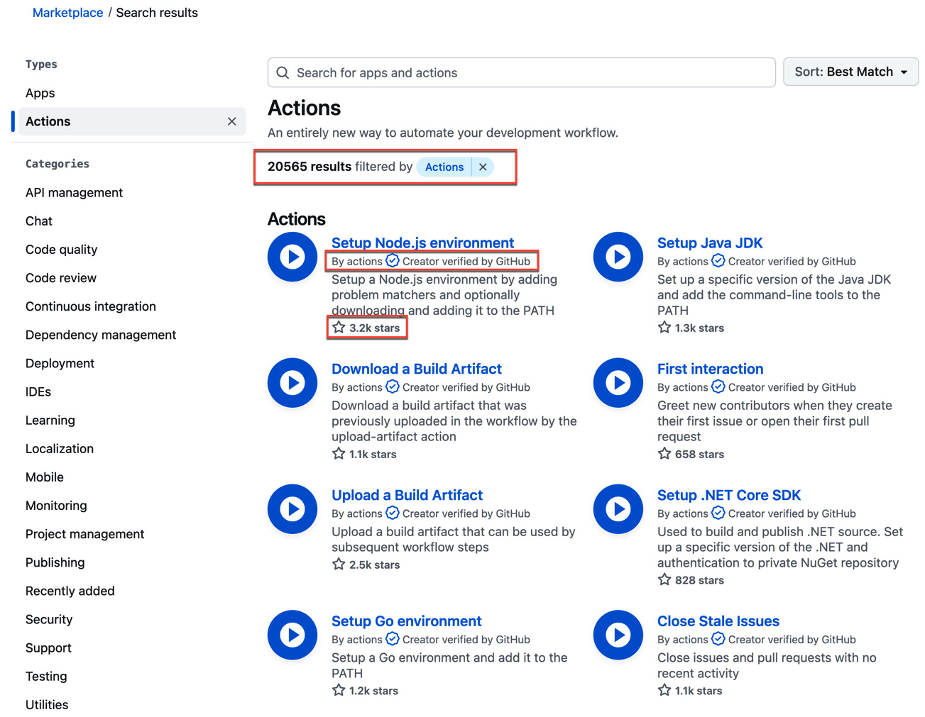
Figure 1.3 –GitHub Marketplace contains more than 20,000 reusable actions
If an action is by the author actions, that means it is a native action by GitHub. You can see the number of people who have starred an action in the overview. This will give you a good indication of the popularity of the action. And you will see the blue badge that indicates that the author of an action was verified by GitHub.
You can filter the marketplace by multiple categories, you can search by terms, and you can change the sort order of results to Most installed/starred, Best Match, or Recently added (see Figure 1.4):
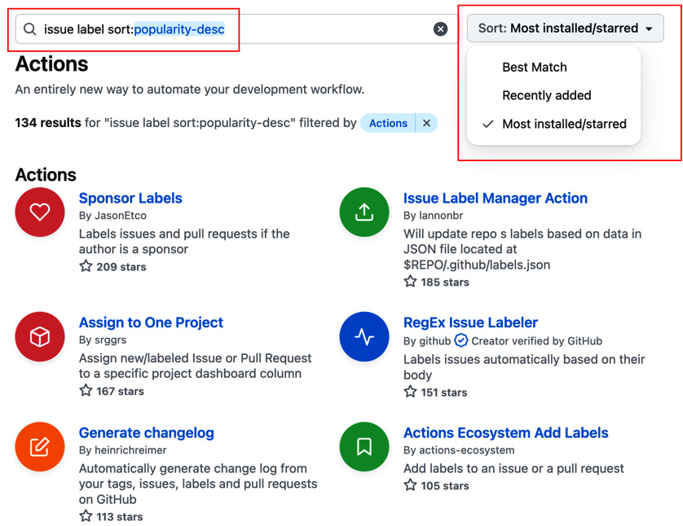
Figure 1.4 – Searching in the marketplace and sorting the results
This way, it is easy to explore the marketplace and find actions that will help you automate tasks in your workflows.
If you click one of the results, it will take you to the details page of the marketplace listing (see Figure 1.5):
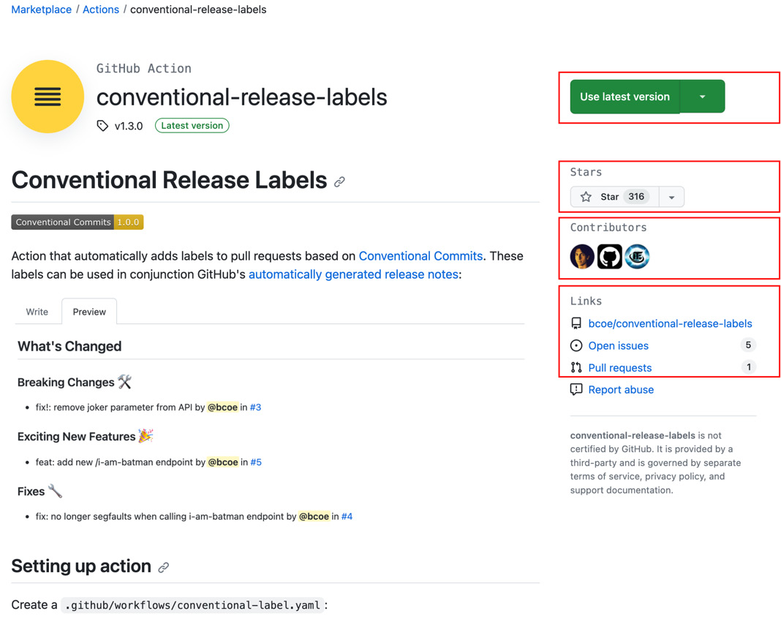
Figure 1.5 – Details of a marketplace listing
You can find released versions, the number of stars, contributors, and – as all published actions are open source – a link to the source repository and the number of open issues and pull requests. This should give you a good idea of how actively the action is used – and it allows you to dig into the code if you wish to do so.
The results of the marketplace are also displayed in the workflow editor, and we will use them in our recipes from it.

Using the workflow editor for writing workflows
GitHub does a good job of guiding people in the workflow designer when writing workflows. That’s why it is best to just start and write your first workflow and familiarize yourself with the platform.

Getting ready
Before you can create your first workflow, you first have to create a repository on GitHub. Navigate to https://github.com/new, authenticate if you are not authenticated yet, and fill in data as in Figure 1.6:
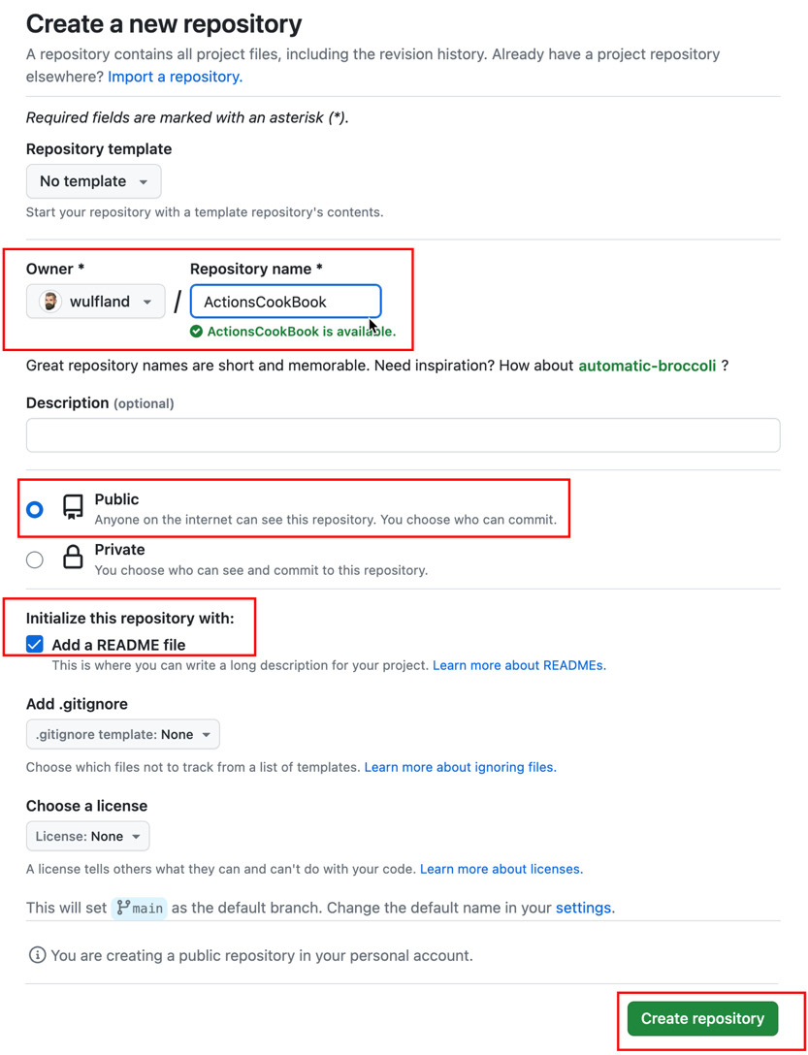
Figure 1.6 – Creating a new repository
Pick your GitHub user as the owner and give the repo a unique name – for example, ActionsCookBook. Make it a public repo so that all workflows and storage are free. Initialize the repo with a README file – this way, we have already files in the repo and something in the workflow to work with.

How to do it…
GitHub Action workflows are YAML files with a .yml or .yaml extension that are located in the .github/workflows folder in a repository. You could create the file manually, but then the workflow editor would only work after the first commit. Therefore, I recommend creating a new workflow from the menu.
- In your new repository, navigate to Actions. Since your repository is new and you don’t have any workflows yet, this will redirect you directly to the Create new workflow page (actions/new). If your repository contains workflows, you will see the workflows here (as later displayed in Figure 1.16), and you would have to click the New workflow button to get to that page.
On this page, you will find a lot of template workflows you could use as a starting point. There are starter workflows for deployments to most clouds, CI for most languages, security scanning of your code, automation in general, and templates to deploy content to GitHub Pages. You can filter the starter workflows by these categories. These workflows give you a good starting point for most of your workflows.
In this recipe, we will focus on familiarizing ourselves with the editor, and we will create a workflow from scratch by clicking set up a workflow yourself (see Figure 1.7):
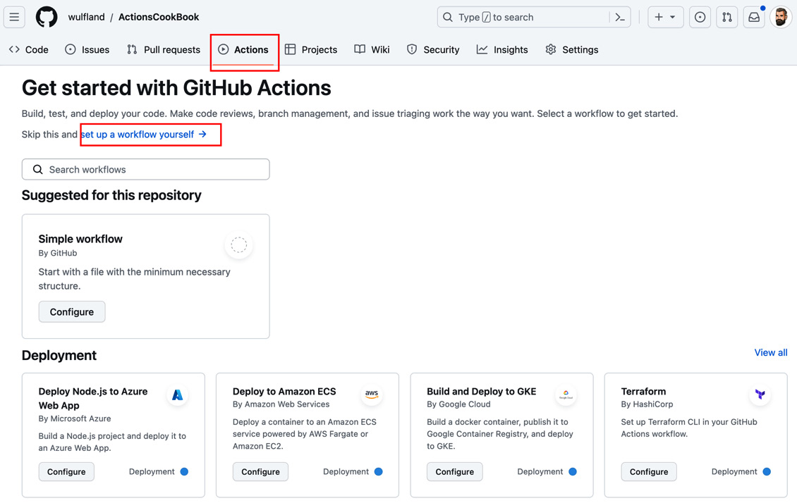
Figure 1.7 – Creating a new workflow in GitHub
- GitHub will create a new main.yml file in .github/workflows on the default branch and display it in the web editor. On the right side of the editor, you have the documentation, and you can search for actions in GitHub Marketplace. In the editor, you can use Ctrl + Space (or Option + Space – depending on your keyboard settings) to trigger autocomplete. The editor will capture the Tab key and by default use it for a two-space indentation. To navigate to other controls on the page using the Tab key, you first have to exit it using Esc or using Ctrl + Shift + M.
Modify the filename to MyFirstWorkflow.yml and familiarize yourself with the editor (see Figure 1.8):
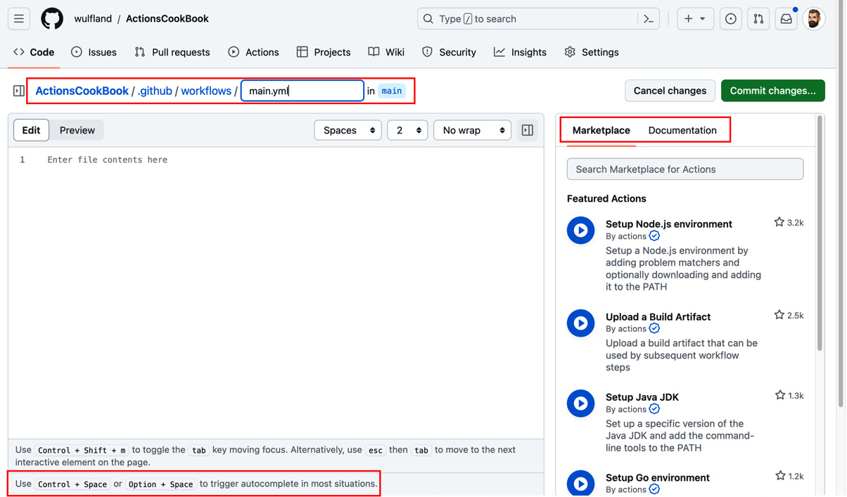
Figure 1.8 – The workflow editor for GitHub Actions
- In the editor, click Ctrl + Space (or Option + Space) to see a list of root elements valid in a workflow file (see Figure 1.9):
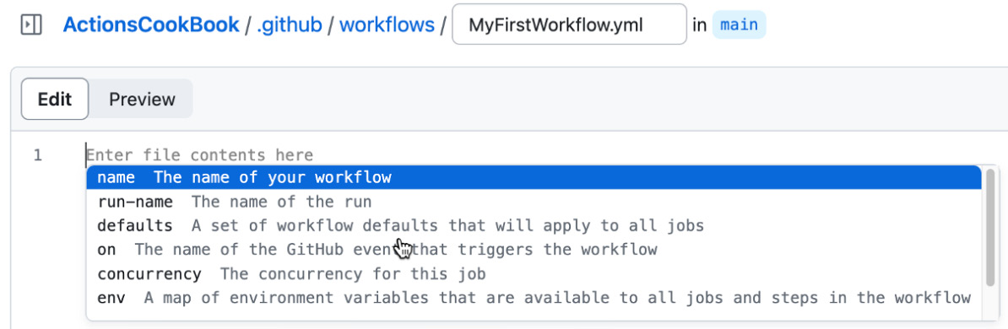
Figure 1.9 – The editor shows you all valid options at a certain level in the workflow file
Typically, workflows are started with the name property, which sets the display name of the workflow in the UI. It’s a good practice to add a comment to the top of the file summarizing the intent of the workflow.
- Add a comment to the top of the file and set the name property using autocomplete. Note that the editor has error checking and indicates that you are still missing the required root key, on (see Figure 1.10):
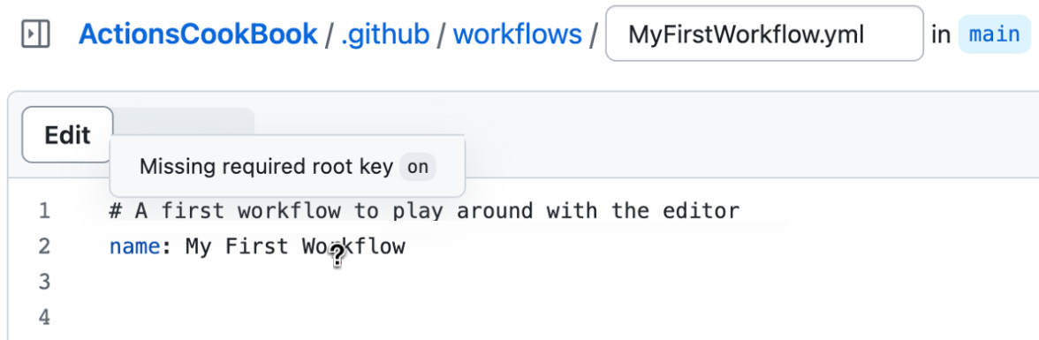
Figure 1.10 – Error checking in the code editor
- Next, we are going to configure events that should trigger the workflow. Note that a workflow can have multiple triggers. Depending on where you are in the designer, autocomplete will give you different results. If you are on the same line as on:, you will get a result in the JSON syntax (see the YAML collection types section); that is, on: [push].
If you add a comma after the first element and click Control + Space again, then you can pick additional elements from autocomplete (see Figure 1.11):
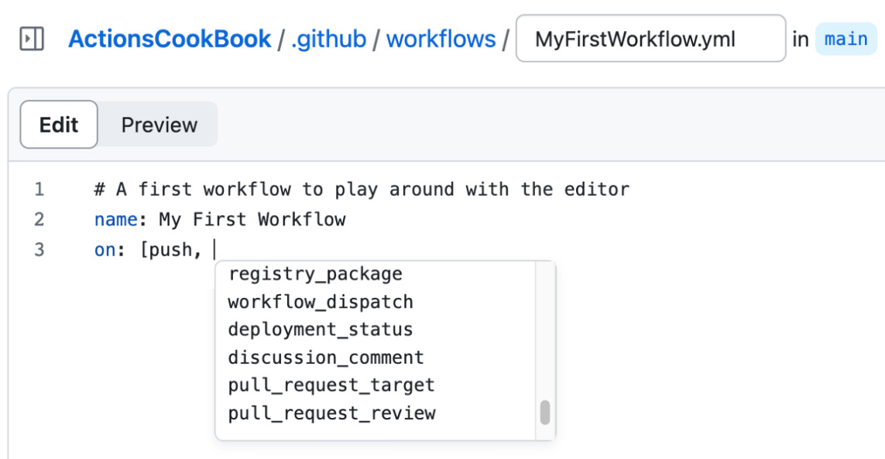
Figure 1.11 – Autocomplete works also inside squared brackets
Each trigger is a map and can contain additional arguments. If you put your cursor on the line below on: and add a two-space indentation, autocomplete will give you the results in the full YAML syntax. It will also give you properties that you can use to configure each trigger (see Figure 1.12):
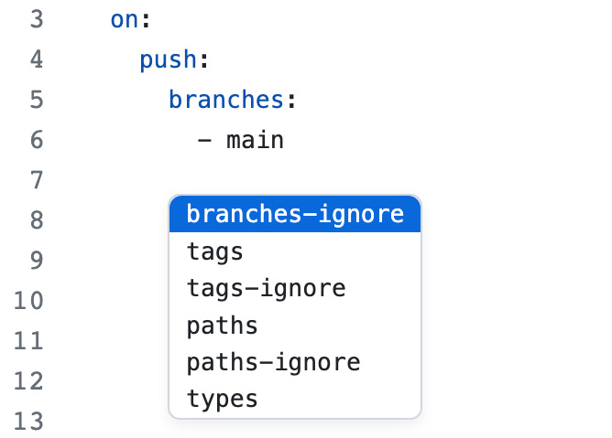
Figure 1.12 – Autocomplete also helps with options for triggers
Note that most arguments – for example, branches or paths – are sequences and need a dash for each entry if you are not using the JSON syntax.
We want our test workflow to run on every push to the main branch. We also want to be able to trigger it manually (see the Events that trigger workflows section). Your workflow code for triggers should look like this:
on:
push:
branches:
- main
workflow_dispatch:
Wildcards
The * character can be used as a wildcard in paths and ** as a recursive wildcard. * is a special character in YAML, so you need to use quotation marks in that case:
push:
branches:
- 'release/**'
paths:
- 'doc/**'
- After configuring the triggers for the workflow, the next step is to add another root element: the jobs. Jobs are a map in YAML – meaning on the next line with two-space indentation, autocomplete will not work as the editor expects you to set a name. Name your job first_job and go to the next line. The name of the job object can only contain alphanumeric values, a dash (-), and an underscore (_). If you want any other characters to be displayed in the workflow, you can use the name property:
jobs:
first_job:
name: My first job
- Every job needs a runner that executes it. Runners are identified by labels. You will learn more about runners in Chapter 4, The Workflow Runtime. We want our workflow to be executed on the latest version of the Ubuntu runners provided by GitHub, so we use the ubuntu-latest label:
runs-on: ubuntu-latest
- A job consists of a sequence of steps that are executed one after the other. The most basic step is the run: command, which will execute a command-line command:
steps:
- name: Greet the user
run: echo "Hello world"
shell: bash
The name is optional and sets the output of the step in the log. The shell is also optional and will default to bash on non-Windows platforms, with a fallback to sh. On Windows, the default is PowerShell Core (pwsh), with a fallback to cmd. But you could configure any shell you want with the {0} placeholder for the input of the step (that is, shell: perl {0}).
To add variable output, we can use expressions that are written between ${{ and }}. In the expression, you can use values from context objects such as the GitHub context. Note that autocomplete also works for these context objects (see Figure 1.13):
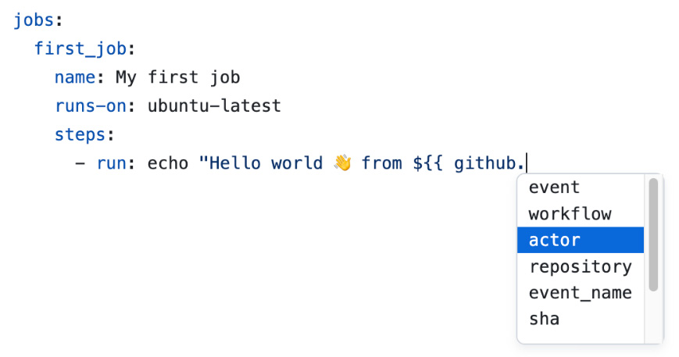
Figure 1.13 – Autocomplete also works for context objects
Pick the actor from the list of values:
- run: echo "Hello world
 from ${{ github.actor }}."
You will learn more about expressions and context syntax throughout the book. But you can refer to the documentation for expressions (https://docs.github.com/en/actions/learn-github-actions/expressions) and context (https://docs.github.com/en/actions/learn-github-actions/contexts) at any time.
- YAML allows you to write multiline scripts without the need to wrestle with quotations and newlines. Just add the pipe operator (|) after run: and write your script in the next line with a four-space indentation. YAML will treat this as one block until the next element – even with new and blank lines in it:
- run: |
echo "Hello world
 from ${{ github.actor }}."
echo "Current branch is '${{ github.ref }}'."
- GitHub Actions workflows will not automatically download the code from your repository. If you want to do something with files in your repository, you have to check out the content first. This is done using a GitHub action – a reusable workflow step that can easily be shared for multiple workflows.
On the right side of the workflow editor is the marketplace. You can directly search there for all kinds of actions. Search for checkout and locate the action from actions (these are built-in actions from GitHub). In the listing, you see the owner of the action, the latest version, and the stars of the repository. The listing contains an Installation section that you can copy into your workflow to use the action (see Figure 1.14):
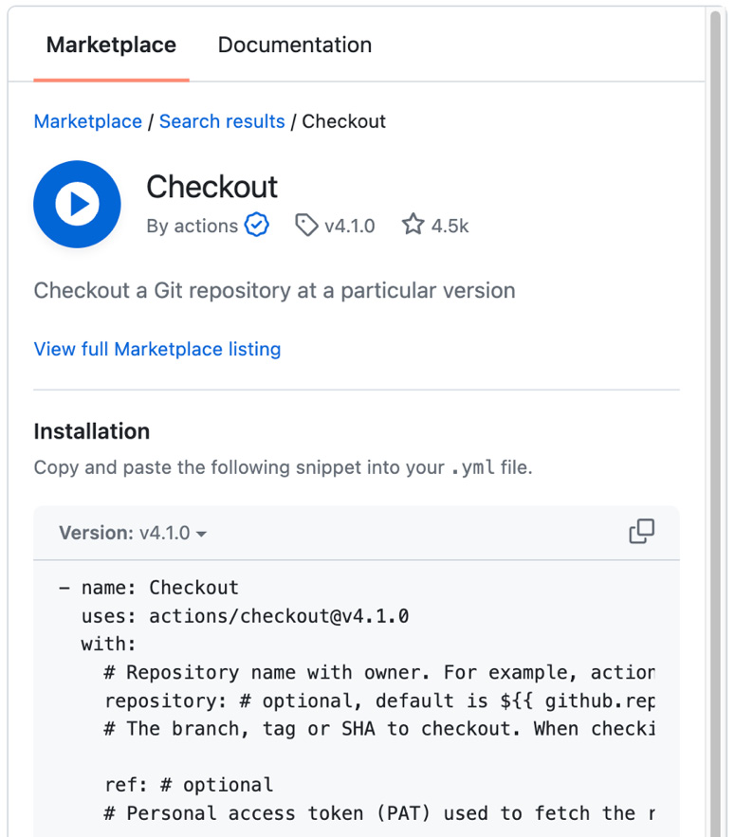
Figure 1.14 – Listing of the marketplace in the workflow editor
Note that many parameters are optional. To check out the repo, you only need the following lines:
- name: Checkout
uses: actions/checkout@v4.1.0
Using GitHub Actions
Actions refer to a location on GitHub. The syntax is {path}@{ref}. The path points to a physical location on GitHub and can be {owner}/{repo} if the actions are in the root of a repository or {owner}/{repo}/{path} if the actions are in a subfolder. The reference after @{ref} is any git reference that points to a commit. It can be a tag, branch, or an individual commit SHA.
- To display the files in our repository after checking them out, we’ll add an extra step:
- run: tree
This will output the files in the repository in a tree structure.
- To run the workflow, just commit the workflow file to the main branch. Click Commit changes…, leave the commit message and branch, and click Commit changes in the dialog to finish the operation (see Figure 1.15):
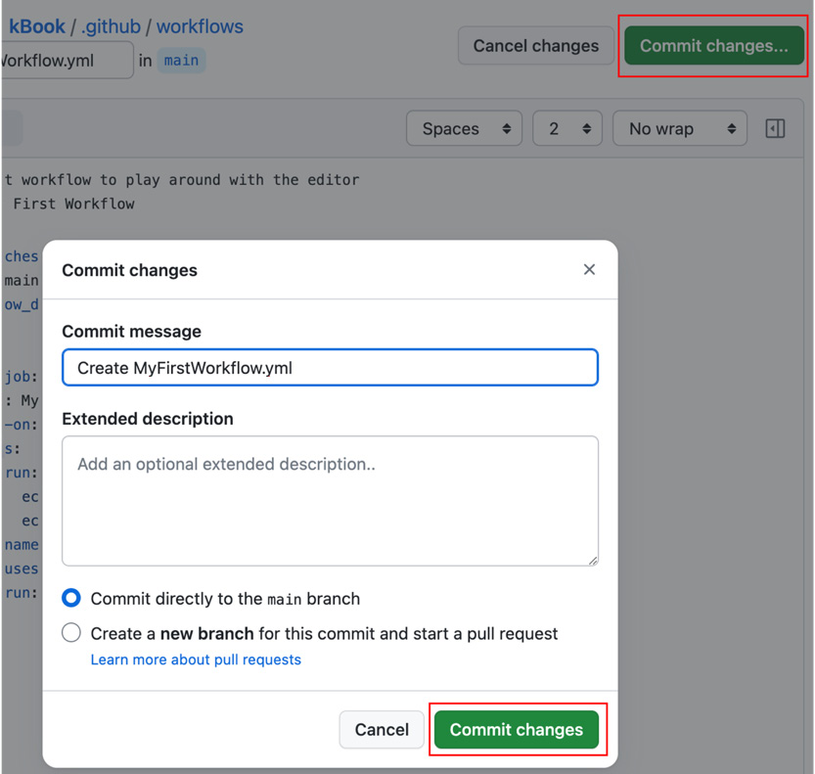
Figure 1.15 – Committing the workflow file
- As we have set a push trigger for the main branch, our commit has automatically triggered the workflow. If you navigate now to Actions in your repository, you will be able to see your workflow and the latest workflow run (see Figure 1.16):
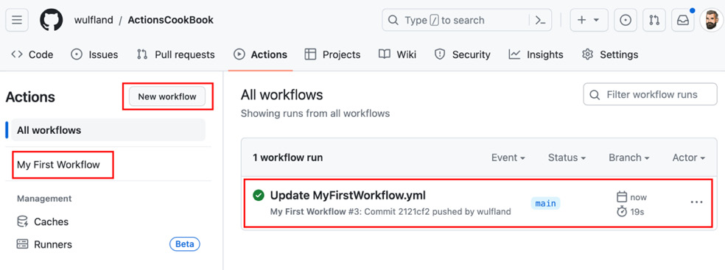
Figure 1.16 – The default view in Actions displays the latest workflow runs of all workflows
Note that the name of the workflow run is the commit message. You can also see the commit that triggered the workflow and the actor that pushed the changes.
- Click on the workflow run to see more details. The workflow summary page contains jobs on the left and a visual representation on the right (see Figure 1.17). It also contains metadata for the trigger, the status, and the duration:
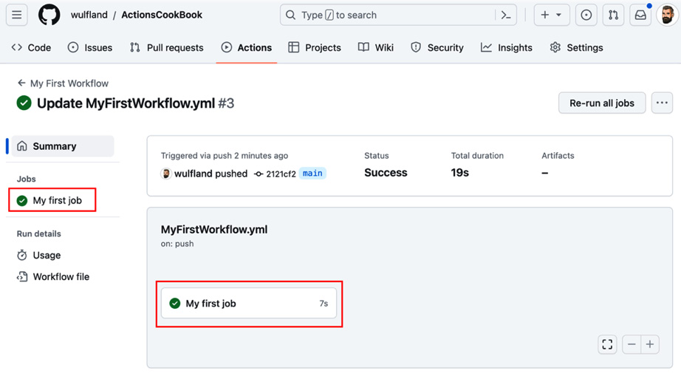
Figure 1.17 – The workflow summary page
- Click on the job to view more details. In the workflow log, you can inspect the individual steps. Note that each line of the workflow file has a clickable number – that is a URL that you could use to identify each line. The Set up job step is a special step that gives you a lot of background information about the workflow runner and workflow permissions (see Figure 1.18). Inspect the output of all steps of your workflow:
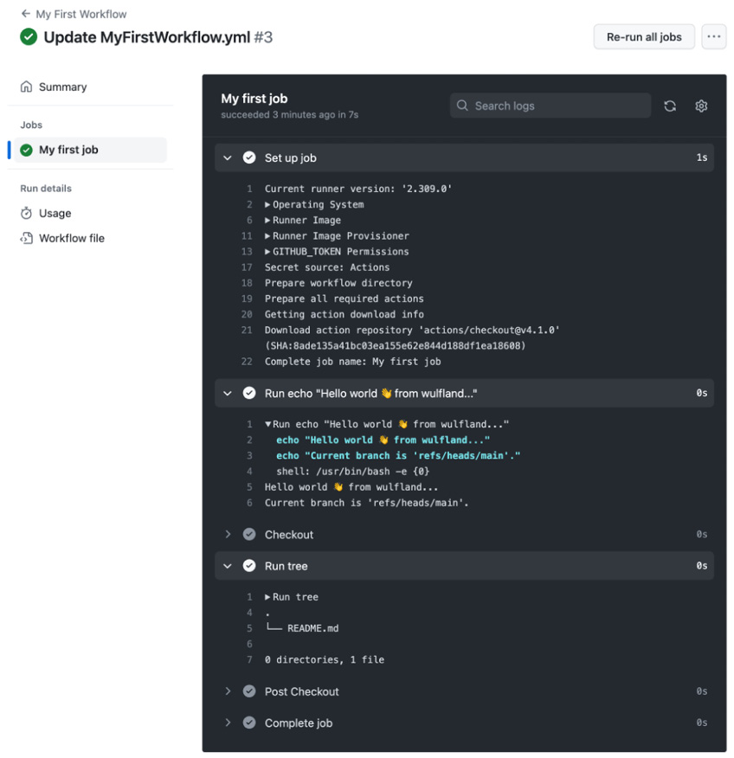
Figure 1.18 – The workflow log for an individual job
- As a last step, we want to trigger the workflow manually to also see the difference in the workflow run. Go back to Actions, select the workflow on the left side (see Figure 1.19), and run the workflow:
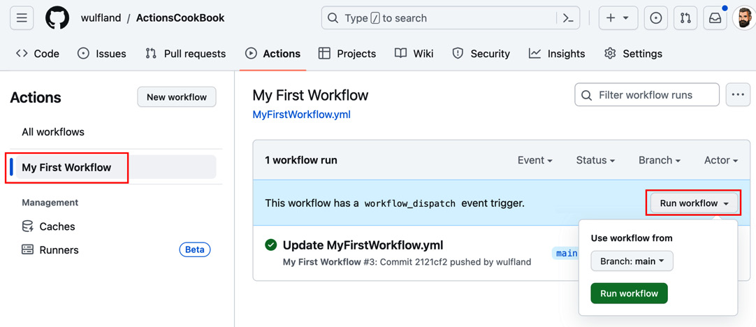
Figure 1.19 – Triggering a workflow manually through the UI
Inspect the new workflow run and its output.

How it works…
Workflow files are YAML files located in the .github/workflows folder in a repository.
YAML basics
YAML stands for YAML Ain’t Markup Language and is a data-serialization language optimized to be directly writable and readable by humans. It is a strict superset of JSON but with syntactically relevant newlines and indentation instead of braces.
You can write comments by prefixing text with a hash (#).
In YAML, you can assign a value to a variable with the following syntax: key: value.
key is the name of the variable. Depending on the data type of value, the type of the variable will be different. Note that keys and values can contain spaces and do not need quotation marks! Only add them if you use some special characters or you want to force certain values to be a string. You can quote keys and values with single or double quotes. Double quotes use the backslash as the escape pattern ("Foo \"bar \" foo"), while single quotes use an additional single quote for this ('foo ''bar'' foo').
YAML collection types
In YAML, there are two different collection types: nested types called maps and lists – also called sequences. Maps use two spaces of indentation:
parent_type:
key1: value1
key2: value2
nested_type:
key1: value1
A sequence is an ordered list of items and has a dash before each line:
sequence:
- item1
- item2
- item3
Since YAML is a superset of JSON, you can also use the JSON syntax to put collections in one line:
key: [item1, item2, item3]
key: {key1: value1, key2: value2}
Events that trigger workflows
There are three types of triggers for workflows: webhook triggers, scheduled triggers, and manual triggers.
Webhook triggers start the workflow based on an event in GitHub. There are many webhook triggers available. For example, you could run a workflow on an issues event, a repository event, or a discussions event. The push trigger in our example is a webhook trigger.
Scheduled triggers can run the workflow at multiple scheduled times. The syntax is the same syntax used for cron jobs:
on:
schedule:
# Runs at every 15th minute
- cron: '*/15 * * * *'
# Runs every hour from 9am to 5pm
- cron: '0 9-17 * * *'
# Runs every Friday at midnight
- cron: '0 2 * * FRI'
Manual triggers allow you to start the workflow manually. The workflow_dispatch trigger will allow you to start the workflow using the web UI or GitHub CLI. You can define input parameters for this trigger using the inputs property. The repository_dispatch trigger can be used to trigger the workflow using the API. This trigger can also be filtered by certain event types and can accept additional JSON payload that can be accessed in the workflow.
To learn more about triggers, check the documentation at https://docs.github.com/en/actions/using-workflows/events-that-trigger-workflows.
Jobs
Every job needs a runner that executes it. Runners are identified by labels. In our recipe, we use the ubuntu-latest label. This means that our job will be executed on the latest Ubuntu image hosted by GitHub. You will learn more about runners in Chapter 4, The Workflow Runtime.
Using GitHub Actions
Actions refer to a location on GitHub. The syntax is {path}@{ref}. The path points to a physical location on GitHub and can be {owner}/{repo} if the actions are in the root of a repository or {owner}/{repo}/{path} if the actions are in a subfolder. The reference after @{ref} is any git reference that points to a commit. It can be a tag, branch, or an individual commit SHA:
# Reference a version using a tag
- uses: actions/checkout@v4.1.0
# Reference the current head of a branch
- uses: actions/checkout@main
# Reference a specific commit
- uses: actions/checkout@8e5e7e5ab8b370d6c329ec480221332ada57f0ab
For local actions in the same repository, you can omit the reference if you check out of the repository.
If the action has defined inputs, you can specify them using the with property:
- uses: ActionsInAction/HelloWorld@v1
with:
WhoToGreet: Mona
Inputs can be optional or required. You can also set environment variables for steps using the env property:
- uses: ActionsInAction/HelloWorld@v1
env:
GITHUB_TOKEN: ${{ secrets.GITHUB_TOKEN }}

There’s more…
This is just a very basic workflow that uses an action to check out code and runs some commands on the command line. In the next two recipes, I’ll show you how to use secrets, variables, and protected environments for more complex workflows.

Using secrets and variables
You can set variables and secrets in a repository that you can access in workflows. In this recipe, we’ll add both and access them in the workflow.

Getting ready
In this recipe, we will use the web UI to set variables and secrets. You can also use the GitHub CLI (https://cli.github.com/) for that. If you want to try that, then you have to install it. But it is not necessary for following the recipe.

How to do it…
- In your repository, navigate to Settings | Secrets and Variables | Actions. You can see all existing secrets in the repository, and you can toggle the tabs between Secrets (settings/secrets/actions) and Variables (settings/variables/actions; see Figure 1.20):
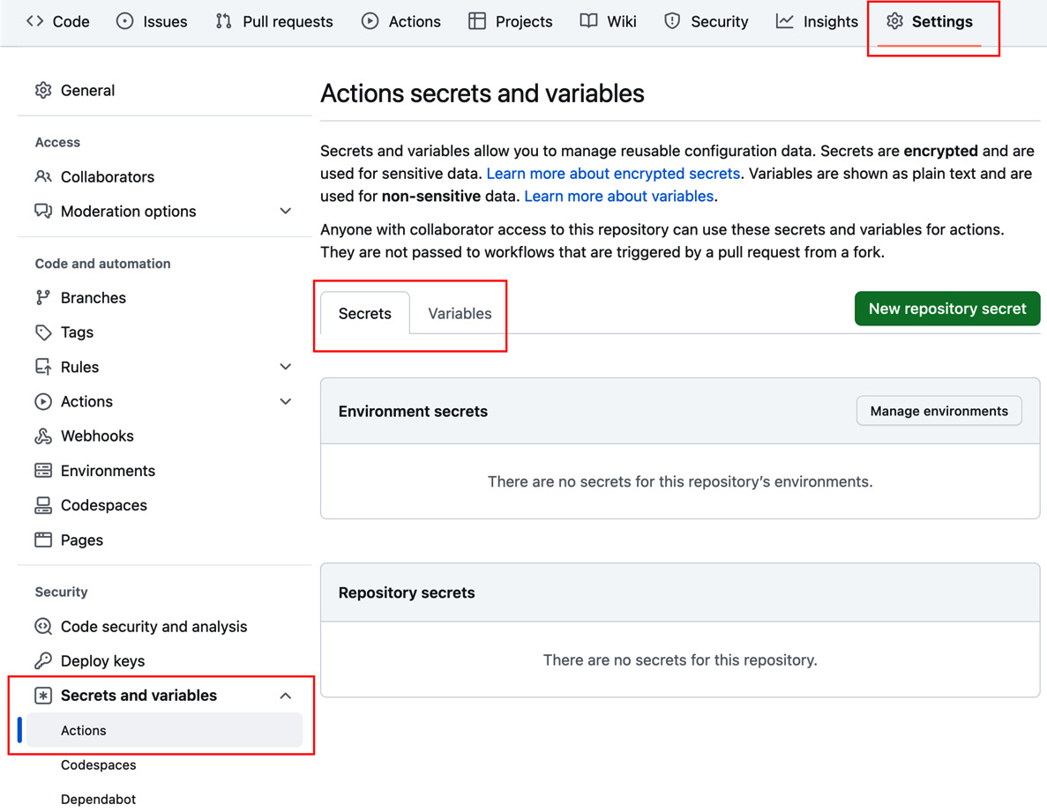
Figure 1.20 – Configuring secrets and variables for a repository
- Clicking New repository secret will open the New secret dialog (settings/secrets/actions/new; see Figure 1.21):
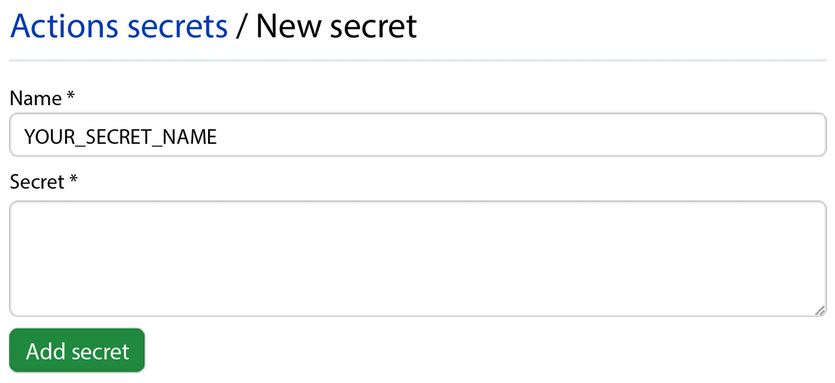
Figure 1.21 – Adding a new secret
Add MY_SECRET as the secret name and a random word such as Abracadabra as the secret, and click Add secret. The secret will be masked in the logs! So, don’t use a common word that could occur in other outputs of random jobs or steps.
Naming conventions for secrets and variables
Secret names are not case-sensitive, and they can only contain normal characters ([a-z] and [A-Z]), numbers ([0-9]), and an underscore (_). They must not start with GITHUB_ or a number.
The best practice is to name secrets with uppercase words separated by the underscore character.
- Repeat the process for New repository variable (settings/variables/actions/new) and create a WHO_TO_GREET variable with the value World.
- Open the .github/workflows/MyFirstWorkflow.yml file from the previous recipe and click the edit icon (see Figure 1.22):
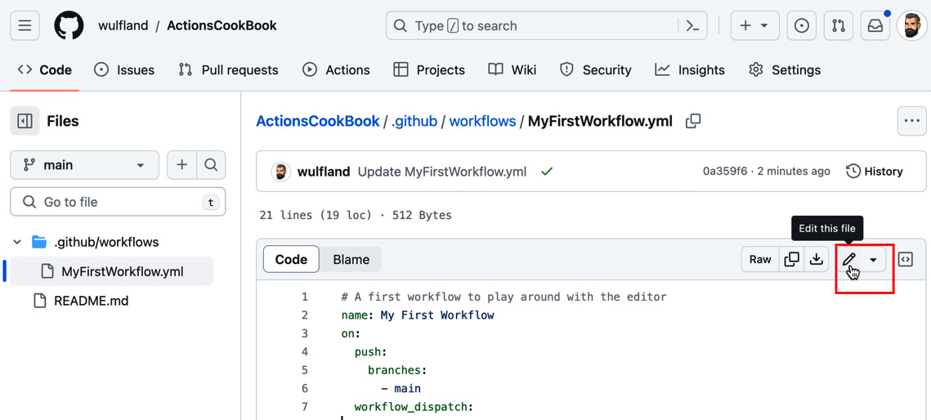
Figure 1.22 – Editing MyFirstWorkflow.yml
Change the word World to the ${{ vars.WHO_TO_GREET }} expression and add a new line using the ${{ secrets.MY_SECRET }} secret:
- run: |
echo "Hello ${{ vars.WHO_TO_GREET }}
 from ${{ github.actor }}."
echo "My secret is
 ${{ secrets.MY_SECRET }}."
- Commit the changes. The workflow will run automatically. Inspect the output in the workflow log. It should look like Figure 1.23:
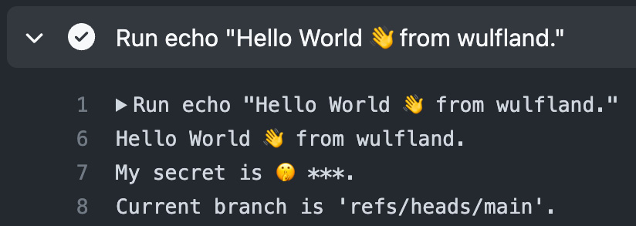
Figure 1.23 – Output of a secret and variable in the log

There’s more…
You can create configuration variables for use across multiple workflows by defining them on one of the following levels:
- Organization level
- Repository level
- Environment level
The three levels work like a hierarchy: you can override a variable or secret on a lower level by providing a new value to the same key. Figure 1.24 illustrates the hierarchy:
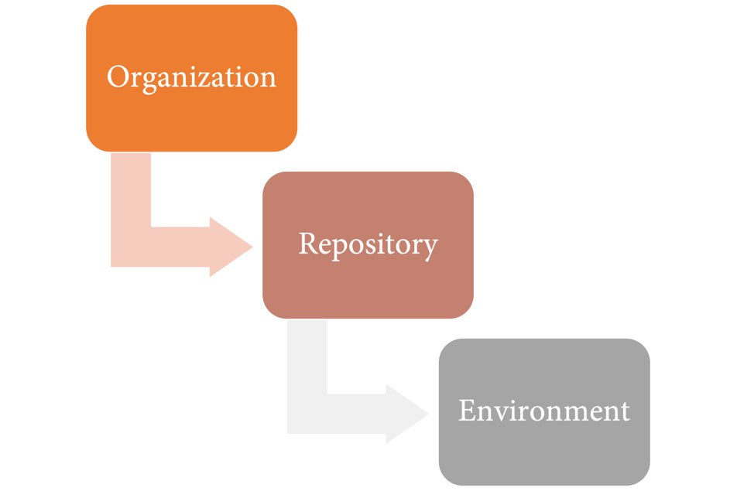
Figure 1.24 – The hierarchy for configuration variables and secrets
Secrets and variables for organizations work the same way as for repositories. You can create a secret or variable under Settings | Secrets and variables | Actions. New organization secrets or variables can have an access policy for the following:
- All repositories
- Private repositories
- Selected repositories
When choosing Selected repositories, you can grant access to individual repositories.
In addition to setting these values through the UI, it is also possible to use the GitHub CLI.
You can use gh secret or gh variable to create new entries:
$ gh secret set secret-name
$ gh variable set var-name
You will be prompted for the secret or variable values, or you can read the value from a file, pipe it to the command, or specify it as the body (-b or --body):
$ gh secret set secret-name < secret.txt
$ gh variable set var-name --body config-value

Creating and using environments
Environments are used to describe a general deployment target such as development, test, staging, or production. You can protect environments with protection rules, and you can provide configuration variables and secrets for specific environments.

Getting ready
We will first create some environments using the web UI and add some protection rules, secrets, and variables. Then, we add them to our existing workflow.

How to do it…
- Navigate to Settings | Environments and click on New environment (see Figure 1.25):
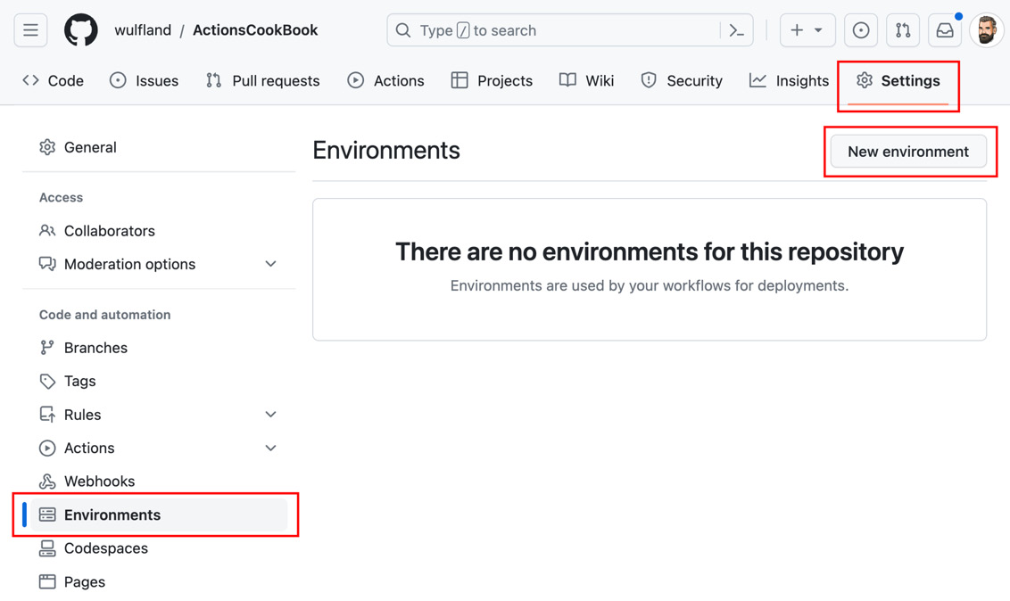
Figure 1.25 – Managing environments in a repository
Enter the name Production and click Configure environment (see Figure 1.26):
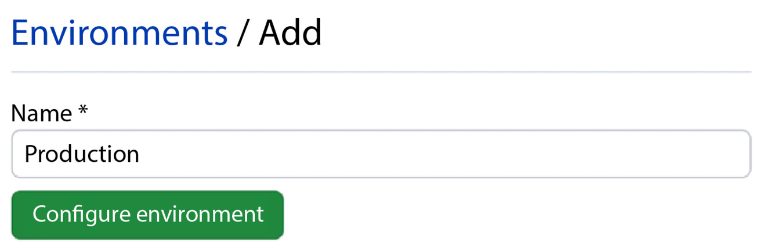
Figure 1.26 – Creating a new environment
- Add yourself as a required reviewer and click Save protection rule (see Figure 1.27):
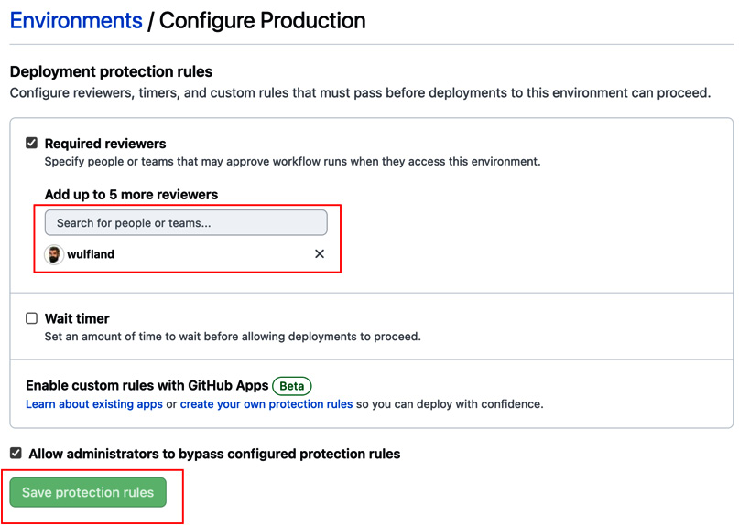
Figure 1.27 – Configuring deployment protection rules
- Under Deployment branches and tags, choose Selected branches and tags, click the plus symbol, and add a name pattern for the main branch (see Figure 1.28):
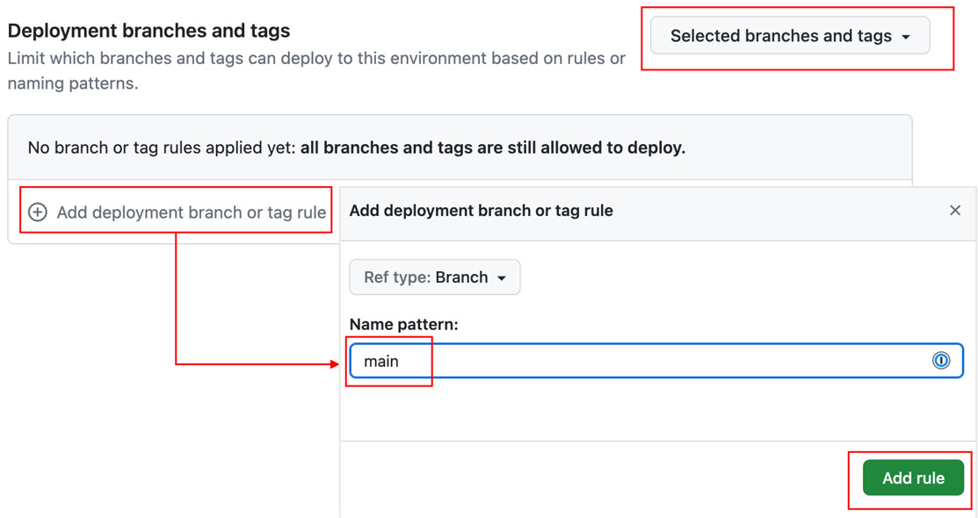
Figure 1.28 – Configuring deployment branches and tags
- Under Environment secrets, click on Add secret and add a new MY_SECRET secret with the value Open Sesame (see Figure 1.29). Repeat this with Add variable and add a WHO_TO_GREET variable with the value Production users:
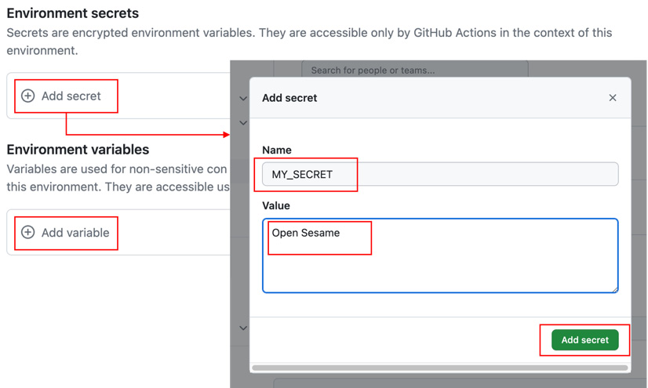
Figure 1.29 – Adding secrets and variables to environments
- Repeat step 1 and create two additional environments, Test and Load-Test. We will use these environments in the next steps to show how to execute jobs in parallel. You don’t have to configure deployment branches or required reviewers. Just add a WHO_TO_GREET variable with the corresponding value. The result should look like Figure 1.30:
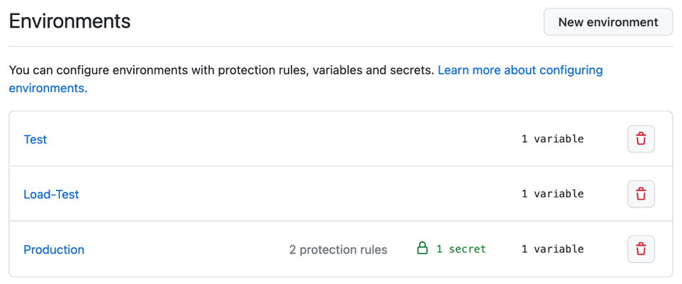
Figure 1.30 – Multiple environments in the settings of the repository
- Now, go back to the workflow file and edit it. Add a new job beneath first_job called Test that runs on the latest Ubuntu image. We associate this job with the Test environment. To run this job after first_job, we use the needs property and set it to the job we depend on:
Test:
runs-on: ubuntu-latest
environment: Test
needs: first_job
To see how secrets are overwritten by the environment, we have to use a little hack. As GitHub searches for the value of secrets in the output of the log to mask it, we have to modify the actual text. We can do this, for example, using the sed 's/./& /g' command. This will add a blank between every character of the secret. With this little hack, the steps of the Test job should look like this:
steps:
- run: |
echo "Hello ${{ vars.WHO_TO_GREET }}
 from ${{ github.actor }}."
sec=$(echo ${{ secrets.MY_SECRET }} | sed 's/./& /g')
echo "My secret is
 '$sec'."
- Next, add a new Load-Test job that is associated with the Load-Test environment and also executes after first_job:
Load-Test:
runs-on: ubuntu-latest
environment: Load-Test
needs: first_job
Just copy the steps from Test. There is no need to change anything.
- The last job is a Production job. In addition to the name, the environment property accepts a URL that later will be displayed in the workflow designer. Set it to any URL you want. To show how after a parallel execution of jobs the workflow can merge again, we will run Production after Test and Load-Test:
Production:
runs-on: ubuntu-latest
environment
:
name
:
Production
url
: https://writeabout.net
needs: [Test, Load-Test]
Just copy the steps from the previous jobs.
- Commit your changes to the main branch. The workflow will run automatically. Navigate to the new workflow run and inspect the workflow designer, which nicely shows the parallel execution. The workflow will pause before executing Production and will wait for approval (see Figure 1.31):
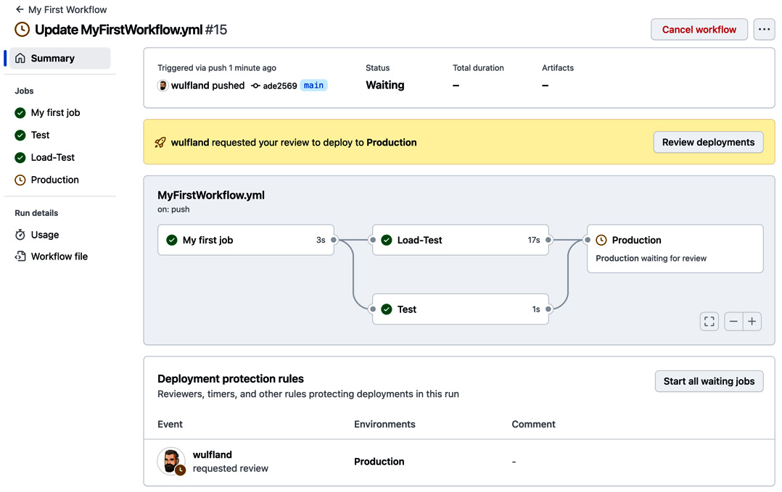
Figure 1.31 – The workflow will stop before an environment with required reviewers and wait for approval
- Click Review deployment, check Production, and add an optional comment. Click Approve and deploy to start executing the Production job (see Figure 1.32):
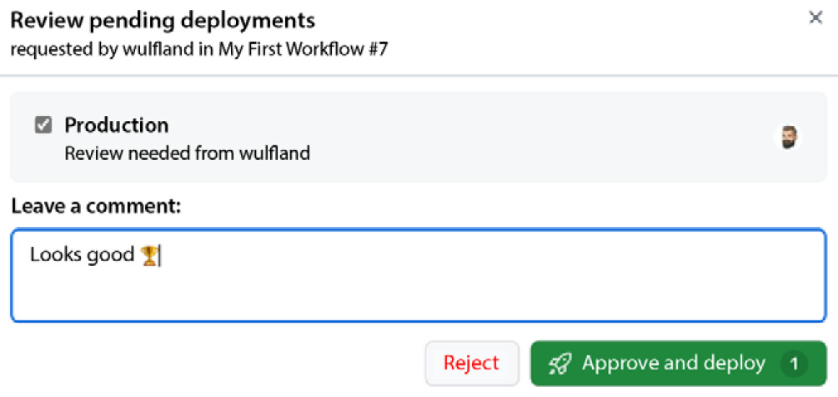
Figure 1.32 – Approving a protected environment
The workflow will execute completely, and the result should look like Figure 1.33. Note that the URL is displayed in the Production environment. Also, note the history of approvals in the workflow summary:
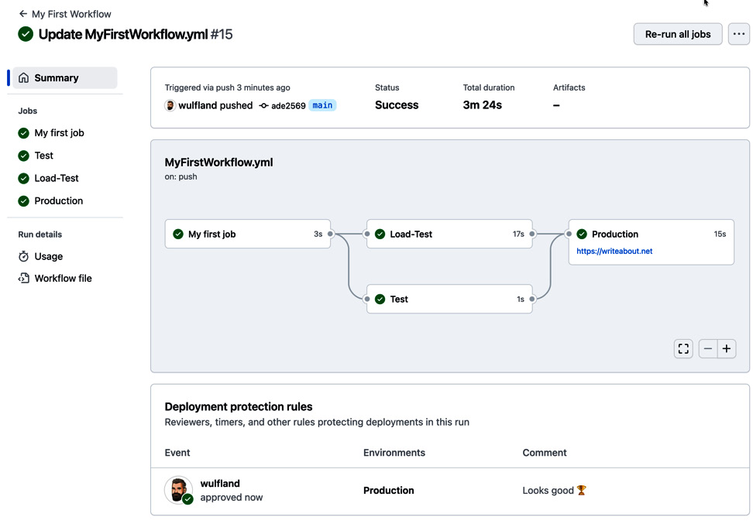
Figure 1.33 – The final summary of the workflow
Open the individual jobs and inspect the output of the step we added (see Figure 1.34). The secrets and variables are used from the repository and are only overridden if we set them in an environment:
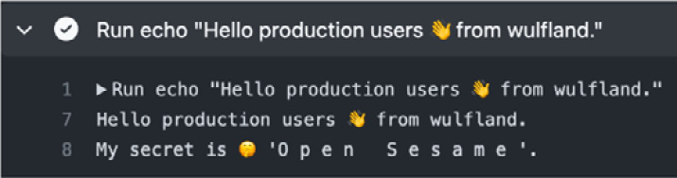
Figure 1.34 – The production secret is only available to the production environment after approval

There’s more…
If you are setting secrets or variables for an environment using the GitHub CLI, then you can specify them using the --env (-e) argument. For organization secrets, you set the visibility (--visibility or -v) to all, private, or selected. For selected, you must specify one or more repos using --repos (-r):
$ gh secret set secret-name
--env
environment-name
$ gh secret set secret-name
--org org
-v private
$ gh secret set secret-name --org org
-v selected -r repo
Environments have more options than we have used in this recipe. You can also configure a wait timer that will pause the workflow for n minutes (with a maximum of 30 days) before executing the deployment job for that particular environment.
There is also a new feature called custom deployment protection rules that is still in beta. This feature allows the creation of GitHub apps that can pause your deployment and wait for a specific condition. There are already apps from Datadog, Honeycomb, Sentry, New Relic, and ServiceNow (see https://docs.github.com/en/actions/deployment/protecting-deployments/configuring-custom-deployment-protection-rules#using-existing-custom-deployment-protection-rules). We’ll have a closer look at custom deployment rules in Chapter 7, Release Your Software with GitHub Actions.
The true power of environment protection rules lies in the deployment branch or tag rules. This can restrict code that does not apply to branch protection rules from deploying to certain environments. This can include all kinds of checks – Codeowners approvals, code reviewers, deployments to certain other environments, SonarQube quality gates, and many other automated code checks (see https://docs.github.com/en/repositories/configuring-branches-and-merges-in-your-repository/managing-protected-branches/about-protected-branches for more information).
2

Authoring and Debugging Workflows
This chapter goes a step further and you will learn best practices for authoring workflows. This includes using Visual Studio Code, running your workflows locally, linting, working in branches, and using advanced logging and monitoring. This will be the foundation for the other chapters, as it gives you plenty of options on how to write your workflows.
This chapter covers the following:
- Using Visual Studio Code for authoring workflows
- Developing workflows in branches
- Linting workflows
- Writing messages to the log
- Enabling debug logging
- Running your workflows locally
Technical requirements
For this chapter, you need Visual Studio Code (VS Code) installed on your local machine. It is available for Windows (x64, x86, and Arm64), Linux (x64, x86, and Arm64), and Mac (Intel and Apple silicon), and you can install it from the following website if you haven’t already done this: https://code.visualstudio.com/download.
Additionally, check that you have an up-to-date Git version installed on your machine. You can get instructions on how to get the Git client here: https://git-scm.com/downloads.
To run your workflows locally, you will also need Docker installed. If you are using macOS, please be sure to follow the steps outlined in Docker Docs for how to install Docker Desktop for Mac (https://docs.docker.com/docker-for-mac/install). If you are using Windows, please follow steps for installing Docker Desktop on Windows (https://docs.docker.com/docker-for-windows/install). If you are using Linux, you will need to install Docker Engine (https://docs.docker.com/engine/install).

Using Visual Studio Code for authoring workflows
Visual Studio Code (VS Code) is one of the most popular and widely used code editors in the world. It has gained significant popularity in the developer community due to its flexibility, extensive ecosystem of extensions, and strong community support.
VS Code has a high level of integration with GitHub. It offers features such as Git integration, the synchronization of your settings using your GitHub account, direct access to repositories, and the ability to create, edit, and manage GitHub Action workflows from within the editor using the extension provided by GitHub. This tight integration simplifies the workflow creation process and streamlines collaboration on GitHub action workflows.
In this recipe, we’ll install the VS Code extension for GitHub Actions and inspect what you can do with it.

Getting ready…
Before we begin, check that your email address and name are set correctly in Git:
$ git config --global user.email
$ git config --global user.name
Keep in mind that we work in public repositories. If you want to keep your email address private, use the mail address from https://github.com/settings/emails (see Figure 2.1):
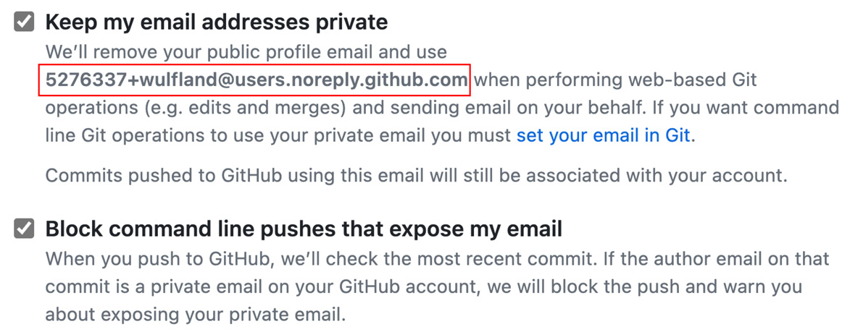
Figure 2.1 – Keep your email address private in public repositories
This email address consists of your GitHub user ID and name in the users.noreply.github.com domain:
$ git config --global user.email 5276337+wulfland@users.noreply.github.com
GitHub will automatically associate your commit with your account without exposing your email address.
Then, clone your repository from Chapter 1 locally. You can find the corresponding URLs in the Code section of your repository under Code | Local (see Figure 2.2):
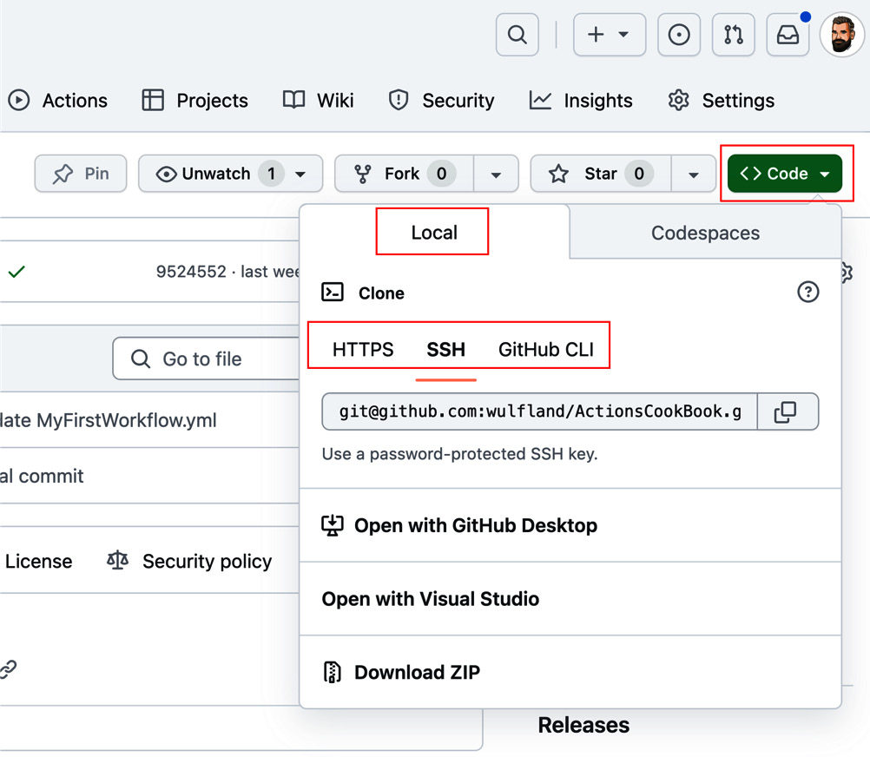
Figure 2.2 – Cloning your repository locally
I used SSH to authenticate, as I can manage my SSH keys in 1Password—but you can also use HTTPS and a PAT token. You can find more information on cloning repositories locally here: https://docs.github.com/en/repositories/creating-and-managing-repositories/cloning-a-repository.

How to do it…
- Open VS Code. Open the extensions window by typing [Shift]+[Command]+[X] or [Ctrl]+[Shift]+[X] or by just clicking the Extension icon in the left bar (see Figure 2.3). Search for github actions and install the action from GitHub with the verified badge (https://marketplace.visualstudio.com/items?itemName=GitHub.vscode-github-actions). Restart VS Code if necessary, and sign in with your GitHub account:
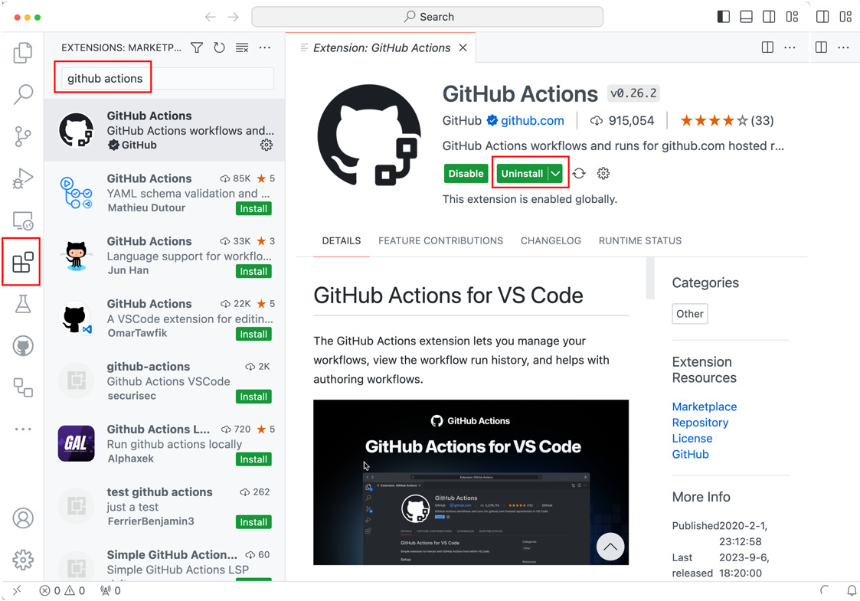
Figure 2.3 – Installing the GitHub Actions extension for VS Code
The extension provides the following features:
- Managing workflows and monitoring workflow runs
- Manually triggering workflows
- Syntax highlighting for workflows and expressions
- Integrated documentation
- Validation and code completion
- Smart validation
Smart validation is especially of great help. It supports code completion for referenced actions and reusable workflows, will parse parameters, inputs, and outputs for referenced actions, and provides validation, code completion, and inline documentation.
- Open your locally cloned repository. There are multiple ways to do this. You could type code . (. stands for the current folder) on the command line inside the locally cloned repository folder. This will open a new instance of VS Code with the current folder open. Or use File | Open Folder in VS Code and select the folder in which you cloned the repository.
- Click the GitHub Actions icon on the left side (see Figure 2.4) and inspect the Current Branch window. You can see all workflow runs in the current branch. Each run has the name of the workflow and the run ID with the hash. You can expand the workflow runs to see the jobs and steps. You can open the job log directly in VS Code, or you can open the step log in your browser:
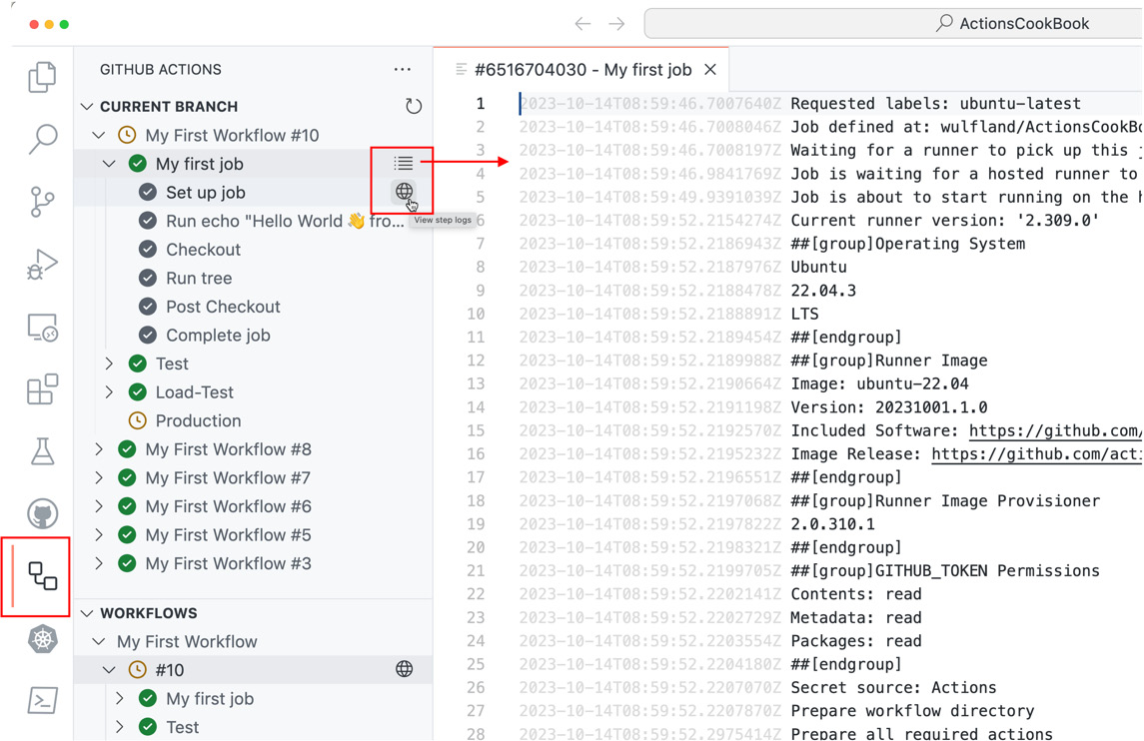
Figure 2.4 – Inspecting the workflow runs in the current branch
- The WORKFLOWS window shows all the workflows in the repository in the main branch. You can pin workflows to the top of the list, open the workflow file for editing, or run a trigger for the workflow if it has a workflow_dispatch trigger (see Figure 2.5):
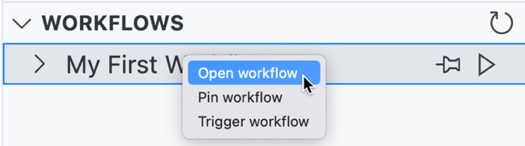
Figure 2.5 – The workflow window allows you to trigger and open workflows
Open the workflow file.
- Next, play around with autocomplete in the workflow file. Remove the value behind vars in line 15. Note the extension knows all your variables and secrets (see Figure 2.6):
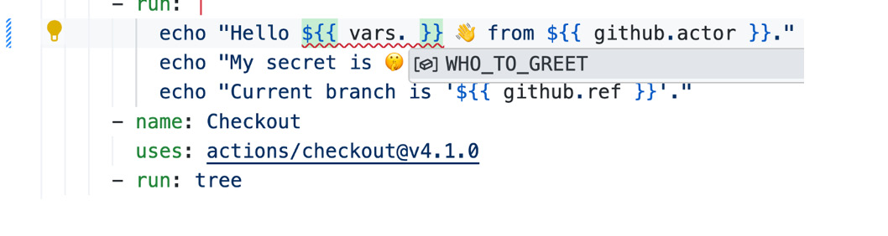
Figure 2.6 – Autocomplete knows all your secrets and variables
It also has the complete workflow syntax. You can press [Control]+[Space] at any point in the workflow file to get a list of valid elements.
VS Code detects problems in your workflow file and provides quick fixes for it (see Figure 2.7):
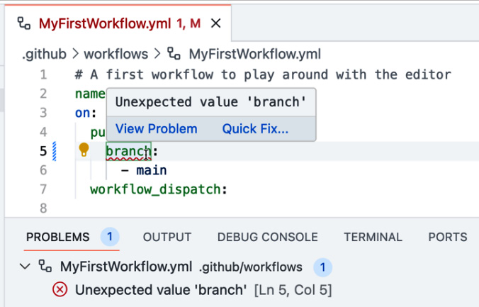
Figure 2.7 – VS Code provides quick fixes for problems
- In the SETTINGS window, you can find all the environments, secrets, and variables from your repository. You cannot create new environments, but you can add secrets and variables at the environment or repository level and edit or delete them (see Figure 2.8):
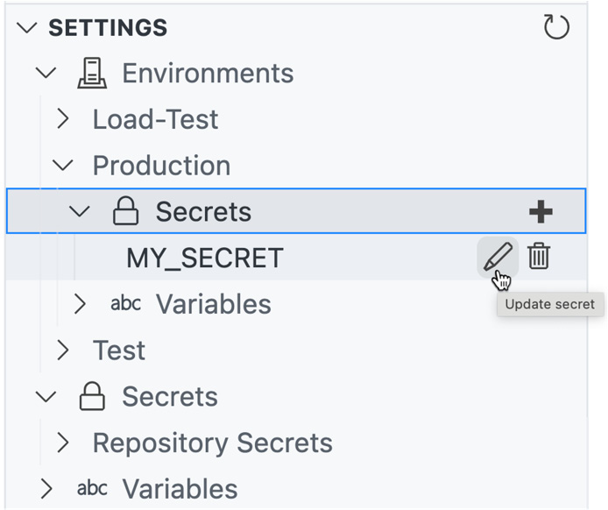
Figure 2.8 – Manage environments, secrets, and variables from within VS Code

How it works…
With the GitHub Actions Extension, VS Code is the perfect editor to write and execute workflows as you have everything in one place, you can work offline, and you have advanced syntax highlighting and auto-complete for workflows and expressions. That’s why we are going to use it in the rest of the book to write our workflows.

There’s more…
VS Code is not just available to install locally—you can also use it directly in the browser. In any GitHub repository, just press the dot [.] key to open the current repository in VS Code directly in your browser or press [Shift]+[>] to open it in a new tab. To open repositories directly in VS Code, you can also navigate to https://github.dev/<owner>/<repository>.
In GitHub.dev, you can work with files and Git as you do locally: first, commit your changes and then push them to GitHub. You can install extensions and you can sync your VS Code settings using your GitHub account.
However, if you need a terminal or install some frameworks, you have to do it locally or use GitHub Codespaces (https://github.com/features/codespaces). Codespaces provide you with a full remote development environment running in Microsoft Azure. You have 120 hours and 15 GB storage per month for free (180 minutes and 20 GB with the GitHub Pro Plan); after that, you pay by minute and GB. A GB costs $0.07 cent per month, and the computing for the machine ranges between $0.18 per hour for a two-core machine to $2.88 per hour for a 32-core machine. For the purposes of this book, I opted for the local version so as to not burn through the free minutes, but if you have never tried Codespaces, I encourage you to do so. It’s a great way to have specialized development environments for each project you are working on.

Developing workflows in branches
Starting in a greenfield repository, it is best to create your workflows on the main branch. However, if you must create the workflow in an active repository that developers are working in and you don’t want to get in their way, then it is possible to write workflows in a branch and merge them back to the main branch using a pull request.
However, some triggers might not work as expected. If you want to run your workflow manually using the workflow_dispatch trigger, your first action must be to merge the workflow with the trigger back to main or use the API to trigger the workflow. After that, you can author the workflow in a branch and select the branch when triggering the workflow through the UI.
If your workflow needs webhook triggers, such as push, pull_request, or pull_request_target, it might be necessary to create the workflow in a fork of the repository, depending on what you plan on doing with the triggers. This way, you can test and debug the workflow without interfering with the developers work, and once you are done, you can merge it back to the original repository.

Getting ready…
If you still have local changes after playing around with the workflow in the previous recipe, be sure to undo all the changes to have a clean version of the repository. You can do this by executing the following command:
$ git reset --hard HEAD
You can also do this in the Git window of VS Code (see Figure 2.9):
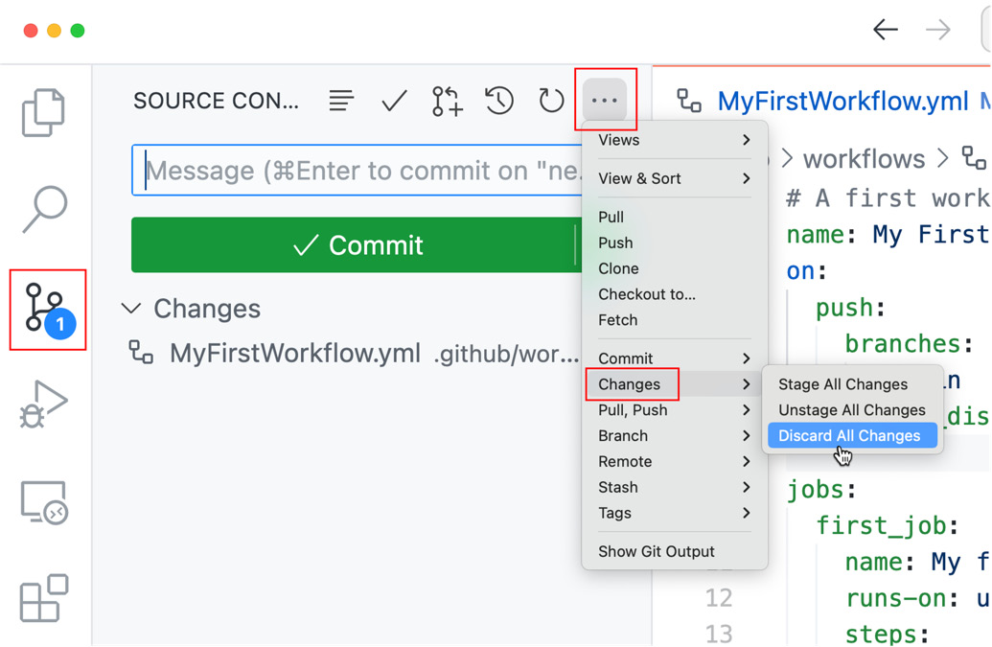
Figure 2.9 – Discard your local changes

How to do it…
- In VS Code, click main in the left bottom corner, select + Create new branch… in the command palette, enter new-workflow as the name for the new branch, and hit [Enter] (see Figure 2.10):
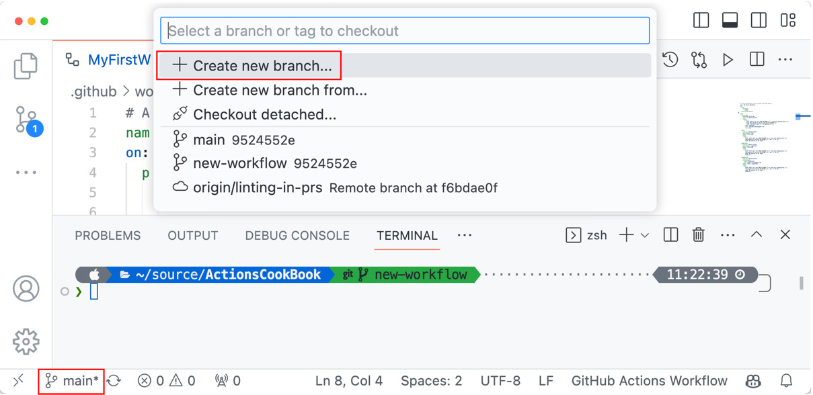
Figure 2.10 – Creating a new branch in VS Code
Alternatively, you can also use the following command:
$ git switch -c new-workflow
- Create a new workflow file in VS Code in the EXPLORER window. Locate and mark the .github/workflow folder and click the New file… icon. Enter DevelopInBranch.yml as the filename and click enter (see Figure 2.11):
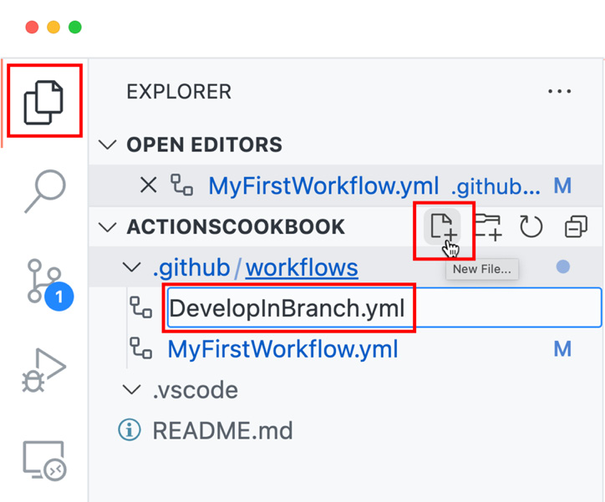
Figure 2.11 – Creating a new workflow file in VS Code
Note that VS Code automatically detects that this is a workflow file. Create a simple workflow with a pull_request and workflow_dispatch trigger that outputs some context values to the console, as is shown in Listing 2.1:
Listing 2.1 – Workflow created in a branch
# workflow to show how to develop workflows in branches
name: Develop in a branch
on: [pull_request, workflow_dispatch]
jobs:
job1:
runs-on: ubuntu-latest
steps:
- run: |
echo "Workflow triggered in branch '${{ github.ref }}'."
Echo "Workflow triggered by event '${{ github.event_name }}'."
Echo "Workflow triggered by actor '${{ github.actor }}''."
- Add the new file (Stage Changes), enter a commit message, and commit the changes (see Figure 2.12):
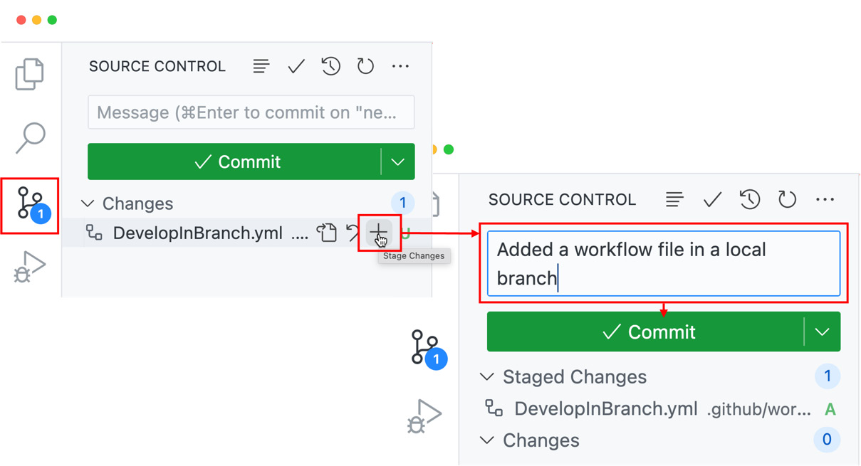
Figure 2.12 – Committing the new file in VS Code
You can also use the command line if you prefer:
$ git add .
$ git commit -m "Added a workflow file in local branch"
- In VS Code, you can push your changes directly by clicking Publish Branch. From the command line, you can use the following:
$ git push -u origin new-workflow
- Next, we’ll create a pull request for our new branch. As we use the pull_request trigger, this will automatically run our new workflow. Go to your repository in the browser and navigate to Pull requests. Git will detect that you have pushed a new branch and will offer you the option to create a pull request (Compare & pull request, see Figure 2.13):
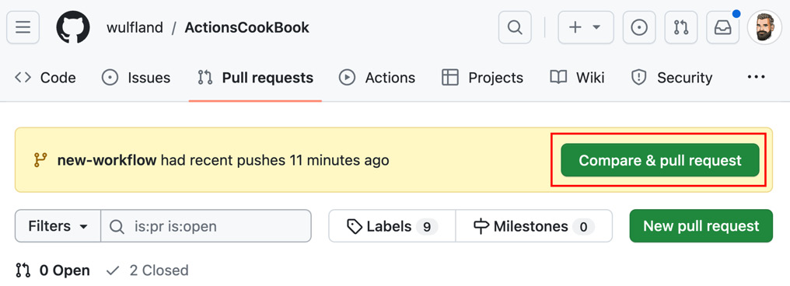
Figure 2.13 – Creating a new pull request in the browser
Just leave the default title (the commit message you added earlier) and click Create pull request (see Figure 2.14):
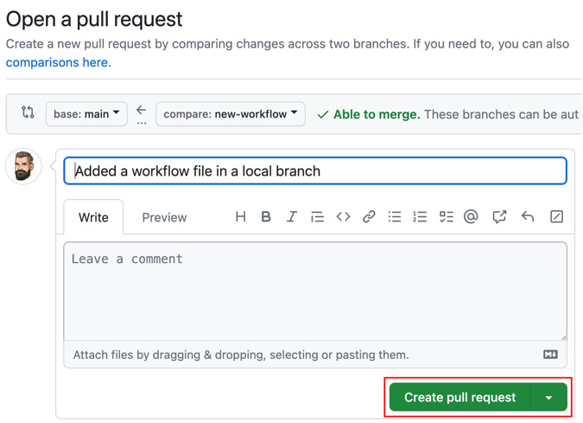
Figure 2.14 – Creating a pull request with title and description
You can also create the pull request using the GitHub CLI:
$ gh pr create --fill
The GitHub CLI
We will use the GitHub CLI (https://cli.github.com/) a lot throughout the book. It is available for all platforms and with a lot of package managers (Homebrew, WinGet, RPM, and many more). See https://github.com/cli/cli#installation for more installation instructions. After installation, you have to authenticate using gh auth login (see https://cli.github.com/manual/gh_auth_login).
- Open your pull request and note that it has executed the workflow as a check automatically (see Figure 2.15):
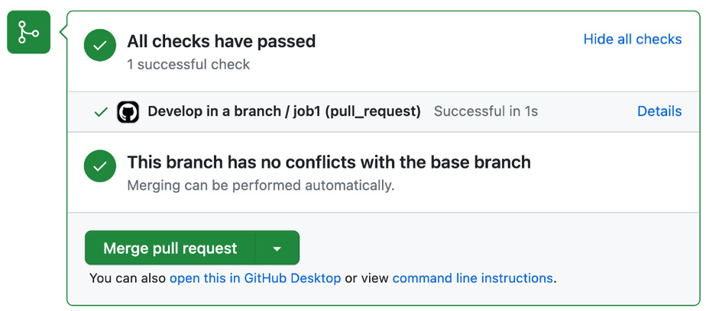
Figure 2.15 – The workflow will automatically run because of the pull_request trigger
You can also see the workflow in the Actions tab, but you cannot run the workflow manually. Even with the workflow_dispatch trigger, the button to run the workflow will only be available if you merge the workflow with that trigger to main once. After that, you will also be able to run it manually on your branch.
You can run the workflow in VS Code, though. Open the GitHub Actions extension and refresh the Workflows window if necessary by using the refresh icon in the top right corner. You should now see the new workflow, and you can trigger it manually using the arrow button (see Figure 2.16):
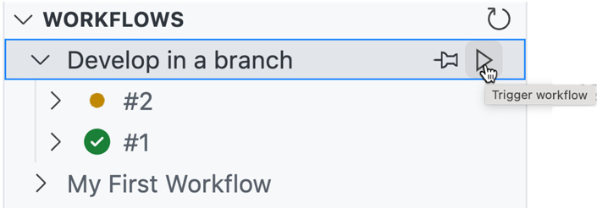
Figure 2.16 – Run the workflow manually in VS Code

How it works…
There are some limitations when it comes to some triggers, but in general, it works really well to develop your workflows in a separate branch and collaborate on the changes using pull requests.

There’s more…
To take this one step further, we’ll add a linter to the workflow that will be able to spot errors, security issues, and missing best practices in all workflows in your repository.

Linting workflows
In this recipe, we’ll add a linting action that will check the workflow and give feedback directly in the pull request.

Getting ready…
Open the workflow file in the branch that you have for the open pull request. Do not merge the changes yet.

How to do it…
- Go to the marketplace and search for the actionlint. The action we are looking for is from devops-actions. The action needs to access the workflow files, meaning you have to check out the repository using the checkout action first. Add the following two steps to the end of the job:
- uses: actions/checkout@v4.1.0
- uses: devops-actions/actionlint@v0.1.2
- As we want the action to annotate errors in pull requests, we have to give the workflow write access to pull requests. I’ll explain later how this works. For now, just add a section permissions to the job like this:
jobs:
job1:
runs-on: ubuntu-latest
permissions:
contents: read
pull-requests: write
- Commit the changes to the branch new-workflow and push them to the remote. This will trigger the build, and the workflow should complete without errors.
- To test the linting process, we are going to add some malicious code. If you use user-controlled input in a run event, such as the title of a pull request, attackers might be able to exploit this by injecting a script in the title. This is especially critical if you have a public repository and people can create pull requests from forks. Let’s assume you output the title of a pull request using echo:
- run: echo "${{ github.event.pull_request.title }}"
Creating a pull request with the title "Hi";ls $GITHUB_WORKSPACE;echo "-" would execute the following command:
$ echo "Hi";ls $GITHUB_WORKSPACE;echo "-"
The script ls $GITHUB_WORKSPACE will be executed without errors, and from there, you can find other ways to inject more harmful script.
Add the following line to the steps in the job:
steps:
- run: echo "PR title is '${{ github.event.pull_request.title }}'."
- Commit the changes to the branch new-workflow and push them to the remote. This time, the workflow should fail, and the checks of the pull request show an error, as is shown in Figure 2.17:
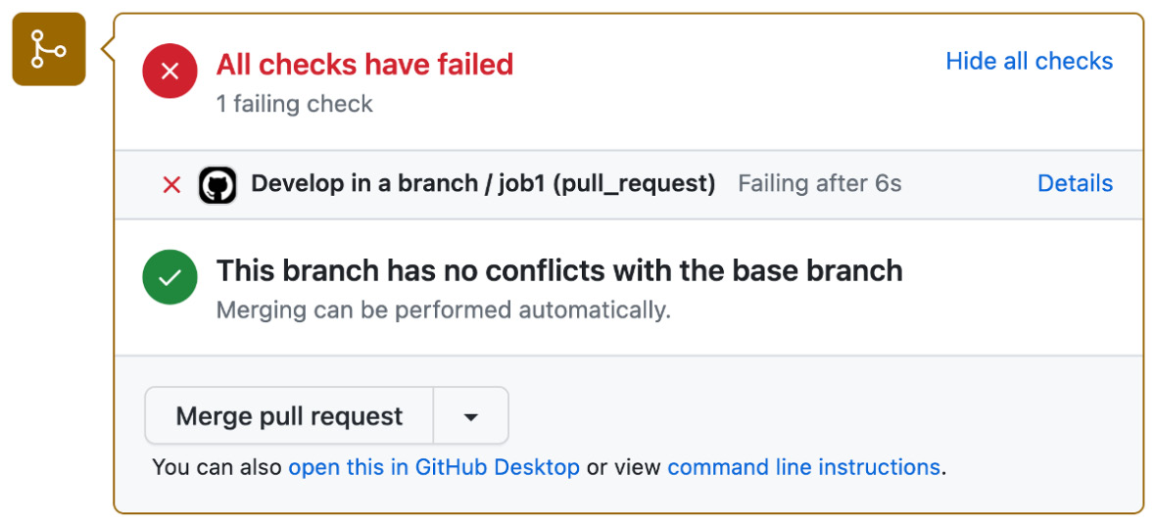
Figure 2.17 – Linting can fail a pull request if there are potential script attacks in your workflow
- In the pull request, navigate to Files changes. Note that the linting action has annotated the pull request at the correct line number that contains the potential script injection attack (see Figure 2.18):
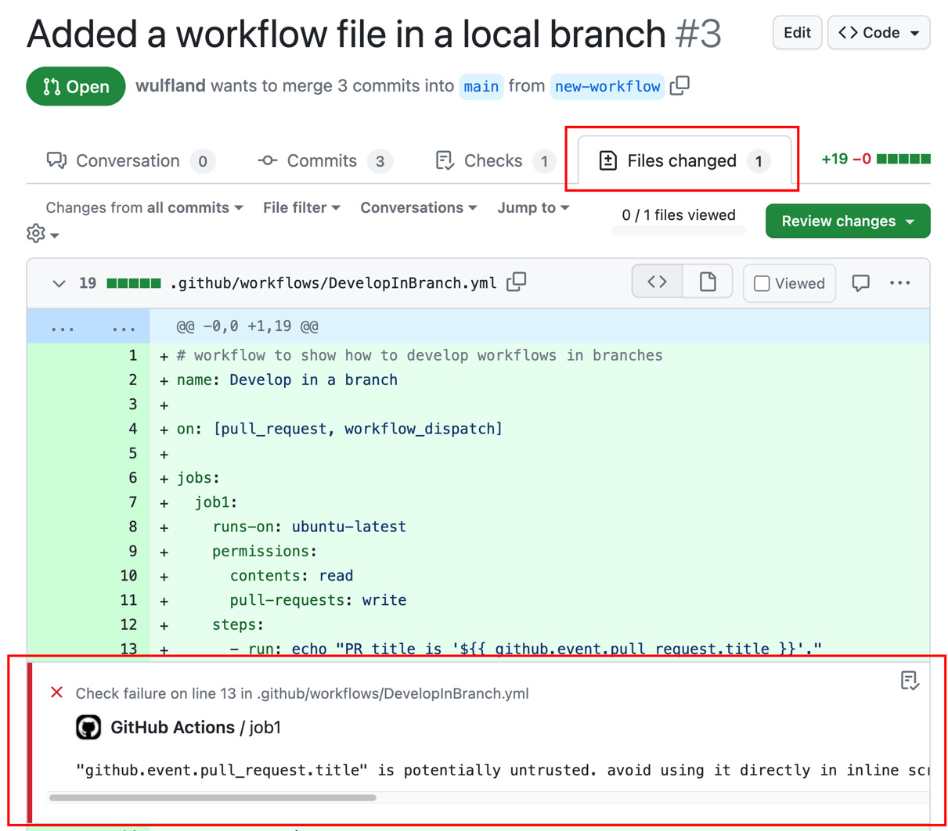
Figure 2.18 – Pull request annotations in workflow files

How it works…
The action devops-actions/actionlint (https://github.com/marketplace/actions/rhysd-actionlint) is a wrapper for @rhysd (this is the GitHub user) actionlint container (see https://github.com/rhysd/actionlint). You can run actionlint locally or on the web. It has a ton of checks that it performs on a workflow (see https://github.com/rhysd/actionlint/blob/main/docs/checks.md for a complete list). The action is a wrapper that runs action lint against all workflows found in your repository. Therefore, you have to check out the repository first. The action then uses Problem matchers (see https://github.com/actions/toolkit/blob/main/docs/problem-matchers.md) to annotate your workflows in pull requests. Problem matchers use regular expression patterns to read findings from a result file and annotate your pull requests with them. They are activated and deactivated by the workflow commands add-matcher and remove-matcher. Workflow commands can be used in workflow steps and actions to communicate with the workflow and the runner machine. They can be used to write messages to the workflow log, pass values to other steps or actions, set environment variables, or write debug messages.
Workflow commands use the echo command with a specific format:
echo "::workflow-command param1={data},param2={data}::{command value}"
If you are using JavaScript, the toolkit (https://github.com/actions/toolkit) provides a lot of wrappers that can be used instead of using echo to write to standard output. In the subsequent sections, you will learn some examples of useful workflow commands to write to the workflow log and to annotate files.
The problem matchers are added using the following workflow command:
echo "::add-matcher::$GITHUB_ACTION_PATH/actionlint-matcher.json"
The command takes the path to the results file. You could disable matching using remove-matcher and passing in the owner:
echo "::remove-matcher owner= actionlint::"
To access the pull request, the workflow uses the GITHUB_TOKEN, which is a special token that is automatically created by GitHub and can be accessed through the github context (github.token) or the secrets context (secrets.GITHUB_TOKEN). The token can be accessed by a GitHub Action, even if the workflow does not provide it as an input or environment variable. The token can be used to authenticate the workflow when accessing GitHub resources. The default permissions can be set to permissive (read and write) or restricted (read-only), but the permissions can be adjusted in the workflow. You can see the workflow permissions in the workflow log under Set up job | GITHUB_TOKEN Permissions. It is best practice to always explicitly set the permissions your workflow needs. All other permissions will be set to none automatically. The permissions can be set for an individual job or the entire workflow.
In our case, we gave the workflow job permission to read content and write to pull requests:
permissions:
contents: read
pull-requests: write

There’s more…
In this recipe, we added the workflow linter as a check for the pull request by just adding the pull_request trigger to the workflow. However, we would still be able to merge the changes back to the main branch, even if the check fails. To prevent workflows with linting errors from being merged, you can enable branch protection (see https://docs.github.com/en/repositories/configuring-branches-and-merges-in-your-repository/managing-protected-branches/about-protected-branches) or create rulesets (see https://docs.github.com/en/repositories/configuring-branches-and-merges-in-your-repository/managing-rulesets/about-rulesets). Together with codeowners (see https://docs.github.com/en/repositories/managing-your-repositorys-settings-and-features/customizing-your-repository/about-code-owners), you can ensure that only workflows without linting errors that have been manually reviewed by a team or person are merged back to your main branch.

Writing messages to the log
What problem matchers do based on existing result files can also be achieved by writing individual warning or error events to the log by also using workflow commands. In this recipe, we will add some output to our workflow and annotate our workflow file.

Getting ready…
Make sure you still have your pull request from the previous recipe open. Just use VS Code to add additional changes, and pushing will automatically trigger the workflow.

How to do it…
- Open .github/workflows/DevelopInBranch.yml in the new-workflow branch in VS Code and add the following code snipped directly before the checkout action:
- run: |
echo "::debug::This is a debug message."
echo "::notice::This is a notice message."
echo "::warning::This is a warning message."
echo "::error::This is an error message."
This will write different kinds of messages to the workflow log and workflow summary.
- Commit and push the changes. This will automatically trigger a new workflow run.
- Open the workflow log and inspect the output. It should look like Figure 2.19:
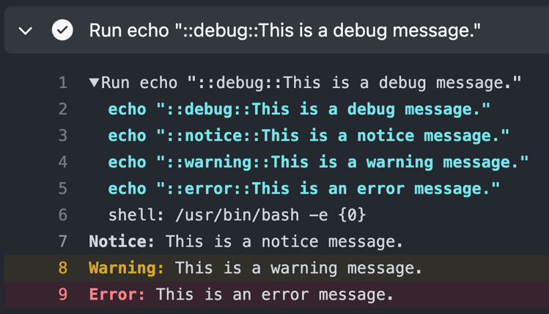
Figure 2.19 – Writing messages to the workflow log
Note that the debug message is not visible. Check the workflow summary and that it contains the messages there together with our error from the linting (the result should look like Figure 2.20):
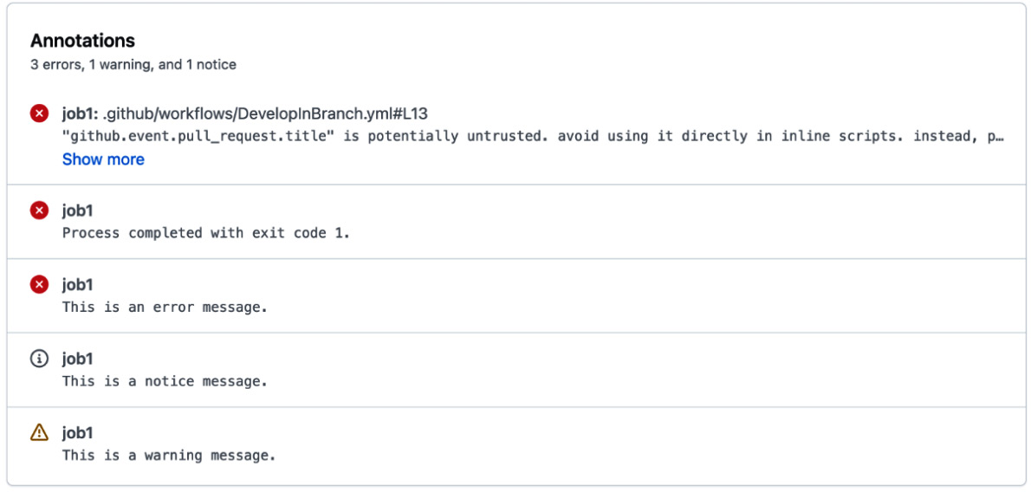
Figure 2.20 – Workflow annotations in the summary
- To see the debug message in action, we can rerun the workflow job with debug logging enabled. In the workflow summary, click Re-run jobs | Re-run all jobs, select Enable debug logging, and click Re-run jobs (as shown in Figure 2.21):
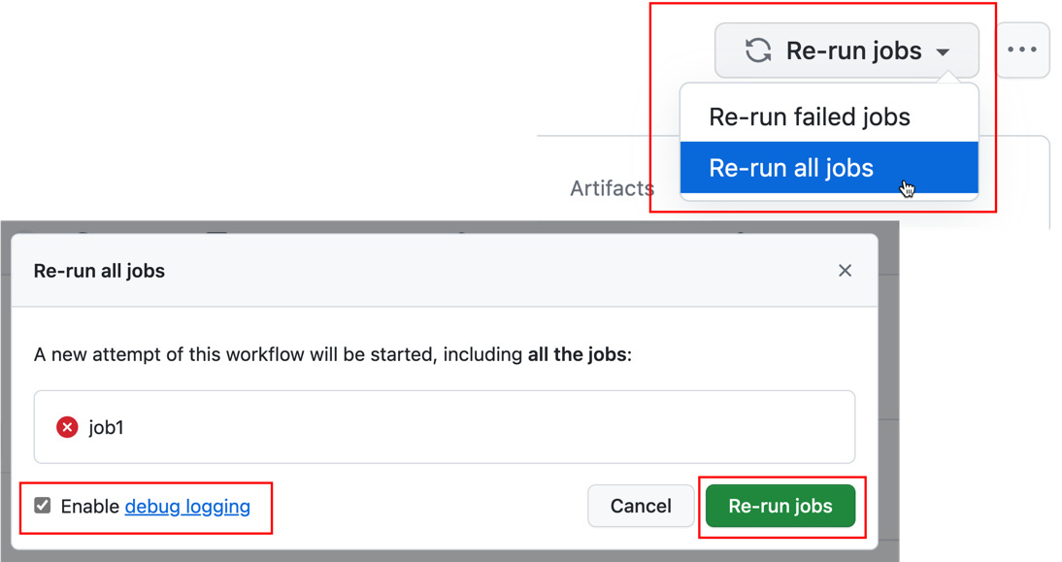
Figure 2.21 – Rerun jobs with debug logging enabled
- Check the workflow log again and see the additional messages (as shown in Figure 2.22):
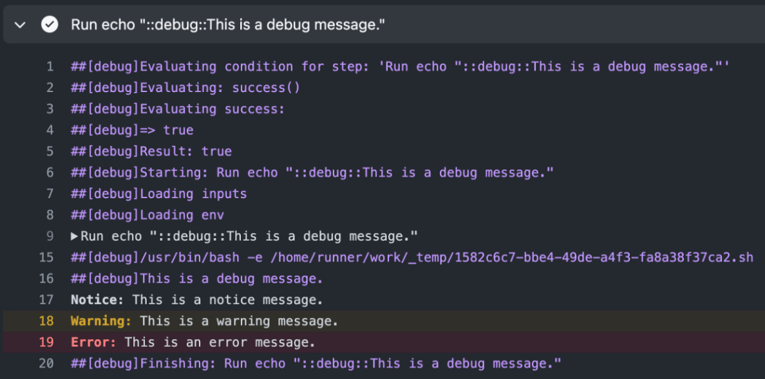
Figure 2.22 – The workflow log with debug logging on
- However, notice, warning, and error can do more than just write to the log. We can use them to annotate files. Add the following snippet to the workflow:
- run: |
echo "::
notice
file=.github/workflows/DevelopInBranch.yml,line=19,col=11,endColumn=51::There is a debug message that is not always visible!"
echo "::
warning
file=.github/workflows/DevelopInBranch.yml,line=19,endline=21::A lot of messages"
echo "::
error
title=Script Injection,file=.github/workflows/DevelopInBranch.yml,line=13,col=37,endColumn=68::Potential script injection"
This will add a notice annotation to line 19, a warning to lines 19 to 21, and an error to line 13 for columns 37 to 68. Adjust the values if your line numbers and indentations are different!
- Commit and push the changes. Open the pull request and see the annotations within the Files changed tab (see Figure 2.23):
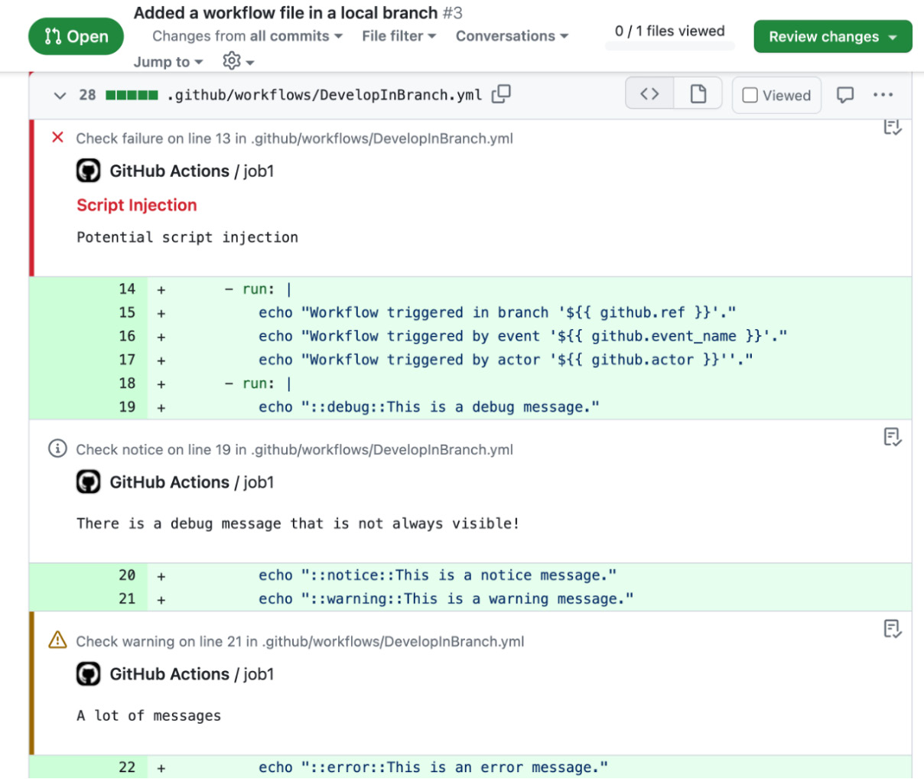
Figure 2.23 – Workflow annotation in the pull request changes

How it works…
In the same way that the matchers work, you can create warning and error messages and print them to the log. The messages will create an annotation, which can associate the message with a particular file in your repository. Optionally, your message can specify a position within the file:
::notice file={name},line={line},endLine={el},title={title}::{message}
::warning file={name},line={line},endLine={el},title={title}::{message}
::error file={name},line={line},endLine={el},title={title}::{message}
The parameters are the following:
- Title: A custom title for the message
- File: The filename that raised the error or warning
- Col: Column/character number, starting at 1
- EndColumn: The end column number
- Line: The line number in the file starting with 1
- EndLine: The end line number
The only message that cannot annotate files is the debug message. This workflow command only accepts the message as a parameter.

Enabling debug logging
In the previous recipe, we saw that you can rerun failed jobs or all jobs with debug logging enabled. However, you can also enable or disable debug logging on a repository base.

How to do it…
We can enable or disable debug logging by adding a variable called ACTIONS_STEP_DEBUG to our repository and setting the value to true or false. This will add a very verbose output to our workflow logs and all debug messages, and this will be displayed from all actions.
You can configure the variable using the web, the GitHub CLI, or VS Code. To set the variable using the web, in the repository, navigate to Settings | Secrets and variables | Actions and pick the Variables tab (/settings/variables/actions). Click New repository variable (which will redirect you to /settings/variables/actions/new), enter ACTIONS_STEP_DEBUG as the name, true as the value, and click Add variable.
To set it using the CLI, just execute the following line:
$ gh variable set ACTIONS_STEP_DEBUG --body true
If you want to set the variable in VS Code, just open the Actions extension, navigate to Variables | Repository Variables, click the + symbol (see Figure 2.24), enter ACTIONS_STEP_DEBUG, and hit [Enter]; enter true and hit [Enter] again. In VS Code, it is also very convenient to change the variable using the update option:
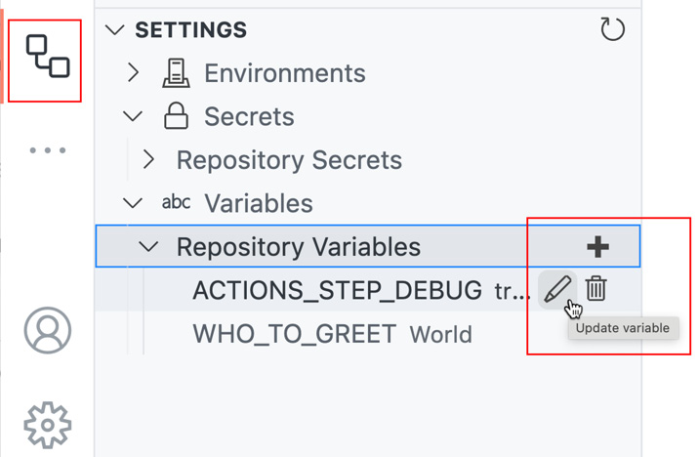
Figure 2.24 – Setting step debugging to true in VS Code
Run your workflow and inspect the verbose output.

There’s more…
You can also activate additional logs for runners by setting the variable ACTIONS_RUNNER_DEBUG to true. The runner debug log will be included in the log archive from the workflow that you can download from the workflow job log. If you want to learn more about monitoring and troubleshooting, then you can refer to https://docs.github.com/en/actions/monitoring-and-troubleshooting-workflows/enabling-debug-logging.

Running your workflows locally
Committing workflows every time and running them on the server can be a slow process, especially for complex workflows. In this recipe, we will learn how to run a workflow locally using act (https://github.com/nektos/act).

Getting ready…
Act depends on Docker to run workflows. Make sure you have Docker running.
You can install act using different package managers (see https://github.com/nektos/act#installation-through-package-managers). Just pick the one that fits your environment and follow the instructions.
When running act for the first time, it will ask you to choose a Docker image to be used as the default. It will save that information to ~/.actrc. There are different images available. There are small images available (node:16-buster-slim) that will only support NodeJS and nothing more. The big images are more than 18 GB in size. Keep that in mind. However, with today’s disk space and internet, you will get the best results by using big images. For the current workflow to run, you should pick at least the Medium image (see Figure 2.25):
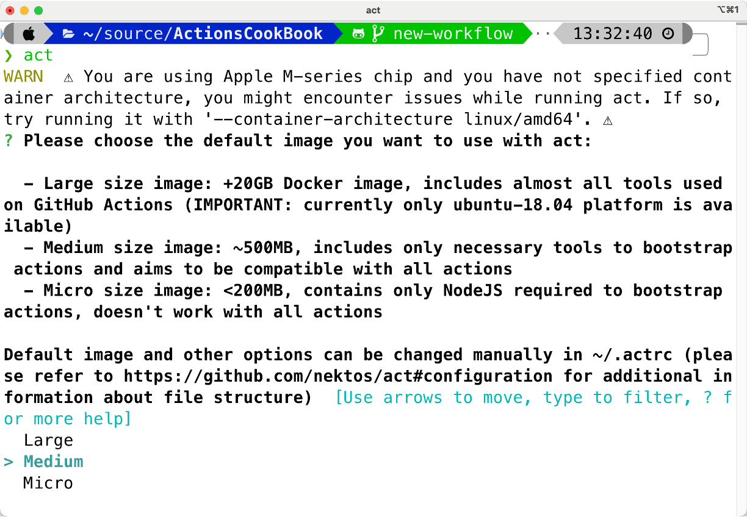
Figure 2.25 – Picking the container image on the first run of act

How to do it…
Open the command prompt in our current repository and see the new workflow branch. Act uses the workflow triggers to act on workflows, and it will default to push. As our workflow only has the pull_request trigger, you have to specify. With the -l option, act will list all workflows and jobs with the corresponding trigger in the repository. Execute the following command:
$ act pull_request
-l
Inspect the workflow and the jobs. To perform a dry run, you can use the option -n:
$ act pull_request
-n
Note that the workflow finishes successfully, as the linting of the workflow is not performed. To really execute the workflow in the container, run the following command:
$ act pull_request
The workflow will execute and fail in the linting step in the same way that it does in the pull request on the server. The result should look like Figure 2.26:
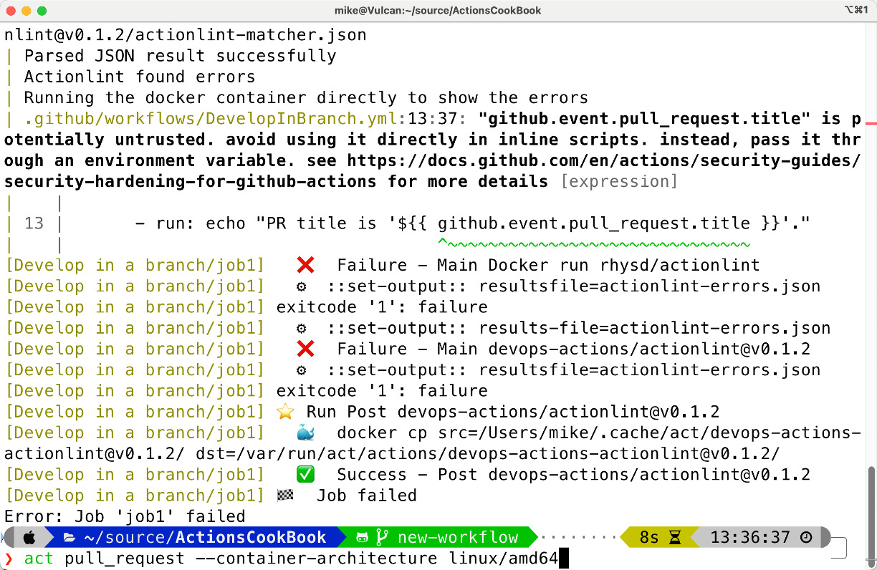
Figure 2.26 – Workflow linting fails with the same error as on the server
I think it is obvious how powerful it is to be able to run your workflows locally before pushing the changes to the server. However, depending on your workflow, the results might not be 100% reliable, and you might need to use a large Docker image that are over 20 GB in size.

How it works…
Act uses docker containers to run your workflows locally. It reads your GitHub Actions from .github/workflows/ and determines the set of actions that need to be run. It uses the Docker API to either pull or build the necessary images, as defined in your workflow files, and finally, it determines the execution path based on the dependencies that were defined. Once it has the execution path, it then uses the Docker API to run containers for each action based on the images prepared earlier. The environment variables and filesystem are all configured to match what GitHub provides.
If your workflow uses the GITHUB_TOKEN, then you have to provide a personal access token (PAT); act will use it to communicate with GitHub:
$ act -s GITHUB_TOKEN=[insert personal access token]
You can use the GitHub CLI with gh auth token to automatically pass the token from the CLI to act:
$ act -s GITHUB_TOKEN="$(gh auth token)"

There’s more…
The problem with act is that the images of the default GitHub-hosted runners are huge. For good local performance, it is just impossible to include all tools that are installed on these runners. For 90% of the workflows, this is also not necessary, as actions run in NodeJS or bring their own containers. However, especially with command line tools in custom scripts in run: steps, this is a problem.
What works great with act is using custom images for your workflow jobs. Instead of relying on the tools of the GitHub hosted runners, you can assign custom Docker images for jobs like this:
jobs:
container-test-job:
runs-on: ubuntu-latest
container:
image:
custom-image:latest
This way, local execution and the execution on the server are basically the same. This is also a good option if you have to keep your build environments for a longer period. You can learn more about running jobs in containers here: https://docs.github.com/en/actions/using-jobs/running-jobs-in-a-container.
3

Building GitHub Actions
Now that you’ve learned how to author workflows and already used some actions from the marketplace, it is time to fully understand what actions are and how they work. In this chapter, I will explain the different types of actions and we will cover the following recipes so that you know how to write actions yourself:
- Creating a Docker container action
- Adding output parameters and using job summaries
- Creating a TypeScript action
- Creating a composite action
- Sharing actions to the marketplace
- Best practices for developing custom actions
You will learn how to pass in parameters to actions and use output parameters in subsequent workflow steps. You will also learn how to write to the workflow log and annotate changes in files from within the action and how to create rich job summaries.

Technical requirements
In the following recipes, I’ll be using VS Code. You’ll need a version of that and a local git client to follow along.
If you want to run the Docker image that we provision as an action locally, you will also need Docker installed on your machine. You could also use GitHub Codespaces if you want.
For the TypeScript action, you’ll need to have a reasonably modern version of Node.js installed. If you are using a version manager such as nodenv or nvm, you can run nodenv install in the root of your repository to install the version specified in package.json. Otherwise, 20.x or later should work. Check the README.md file at https://github.com/actions/typescript-action for updated requirements. If you don’t want to install Node.js, just use GitHub Codespaces for that recipe.

Creating a Docker container action
In this recipe, you will create a simple Docker container action from a Dockerfile and use it in a continuous integration (CI) workflow that will run the action from within the workflow every time you change something.

Getting ready…
Create a new repository called DockerActionRecipe. Make it public so that you don’t consume any action minutes and initialize it with a README file (see Figure 3.1):
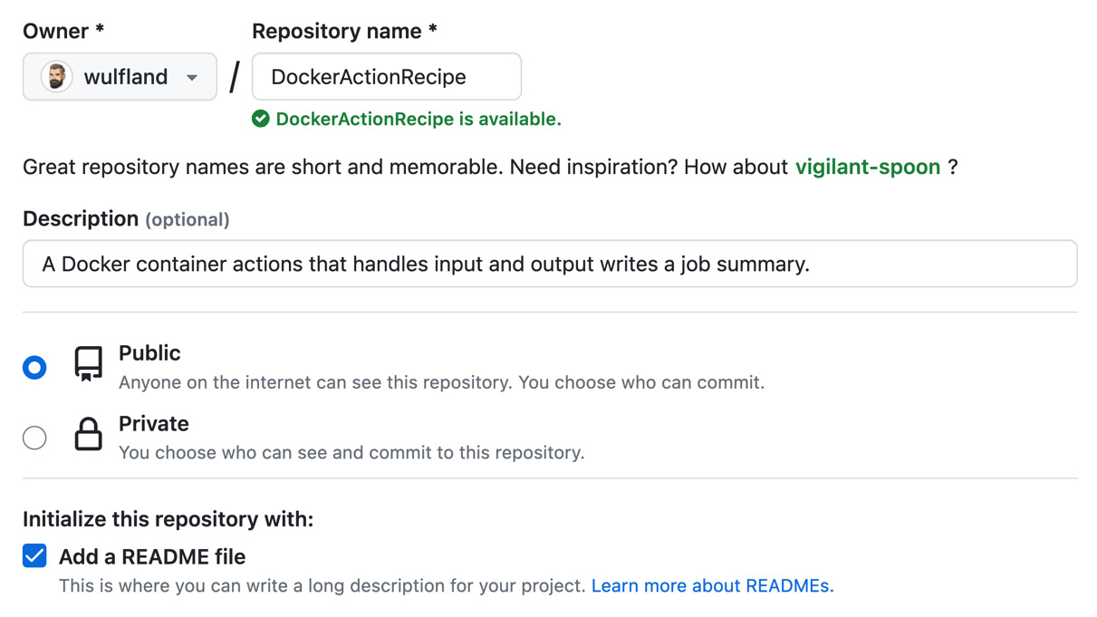
Figure 3.1 – Creating a new repository for the Docker container action
Clone the repository locally and open it in VS Code or GitHub Codespaces.

How to do it…
- Create a new file called Dockerfile in the root of the repository. Add the following content to the file:
# Container image that runs your code
FROM alpine:latest
CMD echo "Hello World"
This will create an image based on the latest Alpine image and add a layer that writes “Hello World” to the console.
- Run the Docker container locally with the following command:
$ docker run $(docker build -q .)
It will create an image (docker build) and run it (docker run). You should be able to see Hello World on the console.
- To be more flexible, let’s move our script code to its own file. Create a new file called entrypoint.sh and add the following content:
#!/bin/sh -l
echo "Hello World"
- Now, adjust the Dockerfile so that it executes the script instead of directly writing to the console. Copy the script file to the root of the container, and then use it as the entry point:
FROM alpine:3.10
COPY entrypoint.sh /entrypoint.sh
RUN chmod +x entrypoint.sh
ENTRYPOINT ["/entrypoint.sh"]
Note that I added the chmod +x entrypoint.sh command to make the script executable. Otherwise, if you try to run the container locally, it will fail, with a message stating exec: "/entrypoint.sh": permission denied. On all Unix-based systems, you can just run chmod +x entrypoint.sh locally, and the attribute will be attached to the file when committing to git. On Windows, you can use git to set the file permissions:
$ git add entrypoint.sh
$ git update-index --chmod=+x entrypoint.sh
Run the Docker container again. You should see Hello World again – this time from the script file:
$ docker run $(docker build -q .)
- In the action, we want to make use of an input parameter. That’s why we are going to parameterize the script. Replace the word World with the arguments that were passed to Docker ($@ for all arguments):
#!/bin/sh -l
echo "Hello $@"
Try to run the container again locally and pass in some words. The container will print the result, as follows:
$ docker run $(docker build -q .) foo bar
> Hello foo bar
- Next, add a new file to your repository called action.yml and add the following input:
name: 'Docker Action Recipe'
description: 'Greet someone'
inputs:
who-to-greet:
description: 'Who to greet'
required: true
default: 'World'
runs:
using: 'docker'
image: 'Dockerfile'
args:
- ${{ inputs.who-to-greet }}
- At this point, the action is ready. To test it, we’ll add a local workflow file called .github/workflows/ci.yml that will run on every push. It will download the repository and execute our action with a custom input parameter:
name: Action CI
on: [push]
jobs:
ci:
runs-on: ubuntu-latest
steps:
- uses: actions/checkout@v4.1.1
- name: Run my own container action
uses: ./
with:
who-to-greet: '@wulfland'
Referencing local actions
Note that we are referencing the action by the local path, ./ – that’s the reason why we have to use the checkout action first. The workflow will use the same version the workflow runs on. You could also reference the action normally by specifying <owner>/DockerActionRecipe@main – the same way you would reference it from another repository.
- Commit and push all your changes. The push trigger will automatically run your workflow and you can inspect the output of your action. It should look like what’s shown in Figure 3.2:
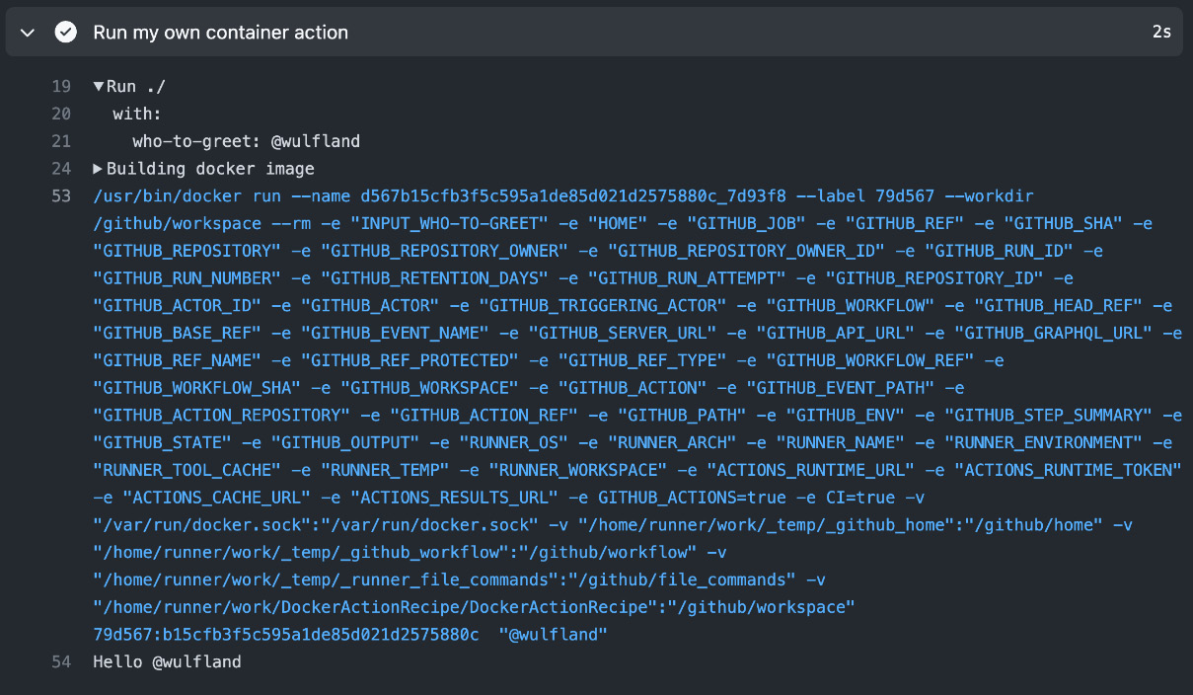
Figure 3.2 – Output of your action in the workflow
Check the output of the action via the Docker daemon and the parameter that was passed to the action.

How it works…
There are three different types of actions:
- Docker container actions
- JavaScript actions
- Composite actions
Docker container actions run on Linux only, whereas JavaScript actions and Composite actions can be used on any platform.
All actions are defined by a file called action.yml (or action.yaml) that contains the metadata that defines the action. This file cannot be named differently, meaning an action must reside in its own repository or folder. The run section in the action.yml file defines what type of action it is.
Docker container actions contain all their dependencies in the container and are therefore very consistent. They allow you to develop your actions in any language – the only restriction is that it must run on Linux. Docker container actions are slower than JavaScript actions because of the time it takes to retrieve or build the image and start the container.
Docker container actions can reference an image in a container registry, such as Docker Hub or GitHub Packages, or it can build a Dockerfile at runtime that you provide with the other action files. In this case, you must specify Dockerfile as the image name in the action.yml file.

There’s more…
Container actions are very powerful as you can write them in any language. You can return output parameters to your workflow, write messages to the workflow log, annotate files in pull requests, and write rich job summaries. In the next short recipe, we’ll add output parameters and write to the job summary.

Adding output parameters and using job summaries
In this recipe, we’ll add an output parameter to the action that can be used in subsequent steps, and we are going to write content to the workflow job summary.

Getting ready…
You will have to finish the previous recipe to continue with this one.

How to do it…
- Open the action.yml file and add the following code right under the inputs section but before the runs section:
outputs:
answer:
description: 'The answer to everything (always 42)'
This defines one output with an ID of answer.
- Next, open entrypoint.sh and add the following line to the end of the file:
echo "answer=42" >> $GITHUB_OUTPUT
This will set the output value for answer to 42.
- Now, add the following lines to the end of entrypoint.sh to write some Markdown and HTML to the step summary:
echo "### Hello $@!
:rocket:" >> $GITHUB_STEP_SUMMARY
echo "<h3> The answer from Deep Thought is 42 :robot:</h3>" >> $GITHUB_STEP_SUMMARY
- Before we commit the changes, we must adjust the workflow file, .github/workflows/ci.yml, so that it uses the output parameter. Add an ID of my-action to the step that executes our action, like this:
- name: Run my own container action
id: my-action
uses: ./
with:
who-to-greet: '@wulfland'
Add another step that outputs the result to the workflow log:
- name: Output the answer
run: echo "The answer is ${{ steps.
my-action
.outputs.
answer
}}"
- To fail the CI build when an unexpected result is returned from the Docker container action, we must add a new step that only gets executed when the result is not expected. Returning a non-zero value (for example, exit 1) will indicate to the workflow that the step has failed. We can use file annotation to indicate where the error is (the same way we did in Chapter 2):
- name: Test the container
if: ${{ steps.
my-action
.outputs.
answer
!= 42 }}
run: |
echo "::error file=entrypoint.sh,line=4,title=Error in container::The answer was not expected"
exit 1
- Commit and push all your changes. The build will run automatically and should succeed. Inspect the workflow log and ensure the output parameter was passed to the next steps correctly (see Figure 3.3):
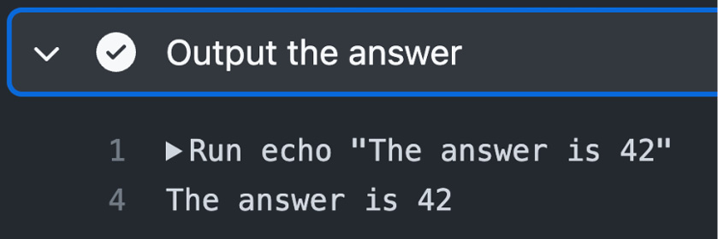
Figure 3.3 – The output of the Docker container action
Also, take a look at the job summary on the summary page, which has rendered our Markdown/HTML (see Figure 3.4):
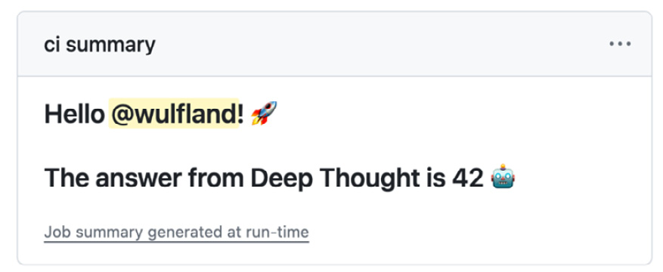
Figure 3.4 – Job summary on the workflow summary page
- Finally, we want to ensure that our CI build fails if an unexpected value is returned. Open entrypoint.sh and change 42 to something different (for example, 7).
Switch to another branch, commit and push, and create a new pull request:
$ git switch -c fail-ci-build
$ git commit -m "Fail CI build"
$ git push -u origin fail-ci-build
$ gh pr create --fill
The checks for the pull request will fail, and it will annotate the corresponding file (see Figure 3.5):
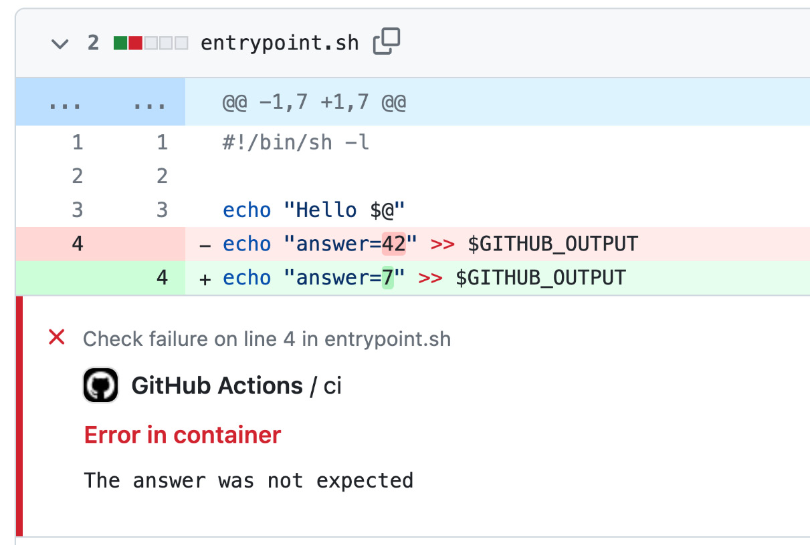
Figure 3.5 – The CI build will fail the pull request if the output is unexpected
Note how GitHub marks the change and annotates the exact line.

How it works…
Let’s understand how the code works.
Environment files
Passing output values to subsequent steps and jobs works by piping a name-value pair to the environment file – that is, $GITHUB_OUTPUT:
echo "{name}={value}" >> "$GITHUB_OUTPUT"
The >> operator appends the name-value pair to the end of the file. The path and filename of the file are stored in the $GITHUB_OUTPUT environment variable. You can access the output using the output property of the step in the steps context:
"${{ steps.
<step-id>
.outputs.
<name>
}}"
Outputs are Unicode strings and cannot exceed 1 MB in size. The total of all outputs in a workflow run cannot exceed 50 MB.
Another use case for environment files is setting environment variables for subsequent steps in a job. The path to the corresponding environment file is stored in $GITHUB_ENV. You just append another name-value pair to the end of the file, like this:
echo "{environment_variable_name}={value}" >> "$GITHUB_ENV"
Note that the name is case-sensitive! Here is a complete example of how to set an environment variable in one step and access it in a subsequent step using the env context:
steps:
- name: Set the value
id: step_one
run: |
echo "action_state=yellow" >> "$GITHUB_ENV"
- run: |
echo "${{ env.action_state }}" # This will output 'yellow'
Job summaries
You can set custom Markdown for each job in a workflow. The rendered Markdown will be displayed on the summary page of the workflow run. Job summaries can be used to display content, such as test or code coverage results, so that someone viewing the result of a workflow run doesn’t need to go into the logs or an external system.
Job summaries support GitHub-flavored markdown. But since Markdown is HTML, you can also output HTML to the job summary file. Note that in this recipe, my GitHub username, @wulfland, is a link to my profile with a preview and that all the GitHub emojis are supported.
Adding results from your step to the job summary can be achieved by appending Markdown to the following file:
echo "{markdown content}" >> $GITHUB_STEP_SUMMARY
The steps are isolated and restricted to 1 MiB (1.04858 MB) so that malformed Markdown from a single step cannot break Markdown rendering for subsequent steps. Only 20 steps can be written to the summary; the output of any step after that will not be visible.
In the next recipe, we will use the toolkit to write more complex things to job summaries.
For a complete reference on environment files and job summaries, please refer to https://docs.github.com/en/actions/using-workflows/workflow-commands-for-github-actions?tool=bash#environment-files.
Expressions and conditional execution
We used expressions (${{ … }}) in Chapters 1 and 2 to output values from context objects. In this recipe, we used an expression with the if property of a step to conditionally execute it:
- name: Test the container
if: ${{ steps.my-action.outputs.answer != 42 }}
This step will only be executed if the value of an output answer of an action with an ID of my-action in the steps context does not equal 42.
The if property also exists for jobs to conditionally execute these as well.
When you use expressions in an if property, you can, optionally, omit the ${{ }} expression syntax because GitHub Actions automatically evaluates the if condition as an expression.
For conditional execution, the expression must return true or false. To write expressions and compare context with static values, you can use the operators provided in Table 3.1:
Operator | Description
( ) | Logical grouping
[ ] | Index
. | Property de-reference
! | Not
< , <= | Less than, less than or equal to
> , >= | Greater than, greater than or equal to
== | Equal
!= | Not equal
&& | And
|| | Or
Table 3.1 – Operators for expressions
GitHub offers a set of built-in functions that you can use in expressions. They can help you search strings, format output, or work with arrays. See Table 3.2 for a list of available functions:
Function | Description
contains(search, item) | Returns true if search contains item.  Examples:  contains('Hello world', 'llo') returns true.  contains(github.event.issue.labels.*.name, 'bug') returns true if the issue related to the event has a label bug.
startsWith(search, iten) | Returns true when search starts with item.
endsWith(search, item) | Returns true when search ends with item.
format(string, v0, v1, ...) | Replaces values in string.  Example:  format('Hello {0} {1} {2}', 'Mona', 'the', 'Octocat') returns 'Hello Mona the Octocat'.
join(array, optS) | All values in array are concatenated into a string. If you provide the optional separator, optS, it is inserted between the concatenated values. Otherwise, the default separator, ,, is used.
toJSON(value) | Returns a pretty-print JSON representation of value.
fromJSON(value) | Returns a JSON object or JSON data type for value.
hashFiles(path) | Returns a single hash for the set of files that matches the path pattern.
Table 3.2 – Built-in functions in GitHub for expressions

There’s more…
There are also some special functions to check the status of the current job. In the following example, the last step would only be executed if a previous step of the jobs failed – meaning it returns a non-zero value:
steps:
- run: exit 1
- name: The job has failed
if: ${{ failure() }}
For a list of available functions to check the status of the job, see Table 3.3:
Function | Description
success() | Returns true if none of the previous steps have failed or been canceled.
always() | Returns true, even if a previous step was canceled, and causes the step to always get executed anyway.
cancelled() | Returns only true if the workflow was canceled.
failure() | Returns true if a previous step of the job had failed.
Table 3.3 – Functions to check the status of the workflow job
These functions can also help you to conditionally execute some steps and perform – for example – a cleanup. To learn more about expressions for conditional execution, please refer to https://docs.github.com/en/actions/learn-github-actions/expressions and https://docs.github.com/en/actions/using-jobs/using-conditions-to-control-job-execution.

Creating a TypeScript action
In this recipe, you will create a basic TypeScript action from a template, build and publish it, and use it in a workflow.

Getting ready…
Make sure you have a reasonably modern version of Node.js (https://nodejs.org/en/download) installed. Follow these steps:
- Go to https://github.com/actions/typescript-action and click Use this template | Create a new repository in the top-right corner of the repository (see Figure 3.6):
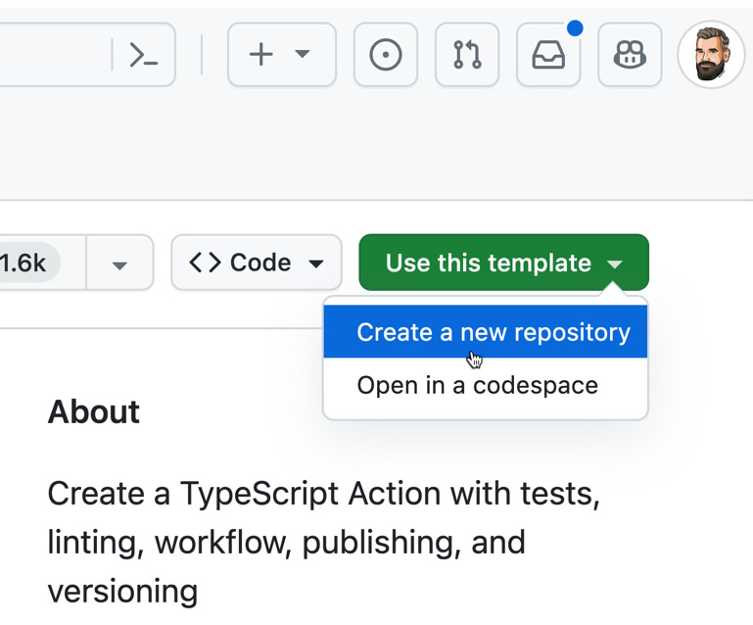
Figure 3.6 – Creating a new repository from the typescript-action template
- Choose your GitHub account as the owner, name it TypeScriptActionRecipe, leave its visibility set to Public, and click Create repository.
- Clone the repository locally and open the folder in VS Code.

How to do it…
- Open a terminal and go to the root of the repository. Install all the necessary dependencies:
$ npm install
The repository contains some unit tests. Run them to check that everything is OK:
$ npm test
- Open the action.yml file and update the metadata for name, description, and author:
name: 'TypeScript Action Recipe'
description: 'Waites for some milliseconds, writes an awesome job summary to the workflow output and returns the current date and time.'
author: 'Michael Kaufmann'
Ignore the branding for now – but note that the action has a defined input parameter (milliseconds) and output parameter (time):
# Define your inputs here.
inputs:
milliseconds:
description: 'Your input description here'
required: true
default: '1000'
# Define your outputs here.
outputs:
time:
description: 'Your output description here'
- Open the src/main.ts file and locate the run function:
export async function run(): Promise<void> {
Note that it uses the toolkit (@actions/core; see https://github.com/actions/toolkit) to read the input parameter:
const ms: string = core.getInput('milliseconds')
It also uses the toolkit to write debug messages. This is similar to the echo "::debug::{debug message}" workflow command that we used in Chapter 2:
core.debug(`Waiting ${ms} milliseconds ...`)
The same is true for setting the output parameter. This is the same as writing to the GITHUB_OUTPUT environment file:
echo "answer=42" >> $GITHUB_OUTPUT
With the toolkit, this looks as follows:
core.setOutput('time', new Date().toTimeString())
- The next step is to write our job summary beneath core.setOutput in the run function. Start with core.summary and note that you have auto-complete to help you with all the available functions and syntax. Add a h2 heading:
// Write an advanced job summary
core.summary
.addHeading('Advanced Job Summary', 'h2')
The core.summary object has a fluent interface. This means you can add new methods directly to the output of the previous one. Add an image and set the size to 64x64:
.addImage(
'https://octodex.github.com/images/droidtocat.png',
'Droidtocat',
{
width: '64',
height: '64'
}
)
Add a table with some data:
.addTable([
[
{ data: 'File', header: true },
{ data: 'Result', header: true }
],
['foo.js', 'Pass
'],
['bar.js', 'Fail
'],
['test.js', 'Pass
']
])
And a simple link:
.addLink('My custom link', 'https://writeabout.net')
You have to finish the summary using the write function, to write the buffer to the environment file:
.write()
You can check the code here: https://github.com/wulfland/TypeScriptActionRecipe.
- Package the TypeScript for distribution. This is an important step, and you have to do it every time you modify a .ts file!
$ npm run bundle
- Commit your changes. This will automatically trigger some workflows – and while they run, you can use the time to see what they are doing..github/workflows/linter.yml runs on all push and pull requests to main and it will lint your code base:
- name: Lint Code Base
id: super-linter
uses: super-linter/super-linter/slim@v5
env:
DEFAULT_BRANCH: main
GITHUB_TOKEN: ${{ secrets.GITHUB_TOKEN }}
TYPESCRIPT_DEFAULT_STYLE: prettier
VALIDATE_JSCPD: false
If this fails, then you probably forgot to run npm run bundle before committing your changes. You can also run prettier locally to make sure you adhere to the linting standards:
$ npx prettier .
--check
$ npx prettier .
--write
The.github/workflows/codeql-analysis.yml workflow will also run on every push and pull request to main – but also once a week. It will scan your code for security vulnerabilities.
Check dist (.github/workflows/check-dist.yml) is a simple workflow that will run npm run bundle and compare the output with your dist folder. It will fail if you forget to package your TypeScript using a small and simple script:
- name: Compare Expected and Actual Directories
id: diff
run: |
if [ "$(git diff --ignore-space-at-eol --text dist/ | wc -l)" -gt "0" ]; then
echo "Detected uncommitted changes after build.
See status below:"
git diff --ignore-space-at-eol --text dist/
exit 1
fi
The last one is the CI build (.github/workflows/ci.yml). It has two jobs. One installs all your dependencies and runs the unit tests, while the other executes your action and uses the output, as we did in Chapter 2:
- name: Test Local Action
id: test-action
uses: ./
with:
milliseconds: 1000
- name: Print Output
id: output
run: echo "${{ steps.test-action.outputs.time }}"
The test-typescript job will fail as we did not adjust the unit tests, but the second job should succeed. At this point, you can inspect your job summary; it should look like what’s shown in Figure 3.6:
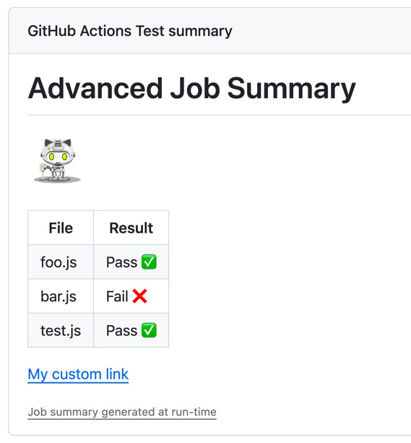
Figure 3.7 – The job summary created using the toolkit
Also, inspect the value of the output parameter in your workflow log (see Figure 3.7):
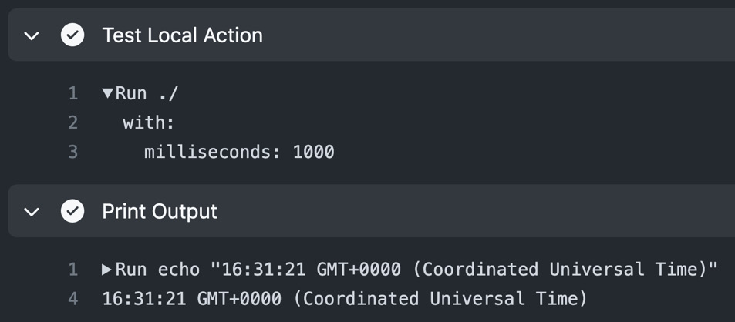
Figure 3.8 – Output of the TypeScript action in the workflow log
Fixing the unit tests
I haven’t included a recipe for adjusting the unit tests in this book as this book is about GitHub Actions and not about TypeScript. But if you want to fix the tests, you can start by looking at the example at https://github.com/wulfland/TypeScriptActionRecipe/blob/main/__tests__/main.test.ts.
- If you go back to main.ts, at the end, you will see that the action will fail if it encounters an error. It does so by using core.setFailed instead of returning a non-zero value:
} catch (error) {
// Fail the workflow run if an error occurs
if (error instanceof Error) core.setFailed(error.message)
}
- Create a new branch called fail-ci-build and switch to it:
$ git switch -c fail-ci-build
Add the following code block to the catch block before the line that contains core.setFailed:
core.error('Something bad happened', {
title: 'Bad Error',
file: '.github/workflows/ci.yml',
startLine: 59,
startColumn: 11,
endColumn: 23
})
In .github/workflows/ci.yml, modify the milliseconds argument to something that cannot be converted into an integer:
- name: Test Local Action
id: test-action
uses: ./
with:
milliseconds: xxx
Package the TypeScript, commit your changes, and create a pull request:
$ npm run bundle
$ git add .
$ git commit -m "Fail CI build"
$ git push –set-upstream origin fail-ci-build
$ gh pr create --fill
- Inspect the pull request you created and note the output in the log from core.setFailed and core.error (see Figure 3.9):
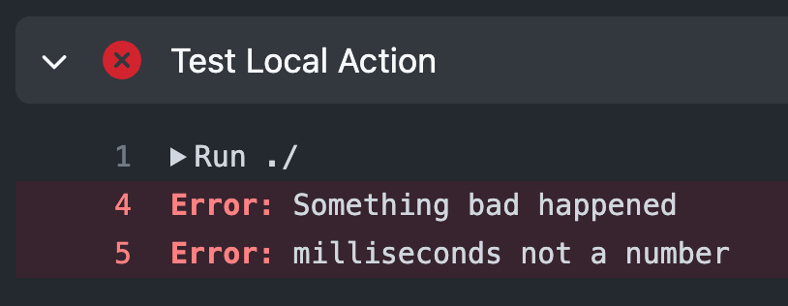
Figure 3.9 – Output of the failed action in the workflow log
Also, note that the annotation is displayed in the workflow file (see Figure 3.10):
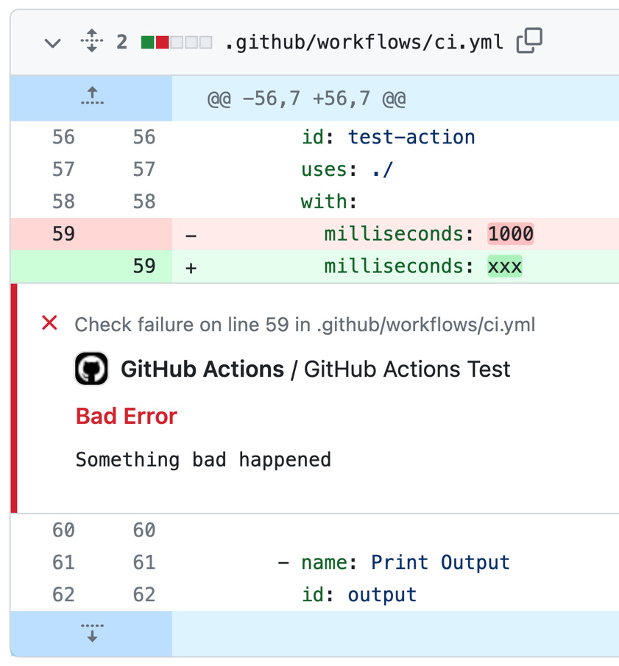
Figure 3.10 – Annotations from the toolkit
The tooling around TypeScript and the toolkit make developing GitHub actions comfortable and are a great help in authoring high-quality actions.

How it works…
TypeScript actions are not so different from container actions – they just run in a Node.js environment instead of a Docker container. TypeScript is just a layer on top of JavaScript that gets transpiled to JavaScript (into the /dist folder) if you run npm run bundle. If you are new to TypeScript, all these tools might seem overwhelming – but these tools also make it quite easy to get started. Auto-complete and IntelliSense in VS Code, automated linting and formatting, unit testing with mocking – there are a lot of tools that will help you write good code.

There’s more…
We just have scratched the surface of what you can do with the toolkit (https://github.com/actions/toolkit). It can also help you work with the GitHub REST or GraphQL API, OICD tokens, and many more. If you plan to do more with GitHub Actions, it’s worth learning at least a little bit of Typescript to be able to leverage the power of the toolkit.

Creating a composite action
The third type of actions, besides Docker container actions and JavaScript/TypeScript actions, are composite actions. Composite actions are a wrapper for other actions. In this recipe, you will create a simple composite action and use it in a workflow – once with a bash script and once with a GitHub script.

Getting ready…
Create a new repository called CompositeActionRecipe. Make it public so that you don’t consume any action minutes and initialize it with a README file. Clone the repository locally and open it in VS Code or open it in GitHub Codespaces.

How to do it…
- Add a new file called action.yml to the root of the repository. Add a name and description:
name: 'Composite Action Recipe'
description: 'Greets the user and returns 42.'
- Add an input called who-to-greet and an output called answer. Note that you need the step ID to access the output. We’ll add that in the next step:
inputs:
who-to-greet
:
description: 'Who to greet'
required: true
default: 'World'
outputs:
answer:
description: "Answer to life, the universe, and everything"
value: ${{ steps.
deep-thought
.outputs.
answer
}}
- Next, add the runs section, set using to composite, and add one step that executes a bash script. Note that you have to specify the shell in composite actions, and you cannot rely on the default shell:
runs:
using: "composite"
steps:
- name: Awesome bash script action
id:
deep-thought
shell: bash
run: |
echo "Hello '${{ inputs.
who-to-greet
}}'."
echo "
answer
=42" >> $GITHUB_OUTPUT
echo "So long, and thanks for all the fish."
We use the input to write a greeting message to the workflow log and we set the output parameter to 42 the same way we did it in the container action. The only difference is that we execute the script directly on the workflow runner and not in a container.
- Add a new workflow file called .github/workflows/ci.yml and configure it so that it runs on push and pull_requests:
name: CI Workflow
on: [push, pull_request]
Add a job that checks out the repository and runs the composite action with an input parameter. Give the step an ID to access the output, like this:
jobs:
ci-job:
runs-on: ubuntu-latest
steps:
- uses: actions/checkout@v4.1.1
- name: Run my own composite action
id:
my-action
uses: ./
with:
who-to-greet: '@wulfland'
Then, add an additional step that writes the output to the console:
- name: Output the answer
run: echo "The answer is ${{ steps.my-action.outputs.answer }}"
These concepts should be already familiar from looking at the other action types.
- Commit and push your changes. This will trigger the workflow; you can inspect the workflow log to see your action in action.

How it works…
Composite actions are wrappers for steps and other actions. You can use them to bundle together multiple run commands or actions – whether you own them or they’re from the marketplace – and you can provide default values for other actions to the users in your organization.
Composite actions have steps in the runs section of the action.yml file – like you would have in a normal workflow. You can access input arguments using the inputs context. Output parameters can be accessed using the outputs context of the step in the steps context.

There’s more…
Composite actions get executed directly on the workflow runner. Because every runner has Node.js installed, you can run JavaScript and TypeScript in a composite action as well. We will use an action called github-script to leverage the power of the toolkit in a composite action. Of course, you can also use the action directly in your workflows.

Using github-script in a composite action to add a comment to an issue
In this recipe, we will use an action called github-script to leverage the power of the toolkit inside a composite action.

How to do it…
- Remove the run step with the bash script from the action.yml file and replace it with a github-script action:
- name: Awesome github script action
uses: actions/github-script@v6
with:
script: |
- Use the toolkit to read the input parameter, write a greeting to the log, and set the output parameter. This should be familiar from the Creating a TypeScript action recipe:
var whoToGreet = core.getInput('who-to-greet')
core.notice(`Hello ${whoToGreet}`)
core.setOutput('answer', 42)
- Now, we want to add some additional functionality. If the workflow was triggered by an issues event, then we want to add a comment to that issue. Check that the event that triggered the workflow was in fact issues and that we used github.rest.issues to create a comment:
if (context.eventName === 'issues') {
github.rest.issues.createComment({
issue_number: context.issue.number,
owner: context.repo.owner,
repo: context.repo.repo,
body: '
 Thanks for reporting!'
})
}
- In the CI workflow, add an additional trigger that executes the workflow when a new issue is opened:
on:
issues:
types: [opened]
- Commit and push your changes.
- Create a new issue in your repository under Issues | New issue (issues/new), give it a title, and save it. The workflow will run and add a comment on that issue, as shown in Figure 3.11:
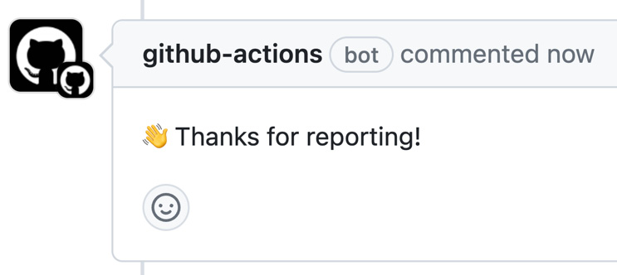
Figure 3.11 – The github-script action commenting on a new issue
The github-script action is a great way to prototype things using the power of the toolkit and without the need to create a separate action.

How it works…
The github-script action makes it easy to quickly write a script in your workflow or composite action that uses the GitHub API and the workflow run context. It uses an input named script that contains the body of an asynchronous function call. The following arguments will be provided by the action:
- github: A pre-authenticated octokit/rest.js client with pagination plugins
- context: An object containing the context of the workflow run
- core: A reference to the @actions/core package
- glob: A reference to the @actions/glob package
- io: A reference to the @actions/io package
- exec: A reference to the @actions/exec package
- fetch: A reference to the node-fetch package
- require: A proxy wrapper around the normal Node.js require to enable requiring relative paths to the current working directory and requiring npm packages to be installed in the current working directory
Since the script is just a function body, these values will already be defined, so you don’t have to import them and you can directly use them as we did with core, context, and github in our example.
To learn more about github-script, please visit https://github.com/actions/github-script.

There’s more…
The editing and debugging experience in the YAML file are not great. However, you can use the script file in the action like this:
with:
script: |
const script = require('./path/to/script.js')
await script({github, context, core})
This way, you can combine the simplicity of the github-script action with a better authoring experience for JavaScript.
The github-script action is a great way to quickly try something out and create a proof of concept for some integrations. With composite actions, you can gradually put it into building blocks that are easy to share. Composite actions are also an easy way to package reusable functionality. As your solution evolves, you probably want to think about moving it to a TypeScript or Docker container action for better maintainability.

Sharing actions to the marketplace
The power of GitHub actions is the community – and sharing is caring. That’s why the GitHub marketplace plays an essential role in empowering community-based workflows. In this recipe, you will add branding and other metadata to one of the actions and share it in the marketplace.

Getting ready…
I will use the Docker container action we created earlier for this recipe – but you can also use the TypeScript action or composite action. It doesn’t matter. So long as the action resides in its own public repository, it’ll work.

How to do it…
- Navigate to the root of your repository in your browser. GitHub will detect that your repository contains an action.yml file and will propose that you publish a release in a blue banner (see Figure 3.12):
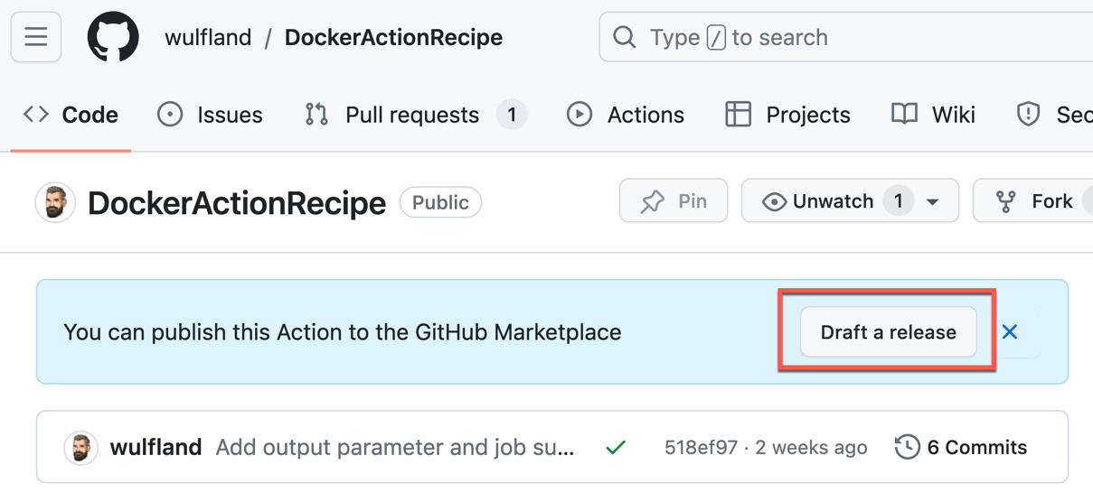
Figure 3.12 – Drafting a release to publish an action to the marketplace
This is the same as going to Releases and clicking Draft a new release (/releases/new).
- In the dialogue, GitHub will show some warnings to help you improve your marketplace listing (see Figure 3.13):
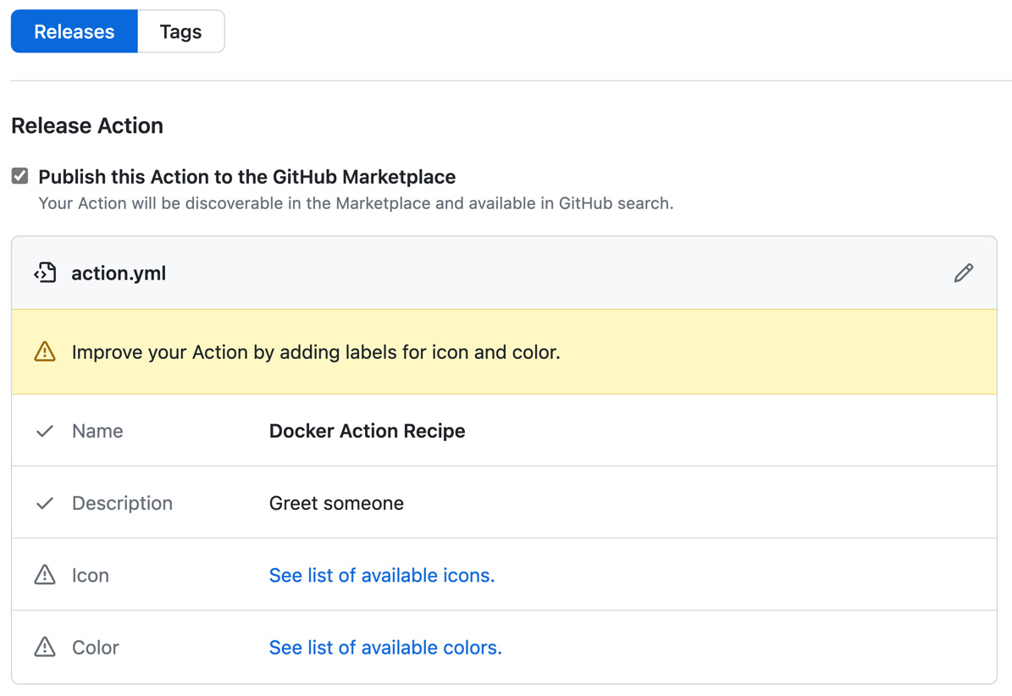
Figure 3.13 – Guidance for publishing actions to the marketplace
Click on the link for available icons and colors and pick one of each. I’ll go with bell and purple.
- Open your action.yml file in VS Code and add branding and author information:
name: 'Docker Action Recipe'
description: 'Greet someone'
branding
:
icon:
bell
color:
purple
author: 'Michael Kaufmann'
- A good README.md file is important for the marketplace listing. Add a section for inputs, outputs, and a usage example. Check out https://github.com/wulfland/DockerActionRecipe for a suggestion.
- Commit and push your changes.
- Go back to your browser and refresh the new release window. The check should now show no warnings and look like what’s shown in Figure 3.14):
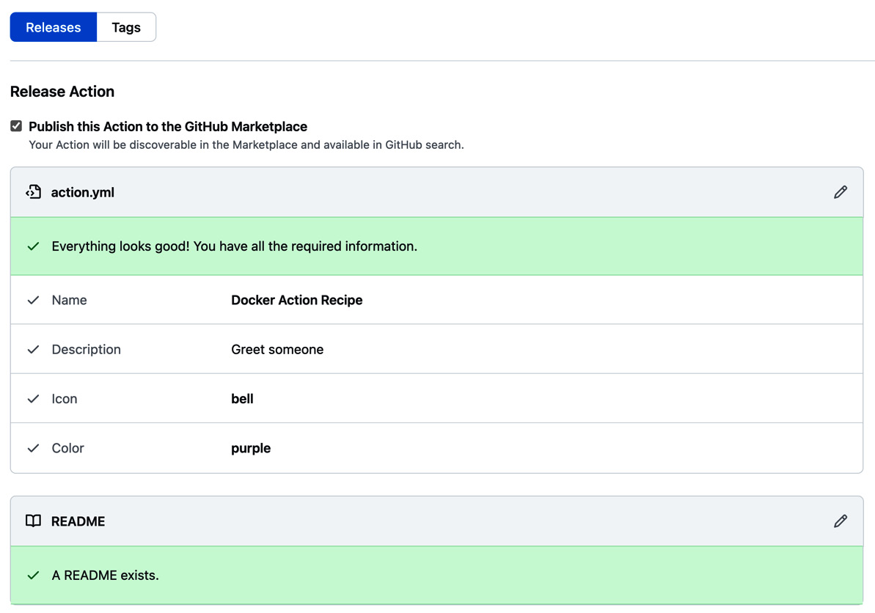
Figure 3.14 – The check is successful as has a unique name, branding, description, and a README file
- Click Choose a tag, enter v1.0, and click Create new tag (see Figure 3.15):
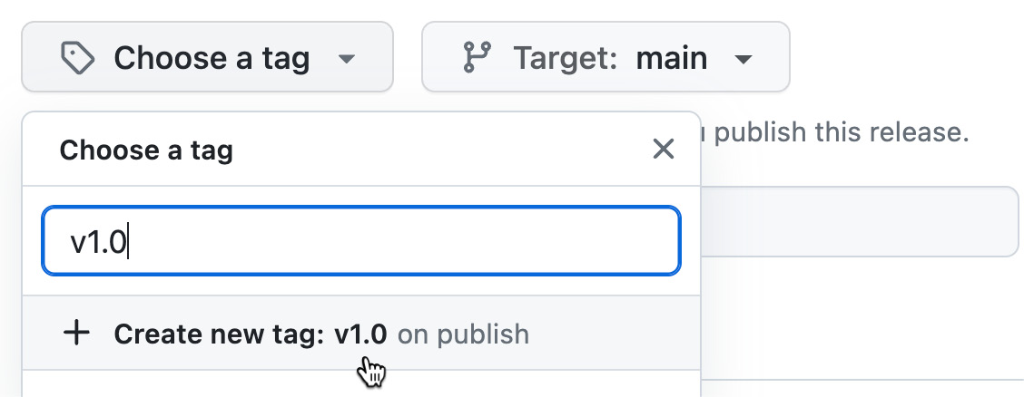
Figure 3.15 – Creating or choosing a tag to create a release
- Add v1.0 as the title of the release. Note that you can automatically generate release notes for your release. However, the results will only be very good if you work with pull requests. You can also add a description manually.
- Click Publish release. In the release, you will see the Marketplace and Latest labels (see Figure 3.16):
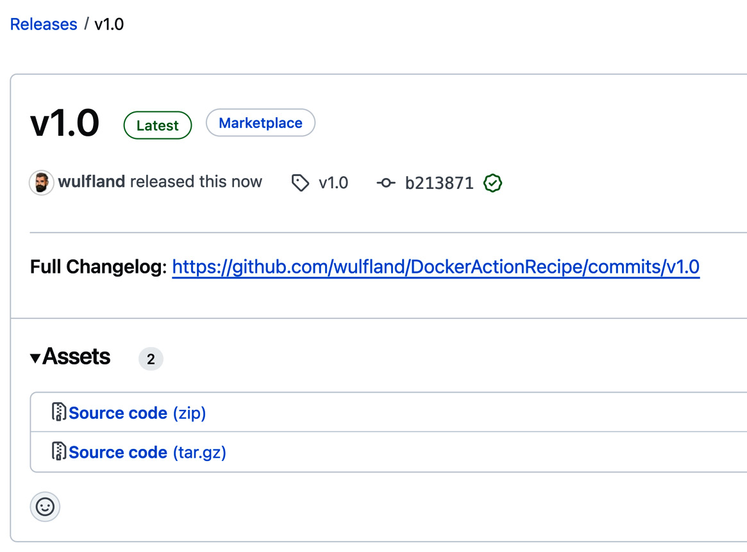
Figure 3.16 – Content of a release in your repository
- Click the Marketplace label. This will bring you to your marketplace listing.
- Note the icon with the color you specified under branding in your action.yml, next to the name of the action. The README.md file of your repository will cover the biggest part of the listing. On the right, you have a button to Delist the action (remove it from the marketplace), a version picker, and important links. The first one will bring you back to your repository (see Figure 3.17 for the regions of the listing):
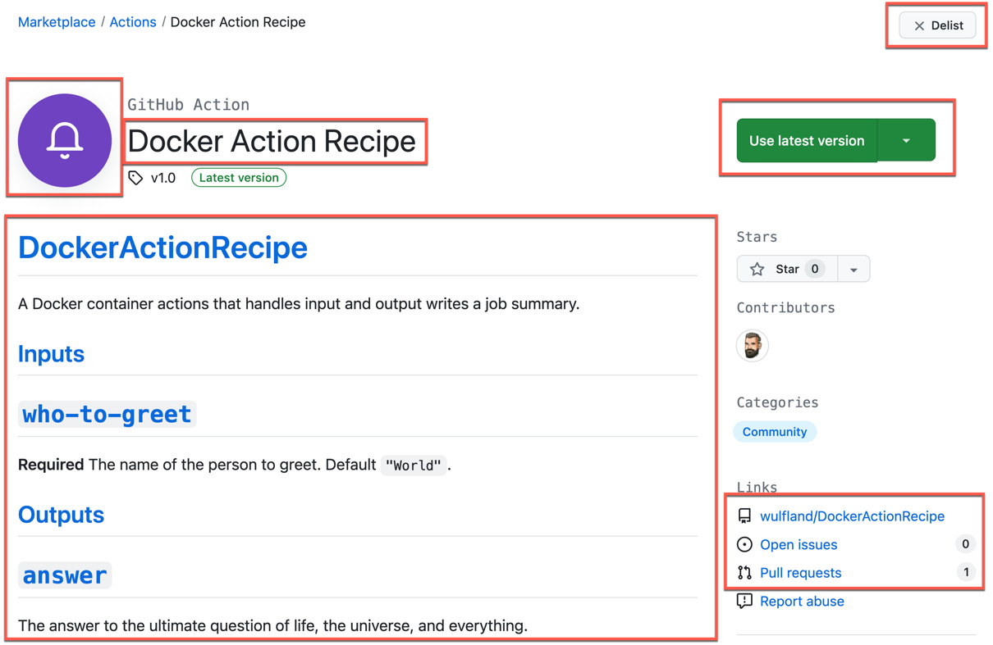
Figure 3.17 – A marketplace listing
- Go back to your repository and create a new release called v1.1 by repeating the same steps. Note that this time, the dialogue has a flag set as the latest release (see Figure 3.18). If you forget this, GitHub will not label the release as the latest – independent of the version number you pick as a label:
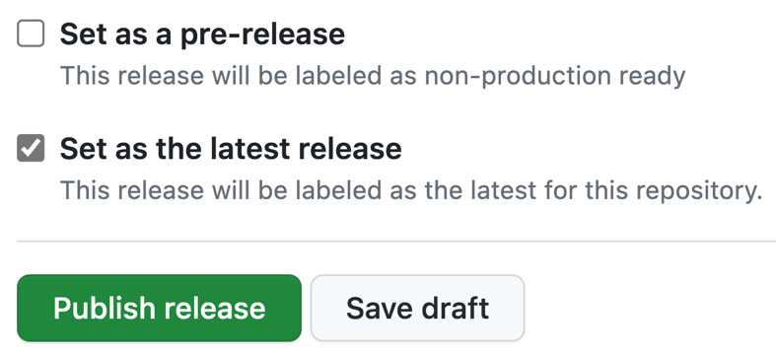
Figure 3.18 – You have to manually set a release as the latest when creating or editing it
- Finally, create a new workflow file or edit an existing workflow in your browser. On the right-hand side, enter the name of your action in the marketplace window. Your action should be found instantly. Note the installation instructions that GitHub automatically creates from your release (see Figure 3.19):
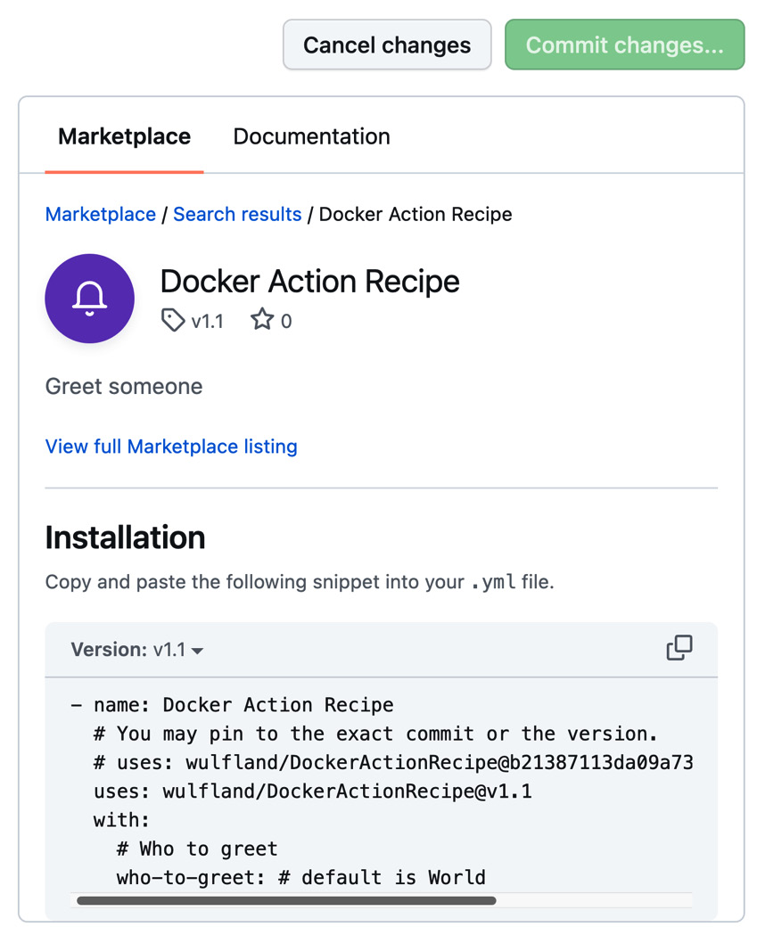
Figure 3.19 – The listing in the workflow editor
- Delist your action if you don’t want to keep it in the marketplace, as shown in Figure 3.17.

How it works…
The GitHub marketplace is built on top of GitHub releases (see (https://docs.github.com/en/repositories/releasing-projects-on-github), which are built on top of git tags.
A tag can be any text – but you are encouraged to use semantic versioning to give the versions a meaning.
Semantic versioning is a formal convention for specifying version numbers for software. It consists of different parts with different meanings. Examples of semantic version numbers are 1.0.0 or 1.5.99-beta. The format is as follows:
<major>.<minor>.<patch>-<pre>
Let’s take a closer look:
- Major version: A numeric identifier that gets increased if the version is not backward-compatible and has breaking changes. An update to a new major version must be handled with caution! A major version of zero is for the initial development.
- Minor version: A numeric identifier that gets increased if new features are added but the version is backward-compatible with the previous version and can be updated without breaking anything if you need the new functionality.
- Patch: A numeric identifier that gets increased if you release backward-compatible bug fixes. New patches should always be installed.
- Pre-version: A text identifier that is appended using a hyphen. The identifier must only use ASCII alphanumeric characters and hyphens ([0-9A-Za-z-]). The longer the text, the smaller the pre-version (meaning -alpha < -beta < -rc). A prerelease version is always smaller than a normal version (1.0.0-alpha < 1.0.0).
It is considered best practice to prefix semantic versions in GitHub releases with v (for example, v1.0, v1.0.1, and so on).
See https://semver.org/ for the complete specification regarding semantic versions.

There’s more…
Versioning with tags opposes some kind of risk as everybody with write permissions to a repository can modify a tag. That’s why, as the maintainer of a GitHub action, you are encouraged to use tag protection rules in addition to your branch protection rules (see https://docs.github.com/en/repositories/managing-your-repositorys-settings-and-features/managing-repository-settings/configuring-tag-protection-rules). A tag protection rule for v* will prevent everybody without admin permissions to your repository to modify tags starting with a v.
If you want to automate the process of creating semantic versions for your releases and the automatic creation of good release notes, then you can use conventional commits (see https://www.conventionalcommits.org). Conventional commits add a prefix to every commit, indicating if it is a feature or a fix and if it is breaking or not. You can combine this with GitVersion (see https://gitversion.net/docs/) to automatically create semantic versions for your release. You will learn more about this in Chapter 7, Release Your Software with GitHub Actions.
4

The Workflow Runtime
In this chapter, you will learn about the different runtime options for GitHub Actions. You will learn how to use different GitHub-hosted runners and how to set up self-hosted runners.
This chapter will cover the following topics:
- Setting up a self-hosted runner
- Auto-scaling self-hosted runners
- Scaling self-hosted runners with Kubernetes using Actions Runner Controller (ARC)
- Runners and runner groups
- GitHub-hosted runners
- Setting up a large runner
- Managing and auto-scaling ephemeral runners
- Security for GitHub-hosted and self-hosted runners

Technical requirements
For this chapter, you will need Docker and Visual Studio Code, though alternatively, you can use GitHub Codespaces. For the Scaling self-hosted runners with Kubernetes using ARC recipe, you will need either a Kubernetes cluster or an Azure subscription with the Azure CLI to set one up. For the recipes about runner groups, you will need a paid Team or Enterprise plan for a GitHub organization.

Setting up a self-hosted runner
So far, we have only used the ubuntu-latest label for our jobs. This runs the workflows on the latest version of a Ubuntu image hosted by GitHub. But there are also runners on macOS and Windows, with different configurations. You can host your own runners on any platform you like. In this first recipe, we will set up a self-hosted runner in a Linux Docker container. This way, it will be easy to scale it up and clean up the resources after our workflow run.

Getting ready…
You will need Docker installed for this recipe. You will also need to know your processor architecture. If you don’t know it, just run docker info and look for Architecture:
$ docker info | grep Architecture

How to do it…
- Go to a repository on GitHub. You can create a new one or you can use the GitHubActionsCookbook repository, which you created in Chapter 1. Go to Settings | Actions | Runners (/settings/actions/runners) and click on New self-hosted runner (see Figure 4.1):
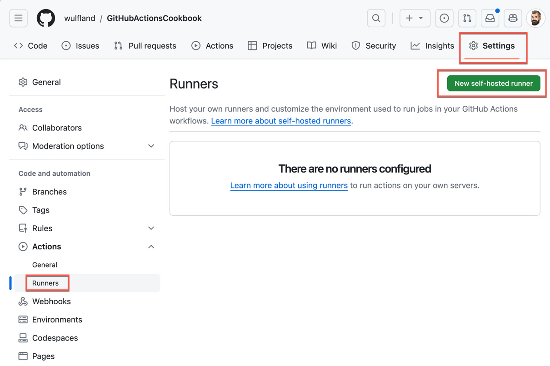
Figure 4.1 – Self-hosted runners can be added by going to a repository’s Settings area
This will redirect you to /settings/actions/runners/new. Pick Linux for Runner image and set up the Architecture property according to your Docker environment.
Note the different scripts for each platform and processor architecture. You can copy the entire script for an installation on a VM. However, since we are in a Docker container, we will need some additional steps. Note that you can also copy individual lines (see Figure 4.2):
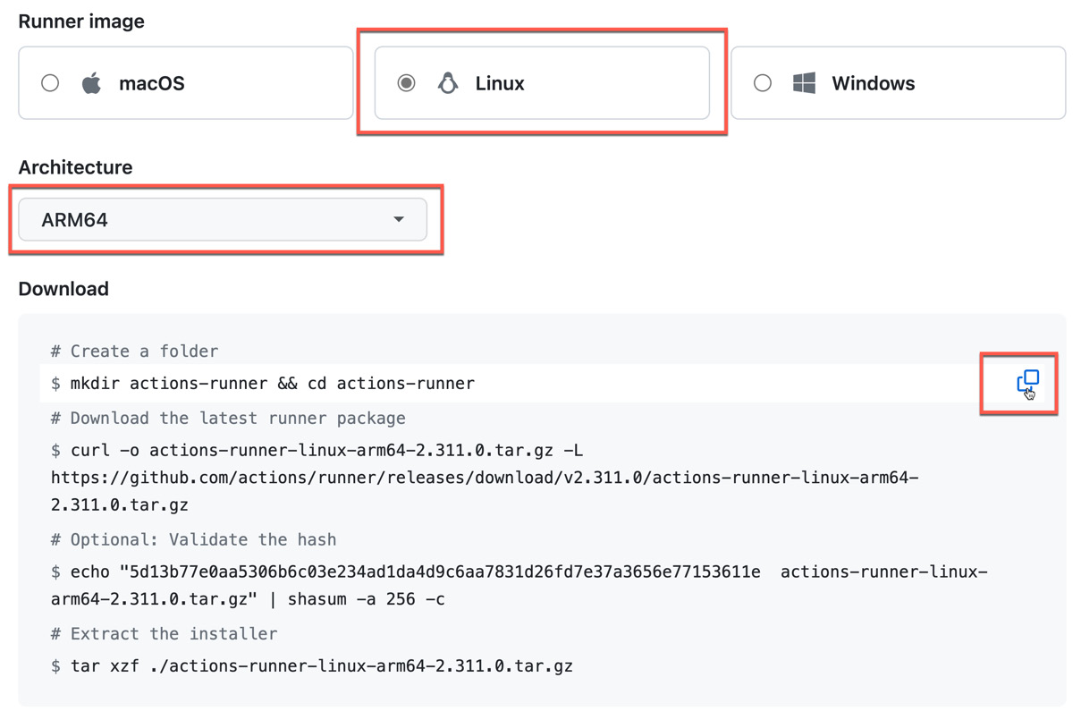
Figure 4.2 – Script to install self-hosted runners on different platforms
- Start a console in the latest version of an Ubuntu container:
$ docker run -it ubuntu:latest /bin/bash
- Run the first line of the script. This will create a folder for the runner and change directory into it:
$ mkdir actions-runner && cd actions-runner
- To download the runner binaries, we have to install curl in the container as this is not part of the normal Ubuntu image:
$ apt-get -y update; apt-get -y install curl
- Now, execute the line from the script that downloads the latest runner package. Just copy and paste the line from your browser to your console:
$ curl -o actions-runner-
{version}
.tar.gz -L https://
{URL}
.tar.gz
- Unzip the package using the tar command from the script:
tar xzf ./actions-runner-
{version}
.tar.gz
- Install the dependencies that are needed for the runner by executing the following script:
$ ./bin/installdependencies.sh
- Before we can configure the runner, we have to allow it to run as root as our container runs as root per default. We can do this by setting the RUNNER_ALLOW_RUNASROOT environment variable to a non-zero value:
$ export RUNNER_ALLOW_RUNASROOT="1"
- Now, we can run the configuration script. If the other steps took too long for you to execute, then you might have to refresh the page in your browser as the tokens are only valid for a short period. Copy and execute the line containing the token:
./config.sh --url https://github.com/{OWNER}/{REPO} --token {TOKEN}
Press Enter and accept all default values.
After executing the script, you can navigate back to Settings | Actions | Runners to see the newly registered runner. You will see that it is still offline since we haven’t started the runner process yet (see Figure 4.3):
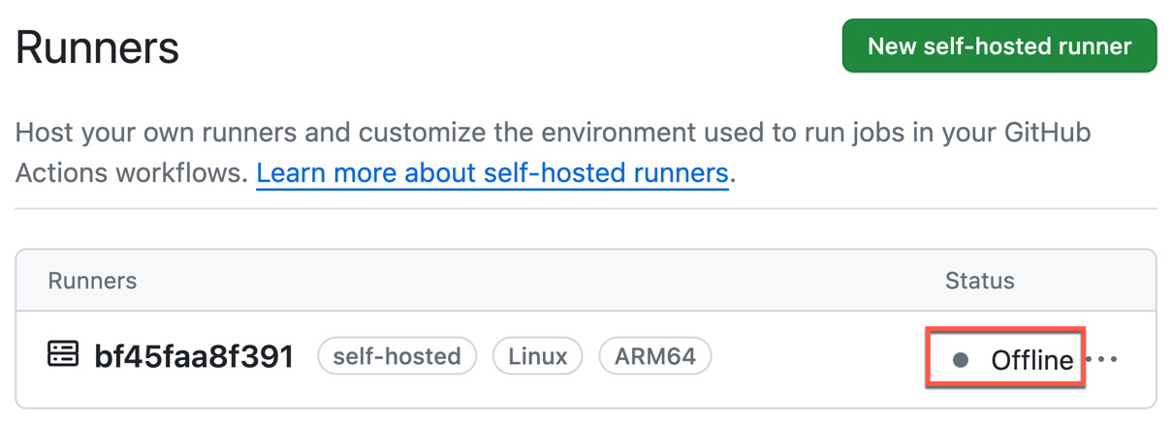
Figure 4.3 – A configured runner that isn’t running is shown as Offline
- Start the runner using the following script:
$ ./run.sh
The runner will change to being in the Idle state, which means it’s waiting for workflows to execute.
- Create a simple workflow that uses the self-hosted label. The bash should be available on all platforms, so we can omit an additional label for Linux. However, you could also do this by running [self-hosted, Linux]:
name: Self-Hosted
on: [workflow_dispatch]
jobs:
main:
runs-on:
self-hosted
steps:
- name: Output environment
shell:
bash
run: |-
echo "Runner Name: '${{ runner.name }}'"
echo "Runner OS: '${{ runner.os }}'"
echo "Runner ARCH: '${{ runner.arch }}'"
- Execute the workflow and monitor your Docker container to see how it executes the workflow. You can repeat this step as many times as you want. So long as your container is running, it will execute all workflows with matching labels.
- If you kill your container now, the runner will remain offline in GitHub. To remove it, navigate back to Settings | Actions | Runners and select Remove runner from the menu on the right-hand side of the runner (see Figure 4.4):
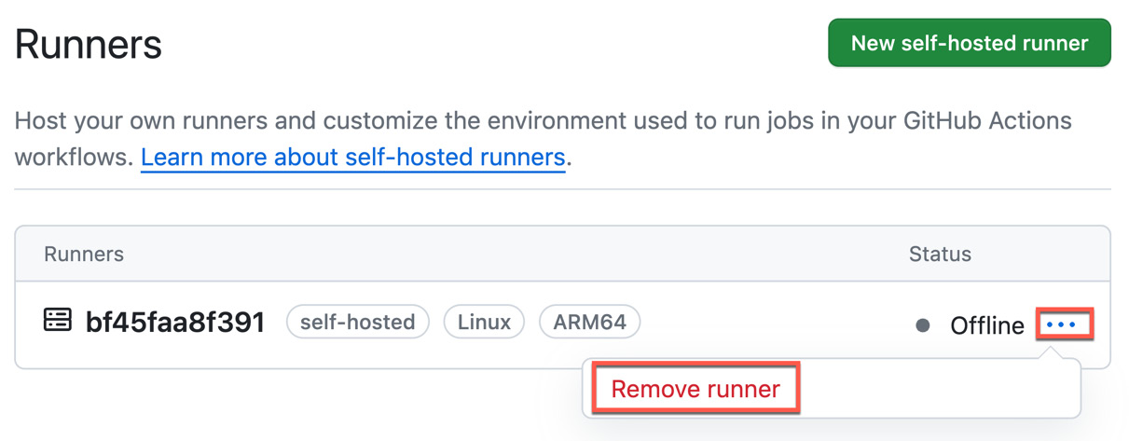
Figure 4.4 – Removing a runner from GitHub
Run the script provided by the dialogue to remove the runner:
$ ./config.sh remove --token
{TOKEN}
The runner will now be gone from GitHub.
- We can also configure the runner so that it only runs one job and then unregisters itself. This makes a lot of sense with containers. For this, you can just add the --ephemeral switch to the configuration step after generating a new token:
./config.sh --url {URL} --token {TOKEN}
--ephemeral
- Run the workflow again; you will see that the runner will be removed after execution.
- Next, we can put everything we’ve learned into a Dockerfile (you can use the file available at https://github.com/wulfland/GitHubActionsCookbook/blob/main/SelfHostedRunner/Dockerfile). This way, we can create a reusable Docker image that will register itself, wait for a job, execute it, and then terminate every time you run it.
We inherit from ubuntu:latest for simplicity. You can easily replace this with a base image that contains all your build tools:
FROM ubuntu:latest
Set the variables that will be used for the connection. Leave TOKEN and RUNNER_NAME empty as these values will be provided when the container starts, not during image creation. Set the correct URL, platform, and version:
ENV TOKEN=
ENV RUNNER_NAME=
ENV RUNNER_URL="https://github.com/
{owner}
/
{repo}
"
ENV GH_RUNNER_PLATFORM="
linux-arm64
"
ENV GH_RUNNER_VERSION="
2.311.0
"
ENV LABELS="self-hosted,ARM64,Linux"
ENV RUNNER_GROUP="Default"
Before installing the missing packages, we have to set DEBIAN_FRONTEND to noninteractive to ensure that the operating system does not prompt for user input during the Docker image build process:
ARG DEBIAN_FRONTEND=noninteractive
To have fewer layers in the Docker image, it is best to combine the entire script into one RUN command. The script updates the package manager and all its packages and installs all dependencies, adds the docker user that the container will run under (we don’t want the container to run as root), downloads the corresponding package, unzips it, changes the owner to the docker user, and executes the installdependencies.sh script:
RUN apt-get -y update && \
apt-get upgrade -y && \
useradd -m docker && \
apt-get install -y --no-install-recommends curl ca-certificates && \
mkdir -p /opt/hostedtoolcache /home/docker/actions-runner && \
curl -L https://github.com/actions/runner/releases/download/v${GH_RUNNER_VERSION}/actions-runner-${GH_RUNNER_PLATFORM}-${GH_RUNNER_VERSION}.tar.gz -o /home/docker/actions-runner/actions-runner.tar.gz && \
tar xzf /home/docker/actions-runner/actions-runner.tar.gz -C /home/docker/actions-runner && \
chown -R docker /home/docker && \
/home/docker/actions-runner/bin/installdependencies.sh
Run the container as the docker user and set the working directory to actions-runner in the home directory of that user:
USER docker
WORKDIR /home/docker/actions-runner
If the container will run, we must check if TOKEN and RUNNER_NAME are provided. Then, we must run the config script with all parameters – including --ephemeral – and then run the run.sh script:
CMD if [ -z "$TOKEN" ]; then echo 'TOKEN is not set'; exit 1; fi && \
if [ -z "$RUNNER_NAME" ]; then echo 'RUNNER_NAME is not set'; exit 1; fi && \
./config.sh --url "${RUNNER_URL}" --token "${TOKEN}" --name "${RUNNER_NAME}" --work "_work" --labels "${LABELS}" --runnergroup "${RUNNER_GROUP}" --unattended --ephemeral && \
./run.sh
- Step into the folder containing the Dockerfile and create a Docker image from the file:
$ docker build -t
simple-ubuntu-runner
.
- Now, run as many instances of the image as you like with docker run. The -d (--detached) option will run the container in detached mode in the background. It will not block your console, but it will not receive input or display output in the terminal. The --rm option will remove the container when it exits. Pass in arguments for RUNNER_NAME and TOKEN using the -e option. Keep in mind that these names are case-sensitive!
$ docker run -d --rm -e RUNNER_NAME=
Runner1
-e TOKEN=
{TOKEN}
simple-ubuntu-runner
You will see the runners in the Settings area of your repository, as shown in Figure 4.5:
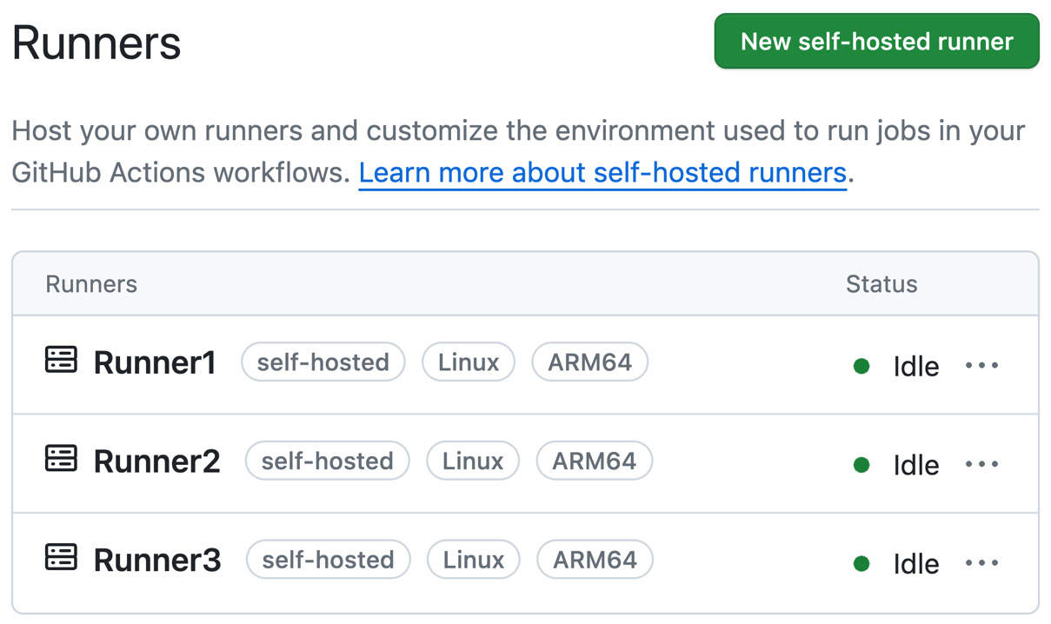
Figure 4.5 – Running the same Docker image multiple times to get ephemeral runners waiting for incoming jobs
Start the workflow as many times as you have created containers to run a workflow and clean up the container after execution.

How it works…
Let’s understand how the flow works.
The self-hosted runner application
A self-hosted runner is created by installing the open source runner application (https://github.com/actions/runner). The application is based on the .NET Core runtime and can run on a large number of operating systems and processor architectures. It can run on macOS 11 (Big Sur) or later, Windows (7 to 10 and Server 2012 R2 to 20222), and many Linux distributions (Red Hat Enterprise 7 or later, Fedora 29 or later, Ubuntu 16.04 or later, and many more). It can also run on x64, ARM64, and ARM32. For an up-to-date list of supported operating systems, see https://docs.github.com/en/actions/hosting-your-own-runners/managing-self-hosted-runners/about-self-hosted-runners#supported-architectures-and-operating-systems-for-self-hosted-runners. You can use the bin/installdependencies.sh script in the runner applications folder to install all the required libraries for the .NET Core runtime.
If you want to run Docker-based actions, you must use a Linux image. Windows and macOS are not supported for running Docker-based actions!
Authentication to GitHub
Connecting the runner to GitHub is done using a configuration token that can be generated by a user through the GitHub UI. The token is only valid for 1 hour and you can only use the token to install runners. You can also create an installation token through the REST API on demand by sending a POST request to https://api.github.com/repos/{OWNER}/{REPO}/actions/runners/registration-token (or https://api.github.com/orgs/{ORG}/actions/runners/registration-token for runners at the organization level).
Here’s an example of how you would receive a token using a personal access token (PAT):
$ curl -L \
> -X POST \
> -H "Accept: application/vnd.github+json" \
> -H "Authorization: Bearer
<YOUR-PAT>
" \
> -H "X-GitHub-Api-Version: 2022-11-28" \
> https://api.github.com/repos/
{OWNER}
/
{REPO}
/actions/runners/registration-token
The result also contains the expiration date. If you want to use the token in a variable, pipe the result to jq, like this:
$ TOKEN=$(<curl command> | jq .token --raw-output)
You must authenticate using a PAT access token with the repo scope to use this endpoint. GitHub Apps must have administration permission for repositories and the organization_self_hosted_runners permission for organizations. Authenticated users must have admin access to repositories or organizations, or the manage_runners:enterprise scope for enterprises.
The token is only valid for registration. During the registration process, a JWT (JSON Web Token for OAuth exchange) will be received from the server that only has permission to listen to the queue. When a workflow run starts, another pre-built token with a limited scope (defined by the workflow) will be created for the life of the build. That token can’t be accessed via ad hoc scripts or untrusted code – only by the build agent and tasks. The RSA private key for the OAuth token exchange between the agent and server will be stored in a file called .credentials_rsaparams and the server holds the public key. Every 50 minutes, the server will send a new token to the agent that’s encrypted by the public key. The OAuth configuration is stored in the .credentials file:
{
"scheme": "OAuth",
"data": {
"clientId": "
{CLIENT_ID}
",
"authorizationUrl": "https://pipelinesghubeus4.actions.githubusercontent.com/
{TOKEN}
/_apis/oauth2/token",
"requireFipsCryptography": "True"
}
Running the application as a service
On Windows, the configuration script will ask you if you want to execute the runner as a service so that it will start alongside the environment. On Linux, you will have to configure the service yourself using the svc.sh script:
sudo ./svc.sh install
sudo ./svc.sh start
Network communication
The runner application communicates with GitHub using an outgoing HTTPS connection on port 443 using long polling with a 50-second timeout. This means that the application asks GitHub if any work is queued for the labels of the runner and then waits for 50 seconds for a response before the connection is closed. Immediately after closing the connection, a new connection is started. There is no need for any inbound connection from GitHub or to open any firewall ports. Only secure outbound connections using SSL over port 443.
Updating self-hosted runners
Self-hosted runners will automatically check if there is a new version of the runner application available and update it. GitHub will only update the runner itself – the rest of the machine is managed by the customer.
Cleaning up
It is worth noting that the GitHub runner application will not clean up resources after a workflow run. This behavior is different from GitHub-hosted runners as they provide an ephemeral fresh environment for every workflow run. If you download your repository and perform a build, all files will just stay there. If you want to use a runner application for multiple workflow runs, then you have to clean up everything yourself. That’s why I emphasize the use of ephemeral runners in containers. This way, you always have a clean environment.
You can use workflow logic to clean up after your workflow runs – but you can also use pre- or post-job scripts to do this on the runner. To configure a pre- or post-job script, you need to save a script file in a location to which the runner has access, and then configure an environment variable with one of the following names and the full path to the script as the value:
- ACTIONS_RUNNER_HOOK_JOB_STARTED
- ACTIONS_RUNNER_HOOK_JOB_COMPLETED
As an alternative, you can store key-value pairs in a .env file inside the runner application directory.

There’s more…
Installing the runner on macOS is the same as it is for Linux. The difference on Windows is that the script is a PowerShell script instead of a bash script. It uses Invoke-WebRequest instead of curl, for example, but all the steps are the same. The scripts to configure and start the runner have the .cmd extension instead of .sh:
$ ./config.cmd --url
<URL>
--token
<TOKEN>
$ ./run.cmd
If you’ve successfully installed the runner in a Linux container, then you will have no problem installing it on Windows.

Auto-scaling self-hosted runners
In this recipe, we’ll be building on the previous recipe so that we have a solution that automatically starts a new instance of the ephemeral Docker container every time a new workflow is triggered. We’ll use a GitHub webhook for that.

Getting ready…
Make sure you still have the simple-ubuntu-runner Docker image we created in the previous recipe on your machine or GitHub Codespaces.

How to do it…
- Go to https://github.com/settings/apps and click on New GitHub App.
- Set GitHub App Name to auto-scale-runners and Homepage URL to the URL of the repository you are using (see Figure 4.6):
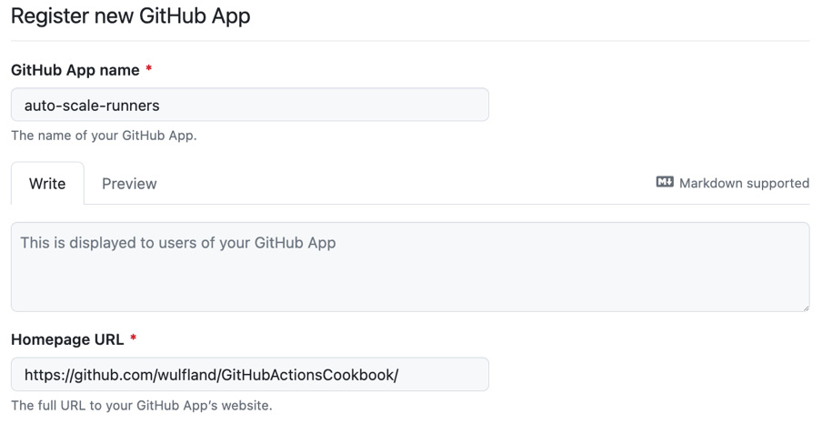
Figure 4.6 – Setting the name and URL for the new app
- Skip the Identifying and authorizing users and Post installation section and proceed to Webhook.
- Open another browser tab, go to https://smee.io, and click on Start new channel. Copy the Webhook Proxy URL value.
- Go back to the other tab and paste the URL into the Webhook URL field. Set Webhook secret to a string that you will remember later (see Figure 4.7):
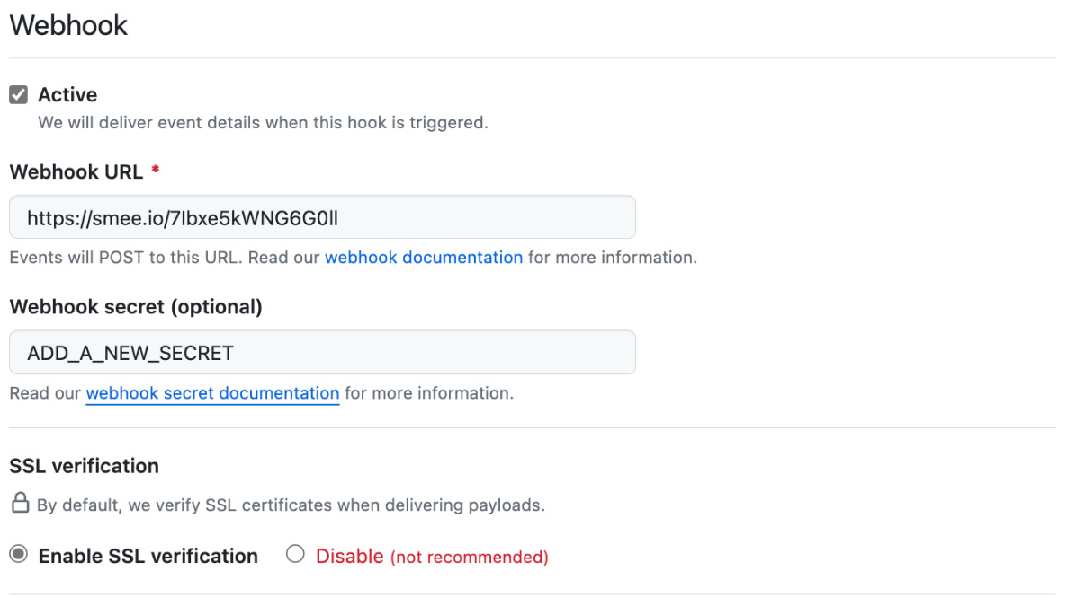
Figure 4.7 – Configuring the webhook
- Under Permissions | Repository permissions, set Actions to Read-only and Administration to Read and write (see Figure 4.8):
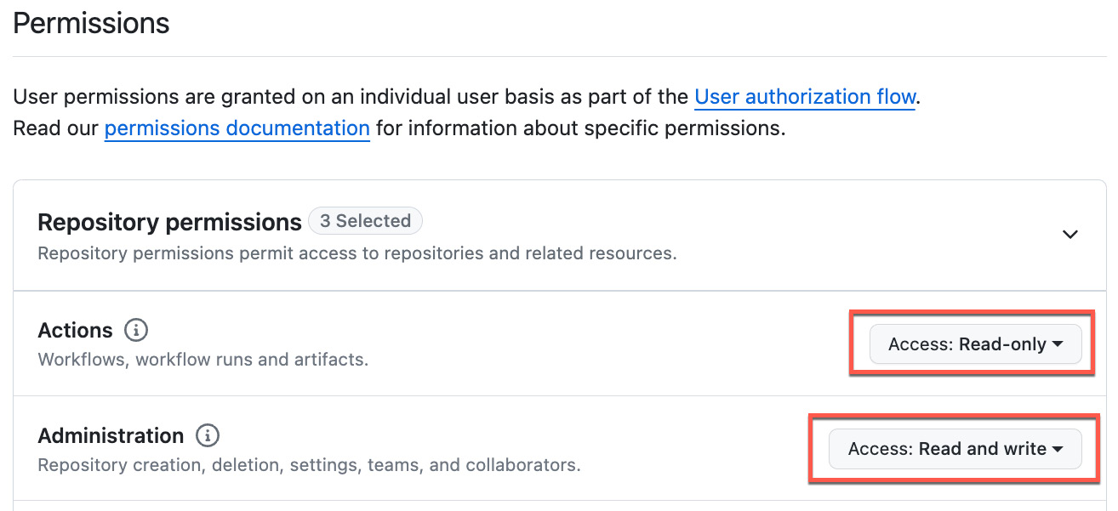
Figure 4.8 – Configuring Repository permissions for the app
- Under Subscribe to events, select Workflow job (see Figure 4.9):
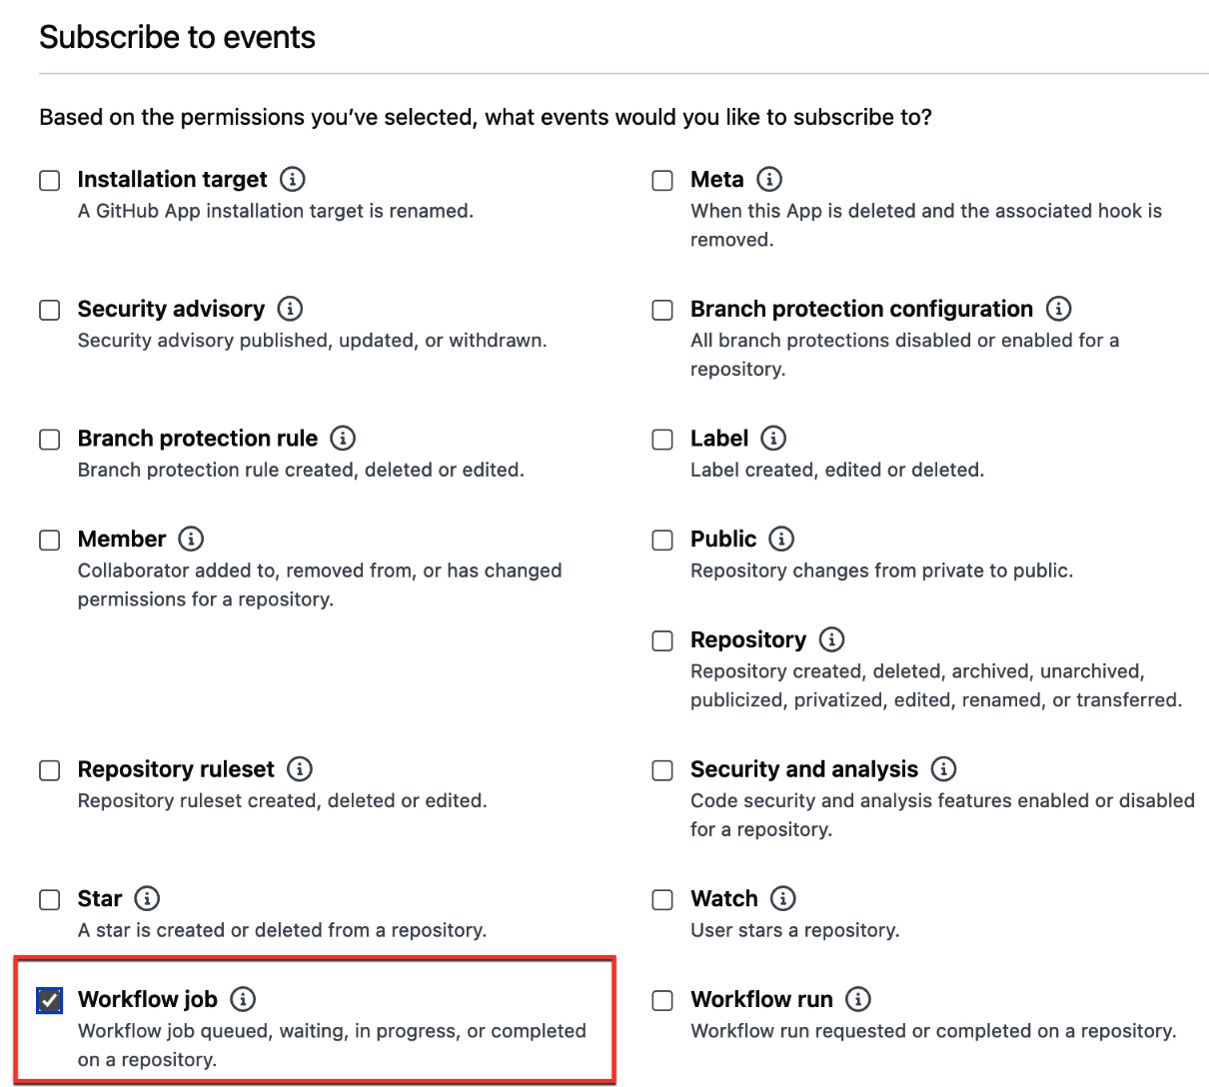
Figure 4.9 – Subscribing to the workflow job webhook
- Under Where can this GitHub App be installed, select Only on this account and click Create GitHub App.
- In your newly created app, click on Generate a private key. The private key will be automatically downloaded. Move it to your repository.
- Copy the App ID value from the General tab of the app (see Figure 4.10):
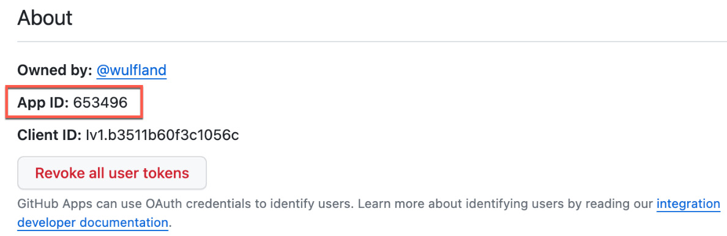
Figure 4.10 – Getting the App ID value
- In your repository, create a new file called .env and add variables for APP_ID, WEBHOOK_SECRET, and PRIVATE_KEY_PATH with the corresponding values:
APP_ID="653496"
WEBHOOK_SECRET="YOUR_SECRET"
PRIVATE_KEY_PATH="auto-scale-runners.2023-11-26.private-key.pem"
We will use these environment variables in our application later to authenticate to GitHub.
- Add the .env file to the .gitignore file so that you don’t accidentally commit this:
$ echo ".env" >> .gitignore
- In the app in GitHub, select Install App and click Install (see Figure 4.11):
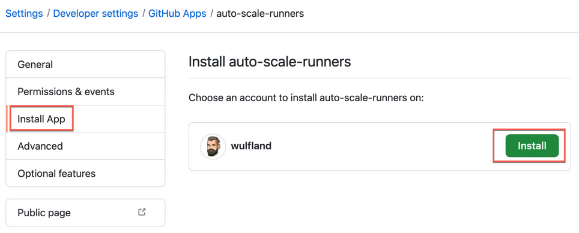
Figure 4.11 – Installing the app
- In the dialogue that appears, select your repository and click Install (see Figure 4.12):
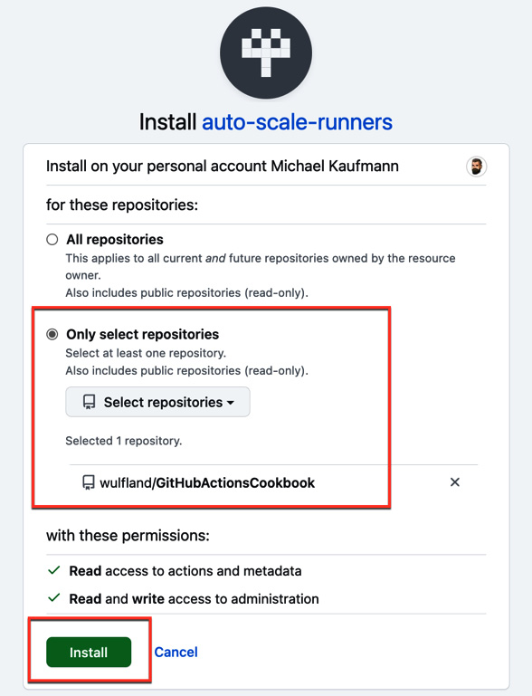
Figure 4.12 – Installing the app in your repository
- Next, we will create the server that will run when it receives a payload from the webhook. Go to your repository and initialize it:
$ npm init –yes
Add the dependencies we are using in the code:
$ npm install octokit
$ npm install dotenv
$ npm install smee-client --save-dev
Add the node_modules folder to.gitignore:
$ echo "node_modules" >> .gitignore
- Create a new file called app.js. You can copy the content from here: https://github.com/wulfland/GitHubActionsCookbook/blob/main/SelfHostedRunner/auto-scale/app.js. However, I will still go through the code here step by step.
- Add the necessary dependencies:
import dotenv from "dotenv";
import {App} from "octokit";
import {createNodeMiddleware} from "@octokit/webhooks";
import fs from "fs";
import http from "http";
import { exec } from 'child_process';
- Next, use the dotenv package to read the environment variables from the .env file we created earlier:
dotenv.config();
const appId = process.env.APP_ID;
const webhookSecret = process.env.WEBHOOK_SECRET;
const privateKeyPath = process.env.PRIVATE_KEY_PATH;
- Next, load the private key from the corresponding path:
const privateKey = fs.readFileSync(privateKeyPath, "utf8");
- Create a new instance of the app class from octokit:
const app = new App({
appId: appId,
privateKey: privateKey,
webhooks: {
secret: webhookSecret
},
});
Then, register an event handler for the workflow_job.queued event:
app.webhooks.on("workflow_job.queued", handleNewQueuedJobsRequestOpened);
- Call the GitHub API to receive a new token that can register runners. We need the token so that we can pass it to our container. We must use workflow_job.id to create a unique name for our runner:
const response = await octokit.request('POST /repos/{owner}/{repo}/
actions/runners/registration-token
', {
owner: payload.repository.owner.login,
repo: payload.repository.name,
headers: {
'X-GitHub-Api-Version': '2022-11-28'
}
});
const token =
response.data.token
;
const runner_name = `Runner_${
payload.workflow_job.id
}`;
- Then, we must create a new instance of our Docker container and pass in the token and name:
exec(`docker run -d --rm -e RUNNER_NAME=${runner_name} -e TOKEN=${token}
simple-ubuntu-runner
`, (error, stdout, stderr) => {
if (error) {
console.error(`exec error: ${error}`);
return;
}
console.log(`stdout: ${stdout}`);
console.error(`stderr: ${stderr}`);
});
I’ve skipped the error handling part here as it isn’t relevant.
- In the last part of the file, we must create a development server that will listen on port 3000:
const port = 3000;
const host = 'localhost';
const path = "/api/webhook";
const localWebhookUrl = `http://${host}:${port}${path}`;
const middleware = createNodeMiddleware(app.webhooks, {path});
http.createServer(middleware).listen(port, () => {
console.log(`Server is listening for events at: ${localWebhookUrl}`);
console.log('Press Ctrl + C to quit.')
});
- In the package.json file, add a top-level entry called type and set it to module. Then, add a script called server that will run the application:
"type": "module",
"scripts": {
"server": "
node app.js
"
},
- We are ready! Open a new terminal and start a smee client with the URL of your channel (Step 4):
$ npx smee -u
https://smee.io/{ID}
-t http://localhost:3000/api/webhook
In a terminal in your repository, run the app:
$ npm run server
Start a new workflow run for the Self-Hosted workflow:
$ gh workflow run Self-Hosted
Note how your smee client receives the webhook that was forwarded from GitHub and how your server processes it and starts a new container that executes your workflow.

How it works…
GitHub Apps provide you with an easy way to authenticate to GitHub and register to webhooks. In this recipe, we registered to the workflow_job webhook with the queued action type so that every time a new workflow is queued, we can start a new runner. If you have larger images that take longer to load, you could also have a pool of existing runners and still load a new one if a job gets queued. The ephemeral runner you start does not have to be the one executing your job.
As we needed an endpoint that could be reached by GitHub, we used smee.io as a proxy and had it forward the payload in case of an event. This is not meant for production use. It just gives us a convenient way to develop locally or in a GitHub Codespace, without the need to have a publicly available inbound port. For production use, you should host the application on a web server.

There’s more…
This recipe intended to provide you with the basic building blocks to create your own solution for scaling self-hosted runners. Using ephemeral runners and webhooks, it is easy to automate this process. But if you need a more scalable, mature solution, then you should probably look into doing this with Kubernetes.

Scaling self-hosted runners with Kubernetes using ARC
Kubernetes is very powerful but also quite complex. Be aware that in this recipe, I will only focus on getting you started when it comes to scaling self-hosted runners in Kubernetes. If you want to run and maintain a secure environment, you will need deeper Kubernetes know-how and must take on more work, depending on your needs.
ARC is a Kubernetes operator that orchestrates and scales your self-hosted runners’ workloads. It is an open source project but it is now fully supported by GitHub.

Getting ready…
If you already have a Kubernetes cluster, you can use that. If not, you can create a new one in Azure by running the following commands:
$ az group create --name AKSCluster -l westeurope
$ az aks create --resource-group AKSCluster \
> --name AKSCluster \
> --node-count 3 \
> --enable-addons monitoring \
> --generate-ssh-keys
$ az aks get-credentials --resource-group AKSCluster --name AKSCluster
Make sure you have cert-manager installed in the cluster (https://cert-manager.io/docs/installation/). You can do this by running the following command. Make sure you replace the version number with an up-to-date version:
$ kubectl apply -f https://github.com/cert-manager/cert-manager/releases/download/
v1.13.2
/cert-manager.yaml
You can check if the prerequisites have changed in the quick-start tutorial for ARC: https://github.com/actions/actions-runner-controller/blob/master/docs/quickstart.md.

How to do it…
- Deploy ARC to your cluster. Make sure you change its version to an up-to-date version:
$ kubectl apply -f https://github.com/actions/actions-runner-controller/releases/download/
v0.23.7
/actions-runner-controller.yaml
- Create a PAT in GitHub with the repo scope. Go to https://github.com/settings/tokens/new, select repo, set the expiration date, and click Generate token. Then, copy the token.
- Now, save the token as a secret in Kubernetes:
$ kubectl create secret generic controller-manager \
> -n actions-runner-system \
> --from-literal=github_token=
<YOUR_TOKEN>
- Create a file called runnerdeployment.yml in your repository with the following content. Replace the repository owner and name with the values for your repository:
apiVersion: actions.summerwind.dev/v1alpha1
kind: RunnerDeployment
metadata:
name: example-runnerdeploy
spec:
replicas: 1
template:
spec:
repository:
wulfland/GitHubActionsCookbook
- Apply RunnerDeployment to your cluster:
$ kubectl apply -f runnerdeployment.yml
- Now, you should have one runner and two pods running:
$ kubectl get runners
$ kubectl get pods
Verify that you can see the runner in GitHub (settings/actions/runners). Note that the name will change after every workflow run (see Figure 4.13):
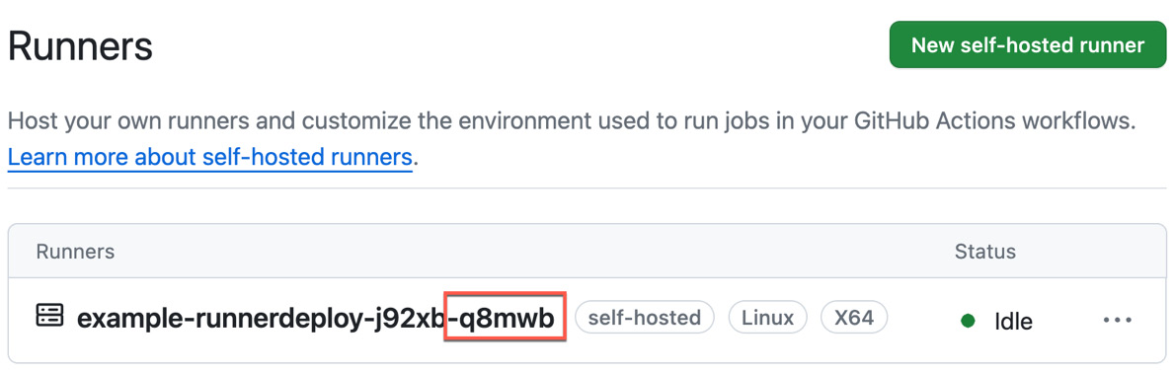
Figure 4.13 – The ARC runner in GitHub
- Run your .github/workflows/self-hosted.yml workflow from the previous recipes and inspect the output. Note that it is executed in your AKS cluster (see Figure 4.14):
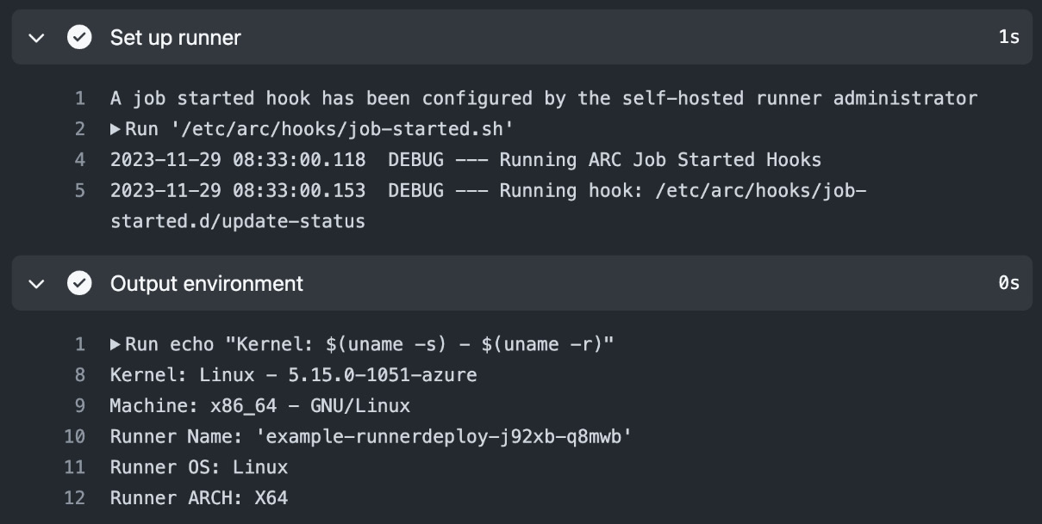
Figure 4.14 – The self-hosted workflow is executed by ARC in the Kubernetes cluster

How it works…
ARC runners are set up as ephemeral by default. They use Kubernetes replica sets and spin up a new container after execution automatically. ARC provides three options to scale:
- Scheduled: Scale up and down based on a schedule
- Scale based: The percentage of runners that are busy executing a job
- On-demand: Start an instance when a new workflow job is queued
ARC supports creating runners at the enterprise, organization, and repository levels. You can authenticate at the organization and repository levels using a GitHub app or PAT. However, at the enterprise level, you have to use a PAT as apps cannot be scoped to an enterprise.
You can configure scale sets with different images and namespaces for different teams. This also allows you to limit networking access between them.

There’s more…
Attacks on the software supply chain and the build process oppose a big thread. You should be very careful, especially with self-hosted runners. Never use them with public repositories that allow forking and take measures to control all the dependencies you pull on your runners so that nobody can do the following:
- Tamper with files in your build process
- Escape your container/sandbox or access files from outside the workflow scope
- Compromise your dependencies by manipulating the dependency cache (cache poisoning)
- Exfiltrate data or secrets and send data to a control server
You can use the Harden-Runner action from StepSecurity (https://github.com/step-security/harden-runner) in your workflows. It will monitor your workflow on policies such as outbound network egress:
steps:
- uses: step-security/harden-runner@v2.6.1
with:
egress-policy: audit
You can also use it to block traffic and only allow certain endpoints and ports:
egress-policy: block
allowed-endpoints: >
api.nuget.org:443
github.com:443
For ARC, instead of adding the Harden-Runner action to each workflow job, you can install the ARC Harden-Runner DaemonSet on your Kubernetes cluster. The DaemonSet will constantly monitor each workflow run without the need to add the action to each workflow.
You can access security insights and runtime detections under the Runtime Security tab in your dashboard.
Please note that this is not free software. There is a free community license for public repositories on https://github.com, but for private repositories or GitHub Enterprise Server (GHES), you will have to purchase a license (see https://www.stepsecurity.io/pricing).

Runners and runner groups
At the organization and enterprise levels, access to runners is organized in runner groups. The association from workflow to runner is done by labels – but runner groups control what runners a workflow has access to.

Getting ready…
Please note that in free organizations, there is only one runner group, called Default, that you can use to add self-hosted runners. To create multiple runner groups or use them for GitHub-hosted runners, you will need a paid Team or Enterprise plan.

How to do it…
- In an organization with a paid plan, navigate to Settings | Actions | Runner groups (/settings/actions/runner-groups) and click New group.
Give the group a name. Under Repository access, change the selection from All repositories to Selected repositories and click the gear icon to select one or multiple repositories that will have access to the group (see Figure 4.15). Note that you can allow access to public repositories here but that this option is disabled by default:
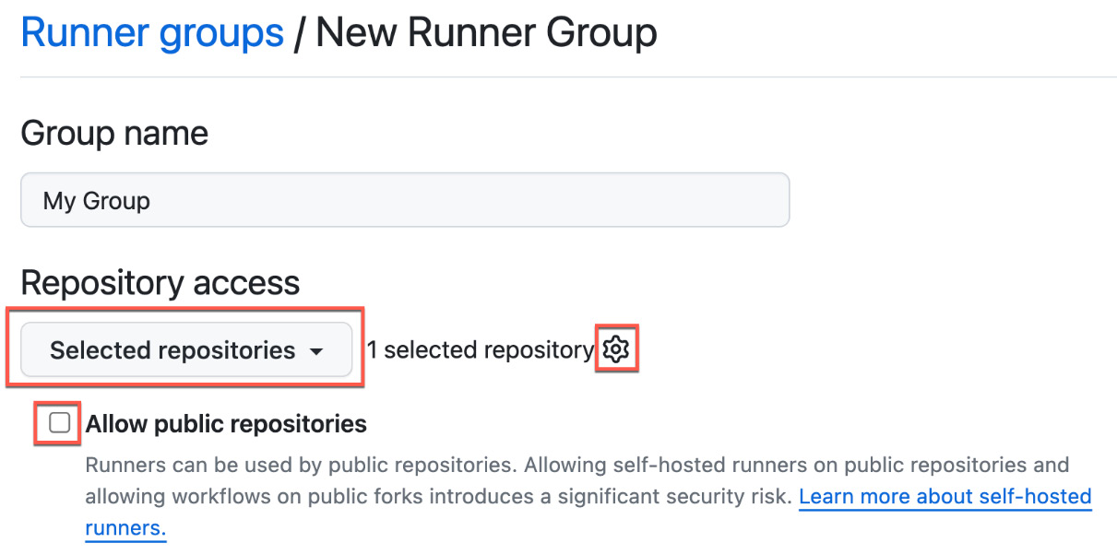
Figure 4.15 – Managing access to a group for repositories
- Under Workflow access, pick Selected workflows and click the gear icon (see Figure 4.16):
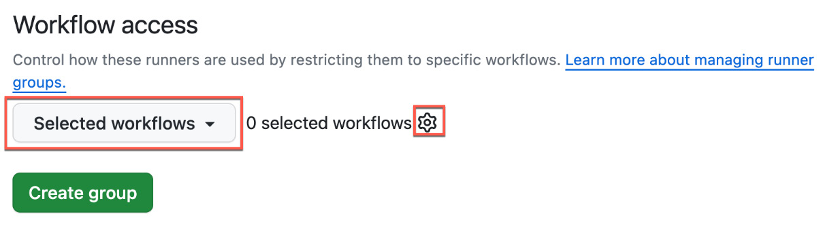
Figure 4.16 – Limiting access to certain workflows
Note that in the dialogue that appears, you can add multiple patterns to identify workflows (see Figure 4.17):
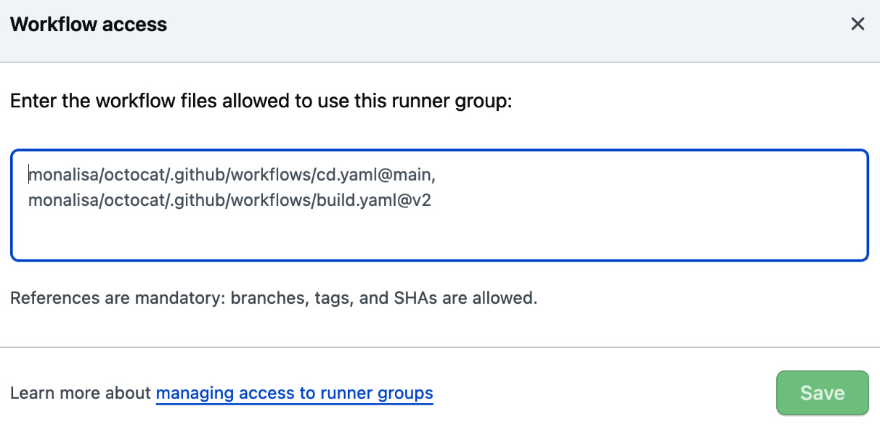
Figure 4.17 – Syntax for limiting access to workflow versions
Workflows are specified with the path to the workflow file and a valid git reference. The reference can be a branch, tag, or SHA value.
- Exit the dialogue, set the value back to All workflows, and click Create group. You can add now self-hosted runners and GitHub-hosted runners to the group. We’ll cover GitHub-hosted runners in the next recipe. Click New self-hosted runner (see Figure 4.18):
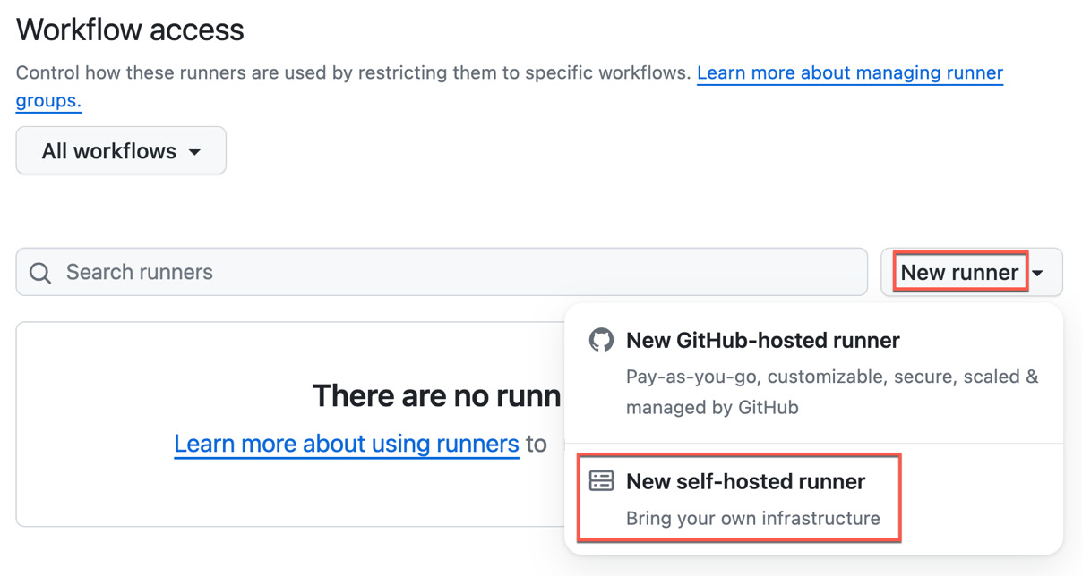
Figure 4.18 – Adding self-hosted runners to a runner group
- Note that the dialogue for adding runners is the same as what appeared in the Setting up a self-hosted runner recipe. You can test this with your container by overriding RUNNER_URL:
$ docker run -d --rm -e RUNNER_NAME=Runner_Group \
> -e TOKEN=
{TOKEN}
\
> -e RUNNER_URL=https://github.com/
{org}
\
> simple-ubuntu-runner
This will create the runner in the Default group! Open the runner and assign it to the new group you created (see Figure 4.19):
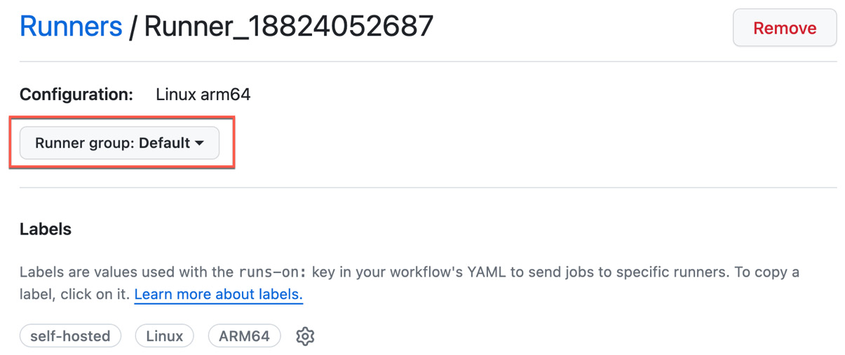
Figure 4.19 – Assigning a runner to a runner group
Note that a runner can only be assigned to one group. To directly assign the runner to a group while setting it up, you have to pass the parameter to the config script, which is not in the instructions:
$ ./config.sh --url $org_or_enterprise_url --token $token --runnergroup rg-runnergroup
Runner groups are an important feature for organizations and enterprises to manage access to runners. The feature is straightforward and does not need a lot of explaining – that’s why I’d rather keep it short and simple. In the next recipe, we will use runner groups to add larger GitHub-hosted runners.

GitHub-hosted runners
In this last recipe of this chapter, we’ll be creating a larger GitHub-hosted runner with network isolation in the runner group.

Getting ready…
You need the runner group you created in the previous recipe in an enterprise or organization with a paid plan!

How to do it…
- In the runner group you created, click New runner | New GitHub-hosted runner (see Figure 4.20):
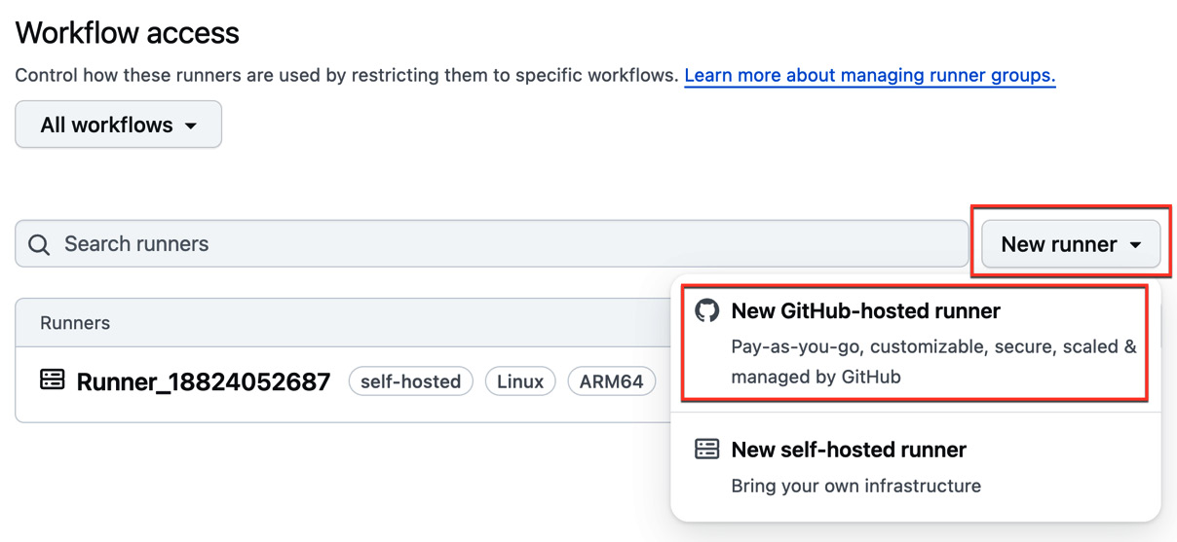
Figure 4.20 – Creating new GitHub-hosted runners
- Give the runner a name. The name must be between 1 and 100 characters, and it may only contain uppercase letters (A-Z) and lowercase letters (a-z), numbers (0-9), dots (.), dashes (-), and underscore (_). Pick a Runner image value (Ubuntu or Windows) and the corresponding version (see Figure 4.21):
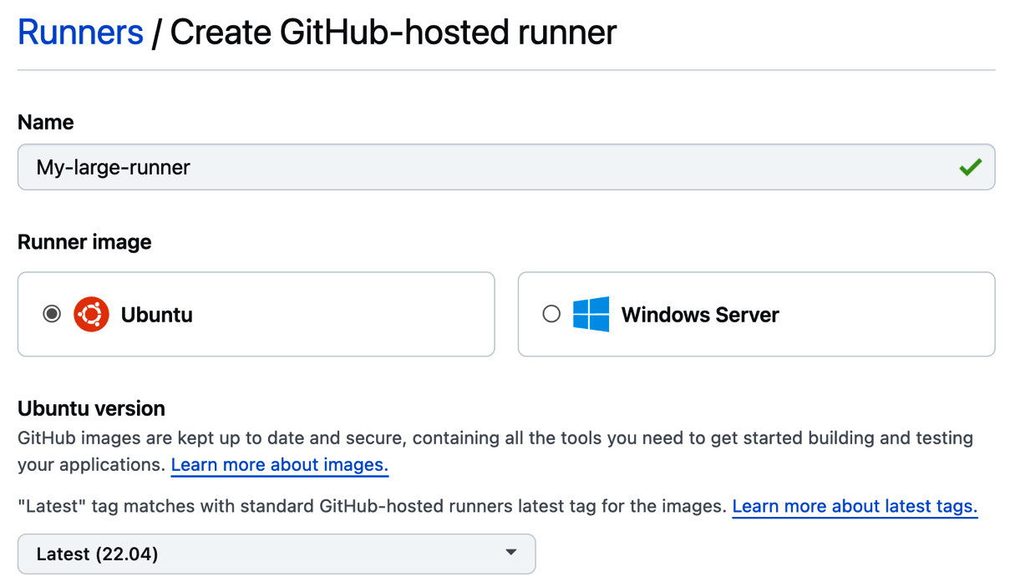
Figure 4.21 – Configuring the name and image for the runner
- Pick the size of the runner (see Figure 4.22). Note that larger runners are more expensive. See Chapter 1 for details on the pricing of larger runners:
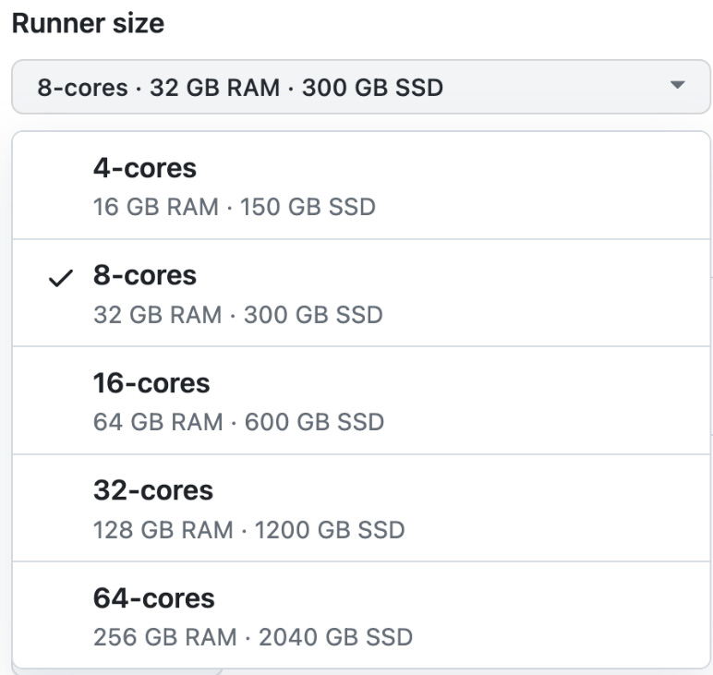
Figure 4.22 – Picking the size for the new runner
- You can limit the maximum number of concurrent jobs. The maximum is 500. Leave it set at the default of 50. Also, leave the runner group that was automatically set to the group in which you started creating the runner (see Figure 4.23):
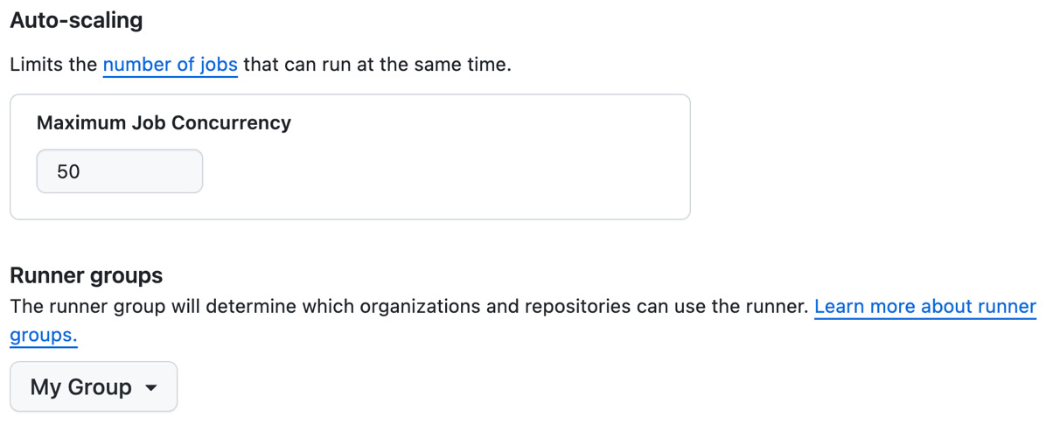
Figure 4.23 – Setting job concurrency and a runner group
- You can enable network isolation by assigning a unique and static public IP address range to the runner (see Figure 4.24). Hit Create runner to finish the process:
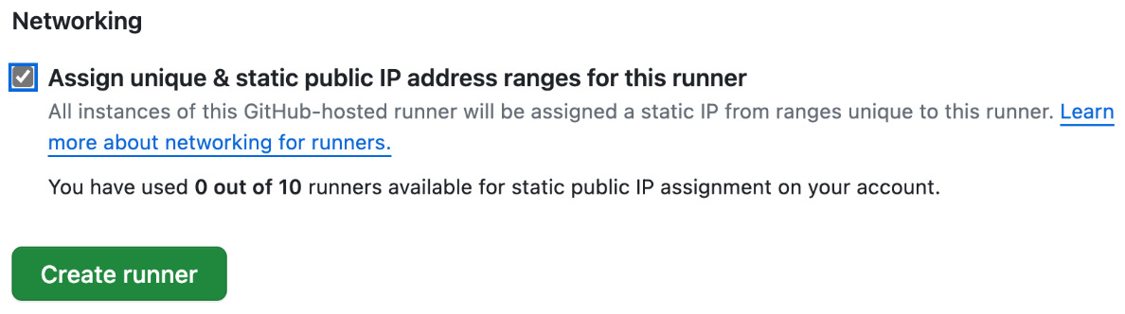
Figure 4.24 – Enabling network isolation for runners
- Note that provisioning takes some time. Once the runner is ready, you can inspect the IP range associated with it, at which point you will see that the label is the same as the runner’s name (see Figure 4.25). You can now start executing workflows on your larger runner!
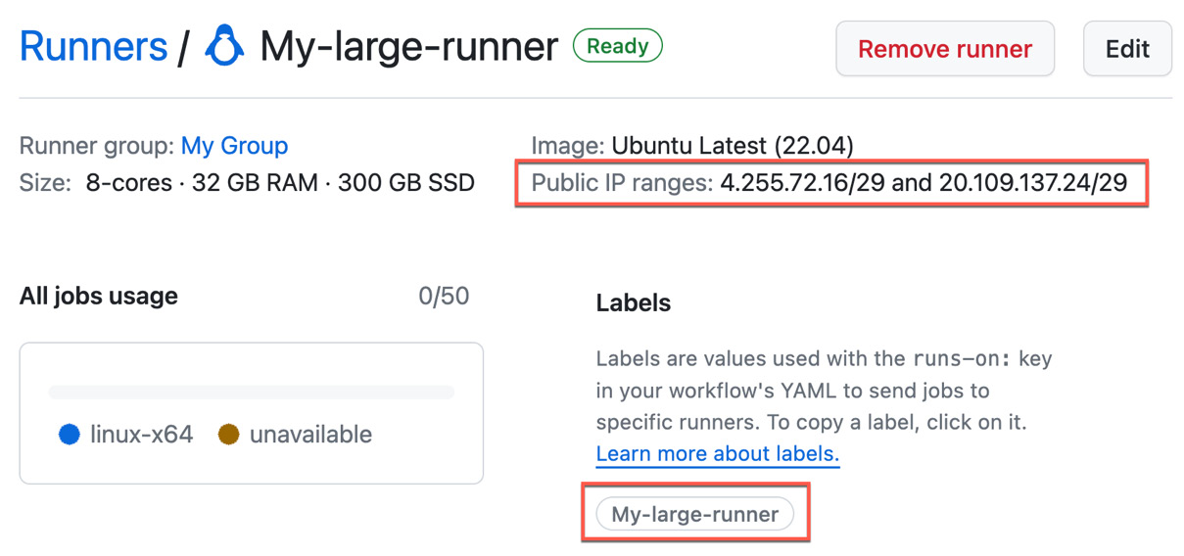
Figure 4.25 – Larger runners with network isolation

How it works…
GitHub will provision the larger runners for you and it will assign a static public IP range if you wish. Note that you have to use the runner; if not, GitHub will shut it down after some time. Network isolation allows you to give the runner access to local resources without the need for public access.
5

Automate Tasks in GitHub with GitHub Actions
In this chapter, we will focus on learning how to automate common tasks in GitHub with GitHub Actions using GitHub Issues. This is often called IssueOps. In this chapter, we’ll create a simple solution that allows you to manage repositories. This does not make sense for a personal account, but the solution should be easily adaptable for an enterprise context in which governance of repositories – such as naming conventions and permissions – is an important topic. The chapter contains the following recipes:
- Creating an issue template
- Using the GitHub CLI and GITHUB_TOKEN to access resources
- Using environments for approvals and checks
- Reusable workflows and composite actions

Technical requirements
If you want to follow along with all the details, you will need a GitHub organization. You can create one in GitHub for free. You can also just use your personal account – it will work the same, but it is less of a real-world scenario. You can author the workflows in Visual Studio Code or in the browser – whatever feels right for you.

Creating an issue template
In this recipe, you will create a simple issue template that you can later extend to gather user input for your IssueOps workflows.

Getting ready…
We’ll add the issue template to the repository that you have used in previous chapters. You can clone the repository locally and work in Visual Studio Code or you can do this part in the browser – it doesn’t matter. You can follow the examples in my repository (https://github.com/wulfland/GitHubActionsCookbook).

How to do it…
- Create a new file called .github/ISSUE_TEMPLATE/repo_request.yml in the repository. GitHub will automatically treat the file in the .github/ISSUE_TEMPLATE folder as an issue template as long as it is a YAML or Markdown file.
- Add a name and description for the template:
name: '🗒️ Repository Request'
description: 'Request a new repository.'
- Prefill the title of the new issue with a default value:
title: '🗒️ Repository Request: '
- Apply one or multiple labels to the new issue:
labels:
- 'repo-request'
- 'issue-ops'
Note that these labels must exist in the repository. Create them, in case they are not available (use gh label list to check):
$ gh label create repo-request
$ gh label create issue-ops
You can also provide a description or an explicit color string if you want:
$ gh label create repo-request \
> -c=#D541D0 \
> -d="Request a new repository"
- Assign the issue to one or more users or teams. Just use your GitHub handle in this case:
assignees:
-
wulfland
- You can automatically assign a new issue to a GitHub project. The syntax is {owner}/{project id}:
projects: 'wulfland/19'
Note that the person who creates the issue needs write access to that project.
If you don’t have a project, then just create a new one. Click the + icon in the top-right corner and select New project (see Figure 5.1).
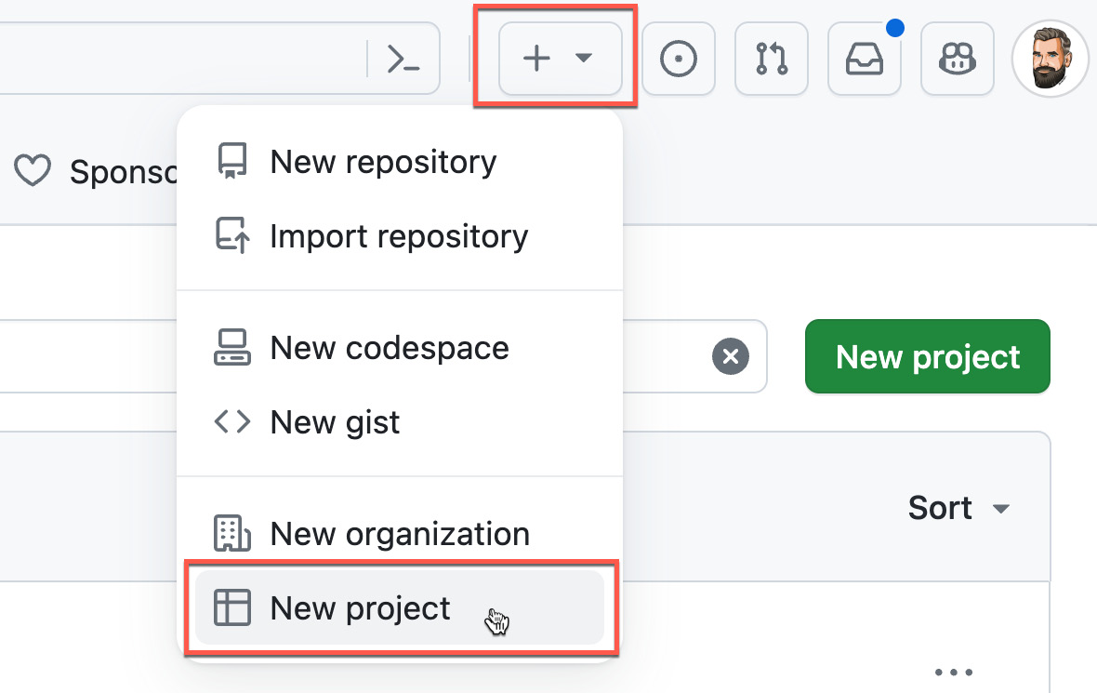
Figure 5.1 – Creating a new project
Pick a template for the project or start from scratch. For a simple project to manage repository requests, you can just start with a simple Board (see Figure 5.2).
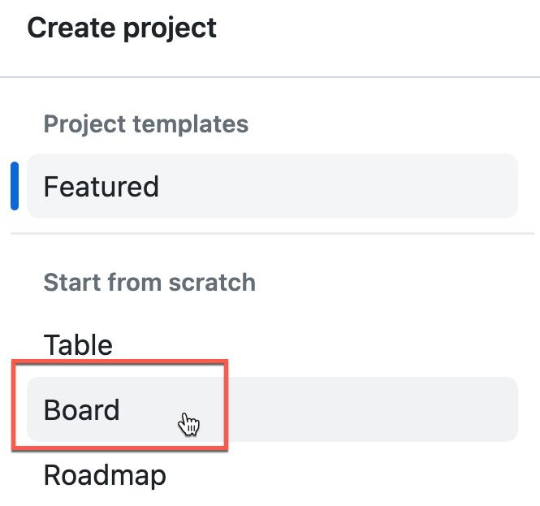
Figure 5.2 – Pick a template or start from scratch
Give the project a name – i.e., Repository Requests, and click Create project. Get the project ID from the URL of the project: https://github.com/users/{owner}/projects/{id}.
- In the body of the form, you can define different fields. Start with a simple text input for the name of the repository that gets requested. You can make fields required and add additional labels, default values, or placeholders:
body:
- type: input
id: name
attributes:
label: 'Name'
description: 'Name of the repository in lower-case and kebab casing.'
placeholder: 'your-name-kebab'
validations:
required: true
- Normally, you’ll have a department, region, or team that you would pick for permissions or naming conventions. Add a simple dropdown with two sample departments to pick from:
- type: dropdown
id: department
attributes:
label: 'Department'
description: 'Pick your department.
It will be used as a prefix for the repository name.'
multiple: false
options:
- dep1
- dep2
default: 0
validations:
required: true
- Commit the file to your repository.
- Under Issues | New issue, you can now pick your template and click Get started (see Figure 5.3).
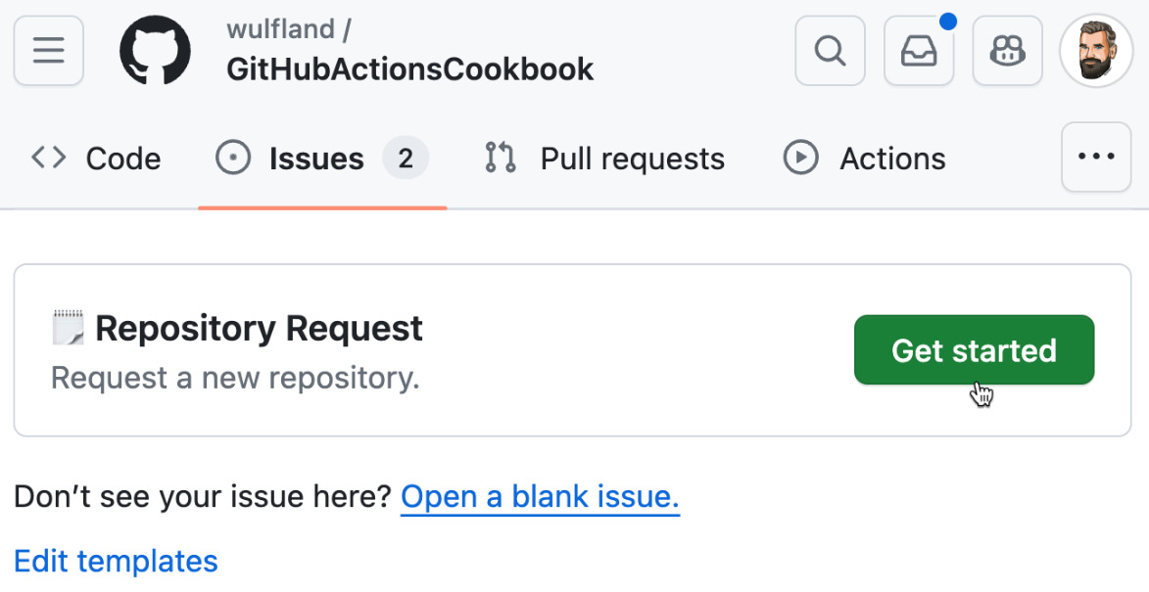
Figure 5.3 – Creating an issue from a template
- Note that the labels, projects, and assignees are set automatically, and the controls are rendered as required fields and set with the correct defaults (see Figure 5.4).
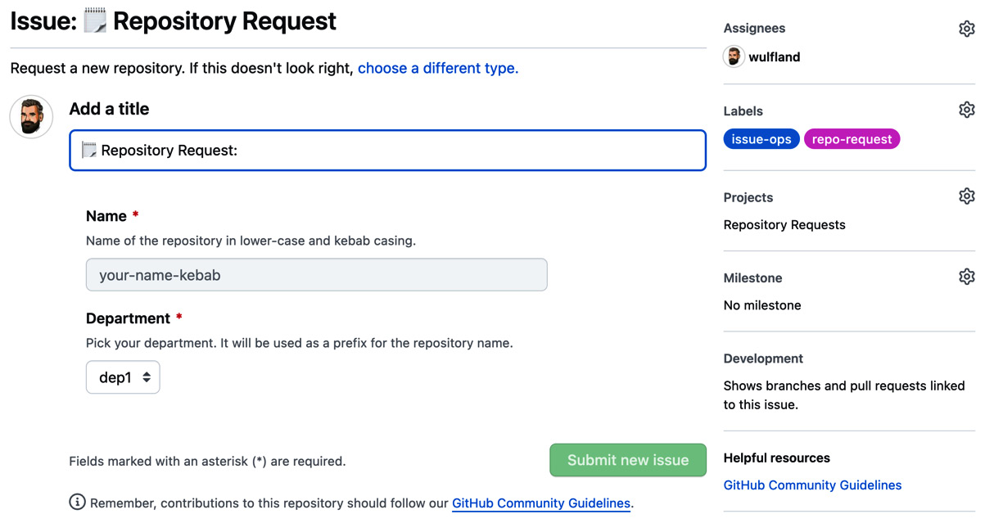
Figure 5.4 – Using the issue template to create a new issue
Fill out the form and save the new issue.

How it works…
Issue and pull request templates are a powerful tool to guide users when creating issues or pull requests. You can generate templates through the UI to make them more discoverable (see https://docs.github.com/en/communities/using-templates-to-encourage-useful-issues-and-pull-requests/syntax-for-issue-forms). The templates can be pure Markdown, but with the new custom templates we are using in this recipe, you can create rich forms with multiple form elements such as markdown, textarea, input, dropdown, and checkbox. You can also add validation and provide default values. For the complete syntax for the GitHub form schema, please refer to https://docs.github.com/en/communities/using-templates-to-encourage-useful-issues-and-pull-requests/syntax-for-githubs-form-schema. Note that after filling out the form, the data is added to the body of the issue or pull request as markdown. Templates only support the user at the time they create the issue or pull request. After that, it is just markdown when editing it.

There is more…
GitHub will display all valid Markdown or YAML form templates from the .github/ISSUE_TEMPLATE folder when creating a new issue. But you can configure additional links to external systems, and you can configure whether you want to allow blank issues or force the user to pick a template (see Figure 5.5).
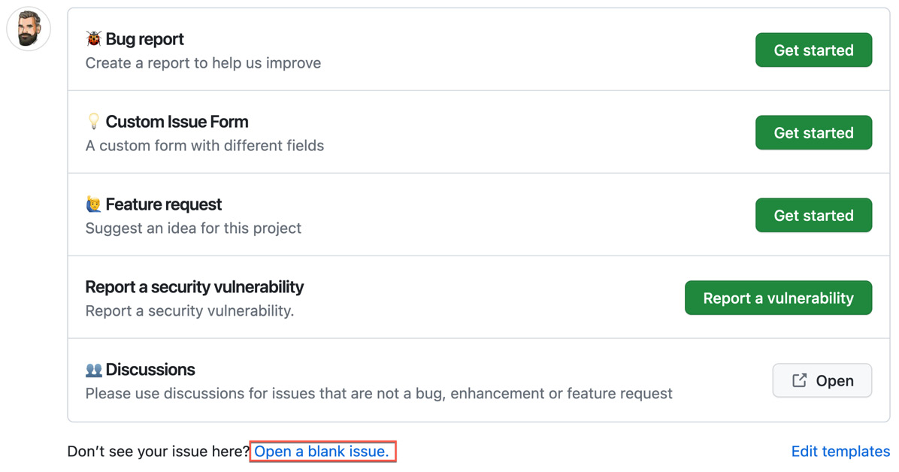
Figure 5.5 – Configuring the template picker form
To configure the template picker, add a config.yml file to the .github/ISSUE_TEMPLATE folder. Set blank_issues_enabled to true or false and add additional links to the contact_links array:
blank_issues_enabled: false
contact_links:
- name: 👥 Discussions
url: https://github.com/wulfland/AccelerateDevOps/discussions/new
about: Please use discussions for issues that are not a bug, enhancement or feature request.
See the documentation (https://docs.github.com/en/communities/using-templates-to-encourage-useful-issues-and-pull-requests/configuring-issue-templates-for-your-repository) for more information.

Using the GitHub CLI and GITHUB_TOKEN to access resources
In this recipe, we will parse the issue from the previous chapter and interact with the issue using the GitHub CLI in the workflow.

Getting ready…
You will need the issue template from the previous chapter. You can create the workflow either in Visual Studio Code or directly in GitHub.

How to do it…
- Create a new workflow .github/workflows/issue-ops.yml and name it issue-ops:
# Issue ops
name: issue-ops
- Use the issues trigger for the workflow. Note that we are not using the created or edited events but rather labeled. This allows users to relabel issues when modifying the request:
on:
issues:
types: [labeled]
- Add an issue-ops job:
jobs:
issue-ops:
We only want to run this job for specific labels. Add a condition like the following to the job:
if: ${{ github.event.label.name == 'repo-request' }}
The job can run on the latest Ubuntu image:
runs-on: ubuntu-latest
- To interact with the issues, the workflow needs write permissions on issues. To use the GitHub CLI, it also needs read permissions for contents:
permissions:
issues: write
contents: read
- There is an action in the marketplace that can help with parsing the body of issues created as forms. Add zentered/issue-forms-body-parser and give it an id property to later access the output:
steps:
- name: Issue Forms Body Parser
id:
parse
uses: zentered/issue-forms-body-parser@v2.0.0
- Next, add our main script. Set id to access the output on the job level. Also, set the GH_TOKEN environment variable to GITHUB_TOKEN. This token will be used by the CLI to interact with the issue:
- name: Repository Request Validation
id:
repo-request
env:
GH_TOKEN
: ${{ github.token }}
run: |
As a first step, read the values from name and department from the output of the step with the parse ID using jq and store them in a variable. In JavaScript, we could directly access the object, but in a bash script, we have to use jq:
repo_name=$(echo '${{ steps.
parse
.outputs.data }}' | jq -r '.name.text')
repo_dept=$(echo '${{ steps.
parse
.outputs.data }}' | jq -r '.department.text')
Combine both variables with your final name (in our case, the department is the prefix):
repo_full_name=$repo_dept-$repo_name
Set the name as the output to be used in later steps or jobs:
echo "REPO_NAME=$repo_full_name" >> "$GITHUB_OUTPUT"
- We are going to add some validation logic. I’ll add two examples here. You can look up the rest in the workflow file: https://github.com/wulfland/GitHubActionsCookbook/blob/main/.github/workflows/issue-ops.yml.
First, set the default message and exit code. The default message consists of two parts: first, we want to mention the user who has created the issue, and then we add the message depending on the output of the validation:
mention="@${{ github.event.issue.user.login }}: "
message="Requested repository '$repo_full_name' will be sent for approval."
exitcode=0
Next, add a validation rule that the name cannot be empty:
# shall not be empty
if [ -z $repo_full_name ]; then
message="Repository name is empty.";
exitcode=1;
fi;
Also, add a validation that it can only use alphanumeric characters and the minus sign (if you want to use kebab casing for your names):
# shall be alphanumeric and minus only
if [[ "$repo_full_name" =~ [^\-a-zA-Z0-9] ]]; then
message="Repository name shall be alphanumeric and minus only.";
exitcode=1;
fi;
- In case the validation fails, remove the label from the issue and tell the user to fix the issue and reapply the label:
if [ $exitcode -ne 0 ]; then
gh issue edit ${{ github.event.issue.number }} \
--remove-label repo-request
message=$message" Please fix the issue and try again by applying the label 'repo-request' again to the issue.";
fi;
- Finally, comment the message on the issue and fail the job in case the validation has failed:
gh issue comment ${{ github.event.issue.number }} \
-b „$mention $message"
exit $exitcode
- Set the REPO_NAME output to the output set in the step. We will use this in the next job to create the actual repository:
outputs:
REPO_NAME
: ${{ steps.repo-request.outputs.
REPO_NAME
}}
- Now, create a new issue using the form template. Start with an invalid name (i.e., my_repo) and see how it adds the comment to the issue (see Figure 5.6).
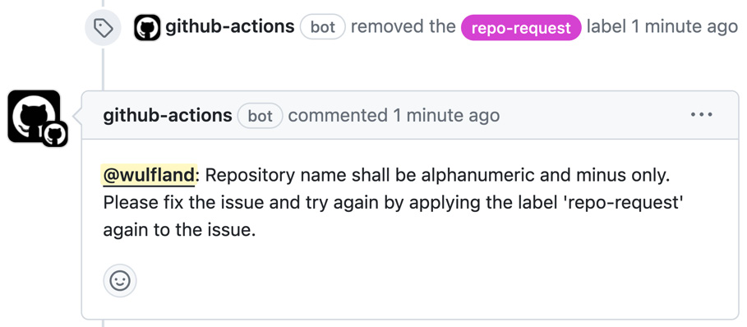
Figure 5.6 – Interacting with the issue from the workflow
Fix the name (to i.e., my-repo) and apply the repo-request label again to the issue.

How it works…
Let’s understand the workflow behind it.
Workflow permissions and the GITHUB_TOKEN
At the start of each workflow job, GitHub automatically creates a unique GITHUB_TOKEN that you can use in your workflow to interact with GitHub. You can use this token to authenticate in the workflow job.
You can configure the default permissions for personal accounts and for organizations and repositories – the default is read-only. The best practice is to leave this at read-only and grant explicit permissions in workflows or jobs.
The permissions for GITHUB_TOKEN can be configured either as a top-level key, to apply to all jobs in the workflow, or within specific jobs. When you add the permissions key within a specific job, all actions and run commands within that job that use GITHUB_TOKEN gain the access rights you specify.
For each of the available scopes, you can assign one of the permissions: read, write, or none.
Note
If you specify the access for any of these scopes, all of those that are not specified are automatically set to none!
You can also set all permissions at once. The following will set all permissions to read-only:
permissions: read-all
The following will grant write access to all scopes:
permissions: write-all
The last one will set all scopes to none:
permissions: {}
In our example, we need permission to write to issues and the CLI needs read access to the repository:
permissions:
issues: write
contents: read
All others will be automatically set to none.
See https://docs.github.com/en/actions/using-jobs/assigning-permissions-to-jobs for more information on GITHUB_TOKEN and workflow permissions.
Step and job outputs
In Chapter 3, Building GitHub Actions, you learned about environment files. We use them in this recipe to set the output that we’ll use in subsequent jobs. We also use them to access the data from the form parser.
The form parser is an action from the marketplace that helps us access the body of an issue that was created with an issue template. We use id to access the output:
steps:
- name: Issue Forms Body Parser
id:
parse
uses: zentered/issue-forms-body-parser@v2.0.0
In JavaScript (i.e., the GitHub Script action), you could directly access the JSON objects:
console.log(data.name.text);
console.log(data.department.text);
In bash, you can’t directly access JSON properties like you can in JavaScript. You need to use a command-line JSON processor such as jq to parse the JSON string and access its properties:
repo_name=$(echo '${{ steps.
parse
.outputs.data }}' |
jq -r '.name.text')
Commenting on issues using the GitHub CLI
In Chapter 3, you commented on an issue using octokit and the REST API. In this recipe, we use the GitHub CLI to do this. For the CLI to work, you have to first check out the repository. You also have to set the GH_TOKEN environment variable to the workflow token on the workflow step:
env:
GH_TOKEN: ${{ github.token }}
Using the CLI is easy – and we leverage the fact that we can use @ plus the username to mention the user in the comment:
mention="@${{ github.event.issue.user.login }}: "
message="Requested repository '$repo_full_name' will be sent for approval."
gh issue comment ${{ github.event.issue.number }} \
-b "$mention $message"

Using environments for approvals and checks
In this recipe, we are going to use environment approvals to acquire approval before creating the repository. We will also use a GitHub App to authenticate as the repository creation normally happens in the organization scope and cannot be done with GITHUB_TOKEN. You must either use a GitHub App or a personal access token (PAT) with the right scopes.

Getting ready…
Make sure you have completed the previous recipe and continue in the same repository.

How to do it…
- In your repository, go to Setting | Environments and click New environment.
- Name the environment repo-creation and click Configure environment.
- Add yourself as Required reviewer and don’t allow administrators to bypass the rule (see Figure 5.7).
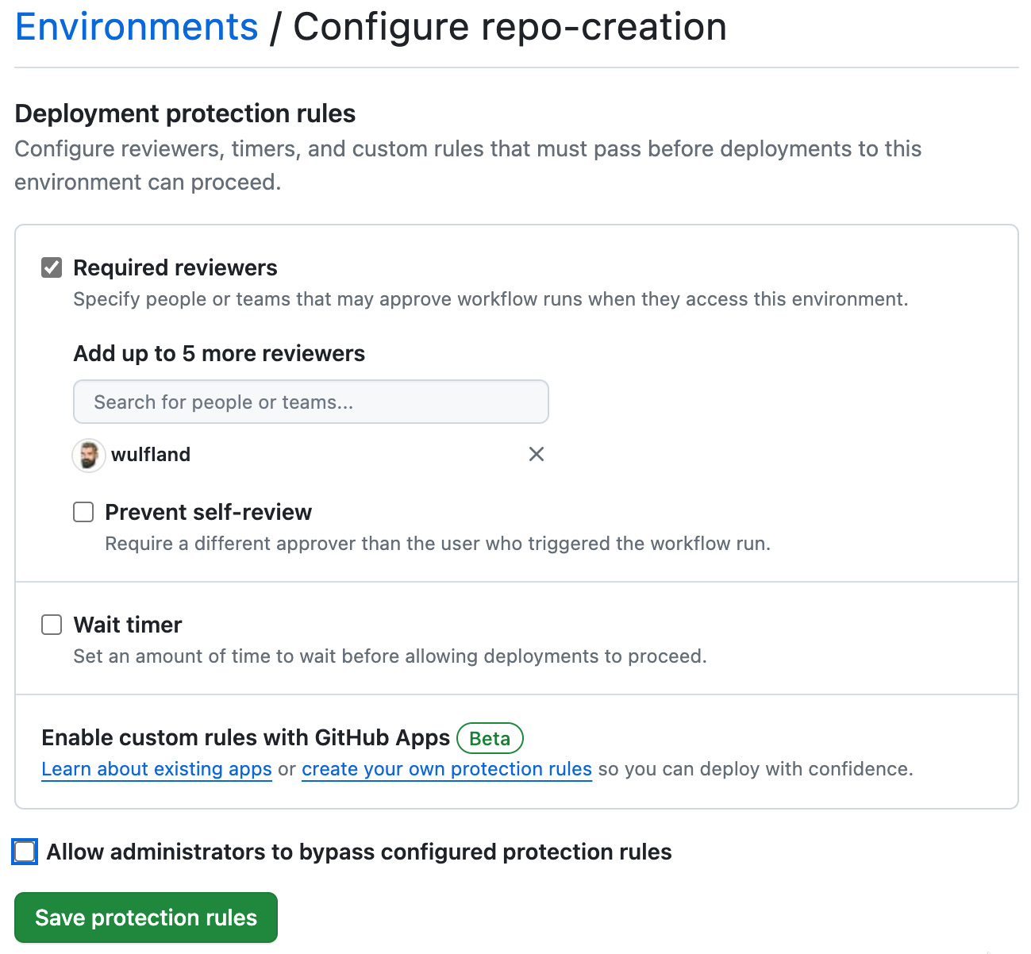
Figure 5.7 – Configuring the environment protection rules
- Click Save protection rules.
- The next step is to create an app to authenticate. I recommend using an organization to try this recipe – but you could also use your personal account. Go to https://github.com/settings/apps and click New GitHub App.
- Give it a unique name (i.e., {your username}-repo-creation) and set Homepage URL to the URL of your repository.
- Under Repository permissions, select Administration: Read and write, Contents: Read and write, Issues: Read and write, and under Organization permissions, select Administration: read and write.
- Save the app. In your newly created app, click on Generate a private key. The private key will be automatically downloaded.
- Copy App ID from the General tab of the app.
- In the app in GitHub, select Install App and click Install. Pick your organization or account, click install, leave All repositories selected, and click Install.
- Go back to the environment in your repository. Add a new secret PRIVATE_KEY and add the content of the key file you downloaded earlier. Also, add an APP_ID variable with the ID of your app (see Figure 5.8).
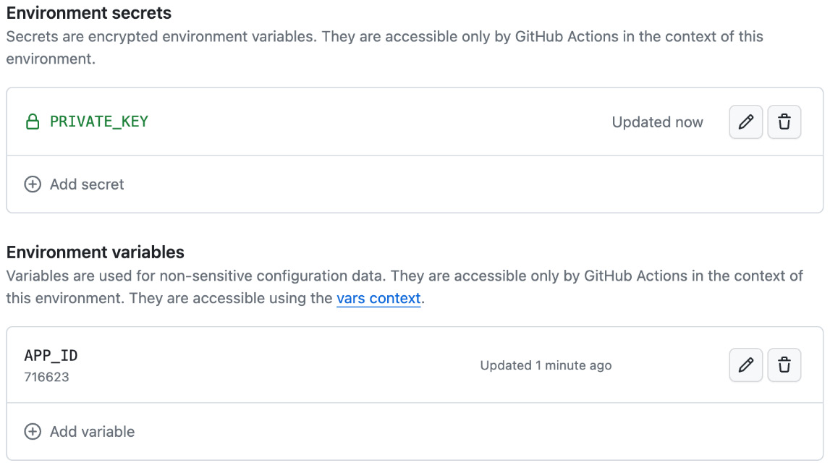
Figure 5.8 – Adding variables and secrets to an environment
- Edit your workflow file and add an additional create-repo job. Make the job depend on the previous job (needs: issue-ops) and assign it the environment that we have created earlier (environment: repo-creation):
create-repo:
needs: issue-ops
runs-on: ubuntu-latest
environment: repo-creation
- To interact with the issue using the GitHub token, set the permission for the workflow:
permissions:
issues: write
contents: read
- We can use global environment variables that we can use in all steps. Set REPO_OWNER to the organization or account in which you have installed the app. You could also save the value as a variable in the environment. Set REPO_NAME to the output of the previous job. USER and ISSUE_NUMBER are set to the values of the context for easy access:
env:
REPO_OWNER: ${{ vars.ORGANIZATION }}
REPO_NAME: ${{ needs.issue-ops.outputs.REPO_NAME }}
USER: ${{ github.event.issue.user.login }}
ISSUE_NUMBER: ${{ github.event.issue.number }}
- To authenticate using the app, we can use the actions/create-github-app-token action. Give it an ID to reference it later:
steps:
- name: Create app token
uses: actions/create-github-app-token@v1.6.2
id:
get-workflow-token
with:
app-id: ${{ vars.APP_ID }}
private-key: ${{ secrets.PRIVATE_KEY }}
owner: ${{ vars.ORGANIZATION }}
- Create the repository and set the URL as an output parameter:
- name: Create repository
id:
create-repo
env:
GH_TOKEN: ${{ steps.
get-workflow-token
.outputs.token }}
run: |
REPO_URL=$(gh repo create $REPO_OWNER/$REPO_NAME --private --clone)
echo "repo_url=$REPO_URL" >> "$GITHUB_OUTPUT"
echo "Repositeory '$REPO_NAME' has been successully created: $REPO_URL"
- If the operation is successful, comment on the issue to inform the user that the repository has been created:
- name: Notify User
if: ${{ success() }}
env:
GH_TOKEN: ${{ github.token }}
REPO_URL: ${{ steps.
create-repo
.outputs.repo_url }}
run: |
gh issue comment $ISSUE_NUMBER \
-b "@$USER: Repository '$REPO_OWNER/$REPO_NAME' has been created successfully: $REPO_URL" \
--repo ${{ github.event.repository.full_name }}
- In case of an error, also inform the user by commenting on the issue:
- name: Handle Exception
if: ${{ failure() }}
env:
GH_TOKEN: ${{ github.token }}
run: |
gh issue comment $ISSUE_NUMBER \
-b "@$USER: Repository '$REPO_OWNER/$REPO_NAME' creation failed.
Please contact the administrator."\
--repo ${{ github.event.repository.full_name }}
- Commit and push the workflow and create a new Repository Request issue. You will receive a notification according to your notification settings to review the workflow as you are configured as the required reviewer for the environment. The workflow looks like Figure 5.9.
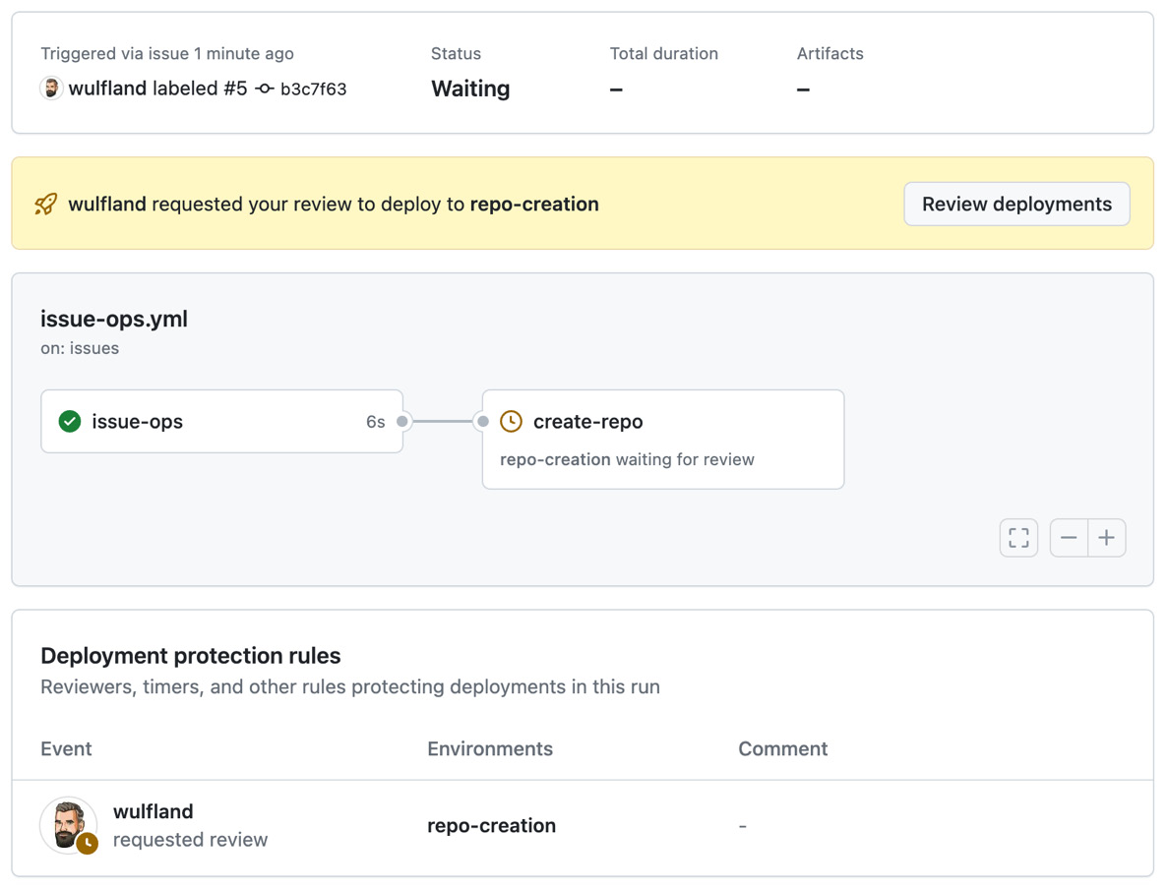
Figure 5.9 – Using environments for manual workflow approvals
- Click Review deployments, select the environment, and click Approve and deploy (see Figure 5.10).
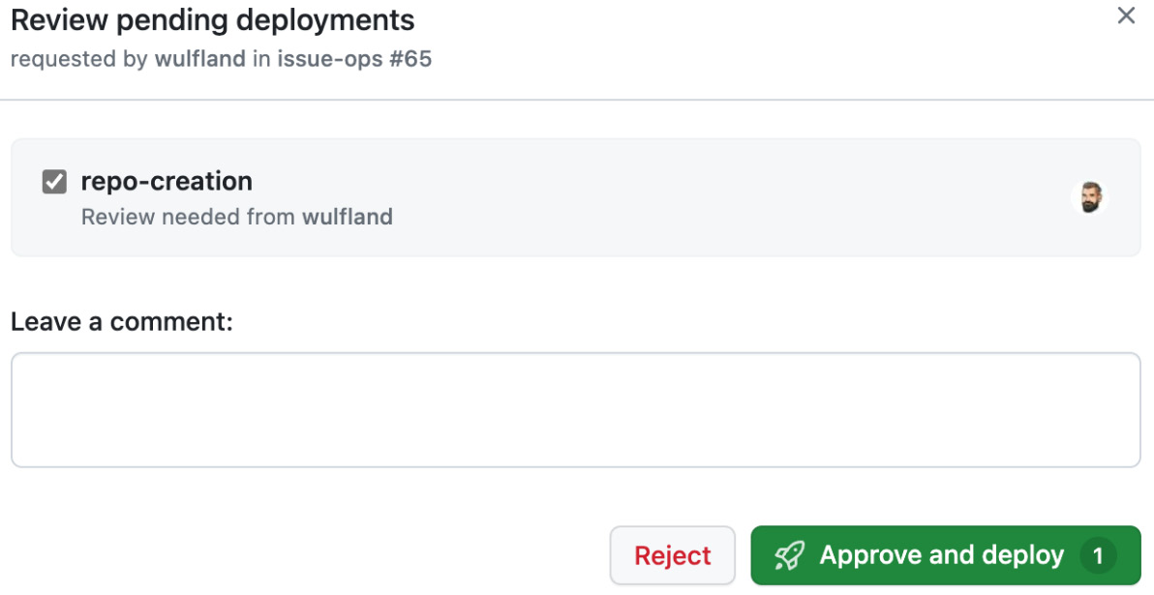
Figure 5.10 – Approving deployment to an environment
The workflow will create the repository and inform the user who initiated the request using comments in the issue (see Figure 5.11).
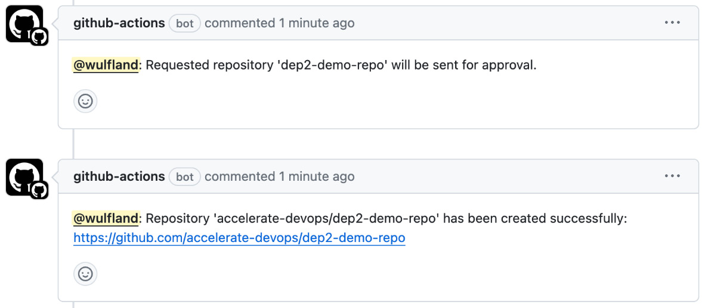
Figure 5.11 – The workflow notifying the user about successful repository creation using the issue comments
Check that the link works and the repository is created correctly.

How it works…
You can assign jobs in a workflow to environments, allowing you to add protection rules and specific variables and secrets for that environment.
Environments
Environments are created in a repository using the web UI or the API:
curl -L \
-X PUT \
-H "Accept: application/vnd.github+json" \
-H "Authorization: Bearer <YOUR-TOKEN>" \
-H "X-GitHub-Api-Version: 2022-11-28" \
https://api.github.com/repos/OWNER/REPO/environments/<NAME> \
-d '{"wait_timer":30,"prevent_self_review":false,"reviewers":[{"type":"User","id":1},{"type":"Team","id":1}],"deployment_branch_policy":{"protected_branches":false,"custom_branch_policies":true}}'
In most cases, you will create it using the web UI like we did in this recipe. In the workflow, the environment is referenced using its name:
jobs:
deployment:
runs-on: ubuntu-latest
environment: production
You can add an additional URL that will be displayed in the workflow:
environment:
name: production
url: https://writeabout.net
This allows you to create dynamic environments in the workflow and deploy to them. This is useful if you want to deploy every pull request to an isolated environment to test it.
You can protect environments with different protection rules:
- Required reviewers: You can list up to six users or teams as required reviewers to approve workflow jobs that reference the environment. The reviewers must have at least read access to the repository. Only one of the required reviewers needs to approve the job for it to proceed.
- Wait timer: You can pause a workflow for a specific amount of time after the job is initially triggered. The time (in minutes) must be an integer between 0 and 43,200 (30 days). You could use the API to cancel the workflow in that time.
- Deployment branches and tags: Use deployment branches and tags to restrict which branches and tags can deploy to the environment. The options for deployment branches and tags for an environment are No restricted, Protected branches only, or Selected branches and tags. In the letter settings, you can add name patterns to target individual or groups of branches or tags – such as main or release/*. Connecting environments to branch protection rules is very powerful, as you have a lot more protection rules for that – such as enforcing code owners or deployment to specific environments.
Environments also have specific secrets and variables that allow you to use different configurations in the same workflow.
There is also Custom deployment rules to protect your environments. This feature is still in public beta at the time of writing this book. Custom deployment rules are basically GitHub Apps that allow you to write your own integration. This allows services such as Datadog, Honeycomb, and ServiceNow to provide automated approvals for deployments.
To learn more about environments, see https://docs.github.com/en/actions/deployment/targeting-different-environments/using-environments-for-deployment.
Authentication
You can do a lot with the GitHub token and workflow permissions. But especially when automating things on the organization level, you probably need to use either a PAT or a GitHub App. GitHub Apps are the recommended way as they are not tied to a user. You already learned about GitHub Apps in the previous chapter. To use GitHub Apps to authenticate in a workflow, you can use the actions/create-github-app-token action:
steps:
- name: Create app token
uses: actions/create-github-app-token@v1.6.2
id:
get-workflow-token
with:
app-id: ${{ vars.APP_ID }}
private-key: ${{ secrets.PRIVATE_KEY }}
It needs the app ID and private key that we store as environment variables and secrets. The token can then be accessed using the output of the workflow step:
- name: Create repository
env:
GH_TOKEN: ${{ steps.
get-workflow-token
.outputs.token }}
With this action, it is really easy to use GitHub Apps in your workflow.

There is more…
Issues are a great way to interact with your users – but you probably also want to store the state of your automation in another place. You could update a YAML or markdown file or call an external system. However, you can also use GitHub Projects to visualize the issues. This way, the issue represents the state over the life cycle of an automated object.
GitHub Projects is very flexible, and you can have issues and pull requests from different repositories in it. This also means it is quite complex and you will need internal IDs to reference the fields. Before adjusting your workflow, run the following command for the project you are tracking your issues at (in my case, the ID is 19 and the owner is wulfland):
$ gh project field-list
<ID>
--owner
<OWNER>
--format json | jq
This will give you a JSON object with all the fields in your project. Look up the IDs. For the Status field, you will also need the options ID:
{
"id": "
PVTSSF_lAHOAFCCsc4AZoDtzgQZkEg
",
"name": "Status",
"type": "ProjectV2SingleSelectField",
"options": [
{
"id": "f75ad846",
"name": "Request"
},
{
"id": "
e05aa0a3
",
"name": "Repository Created"
},
{
"id": "98236657",
"name": "Deleted"
}
]
},
Store the internal IDs as variables in the environment as displayed in Figure 5.12.
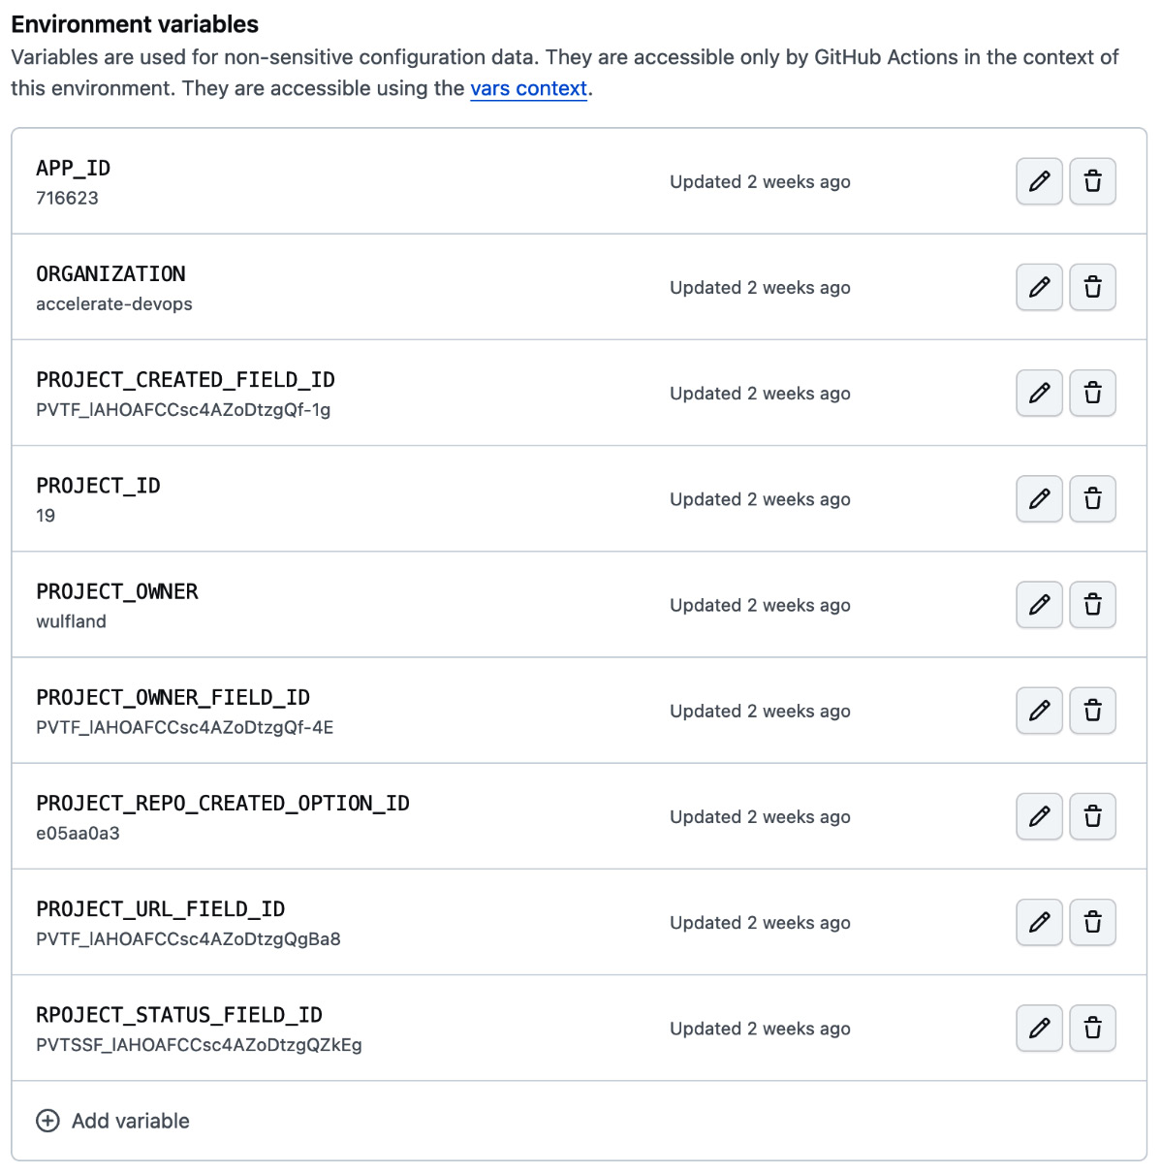
Figure 5.12 – Using the internal project IDs to reference fields and options
In the workflow, add an additional step and set the environment variables:
- name: Update Project
if: ${{ success() }}
env:
GH_TOKEN: ${{ secrets.PROJECT_TOKEN }}
REPO_URL: ${{ steps.create-repo.outputs.repo_url }}
PROJECTNUMBER: ${{ vars.PROJECT_ID }}
PROJECTOWNER: ${{ vars.PROJECT_OWNER}}
First, you have to receive the internal project ID as this is required in subsequent commands. The normal project ID – the number – cannot be used in all commands:
run: |
project_id=$(gh project list --owner "$PROJECTOWNER" --format json | jq -r '.projects[] | select(.number=='$PROJECTNUMBER') | .id')
Next, get the internal issue ID:
issue_id=$(gh project item-list $PROJECTNUMBER \
--owner "$PROJECTOWNER" \
--format json \
| jq -r '.items[] \
| select(.content.number=='$ISSUE_NUMBER') | .id')
Now, you can update the fields to the values from the workflow. Set the status of the item to the created option:
gh project item-edit \
--id $issue_id \
--field-id ${{ vars.RPOJECT_STATUS_FIELD_ID }} \
--single-select-option-id ${{ vars.PROJECT_REPO_CREATED_OPTION_ID }} \
--project-id $project_id
Set the URL of the repository created to the URL field:
gh project item-edit \
--id $issue_id \
--field-id ${{ vars.PROJECT_URL_FIELD_ID }} \
--text $REPO_URL \
--project-id $project_id
And, set the created date field to the current date:
gh project item-edit --id $issue_id \
--field-id ${{ vars.PROJECT_CREATED_FIELD_ID }} \
--date $(date +%Y-%m-%d) \
--project-id $project_id
You can now track the status of your repository requests in Projects (Figure 5.13).
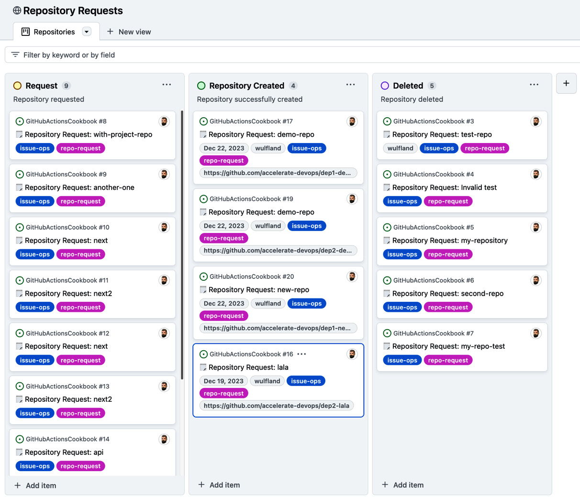
Figure 5.13 – Tracking the state of IssueOps in GitHub Projects
The metadata is also visible on a card in each individual issue (see Figure 5.14).
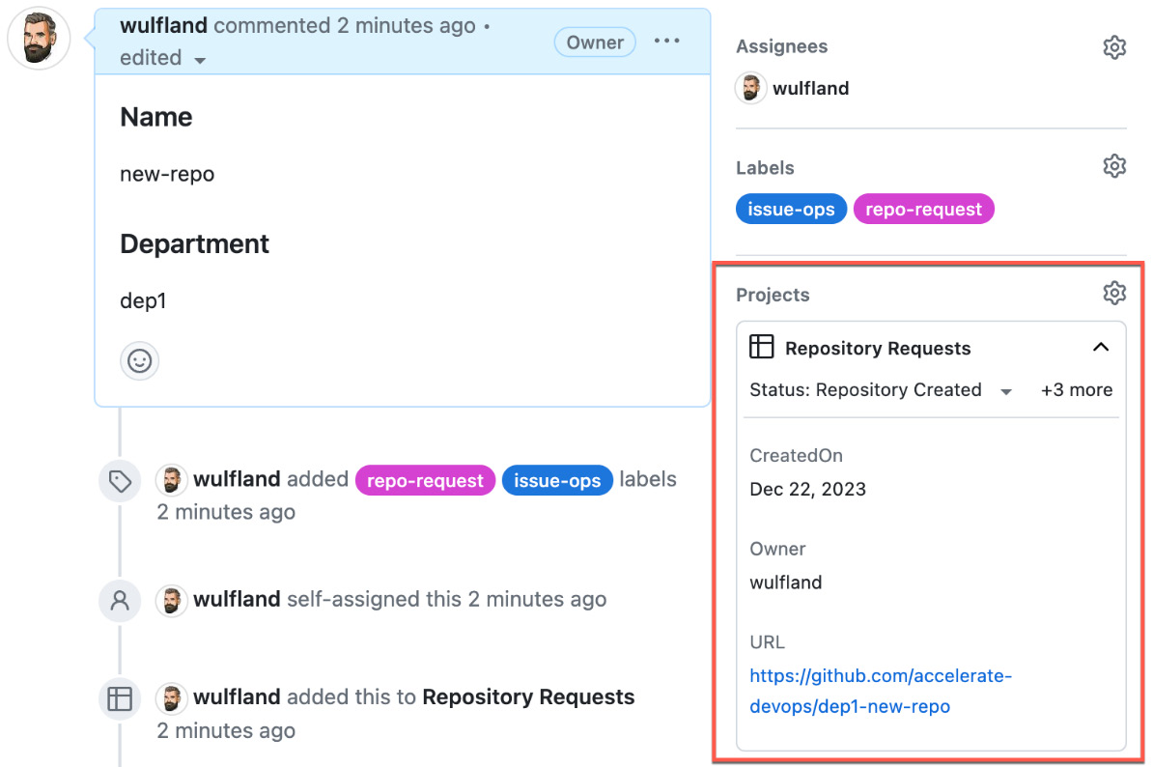
Figure 5.14 – GitHub Projects cards in GitHub Issues
GitHub Projects is great for tracking the status of issues, but it is not so easy to automate it using the GraphQL API or the CLI. However, if you want to do more with IssueOps, it is definitely something you want to invest in.

Reusable workflows and composite actions
If you start automating with IssueOps, workflows get very complex very fast. You will end up with a lot of if clauses on jobs and steps. To keep these solutions maintainable, you can use composite actions or reusable workflows to not only reuse functionality but also break down complex workflows into smaller parts.
We have already covered composite actions in previous chapters. In this recipe, we will use a reusable workflow to add the delete functionality to our IssueOps solution.

Getting ready…
Make sure you have completed the previous recipes in this chapter.

How to do it…
- Create a new delete-repo.yml workflow file.
- As the trigger, we use the workflow_call trigger. This indicates that the workflow is a reusable workflow. Define inputs needed by our workflow:
on:
workflow_call:
inputs:
REPO_NAME:
description: 'Repository name'
required: true
type: string
ISSUE_USER:
description: 'User who created the issue'
required: true
type: string
ISSUE_NUMBER:
description: 'Issue number'
required: true
type: number
- A reusable workflow is just a normal workflow that can have one or multiple jobs that are also associated with an environment:
jobs:
delete:
runs-on: ubuntu-latest
environment:
repo-cleanup
steps:
You can create a new environment for the deletion of the repository and add PRIVATE_KEY, APP_ID, ORGANIZATION, PROJECT_OWNER, and REPO_OWNER. Or, you can just reuse the repo-creation environment for simplicity.
- Get the token from the app to authenticate, as we did in the issue-ops workflow:
- name: Create app token
uses: actions/create-github-app-token@v1.6.2
id: get-workflow-token
with:
app-id: ${{ vars.APP_ID }}
private-key: ${{ secrets.PRIVATE_KEY }}
owner: ${{ vars.ORGANIZATION }}
- Next, delete the repository using the token provided:
- name: Delete repository
id: delete-repo
env:
GH_TOKEN: ${{ steps.get-workflow-token.outputs.token }}
REPO_NAME: ${{ inputs.REPO_NAME }}
REPO_OWNER: ${{ vars.REPO_OWNER }}
run: |
gh repo delete $REPO_OWNER/$REPO_NAME --yes
echo "Repositeory '$REPO_NAME' has been successully deleted."
- Notify the user and close the issue:
- name: Notify User
if: ${{ success() }}
env:
GH_TOKEN: ${{ github.token }}
ISSUE_NUMBER: ${{ inputs.ISSUE_NUMBER }}
ISSUE_USER: ${{ inputs.ISSUE_USER }}
REPO_NAME: ${{ inputs.REPO_NAME }}
REPO_OWNER: ${{ vars.REPO_OWNER }}
run: |
gh issue comment $ISSUE_NUMBER \
-b "@$ISSUE_USER: Repository '$REPO_OWNER/$REPO_NAME' has been deleted successfully."
\
--repo ${{ github.event.repository.full_name }}
gh issue close $ISSUE_NUMBER \
--repo ${{ github.event.repository.full_name }}
- In the case of a failure, also notify the user:
- name: Handle Exception
if: ${{ failure() }}
env:
GH_TOKEN: ${{ github.token }}
ISSUE_NUMBER: ${{ inputs.ISSUE_NUMBER }}
ISSUE_USER: ${{ inputs.ISSUE_USER }}
run: |
gh issue comment $ISSUE_NUMBER \
-b "@$ISSUE_USER: Repository '$REPO_OWNER/$REPO_NAME' deletion failed.
Please contact the administrator."
\
--repo ${{ github.event.repository.full_name }}
- To use this workflow, we create a new workflow file called handle-issue.yml. We have it run on labeled issues and grant it write access to issues:
name: Handle Issue
on:
issues:
types: [labeled]
permissions:
contents: read
issues: write
- To parse the issue, we add a common job that uses the same logic we used in the issue-ops workflow (just copy it over until we set the output variable):
jobs:
parse-issue
:
runs-on: ubuntu-latest
outputs:
REPO_NAME: ${{ steps.repo-request.outputs.REPO_NAME }}
steps:
- name: Issue Forms Body Parser
id: parse
uses: zentered/issue-forms-body-parser@v2.0.0
- name: Repository Request Validation
id: repo-request
env:
GH_TOKEN: ${{ github.token }}
run: |
repo_name=$(echo '${{ steps.parse.outputs.data }}' | jq -r '.name.text')
repo_dept=$(echo '${{ steps.parse.outputs.data }}' | jq -r '.department.text')
repo_full_name=$repo_dept-$repo_name
echo "REPO_NAME=$repo_full_name" >> "$GITHUB_OUTPUT"
- Then, we add the job that will call the other workflow file. Conditionally execute the job when the applied label is delete-repo. Pass in the repository name together with the other parameters using the with section:
repo-deletion:
name: "Delete a repository"
if: github.event.label.name == '
delete-repo
'
uses:
./.github/workflows/delete-repo.yml
needs:
parse-issue
with:
REPO_NAME: ${{ needs.
parse-issue
.outputs.REPO_NAME }}
ISSUE_USER: ${{ github.event.issue.user.login }}
ISSUE_NUMBER: ${{ github.event.issue.number }}
secrets: inherit
With secrets: inherit, you can allow access to all secrets of the parent workflow without having to specify them all as secret parameters.
- Commit and push your files and apply the delete-issue label to the issue that you had used to test the creation of the repositories. Approve the deployment and the repository will be deleted.
Note how jobs from reusable workflows are nested in the workflow jobs section and how they are displayed in the designer (see Figure 5.15).
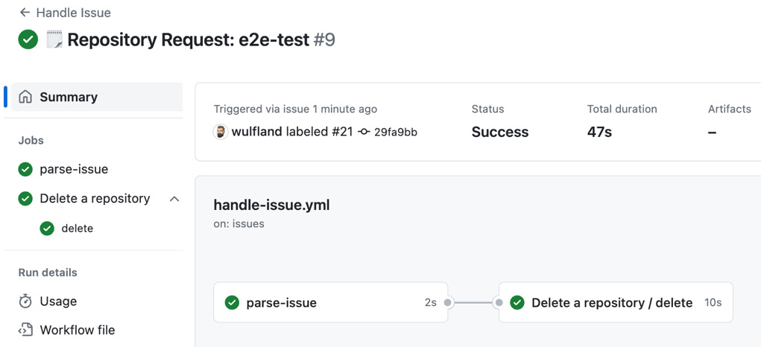
Figure 5.15 – Nested jobs from reusable workflows
Also, note that the issue was closed after the comment that the deletion was successful.

How it works…
Reusable workflows are a great way to structure complex workflows and reuse a more complex functionality that relies on multiple jobs or environments. However, there are some limitations. You can connect up to 4 levels of workflows and you can call a maximum of 20 reusable workflows from a single workflow file. This limit includes any trees of nested reusable workflows that may be called starting from your top-level caller workflow file. Any environment variables set in an env context defined at the workflow level in the caller workflow are not propagated to the called workflow. Similarly, environment variables set in the env context, defined in the called workflow, are not accessible in the env context of the caller workflow. Instead, you must use outputs of the reusable workflow. To reuse variables in multiple workflows, set them at the organization, repository, or environment levels and reference them using the vars context.
To learn more about reusable workflows, see https://docs.github.com/en/actions/using-workflows/reusing-workflows.
Note that I did not update the project fields after the deletion of the repository. GitHub Projects also supports workflows that can be used to update a field if the issue is closed.
Just navigate in your project to Workflows, enable Item closed, and set the value of the status field to the desired value (see Figure 5.16).
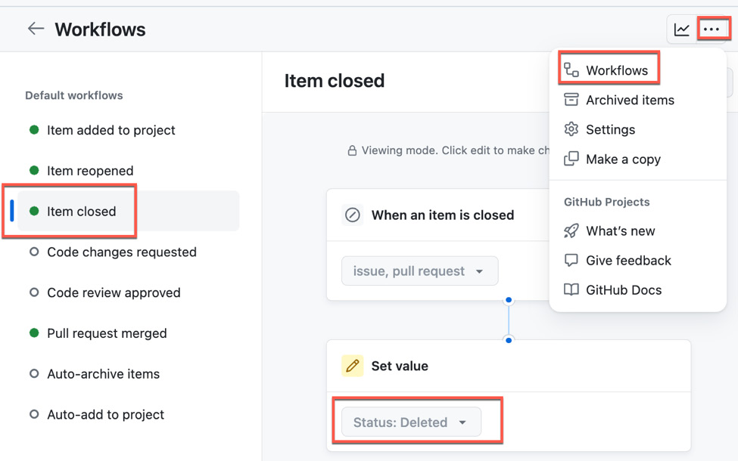
Figure 5.16 – Configuring workflows in GitHub Projects
This will automatically set the status to Deleted in our case when the issue is closed.

There is more…
Of course, this is only the starting point. To adopt this in a real-world scenario, you will have to extend the solution to the following:
- The life cycle of teams
- Granting permissions to teams
- Setting a base configuration for the repositories
- Providing different templates for different solution types
But the building blocks are the same.
You also have to refactor the current solution to include the creation of the repository as a reusable workflow and include it in the handle-issue workflow. I left it like this in my repository to keep the complexity of the individual steps as low as possible while providing a real-world solution.
6

Build and Validate Your Code
In this chapter, you will learn how to use GitHub Actions to build and validate code, validate changes in pull requests, and keep your dependencies up to date. You will learn where to store build output and how to optimize your workflow runs with caching.
We will cover the following recipes:
- Building and testing your code
- Building different versions using a matrix
- Informing the user on details of your build and test results
- Finding security vulnerabilities with CodeQL
- Creating a release and publishing the package
- Versioning your packages
- Generating and using software bills of materials (SBOMs)
- Using caching in workflows

Technical requirements
For this chapter, you will need an up-to-date version of NodeJS and Visual Studio Code. You can also use GitHub Codespaces.

Building and testing your code
In this recipe, we will create a simple Continuous Integration (CI) pipeline that builds and validates code and gets integrated into pull request validation. We’ll use this code in subsequent recipes – that’s why we’re using a very simple JavaScript package.

Getting ready
I think it is best to build a new repository and npm package from scratch. Even if you’re not familiar with JavaScript, this should not be a challenge. You can compare your code or copy it from the following repository: https://github.com/wulfland/package-recipe. If you struggle with this, just clone this repository and work with it.
- Create a new public repository called package-recipe. Initialize it with a .gitignore file and a README file and pick Node as the template for the .gitignore file.
- Clone your repository locally or open it in Codespaces.
- Run the following command:
$ npm init
Follow the wizard. The name of the package is @<github-user-name>/package-recipe. As the test command, add the following code:
jest && make-coverage-badge
Jest is the test framework we will use to test the application, and with make-coverage-badge, we will later create a badge that we will add to the README file.
You can leave the rest of the properties at their default.
- After the wizard has completed, run the following command:
$ npm install
- Install the dependencies:
$ npm install --save-dev jest
$ npm install --save-dev make-coverage-badge
- Next, let’s add the code. Create a new src/index.js file and add the following lines:
module.exports = function greet () {
return 'Hello world!'
}
We’re creating a simple package that will only return Hello world!.
- Add a new __tests__/index.test.js file (with double underscores). Add the following test:
describe('index.js', () => {
it('greet function returns Hello world!', () => {
const greet = require('../src/index')
expect(greet()).toBe('Hello world!')
})
})
This is just a simple test that checks that index.js writes the text as expected to the console.
- Open package.json and add the following configuration for Jest:
"jest": {
"verbose": true,
"coverageReporters": [
"json-summary",
[
"text",
{
"file": "coverage.txt",
"path": "./coverage"
}
],
"lcov"
],
"collectCoverage": true,
"collectCoverageFrom": [
"./src/**"
]
},
This will add multiple report outputs for the code coverage.
- Execute the tests:
$ npm run test
If everything is set up correctly, this will execute the one test and write reports in a coverage folder. It will also generate a badge at coverage/badge.svg.
- Commit your files and push them to GitHub.
- In the repository, go to Settings and scroll down to Pull Requests. Check Allow auto-merge and Automatically delete head branches.

How to do it…
Now that we have our package repository ready that we are going to use for the next recipes, let’s start with adding a CI workflow:
- Create a new _github/workflows/ci.yml file.
Name the workflow CI and trigger it on every pull request to validate the changes. Also, trigger it on every push to the main branch to build a new version that can be released:
name: CI
on:
pull_request:
push:
branches:
- main
- Add a build job that runs on ubuntu-latest and checks out of the repository:
jobs:
build:
runs-on: ubuntu-latest
steps:
- uses: actions/checkout@v4
- Configure the workflow runner to target a specific NodeJS version. We can use a wildcard for minor versions and have the action use the latest version available:
- uses: actions/setup-node@v4
with:
node-version: "21.x"
check-latest: true
- Build and test the code:
- name: Install dependencies
run: npm install
- name: Run tests
run: npm test
- Commit and push the workflow to the main branch. This should already trigger the workflow because of the push trigger, and the build and test should succeed.
- To test the validation, create a new branch:
$ git switch -c fail-pr
- Modify index.js to something that will fail the test (that is, console.log('Hello Mars!');). Add and commit the changes and create a pull request:
$ git add index.js
$ git commit
$ git push -u origin fail-pr
$ gh pr create --fill
The pull request will trigger the workflow, and it will fail because the npm run test command will return a nonzero value.

How it works…
Let’s understand how the validation works.
Checkout
The first thing necessary for CI is checking out of your repository with the checkout action (https://github.com/actions/checkout). The action has many parameters. For example, you can set the depth of the git history you pull down to the runner. The default is 1, and that will only download the HEAD branch. In the recipe to generate version numbers from git, we’ll set that to 0 to download all branches and tags:
steps:
- uses: actions/checkout@v4
with:
fetch-depth:0 # Default: 1
Other options are lfs to determine if Git Large File Storage (LFS) files should be downloaded or not (default is false) or submodules:
steps:
- uses: actions/checkout@v4
with:
lfs: true # Default: false
submodules: true # Default: false
For large monorepos, you can also perform a sparse checkout and only get data for a specific area of the repo. This example only checks out the .github, src, and __tests__ folders:
steps:
- uses: actions/checkout@v4
with:
sparse-checkout: |
.github
src
__tests__
This can reduce the time and storage needed by the workflow tremendously.
Setup environment
There are different setup actions for the following programming languages:
- Node
- Python
- Java
- Go
- .NET
- Ruby
- Elixir
- Haskell
In our case, we use setup-node (https://github.com/actions/setup-node). Setup actions ensure the correct binaries and environment variables are set in the build process. All the actions take some form of version parameter:
- uses: actions/setup-node@v4
with:
node-version: 21
Wildcards are supported as well as aliases. Examples are 21.x, 21.5.0, >=21.5.0, lts/Hydrogen, 21-nightly, latest. If you use wildcards, then you can set check-latest: true to check for the latest version available.
Most checkout actions also support different registries to download dependencies. For node, the parameter is registry-url, which will use the URL provided and a token from env.NODE_AUTH_TOKEN to connect to the specific registry.
Checkout actions normally also cache dependencies. In many cases, it is more efficient to use the corresponding setup action than implementing caching yourself (we have a recipe for that later in this chapter).

There’s more…
A validation workflow is best combined with branch protection and rulesets – and you can add a linter to the mix to further increase the quality.
super-linter
In Chapter 2, Authoring and Debugging Workflows, we used a linter to validate and annotate our workflows in pull requests. The same can be done for code. There is a GitHub action called super-linter (see https://github.com/super-linter/super-linter) that basically combines all available linters in one action. You can use it to lint your code like this:
permissions:
contents: read
packages: read
# To report GitHub Actions status checks
statuses: write
steps:
- name: Checkout code
uses: actions/checkout@v4
with:
# super-linter needs the full git history to get the
# list of files that changed across commits
fetch-depth: 0
- name: Super-linter
uses: super-linter/super-linter@v5.7.2
env:
DEFAULT_BRANCH: main
# To report GitHub Actions status checks
GITHUB_TOKEN: ${{ secrets.GITHUB_TOKEN }}
The image of super-linter is quite huge and can impact the performance of your workflows. If you don’t need all languages, then you can also use the slim version:
super-linter/super-linter/
slim
@[VERSION]
It excludes linters for rust, dotenv, armttk, pwsh, and c#, and the image size is much smaller. In v5, this will reduce the size from 7.35 GB to 4.88 GB in slim-v5, and this will reduce the time to just pull down the image from about 2 minutes to about 1 minute.
Branch protection
In Chapter 2, Authoring and Debugging Workflows, I also introduced you to branch protection. You can protect one or multiple branches in a repository with rules and enforce that commits are merged with a pull request and certain checks are successful. In addition to manual reviews, you can request status checks to be successful (see Figure 6.1):
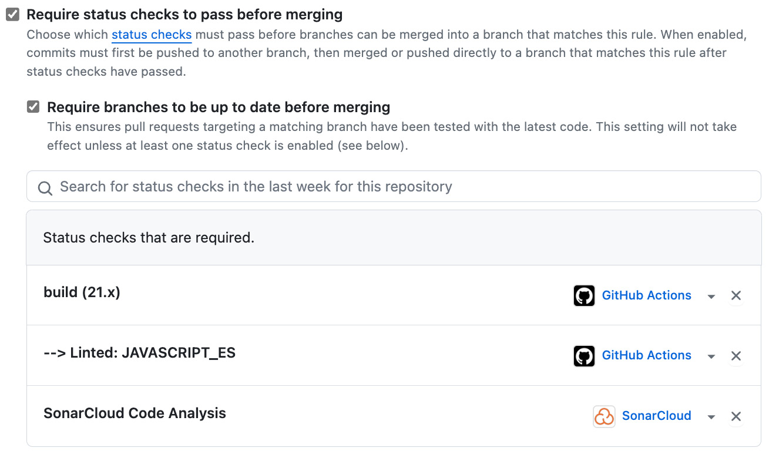
Figure 6.1 – Adding GitHub Action workflow jobs as status checks for a protected branch
Status checks can be a single job of a workflow – or any integration that uses the status API to report status. You can enable a policy for main in your repository for the next recipes and set the status check policy to the jobs of the workflow. See https://docs.github.com/en/repositories/configuring-branches-and-merges-in-your-repository/managing-protected-branches/about-protected-branches for more information on protected branches.
Rulesets
Rulesets are the more powerful successor of branch protection. They have the same power as protected branches. You can also define status checks the same way you do in protected branches (see Figure 6.2):
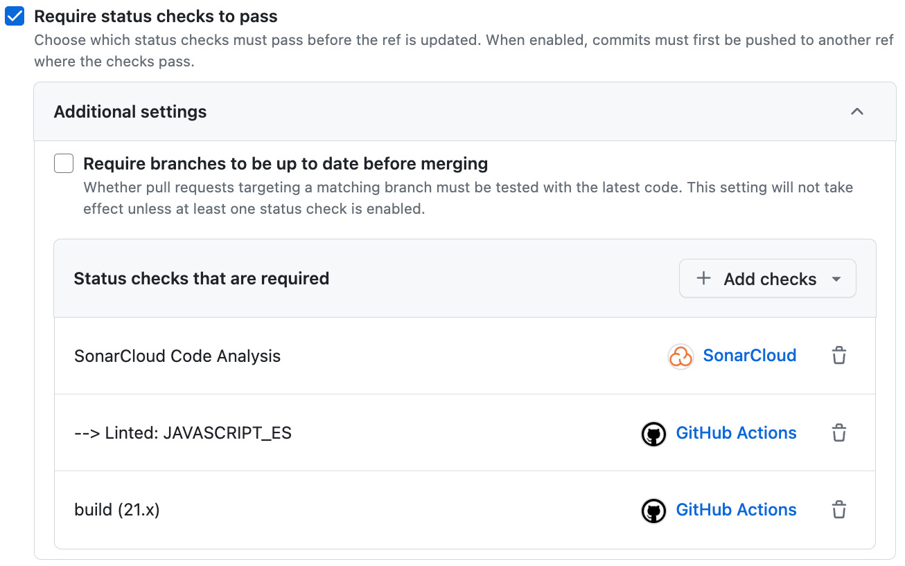
Figure 6.2 – Adding GitHub Action workflow jobs as status checks in a ruleset
Most of the rules that can be used in rulesets are similar to branch protection rules and can be used in combination without changing existing ones.
Rulesets are more advanced and have the following advantages over protection rules:
- Rulesets can be defined at the organization level and can target multiple repositories.
- Rules can be layered by applying multiple rulesets at the same time.
- Rulesets have a status that allows you to activate and deactivate rulesets in a repository without the need to delete them.
- You only need read access to a repository to view all active rulesets. This makes it much more transparent to contributors which rules apply.
- There are some additional rules that are not available in protection rules, such as rules to control commit messages or the author’s email address.
You can learn more about rulesets here: https://docs.github.com/en/repositories/configuring-branches-and-merges-in-your-repository/managing-rulesets/about-rulesets.

Building different versions using a matrix
In this recipe, we are going to build and test our software for different versions, in our case, of the NodeJS environment.

Getting ready
Make sure you have cloned the repository from the previous recipe. Create a new branch to modify the workflow:
$ git switch -c build-matrix
Open the .github/workflows/ci.yml file in an editor.

How to do it…
- Add the following code to the workflow file:
strategy:
matrix:
node-version
: ["21.x", "20.x"]
Adjust the versions if needed.
- In the actions/setup-node action, set the node version to the corresponding value from the matrix context:
- uses: actions/setup-node@v4
with:
node-version: ${{ matrix.
node-version
}}
check-latest: true
- Commit and push your changes and create a pull request:
$ git add .
$ git commit
$ git push -u origin build-matrix
$ gh pr create --fill
- Check the output of the workflow. It will run a separate job for each entry in the matrix array (see Figure 6.3):
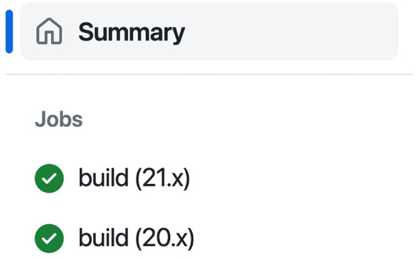
Figure 6.3 – The matrix runs a different job for each entry
- Wait until the workflow has completed. Merge your pull request and clean up your repository:
$ gh pr merge -m

How it works…
The matrix is a convenient way to use the same workflow jobs with different combinations. It can contain one or multiple arrays that can contain many values. The matrix will run all combinations of all values in all arrays. You can think of the matrix as nested for loops. A good example is running and testing different versions on different platforms:
jobs:
example_matrix:
strategy:
matrix:
os: [ubuntu-22.04, ubuntu-20.04]
version: [10, 12, 14]
runs-on:
${{ matrix.os }}
steps:
- uses: actions/setup-node@v3
with:
node-version:
${{ matrix.version }}
This way, you can reuse the same workflow logic to test many different combinations of values at the same time.

There’s more…
The matrix has some additional features. You can set fail-fast to indicate if it will cancel the workflow if one job in the matrix fails or if it should continue. You can define the number of parallel jobs with max-parallel, and you can include and exclude values for certain elements. Here is a more complex example:
jobs:
test:
runs-on: ubuntu-latest
continue-on-error: ${{ matrix.experimental }}
strategy:
fail-fast: true
max-parallel: 2
matrix:
version: [5, 6, 7, 8]
experimental: [false]
include:
- version: 9
experimental: true
To learn more about the matrix strategy, see https://docs.github.com/en/actions/using-jobs/using-a-matrix-for-your-jobs.

Informing the user on details of your build and test results
In this recipe, we are going to decorate pull requests and workflow summaries with details of our test results. We’ll also add badges to the README file to indicate the quality of a branch or release.

Getting ready
Create a new branch to do the modification:
$ git switch -c add-badges

How to do it…
You can download badges for workflows using the following URL:
https://github.com/
OWNER
/
REPO
/actions/workflows/
FILE
.yml/badge.svg
You can also filter by branch or event by adding query parameters (for example, ?branch=main or ?event=push). We want a badge for the main branch, so add the following image to the markdown of your README:
![main](https://github.com/
OWNER
/package-recipe/actions/workflows/ci.yml/badge.svg?branch=main)
The badge will use the name in the workflow file and look like Figure 6.4 in the preview:

Figure 6.4 – Badge for the CI workflow
But we want to go one step further and add a code coverage badge to the README, annotate pull requests with the code coverage output, and add a summary to the workflow.
- To decorate the pull requests, the workflow needs write permissions. And, as we build multiple versions with the matrix, we have to pick one that we use for the creation of the badge. Add the following code to the build job:
jobs:
build:
permissions:
pull-requests: write
env:
MAIN_VERSION: "21.x"
- In the workflow file, add the following code right after run: npm test:
- name: Prepare coverage report in markdown
uses: fingerprintjs/action-coverage-report-md@v1.0.6
id:
coverage
with:
textReportPath: coverage/coverage.txt
This uses the fingerprintjs/action-coverage-report-md action to create a report in markdown that we’ll write to the job summary and the pull request.
- Next, we use the marocchino/sticky-pull-request-comment action to write the markdown report to the pull request:
- name: Add coverage comment to the PR
uses: marocchino/sticky-pull-request-comment@v2.8.0
with:
message: ${{ steps.
coverage
.outputs.markdownReport }}
- Also, write the output to $GITHUB_STEP_SUMMARY. As we run the job in a matrix, add a heading indicating the version number:
- name: Add coverage report to the job summary
run: |
echo "## Code Coverage v${{ matrix.node-version }}" >> "$GITHUB_STEP_SUMMARY"
echo "${{ steps.coverage.outputs.markdownReport }}" >> "$GITHUB_STEP_SUMMARY"
- Commit and push your changes and create a pull request:
$ git add .
$ git commit
$ git push -u origin add-badges
$ gh pr create –fill
This will trigger the workflow with the pull request trigger, and you can inspect in the workflow run the job summary, which should look like Figure 6.5:
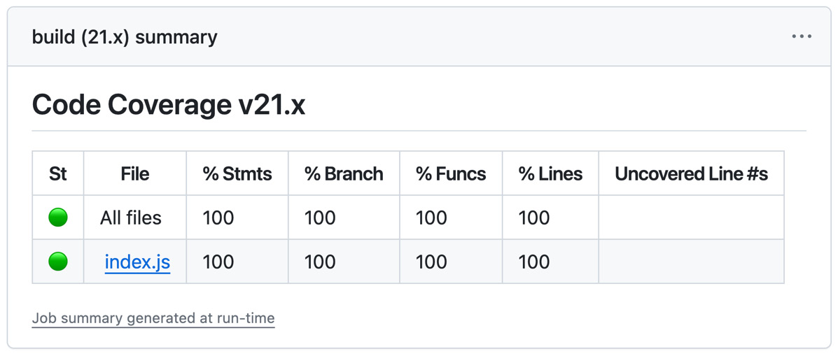
Figure 6.5 – Displaying code coverage results in the workflow summary
The summary is also added as a comment to the pull request (see Figure 6.6):
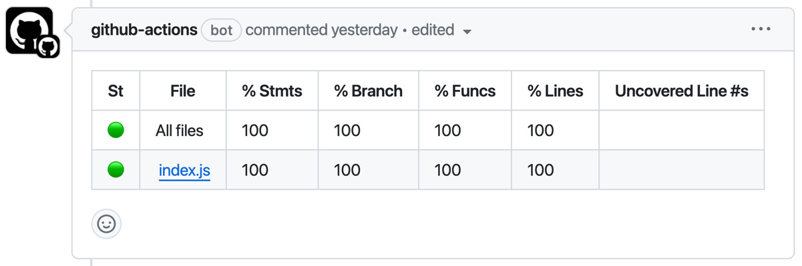
Figure 6.6 – Adding code coverage results as a pull request comment
- The badge for code coverage is automatically created by the npm package during test. But in order to add the badge (that is, to the README), we need a place to host it. We’ll use GitHub Pages for this.
Add the following code to the end of the build job to upload the artifacts to the workflow. Note that this is not the normal actions/upload-artifact action – it is a special action for GitHub Pages:
- name: Upload page artifacts
if: ${{ matrix.node-version == env.MAIN_VERSION }}
uses: actions/upload-
pages
-artifact@v3
with:
path: coverage
As we can only upload one artifact with the same name, we only run this step if the node version of the matrix is our main version.
- Add a new deploy job after build that only runs on pushes to main and depends on the build job:
deploy:
if: ${{ github.ref == 'refs/heads/main' }}
needs: build
runs-on: ubuntu-latest
- Create a concurrency group called pages so that we only deploy one version at a time to the pages environment. But don’t cancel deployments that are in progress to deploy all versions:
concurrency:
group: "pages"
cancel-in-progress: false
- The job needs the following permissions:
permissions:
contents: read
pages: write
id-token: write
- The job deploys to the github-pages environment and uses the URL from the actions/deploy-pages action to display it in the workflow. The URL will point to the root of the package. As the HTML report with our index.html file is in the lcov-report folder, we add this to the URL:
environment:
name: github-pages
url: "${{ steps.
deployment
.outputs.page_url }}lcov-report"
- The job has only two simple steps – configure-pages and deploy-pages:
steps:
- name: Setup Pages
uses: actions/configure-pages@v4
- name: Deploy to GitHub Pages
id:
deployment
uses: actions/deploy-pages@v4
- Commit and push your changes and merge the pull request after the workflow has completed:
$ git add .
$ git commit
$ git push
$ gh merge -m
- After the pull request is merged, a new workflow run will be triggered by the push to main. Once it is completed, you can see the URL to the website that has the report (see Figure 6.7):
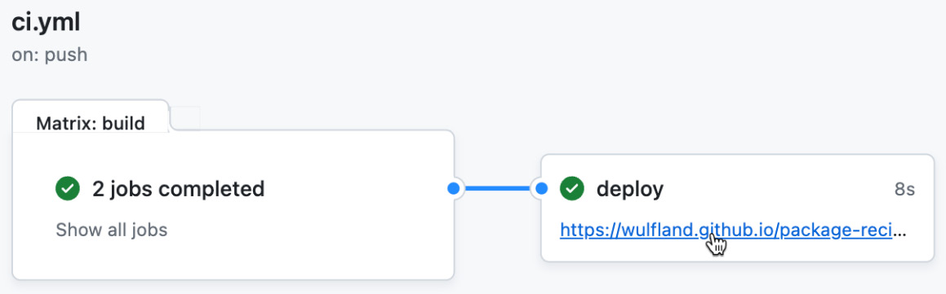
Figure 6.7 – Inspecting the Pages website
- The website created by GitHub contains the badge in the root of the directory. The URL looks like this: https://{OWNER}.github.io/package-recipe/badge.svg. The URL of the badge in markdown would look like this:
[![Coverage](https://wulfland.github.io/package-recipe/badge.svg)]
But as we want to be directed to our lcov-report folder in the website when clicking on the badge, we’ll add a link around the image. Add the following markdown to your README (replace wulfland with your GitHub username):
[![Coverage](https://
wulfland
.github.io/package-recipe/badge.svg)](https://
wulfland
.github.io/package-recipe/lcov-report)
The badge will look like Figure 6.8, and when you click on it, you’ll be redirected to the coverage report:

Figure 6.8 – Adding a badge for test coverage

How it works…
Let’s understand how the code works.
Adding a workflow status badge
You can display a status badge for workflows in your repository to indicate the status of the workflows.
The URL of the badge is the following, and it will use the name of the workflow and show the status of the last workflow run:
https://github.com/
OWNER/REPOSITORY
/actions/workflows/
WORKFLOW-FILE
/badge.svg
Typically, you only want to display the status for a specific branch or event. You can do so by providing the corresponding parameters (that is, ?branch=main or ?event=push). This way, you can display multiple badges for different versions of your software. See https://docs.github.com/en/actions/monitoring-and-troubleshooting-workflows/adding-a-workflow-status-badge for more information.
GitHub Pages
GitHub Pages is a static site hosting service from GitHub that takes static files from a repository and publishes them as a website. The site is hosted on GitHub’s github.io domain, or you can use your own custom domain.
Unless you’re using a custom domain, project sites are available at the following URLs:
- http(s)://<username>.github.io/<repository> or
- http(s)://<organization>.github.io/<repository>.
Pages can be deployed directly from a branch and, optionally, prepossessed with Jekyll (https://github.com/jekyll/jekyll). This way, you can easily render markdown files as a website – for example, to host a blog.
You can find an example under https://wulfland.github.io/AccelerateDevOps/ that renders the content of the https://github.com/wulfland/AccelerateDevOps/tree/main/docs folder.
In addition to deploying from a branch, you can also deploy pages using your own workflows. This is what we did in this recipe. The feature is still in beta at the time of writing – but in my opinion, it can already be used in production.
See https://docs.github.com/en/pages/getting-started-with-github-pages/about-github-pages to learn more about GitHub Pages.
Concurrency groups
By default, GitHub Actions allows multiple jobs within the same workflow and multiple workflow runs within the same repository to run concurrently – meaning that multiple steps can run at the same time.
GitHub Actions also allows you to control the concurrency of workflow runs so that you can ensure that only one run, one job, or one step runs at a time in a specific context. This can be useful for controlling situations when running multiple steps at the same time could cause conflicts or consume more action minutes than expected.
Concurrency groups can have a static name, like we did in our recipe. But you can also use context expressions to group certain contexts – such as branches – together in one group:
concurrency:
group: ${{ github.workflow }}-${{ github.ref }}
cancel-in-progress: true
The cancel-in-progress parameter can be used to cancel a job if a newer version is available and run that instead. This can help save resources. If it is set to false, the workflow will wait until the previous version has completed and then run the next job in the concurrency queue. This way, only one job at a time gets executed for a given group.
You can learn more about concurrency groups here: https://docs.github.com/en/actions/using-jobs/using-concurrency.

There’s more…
Validating code automatically and bringing detailed information to where it is valuable for the developers is very important. In addition to test results, code coverage, and linters, you can also integrate solutions such as SonarQube or SonarCloud. They provide a great GitHub integration and are free for open source. Just log in with your GitHub credentials, and you can configure a new project. The project allows you to create additional badges that you can add to your README (see Figure 6.9):
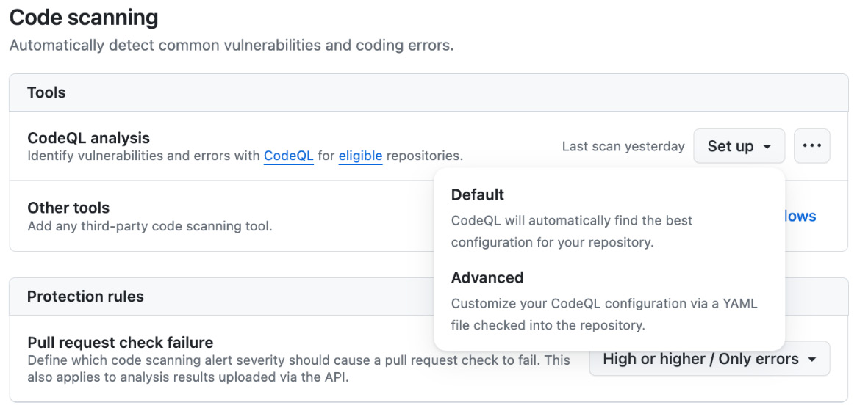
Figure 6.9 – Using SonarCloud badges in your GitHub README
Sonar badges provide a great integration into your pull request and can be used as an additional status check in rulesets and branch protection rules. The quality gates are reported in the pull request (see Figure 6.10):
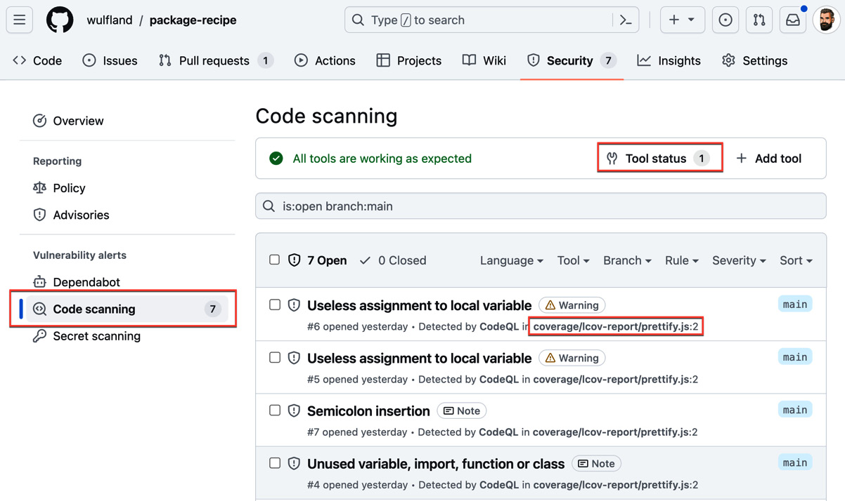
Figure 6.10 – Pull request integration of SonarCloud quality gates
To learn more about GitHub integration for SonarCloud, see the documentation at https://docs.sonarsource.com/sonarcloud/getting-started/github/.

Finding security vulnerabilities with CodeQL
This is a short recipe that we will use to add a CodeQL analysis to our existing CI build. CodeQL is the code analysis engine from GitHub, and it is free for public repositories.

Getting ready
Create a new branch in the package-recipe repository:
$ git switch -c add-codeql

How to do it…
- Open the .github/workflows/ci.yml file and grant the build job permissions to write security events:
build:
permissions:
pull-requests: write
security-events: write
- Add an init action (github/codeql-action/init) to the job. For languages that must be compiled, this has to go before the build process. As JavaScript is a static language, you can add it to the end of the job. Set the language to javascript-typescript and select the security-and-quality query suite:
- name: Initialize CodeQL
uses: github/codeql-action/init@v3
with:
languages: '
javascript-typescript
'
queries:
security-and-quality
- Performing the actual analysis is executed after compilation. Just add the following code to the end of the job:
- name: Perform CodeQL Analysis
uses: github/codeql-action/analyze@v3
with:
category: "/language:javascript-typescript"
- Commit your code, create a pull request, and merge the changes when all the checks have passed:
$ git add .
$ git commit
$ gh pr create --fill
$ gh pr merge -m --auto

How it works…
CodeQL is the code analysis engine from GitHub to automate security and quality checks. It is free in public repositories, and it is available for enterprises that purchase the GitHub Advanced Security license.
You can analyze the following languages:
- C/C++
- C#
- Go
- Java
- Kotlin (in beta at the time of writing)
- JavaScript/TypeScript
- Python
- Ruby
- Swift (in beta at the time of writing)
There are three ways to analyze your code:
- Default: The default setup for CodeQL will automatically detect the languages in your repository and pick the supported ones to analyze. It will apply the default query suites and triggers for the scans. In the repository, under Settings | Code security and analysis, you can select Default if the languages in your repository are supported by that feature (see Figure 6.11):
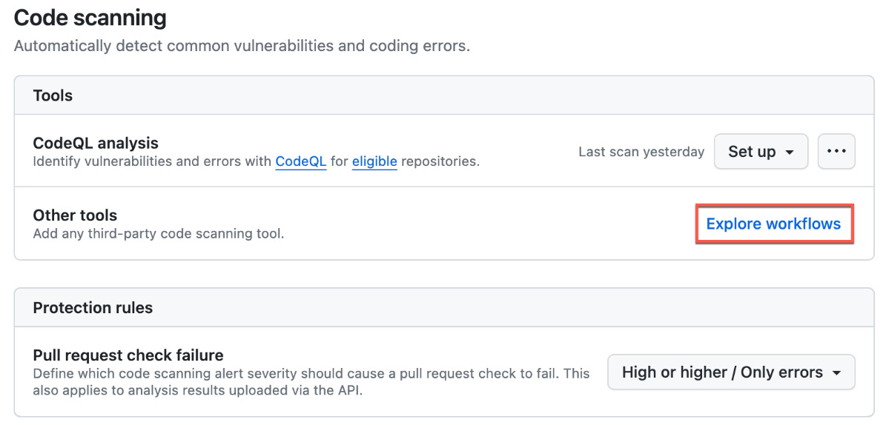
Figure 6.11 – Configuring code scanning with Default or Advanced mode
- Advanced: Use a custom workflow and add the CodeQL analysis as we did in the recipe. If you click on Advanced in Settings (Figure 6.11), this will generate a customizable workflow template for you. It will use a matrix strategy with fail-fast: false to analyze all languages detected in your repository.
- CLI: Run the CodeQL CLI directly in an external CI system and upload the results to GitHub.
The results of the analysis of all tools can be accessed under Security | Code scanning (see Figure 6.12):
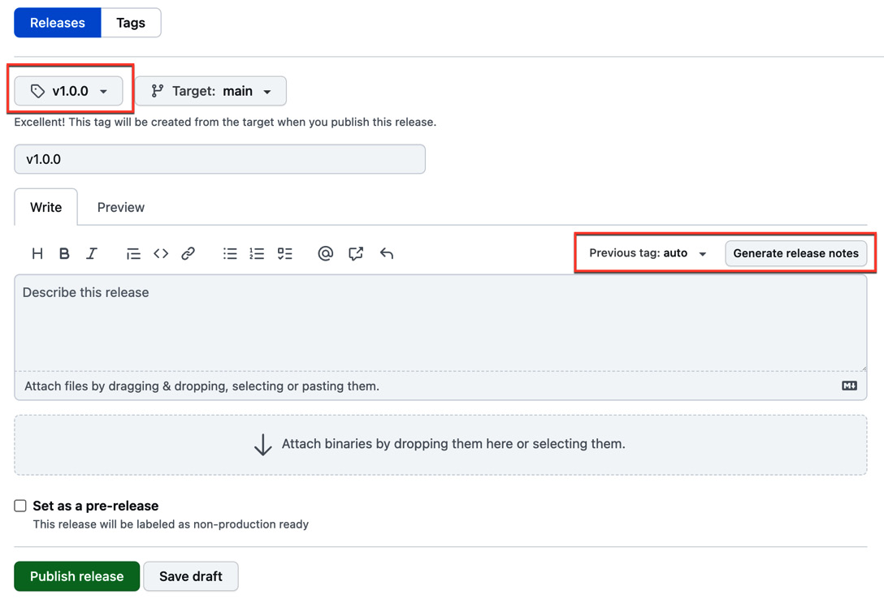
Figure 6.12 – Viewing code analysis results in a repository
You can access the status of all tools that report results. Note that in our repository, the analysis also analyses code generated by our test packages.
To learn more about CodeQL, visit https://docs.github.com/en/code-security/code-scanning/introduction-to-code-scanning/about-code-scanning-with-codeql.

There’s more…
GitHub supports all kinds of other tools – among others, Checkmarx, Snyk, Microsoft Defender for DevOps, and ESLint. It supports many commercial ones but also many that are free or open source.
If you click on Explore workflows in your repository under Settings | Code security and analysis (see Figure 6.13), then you will be redirected to a new workflow page filtered by the security category and code scanning query (https://github.com/OWNER/REPO/actions/new?category=security&query=code+scanning):
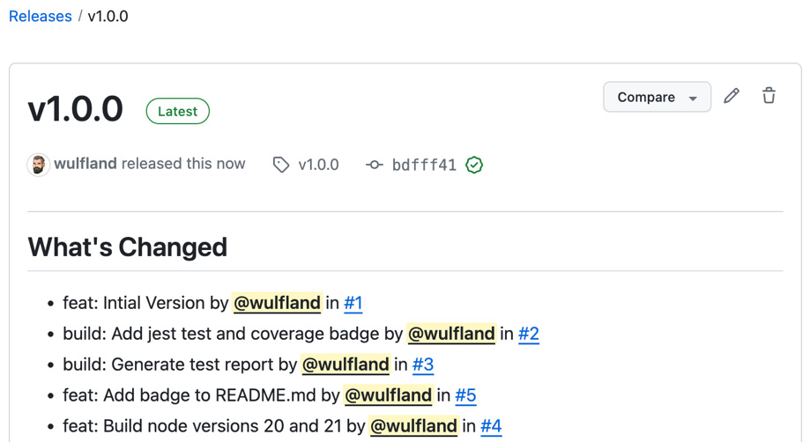
Figure 6.13 – Adding third-party scanning tools to your repository
You can explore all partners that have published a template workflow to the marketplace.
If you have other tools, you can still integrate them as long as they support Static Analysis Results Interchange Format (SARIF; see https://sarifweb.azurewebsites.net/) – the approved Organization for the Advancement of Structured Information Standards (OASIS) standard for static code analysis – as an output format.
To give you an example, you could use Checkov, a static code analysis tool for infrastructure as code (IaC) supporting Terraform, Terraform plan, CloudFormation, AWS Serverless Application Model (SAM), Kubernetes, Helm charts, Kustomize, Dockerfiles, Serverless, Bicep, OpenAPI or ARM templates. Use the action bridgecrewio/checkov-action action to run your analysis and then upload the results to GitHub:
- name: Checkov GitHub Action
uses: bridgecrewio/checkov-action@v12
with:
output_format: sarif
- name: Upload SARIF file
uses: github/codeql-action/upload-sarif@v3
with:
sarif_file: results.sarif
if: always()
This way, you can easily integrate all code scanning tools available on the market, as long as they support SARIF.

Creating a release and publishing the package
In this recipe, we are going to create a workflow that will publish our package whenever a release is created.

Getting ready
Create a new branch:
$ git switch -c add-release-workflow

How to do it…
- Create a new .github/workflows/release.yml workflow file. Name the workflow Release and trigger it on the creation of GitHub releases:
name: Release
on:
release:
types: [created]
- Add a publish job and give it read permission for the repository and write for packages:
jobs:
publish:
runs-on: ubuntu-latest
permissions:
packages: write
contents: read
- Check out the code and configure the NodeJS environment with the correct version. Also, set the registry to use GitHub:
steps:
- uses: actions/checkout@v4
- uses: actions/setup-node@v4
with:
node-version: 21.x
registry-url: https://npm.pkg.github.com/
- Build and test the application and publish it to the registry using a GitHub token:
- name: Install dependencies
run: npm install
- name: Run tests
run: npm test
- run: npm publish
env:
NODE_AUTH_TOKEN: ${{secrets.GITHUB_TOKEN}}
- Commit your changes, create a pull request, and merge the changes once the checks have passed:
$ git add .
$ git commit
$ gh pr create --fill
$ gh pr merge -m --auto
- Once your pull request has been merged, go to Releases on the Code tab of your repository and click Draft a new Release.
- Click Choose a tag, enter v1.0.0, and click Create new tag. Instead of adding the body of the release in markdown, just click Generate release notes (see Figure 6.14):
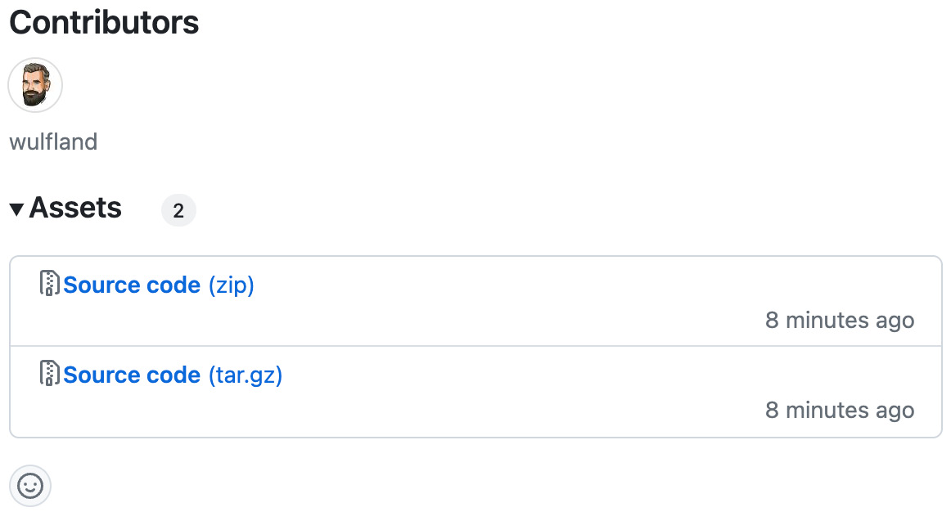
Figure 6.14 – Drafting a new release for a tag and generating release notes
This will generate details for your release from your pull requests. Click Publish release to create the release. The release should look like Figure 6.15:
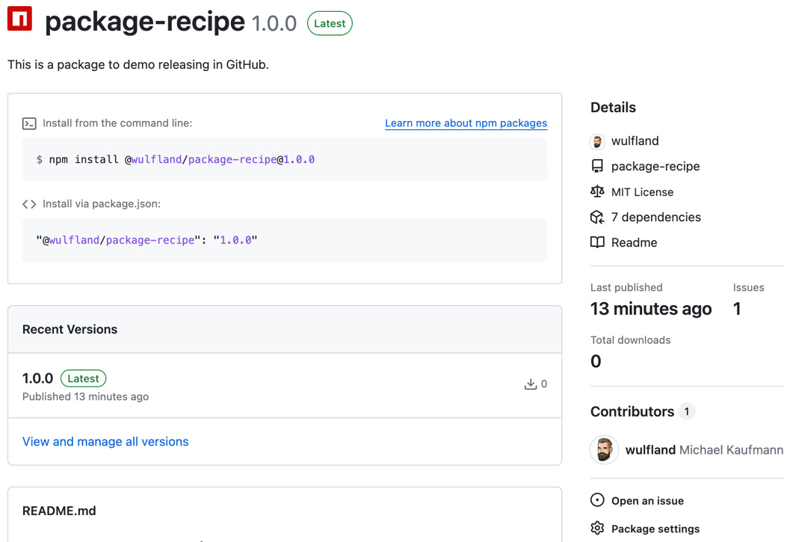
Figure 6.15 – Details of a GitHub release
- It should also contain the source code as .zip and .tar archives per default (see Figure 6.16):
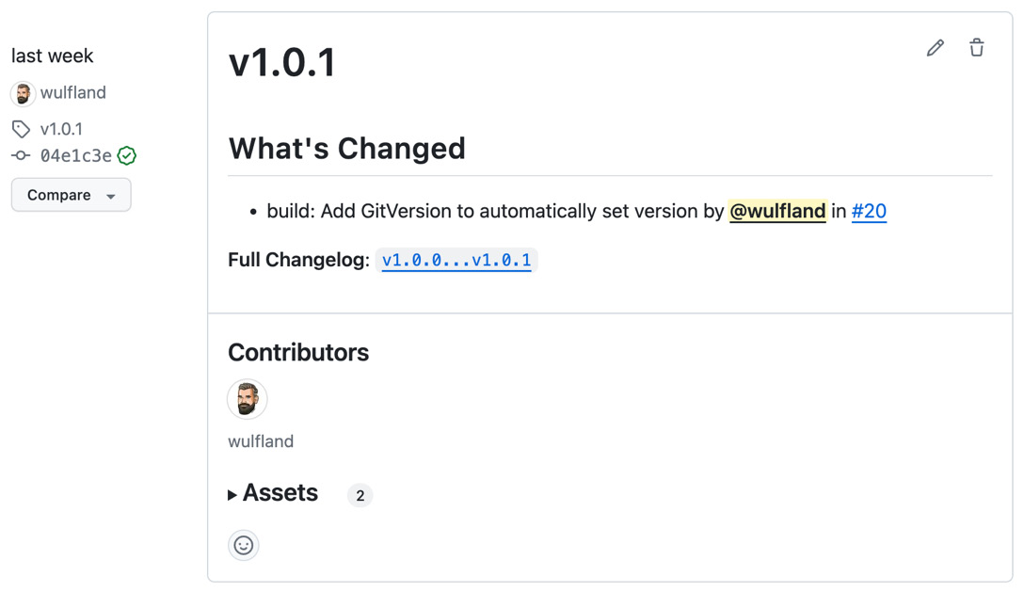
Figure 6.16 – Assets of a release contain the source code as .zip and .tar archives
- The creation of the release will trigger the workflow, and it will publish your package with version 1.0.0 to your repository (note that this comes from your package.json file and not the tag!).
The package looks like Figure 6.17:
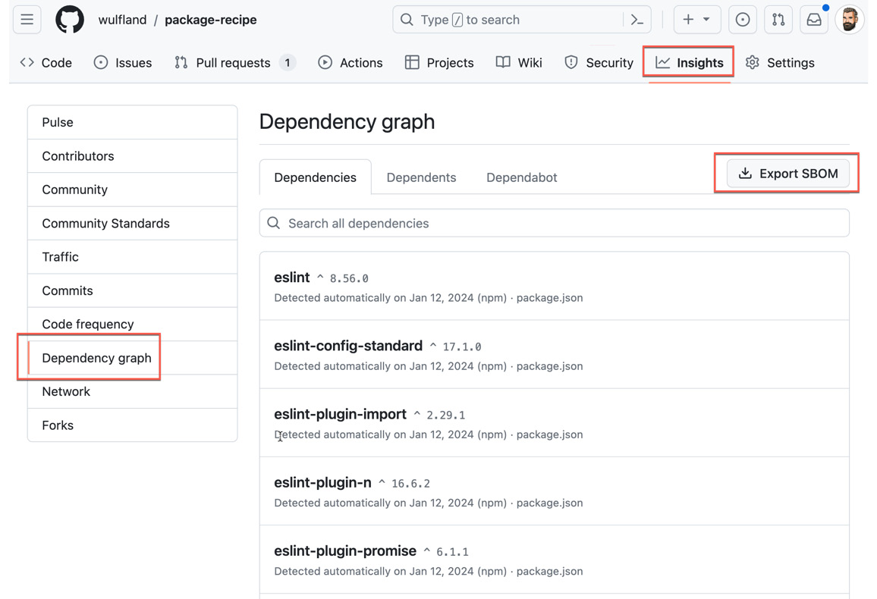
Figure 6.17 – The package in the repository
It contains installation instructions, information on your repository, and the README with your badges.

How it works…
Now, we’ll see how it works.
Semantic versioning
Packages are typically created using semantic versioning, a formal convention for specifying version numbers for software. It consists of different parts with different meanings. Examples of semantic version numbers are 1.0.0 or 1.5.99-beta. The format is as follows:
<major>.<minor>.<patch>-<pre>
- Major version: A numeric identifier that gets increased if the version is not backward compatible and has breaking changes. An update to a new major version must be handled with caution! A major version of zero is for the initial development.
- Minor version: A numeric identifier that gets increased if new features are added, but the version is backward compatible with the previous version and can be updated without breaking anything if you need the new functionality.
- Patch: A numeric identifier that gets increased if you release bug fixes that are backward compatible. New patches should always be installed.
- Pre-version: A text identifier that is appended using a hyphen. The identifier must only use ASCII alphanumeric characters and hyphens ([0-9A-Za-z-]). The longer the text, the smaller the pre-version (meaning -alpha < -beta < -rc). A pre-release version is always smaller than a normal version (1.0.0-alpha < 1.0.0).
See https://semver.org/ for the complete specification.
In our case, the semantic version for the package was set in the package.json file. In the next recipe, we will use the release process to automatically set the version number of the package to the release so that you do not have to do this manually.
Releases
You can create a release to package software, release notes, and binary files for other people to download.
GitHub releases are deployable software versions you can package and make available for a wider audience to download and use. They can contain release notes and other binary files to download.
Releases are based on Git tags, which mark a specific point in your repository’s history.
In the next recipes, we will use GitHub Releases together with tags to automatically version our package and to attach an SBOM in an automated way. To learn more about GitHub Releases, see https://docs.github.com/en/repositories/releasing-projects-on-github.

There’s more…
Releasing and versioning of software depends a lot on your workflow – especially how you work with git branches and tags. In our example, I assume that you start a release process by directly creating a release. You could also use the push of a tag:
on:
push:
tags:
- v*.**
The workflow would be triggered by any push of a tag that starts with v, and you could use it to automatically create a release:
gh release create ${{ github.ref_name }} --generate-notes
You could also do this on pushes to a release branch:
on:
push:
branches:
- release/*

Versioning your packages
If you now created a new release, the workflow would fail as it would try to publish version 1.0.0 again to the package registry. You would manually have to set the version number in the package.json file. In this recipe, we will use GitVersion to automate this process.

Getting ready
Switch to a new branch:
$ git switch -c add-gitversion

How to do it…
- For GitVersion to automatically determine the version of your git workflow, you have to download all references and not just the HEAD branch. We do this by adding the fetch-depth parameter to the checkout action and setting it to 0:
- uses: actions/checkout@v4
with:
fetch-depth: 0
- Set up GitVersion in a specific version:
- name: Install GitVersion
uses: gittools/actions/gitversion/setup@v0.10.2
with:
versionSpec: '5.x'
- Execute GitVersion to determine the version number:
- name: Determine Version
uses: gittools/actions/gitversion/execute@v0.10.2
- Change the version of the npm package:
- name: 'Change NPM version'
uses: reedyuk/npm-version@1.2.2
with:
version: $GITVERSION_SEMVER
- Commit your changes, create a pull request, and merge it when all checks have passed:
$ git add .
$ git commit -m '(build): Add GitVersion to automatically set version'
$ gh pr create --fill
$ gh pr merge -m --auto
$ gh pr checks
- Wait until all checks have passed. Then, create the release:
$ gh release create v1.0.1 --generate-notes
You will have a new release like Figure 6.18 – this time created from the CLI:
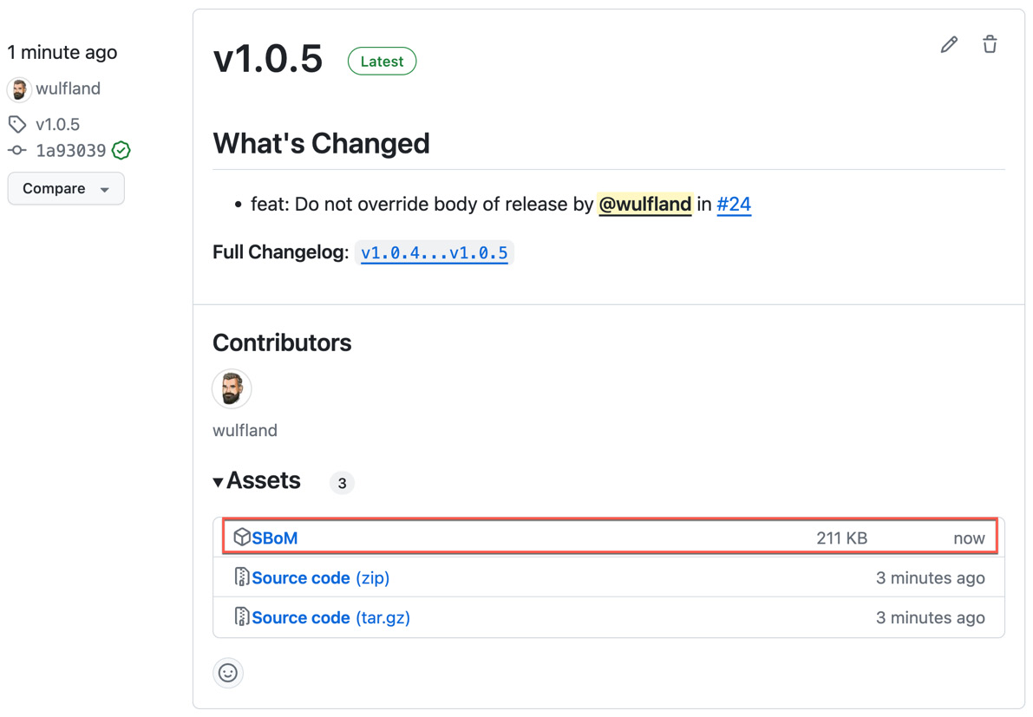
Figure 6.18 – Creating a release from the CLI that will trigger the workflow to publish a new package with the same version as the release
The release will trigger the workflow, and a new package with version 1.0.1 will be released.

How it works…
GitVersion (see https://gitversion.net/docs/) is a tool that automatically generates a semantic version number based on your Git history. GitVersion runs with a default configuration that works with GitHub flow (https://docs.github.com/en/get-started/using-github/github-flow) and Git flow (https://nvie.com/posts/a-successful-git-branching-model/). You can run GitVersion init to launch a wizard that guides you through creating a config file (GitVersion.yml). In our example, we use the Continuous Delivery mode – meaning we explicitly create a version using a tag. But there are also other modes such as Continuous Deployment mode (creating a version from every commit to specific branches) or Mainline mode.
The gittools/actions/gitversion/execute action will execute GitVersion and save the result in the $GITVERSION_SEMVER environment variable. You can also access individual parts of the version and configuration using the output of the action:
- name: Determine Version
id:
gitversion
uses: gittools/actions/gitversion/execute@v0
- name: Display GitVersion outputs (step output)
run: |
echo "Major: ${{ steps.
gitversion
.outputs.major }}"
echo "Minor: ${{ steps.
gitversion
.outputs.minor }}"
echo "Patch: ${{ steps.
gitversion
.outputs.patch }}"

There’s more…
You can also use Conventional Commits (see https://www.conventionalcommits.org) to automatically determine semantic versions out of commit messages. Conventional Commits is a specification that provides a set of rules for creating an explicit commit history by describing features, fixes, and breaking changes made in commit messages. You can use Conventional Commits to create release notes – and you can use it with GitVersion to automatically determine if a new version is a patch, minor, or major number. This is done in the GitVersion.yml configuration:
mode: Mainline
major-version-bump-message: "^(build|chore|ci|docs|feat|fix|perf|refactor|revert|style|test)(\\([\\w\\s-]*\\))?(!:|:.*\\n\\n((.+\\n)+\\n)?BREAKING CHANGE:\\s.+)"
minor-version-bump-message: "^(feat)(\\([\\w\\s-]*\\))?:"
patch-version-bump-message: "^(build|chore|ci|docs|fix|perf|refactor|revert|style|test)(\\([\\w\\s-]*\\))?:"
In the CI build, you can then add a job that determines the version out of the Conventional Commit messages and creates a new release:
publish:
if: ${{ github.ref == 'refs/heads/main' }}
needs: build
runs-on: ubuntu-latest
permissions:
contents: write
steps:
- uses: actions/checkout@v4
with:
fetch-depth: 0
- name: Install GitVersion
uses: gittools/actions/gitversion/setup@v0.10.2
with:
versionSpec: '5.x'
- name: Determine Version
uses: gittools/actions/gitversion/execute@v0.10.2
with:
useConfigFile: true
- name: Create a new release
env:
GH_TOKEN: ${{ github.token }}
run: |
gh release create ${{ env.GITVERSION_SEMVER }} --generate-notes
The two workflows together will then completely automate the creation of new versions after every merge to main.

Generating and using SBOMs
An SBOM (see https://www.cisa.gov/sbom) declares the nested inventory of components that make up the software. The United States government is required to obtain an SBOM for any product they purchase by the Cyber Supply Chain Management and Transparency Act of 2014.
You can manually export an SBOM in GitHub under Insights | Dependency graph | Export SBOM (see Figure 6.19):
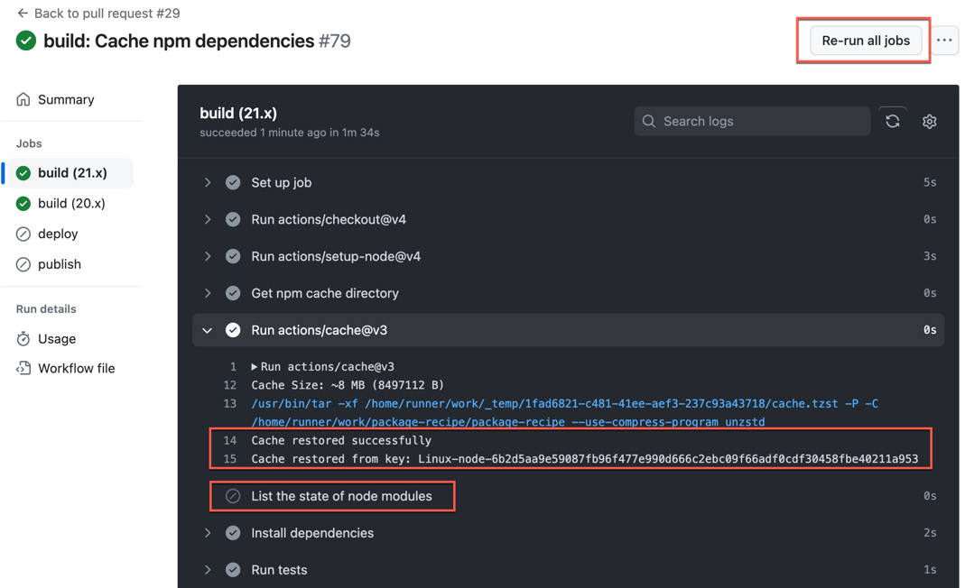
Figure 6.19 – Manually exporting an SBOM in a repository
The SBOM is a JSON file following the Software Package Data Exchange (SPDX) standard.
In this recipe, we will automate the process of generating an SBOM from the current dependencies of the repository and attach it to the release as an additional attachment.

Getting ready
Switch to a new branch:
$ git switch -c upload-sbom

How to do it…
- Edit the .github/workflows/release.yml file. Modify the permission for the publish job to allow write access to permissions:
jobs:
publish:
runs-on: ubuntu-latest
permissions:
packages: write
contents: write
- After the Publish package step, add the following step, which calls the API using the GitHub CLI and downloads the SBOM:
- name: Generate SBoM
env:
GH_TOKEN: ${{ github.token }}
run: |
gh api \
-H "Accept: application/vnd.github+json" \
-H "X-GitHub-Api-Version: 2022-11-28" \
/repos/wulfland/package-recipe/dependency-graph/sbom > sbom.json
- Add the svenstaro/upload-release-action action and upload the SBOM as an attachment to the release:
- name: Upload SBoM to release
uses: svenstaro/upload-release-action@v2
with:
file: sbom.json
asset_name: SBoM
tag: ${{ github.ref }}
overwrite: true
- Commit the workflow, create a pull request, and merge it back once the checks have passed:
$ git add .
$ git commit
$ gh pr create --fill
$ gh pr merge -m --auto
$ gh pr checks
- Wait until all checks have passed. Then, create a release:
$ gh release create v1.0.5 --generate-notes
- The workflow will create a release and attach the SBOM as an asset (see Figure 6.20):
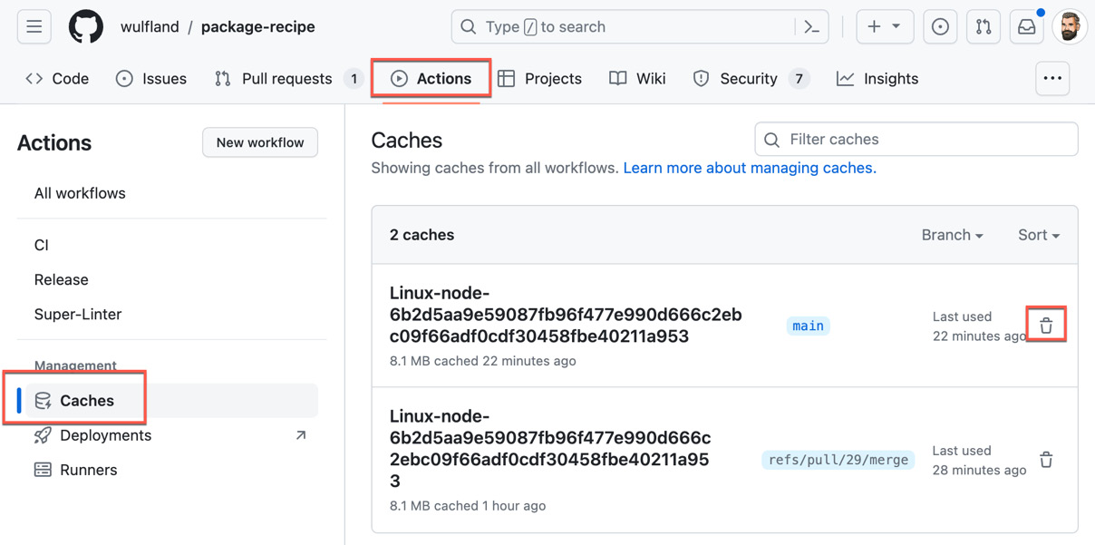
Figure 6.20 – Automatically attached SBOM as an asset in the release
You can download and inspect the JSON file from the release.

How it works…
There is always the need to store output – sometimes binary and sometimes text files, as in this case – when releasing software.
You can upload artifacts to the GitHub workflow using the https://github.com/actions/upload-artifact action:
- uses: actions/upload-artifact@v4
with:
name: my-artifact
path: path/**/[abc]rtifac?/*
We did this with the test badges to publish them to GitHub Pages. You can then download the artifacts from the workflow summary page or in subsequent jobs using the https://github.com/actions/download-artifact action:
- uses: actions/download-artifact@v4
with:
name: my-artifact
But for end users, it is more convenient to store everything in a release. This way, you bundle all build output with an exact version of your source code. You can manage release assets using the API (see https://docs.github.com/en/rest/releases/assets):
gh api \
--method POST \
-H "Accept: application/vnd.github+json" \
-H "X-GitHub-Api-Version: 2022-11-28" \
--hostname HOSTNAME \
/repos/
OWNER
/
REPO
/releases/
ID
/assets?name=example.zip \
-f '@example.zip'
But there are many actions available that help with that. We use the svenstaro/upload-release-action action – but there are many others. For example, GitReleaseManager from GitTools (see https://github.com/GitTools/actions/blob/main/docs/examples/github/gitreleasemanager/index.md) has an entire suite of actions to interact with releases.

There’s more…
There are different common formats for SBOM:
- SPDX: SPDX is an open standard for SBOM with origins in the Linux Foundation. Its origin was license compliance, but it also contains copyrights, security references, and other metadata. SPDX was recently approved as an ISO/IEC standard (ISO/IEC 5962:2021), and it fulfills the National Telecommunications and Information Administration’s (NTIA’s) The Minimum Elements For a Software Bill of Materials.
- CycloneDX (CDX): CDX is a lightweight open source format with origins in the Open Worldwide Application Security Project (OWASP) community. It is optimized for integrating SBOM generation into a release pipeline.
- Software Identification (SWID) tags: SWID is an ISO/IEC industry standard (ISO/IEC 19770-2) used by various commercial software publishers. It supports automation of software inventory, assessment of software vulnerabilities on machines, detection of missing patches, targeting of configuration checklist assessments, software integrity checking, installation and execution whitelists/blacklists, and other security and operational use cases. It is a good format for doing the inventory of the software installed on your build machines.
There are different tools and use cases for each format. SPDX is used by GitHub, FOSSology, and syft. You can use the Anchore SBOM Action (see https://github.com/marketplace/actions/anchore-sbom-action) to generate an SPDX SBOM for a Docker or Open Container Initiative (OCI) container:
- name: Anchore SBOM Action
uses: anchore/sbom-action@v0.6.0
with:
path: .
image: ${{ env.REGISTRY }}/${{ env.IMAGE_NAME }}
registry-username: ${{ github.actor }}
registry-password: ${{ secrets.GITHUB_TOKEN }}
The SBOM is being uploaded as a workflow artifact.
CDX (https://cyclonedx.org/) is more focused on application security. There are versions for NodeJS, .NET, Python, PHP, and Go in the marketplace – but many more languages are supported using the CLI or other package managers (Java, Maven, Conan, and many more). The usage is simple. Here is an example of the action for .NET:
- name: CycloneDX .NET Generate SBOM
uses: CycloneDX/gh-dotnet-generate-sbom@v1.0.1
with:
path: ./CycloneDX.sln
github-bearer-token: ${{ secrets.GITHUB_TOKEN }}
The SBOM does not get uploaded automatically unlike the Anchore action – you would have to do that manually:
- name: Upload a Build Artifact
uses: actions/upload-artifact@v2.3.1
with:
path: bom.xml
CDX is also used in OWASP Dependency-Track (see https://github.com/DependencyTrack/dependency-track) – a component analysis platform that you can run as a container or in Kubernetes. You can upload the SBOM directly into your Dependency-Track instance:
- uses: DependencyTrack/gh-upload-sbom@v1.0.0
with:
serverhostname: '
your-instance.org
'
apikey: ${{ secrets.
DEPENDENCYTRACK_APIKEY
}}
projectname: '
Your Project Name
'
projectversion: '
main
'
SWID tags are more used in software asset management (SAM) solutions such as Snow (https://www.snowsoftware.com/), Microsoft System Center, or ServiceNow IT Operations Management (ITOM). CDX and SPDX can use SWID tags if they are present.
If you want to learn more about SBOM, see https://www.ntia.gov/sbom.

Using caching in workflows
In this recipe, we will use caching to optimize the speed of workflows.

Getting ready
Switch to a new branch:
$ git switch -c cache-npm-packages

How to do it…
- Edit the .github/workflows/ci.yml file. After the setup-node action, add the following script to get the npm cache directory for the correct npm version and store it as an output variable:
- name: Get npm cache directory
id:
npm-cache-dir
run: echo "dir=$(npm config get cache)" >> "${GITHUB_OUTPUT}"
- Add the actual cache step right after that. Also, give it a name and create a key from the hash of the package-lock.json file:
- uses: actions/cache@v3
id:
npm-cache
with:
path: ${{ steps.npm-cache-dir.outputs.dir }}
key: ${{ runner.os }}-node-${{ hashFiles('**/package-lock.json') }}
restore-keys: |
${{ runner.os }}-node-
- The next step will just list the dependencies if they are added to the cache:
- name: List the state of node modules
if: ${{ steps.
npm-cache
.outputs.cache-hit != 'true' }}
continue-on-error: true
run: npm list
- Commit your changes and create a pull request:
$ git add.
$ git commit
$ gh pr create --fill
- Open the CI workflow run in your pull request and inspect the output of the steps we added. Rerun both jobs and note how the action restores the packages from the cache and how cache-hit prevents the next step from executing (see Figure 6.21):
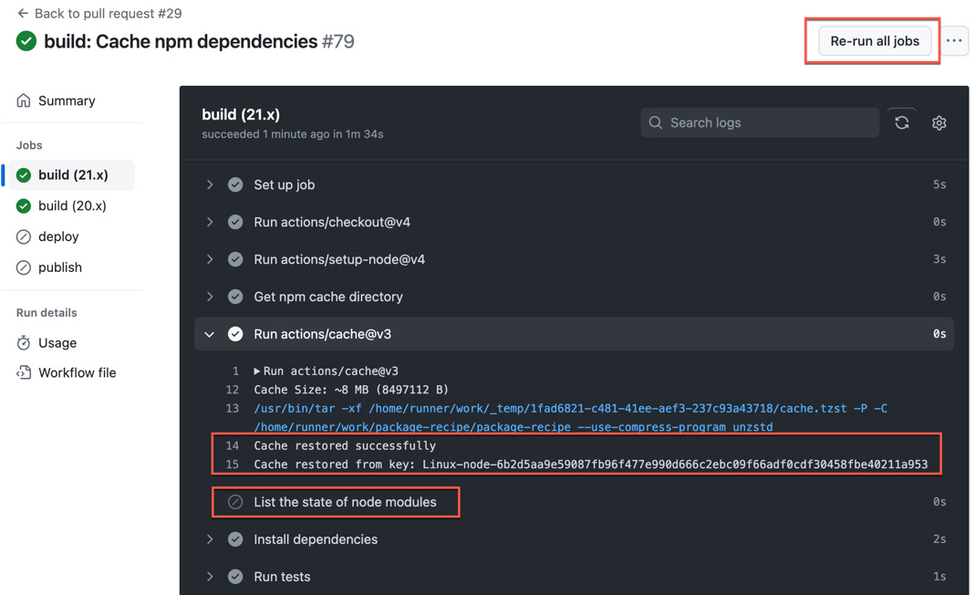
Figure 6.21 – The cache is successfully restored and cache-hit is true
- Merge your pull request:
$ gh pr merge -s --auto

How it works…
It is important to only use the cache if you have performance problems. If you use the setup actions, you probably not going to see a big improvement. But it is important to know how caching works to have the tool available if you need it.
The cache action (https://github.com/actions/cache) stores information on GitHub-owned cloud storage and retrieves it in subsequent runs from that.
Let’s assume you have a long-running operation – such as calculating prime numbers – and you use the output in a subsequent step. (I just use a sleep here to simulate a long-running task):
- name: Generate Prime Numbers
run: |
sleep 60
echo "1 2 3..."
>
primes
- name: Use Prime Numbers
run: cat
primes
You can now add a cache step before that step and cache the folder primes:
- name: Cache Primes
id:
cache-primes
uses: actions/cache@v3
with:
path: primes
key: ${{ runner.os }}-primes
The key here is what has to be unique to determine if the cache has changed. In our example, we used the hash value of the packe-lock.json file. For prime numbers, we might have a different format for the operating system.
In the long-running operation, you can now check if the cache is valid and only execute it, when there is no hit for the current key:
- name: Generate Prime Numbers
if: steps.cache-primes.outputs.cache-hit != 'true'
run: |
sleep 60
echo "1 2 3..."
> primes
This workflow would run the first time for the long-running operation and populate the file in the cache. If you run it a second time, it will load the file from the cache and omit the long-running step.

There’s more…
A repository can store up to 10 GB of data in caches. Once that limit is reached, older files will be removed based on when they were last accessed. Caches that are not used for 1 week will also be cleaned up.
You can manage the cache under Actions | Caches (see Figure 6.22):
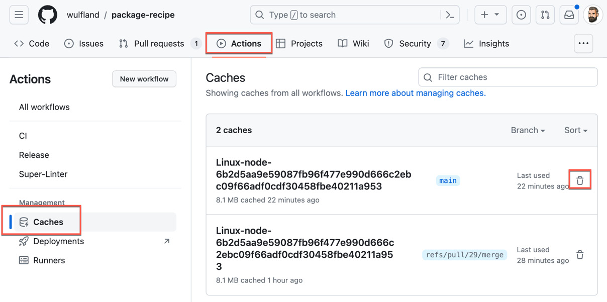
Figure 6.22 – Managing the cache
The cache action (https://github.com/actions/cache) has good documentation and examples for most programming languages. You can also refer to the documentation when you want to implement caching (see https://docs.github.com/en/actions/using-workflows/caching-dependencies-to-speed-up-workflows).
7

Release Your Software with GitHub Actions
In this final chapter, we will dive into using GitHub Actions for continuous deployments (CDs). We will create a container with a simple website that uses the package from Chapter 6, Build and Validate Your Code, and we will deploy it to Kubernetes in the cloud, securing access with OpenID Connect (OIDC). We will use environments to secure the deployment and concurrency groups to control the flow of multiple workflows.
We will use Microsoft Azure Kubernetes Service (AKS) in this chapter as the production environment, but I will point you to documentation to carry out the same recipes with other cloud providers such as Google Kubernetes Engine (GKE) on Google Cloud Platform (GCP) or Elastic Container Services (ECSs) on Amazon Web Services (AWS).
We’ll cover the following recipes:
- Building and publishing a container
- Using OIDC to securely deploy to any cloud
- Environment approval checks
- Releasing the container application to Azure Kubernetes Service (AKS)
- Automating the update of your dependencies

Technical requirements
For this chapter, you will need Docker, Node.js, and the GitHub CLI, either on your local machine, or you can just use GitHub Codespaces. For the Microsoft Azure part, you will need an Azure account. If you don’t have one, just create a free trial account here: https://azure.microsoft.com/en-us/free. You can use the Azure CLI locally or just use Cloud Shell in the Azure portal.
You will also need a GitHub personal access token (PAT) with read and write permission for GitHub packages (https://docs.github.com/en/authentication/keeping-your-account-and-data-secure/managing-your-personal-access-tokens#creating-a-personal-access-token-classic).

Building and publishing a container
In this recipe, we are going to containerize a simple web application and push it to a container registry.

Getting ready…
Open the repository (https://github.com/wulfland/release-recipe) and click on Use this template to create a new copy out of it (direct link: https://github.com/new?template_name=release-recipe&template_owner=wulfland). Create a new public repository in your personal account, name it release-recipe, and clone the repository.
Open the package.json and adjust the author and repository URL.
Under dependencies, adjust the owner and version of the package recipe to your package from Chapter 6, Build and validate your code:
"dependencies": {
"@
wulfland
/package-recipe": "^
2.0.5
",
"express": "^4.18.2"
}
Replace the owner in the file .npmrc:
@
wulfland
:registry=https://npm.pkg.github.com
In a terminal, run the following commands:
$ npm login --registry https://npm.pkg.github.com
Enter your GitHub username and the PAT token with access to packages. Run the following commands:
$ npm install
$ npm start
> release-recipe@1.0.0 start
> node src/index.js
Server running at http://localhost:3000
Now, you should have a Node.js application running on port 3000. Open a browser, navigate to http://localhost:3000, and validate that is displays Hello World!. Stop the server by exiting the process (CTRL+C).

How to do it…
- Create a new file, Dockerfile, in the root of the repository. Inherit your image from the node image and pick the 21-bullseye version. Create a folder, copy the repository content in it, and make it the working folder:
FROM node:21-bullseye
RUN mkdir -p /app
COPY .
/app
WORKDIR /app
- Note that you have to run npm install before building the Docker image to avoid storing your credentials in the container. Rebuild the npm package in the container:
RUN npm rebuild
- Expose port 3000 of our express website and run npm start as the start command of the container:
EXPOSE 3000
CMD [ "npm", "start"]
- Next, build your container image locally and run it:
$ npm install
$ docker build -t hello-world-recipe .
$ docker run -it -p 3000:3000 hello-world-recipe
- Verify that the website runs on port 3000 on your local machine again.
- Create a new workflow .github/workflows/publish.yml. Run it on pull requests and pushes to the main branch:
name: Publish Docker Image
on:
push:
branches: [ main ]
pull_request:
branches: [ main ]
- Set the registry name and image name as environment variables:
env:
REGISTRY: 'ghcr.io'
IMAGE_NAME: '${{ github.repository }}'
- Add a job with permissions for GITHUB_TOKEN to write packages and read content:
jobs:
build-and-push-image:
runs-on: ubuntu-latest
permissions:
packages: write
contents: read
- Add the following steps. Check out the repository and log in to the Docker registry:
- name: Checkout repository
uses: actions/checkout@v4
- name: Log in to the Container registry
uses: docker/login-action@v3
with:
registry: ${{ env.REGISTRY }}
username: ${{ github.actor }}
password: ${{ secrets.GITHUB_TOKEN }}
- Extract the metadata for the image from the registry. We use the long SHA as the tag for the container. Give the step an id to later access the output:
- name: Extract metadata (tags, labels) for Docker
id:
meta
uses: docker/metadata-action@v5
with:
images: ${{ env.REGISTRY }}/${{ env.IMAGE_NAME }}
tags: |
type=sha,format=long
- Set up Node.js to use the correct version and registry. Then, build and test your code. You have to set the NODE_AUTH_TOKEN environment variable to the GITHUB_TOKEN to authenticate to the package registry and receive the npm package from the package recipe from Chapter 6:
- uses: actions/setup-node@v4
with:
node-version: 21.x
registry-url: https://npm.pkg.github.com/
- name: Build and test
env:
NODE_AUTH_TOKEN
: ${{ secrets.GITHUB_TOKEN }}
run: |
npm install
npm run test
- Now, we are ready to build and push the Docker image. Use the output of the meta step to set the tags and labels:
- name: Build and push Docker image
uses: docker/build-push-action@v5
with:
context: .
push: ${{ github.event_name != 'pull_request' }}
tags: ${{ steps.
meta
.outputs.tags }}
labels: ${{ steps.
meta
.outputs.labels }}
- Commit and push your changes. After the workflow run, you will find the Docker image on the Code tab of your repository on the right side under Packages.

How it works…
I use Express (https://expressjs.com/) as a simple web framework to run a website. The website displays the content from our package; we’ll leverage this in the upcoming recipes to automatically keep our dependencies up to date. The code is easy to understand:
const express = require('express');
const greet = require('@wulfland/package-recipe/src/index')
const app = express();
const port = 3000;
app.get('/', (req, res) => {
res.send(greet());
});
app.listen(port, () => {
console.log(`Server running at http://localhost:${port}`);
});
This time, I have omitted all linting and testing, as we have covered this already in Chapter 6. We need to containerize this application to deploy it to the cloud later.
To deploy a container to the cloud, you have to store it in a container registry. We are using GitHub packages here, but using the cloud-specific registries works the same way. You just have to configure a PAT token and cannot use GITHUB_TOKEN, but this is the only difference.

There’s more…
The Docker meta-action (https://github.com/docker/metadata-action) can be used to extract metadata from Git references and GitHub events. Just as for GitVersion in Chapter 6, it can be used to automate the versioning of your containers. It also supports semantic versioning:
- name: Docker meta
id: meta
uses: docker/metadata-action@v5
with:
images: |
${{ env.REGISTRY }}/${{ env.IMAGE_NAME }}
tags: |
type=ref,event=branch
type=ref,event=pr
type=semver,pattern={{version}}
type=semver,pattern={{major}}.{{minor}}
In our example, we just use the Git SHA to be able to deploy every commit, but you can easily extend the versioning according to your workflow.

Using OIDC to securely deploy to any cloud
In this recipe, we will set up our Kubernetes cluster in Azure, and we will configure OIDC in Azure to deploy to the cluster without using stored secrets.

Getting ready…
Make sure you have a PAT with at least read access to packages.
If you are experienced in Azure and you have the Azure CLI (https://docs.microsoft.com/cli/azure/install-azure-cli?view=azure-cli-latest) installed locally, then you can work from there. If you are new to Azure or you don’t have the CLI installed, just use Azure Cloud Shell at https://shell.azure.com.
Set the PAT token as an environment variable:
$ export GHCR_PAT=<YOUR_PAT_TOKEN>
The token will be used by Kubernetes to read from the GitHub Package Registry. Open the script setup-azure.sh and adjust the location variable at the top of the file to the Azure region of your choice. You can get a list of regions using az account list-locations -o table. Commit and push your changes, and then run the script:
$ git clone https://github.com/
{OWNER}
/release-recipe.git
$ cd release-recipe
$ chmod +x setup-azure.sh
$ ./setup-azure.sh
This will create an Azure Kubernetes Service and connect it with the GitHub Container registry. While the script runs, you can configure OIDC to access it from the workflow.

How to do it…
- Use Cloud Shell or a local terminal and create a new app registration:
$ az ad app create --display-name release-recipe
- Then create a service principle using app ID from the registration output:
$ az ad sp create --id <appId>
- Then, open the Azure portal, and in Microsoft Entra, find release-recipe under App registrations. Add the OIDC trust under Certificates & secrets | Federated credentials | Add credentials. Fill out the form. Set the organization to your GitHub username, enter the repository name, and pick Environment as the entity type (see Figure 7.1):
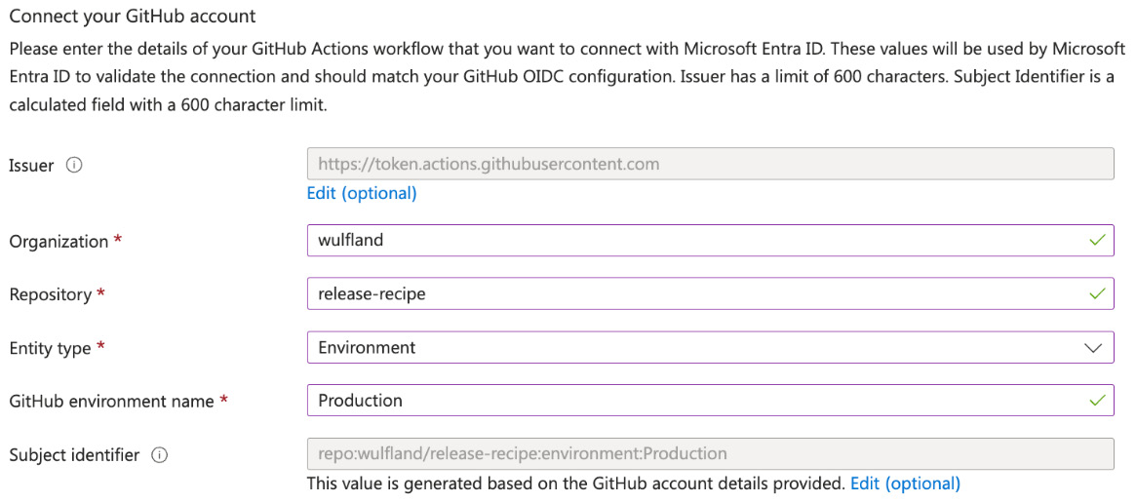
Figure 7.1 – Connecting your GitHub account in Microsoft Entra
Give the credentials a name and click Add. Note the Application (client) ID and Directory (tenant) ID of the release-recipe application (see Figure 7.2). You will need that later:
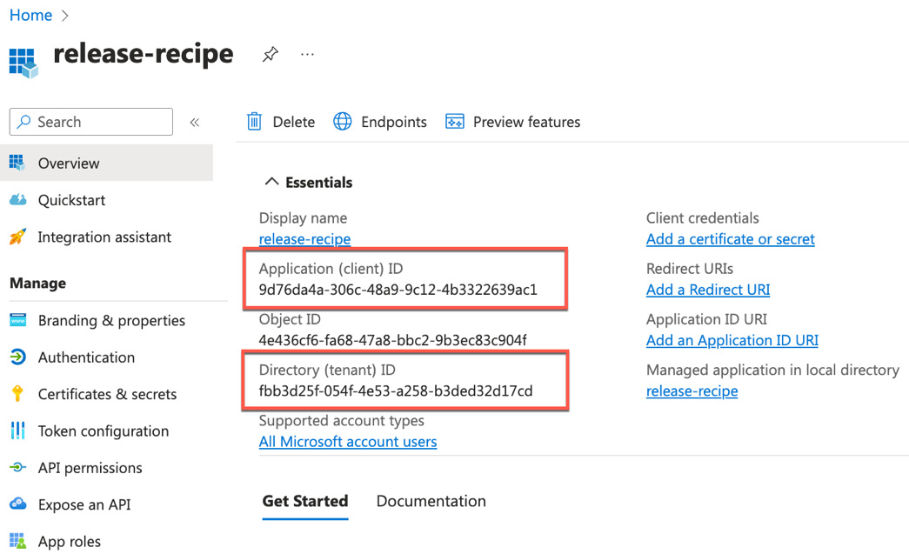
Figure 7.2 – Client and Tenant IDs from the app registration
- Then, assign the service principle a role in your subscription. Open the subscription in the portal. Under Access control (IAM) | Role assignment | Add | Add role assignment, follow the wizard. Select role—for example, Contributor—and click Next. Select User, group, or service principal, and select the service principle you created earlier.

How it works…
Instead of using credentials stored as secrets to connect to a cloud provider, such as Azure, AWS, GCP, or HashiCorp, you can use OIDC. OIDC will exchange short-lived tokens for authentication instead of credentials. Your cloud provider also needs to support OIDC on their end.
When using OIDC, you don’t have to store cloud credentials in GitHub, you have more granular control over what resources the workflow can access, and you have rotating, short-lived tokens that will expire after the workflows run. Figure 7.3 shows an overview of how OIDC works:
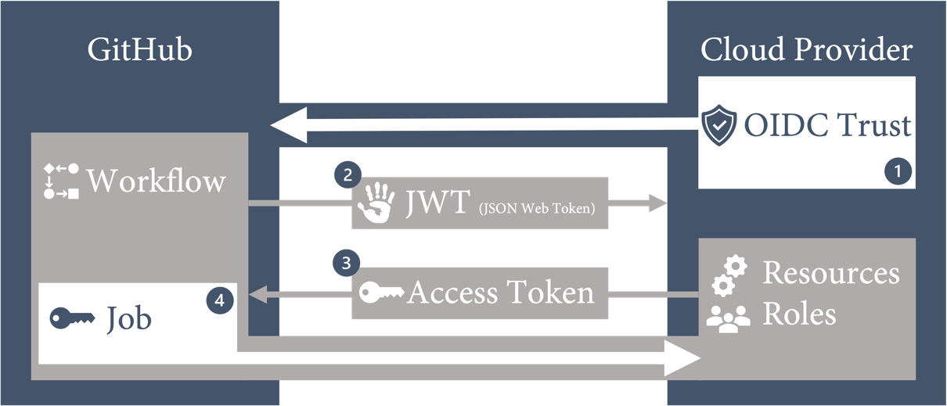
Figure 7.3 – OIDC integration with a cloud provider
The steps are the following:
- Create an OIDC trust between your cloud provider and GitHub. Limit the trust to an organization and repo and further limit access to an environment, branch, or pull request.
- The GitHub OIDC provider auto-generates a JSON web token during a workflow run. The token contains multiple claims to establish a secure and verifiable identity for the specific workflow job.
- The cloud provider validates the claims and provides a short-lived access token that is available only for the lifetime of the job.
- The access token is used to access resources that the identity has access to.
You can use the identity to directly access resources, or you can use it to get credentials from a secure vault (such as Azure Key Vault or HashiCorp Vault). In this way, you can safely connect to services that do not support OIDC and automated secret rotation by using the vault.
In GitHub, you can find instructions on configuring OIDC for AWS, Azure, and GDP at https://docs.github.com/en/actions/deployment/security-hardening-your-deployments.

Environment approval checks
We have already used environments in Chapter 5, Automate tasks in GitHub with GitHub Actions, so this is a repetition. Therefore, I’ll keep the recipe rather short. Environments manage core releases, and we will use them in the following recipes to display the URL of our service in Kubernetes.

Getting ready…
Make sure you have the Application (client) ID, Directory (tenant) ID, and Subscription ID from the previous chapters at hand. The subscription ID can be obtained by using the following:
$ az account show

How to do it…
- In the settings of your repositories, go to Environments, click New environment, and create a new environment: Production.
- Add main as the deployment branch.
- Add a new Environment secret called AZURE_CLIENT_ID and set it to the Application (client) ID.
- Add a new Environment secret called AZURE_TENANT_ID and set it to the Directory (tenant) ID.
- Add a new Environment secret called AZURE_SUBSCRIPTION_ID and set it to the Subscription ID.
- Add a new Environment secret called AZURE_CLUSTER_NAME and set it to the name of the cluster (AKSCluster if you did not modify the setup-azure.sh script).
- Add a new Environment secret called AZURE_RESOURCE_GROUP and set it to the name of the resource group (AKSCluster if you did not modify the setup-azure.sh script).
We will use these environment secrets in the next recipe to securely deploy to Kubernetes in the cloud.

How it works…
Environments add a layer of abstraction over a job in a workflow, and they can be protected by rules. See Chapter 5, Automate Tasks in GitHub with GitHub Actions, for more details on approval checks. Environments can also be trusted by OIDC entities, and this is what we are going to use in the next recipe.

Releasing the container application to AKS
Now, it is time to release our application to the production environment in AKS.

Getting ready…
Open the file .github/workflows/publish.yml.

How to do it…
- Add two more environment variables to the top of the workflow:
env:
REGISTRY: 'ghcr.io'
IMAGE_NAME: '${{ github.repository }}'
APP_NAME: 'release-recipe-app'
SERVICE_NAME: 'release-recipe-service'
Add an output to the job build-and-push-image from the previous recipe so that the new job will be able to access the image name:
outputs:
image_tag: ${{ fromJSON(steps.meta.outputs.json).tags[0] }}
- Add a second job called production to the workflow, which only runs on pushes to main and is associated with the production environment. Set the URL of the environment to the output of a step we’ll add later. The job will need the permissions id-token: write and content: read for OIDC to work:
production:
if: github.ref == 'refs/heads/main' && github.event_name == 'push'
needs: build-and-push-image
runs-on: ubuntu-latest
permissions:
id-token: write
contents: read
environment:
name: Production
url: ${{ steps.get-service-url.outputs.SERVICE_URL}}
- Add steps to check out the repository and log into Azure using OIDC:
- name: Checkout
uses: actions/checkout@v4
- name: 'Az CLI login'
uses: azure/login@v1
with:
client-id: ${{ secrets.AZURE_CLIENT_ID }}
tenant-id: ${{ secrets.AZURE_TENANT_ID }}
subscription-id: ${{ secrets.AZURE_SUBSCRIPTION_ID }}
- Set the context for the Kubernetes deployments:
- name: 'Az CLI set AKS context'
uses: azure/aks-set-context@v3
with:
cluster-name: ${{ secrets.AZURE_CLUSTER_NAME }}
resource-group: ${{ secrets.AZURE_RESOURCE_GROUP }}
- Inspect the file service.yml. It deploys a LoadBalancer that displays port 3000 of our application on port 80. Additionally, inspect deployment.yml, which contains the definition of our application. To replace the environment variables in the files, we use envsubst. We then pipe the result to kubectl and apply the manifest files:
- name: Deploy
env:
IMAGE: ${{ needs.build-and-push-image.outputs.image_tag }}
run: |-
envsubst < service.yml | kubectl apply -f -
envsubst < deployment.yml | kubectl apply -f -
- Get the URL of the service in Kubernetes using kubectl describe service and set it as a step output to be available in the production environment URL:
- name: 'Get Service URL'
id:
get-service-url
run: |
IP=$(kubectl describe service $SERVICE_NAME| grep "LoadBalancer Ingress: " | awk '{print $3}')
echo "
SERVICE_URL
=http://$IP" >> $GITHUB_OUTPUT
- Finally, we want to check if the deployment was successful. If the application would have a /health endpoint, then we would query that, but because out app is very simple, we’ll just rely on the returned status code:
- name: 'Run smoke test'
env:
SERVICE_URL: ${{ steps.get-service-url.outputs.SERVICE_URL}}
run: |
status=`curl -s --head $SERVICE_URL | head -1 | cut -f 2 -d' '`
if [ "$status" != "200" ]
then
echo "Wrong HTTP Status.
Actual: '$status'"
exit 1
fi
What this snippet does is query the header of the website with curl --head. The -s switch suppresses other output. It then takes the first line using head -1. The line looks like HTTP/1.1 200 OK. We cut the string by using blanks and take the second element (the status code). If the status code is not 200 (OK), it raises an exception.
- Commit and push your changes to the main branch. This will trigger the workflow; this will push a new version of the container to the registry and publish it from there in AKS. Follow the URL of the service (see Figure 7.4) and verify that the website is displayed correctly:
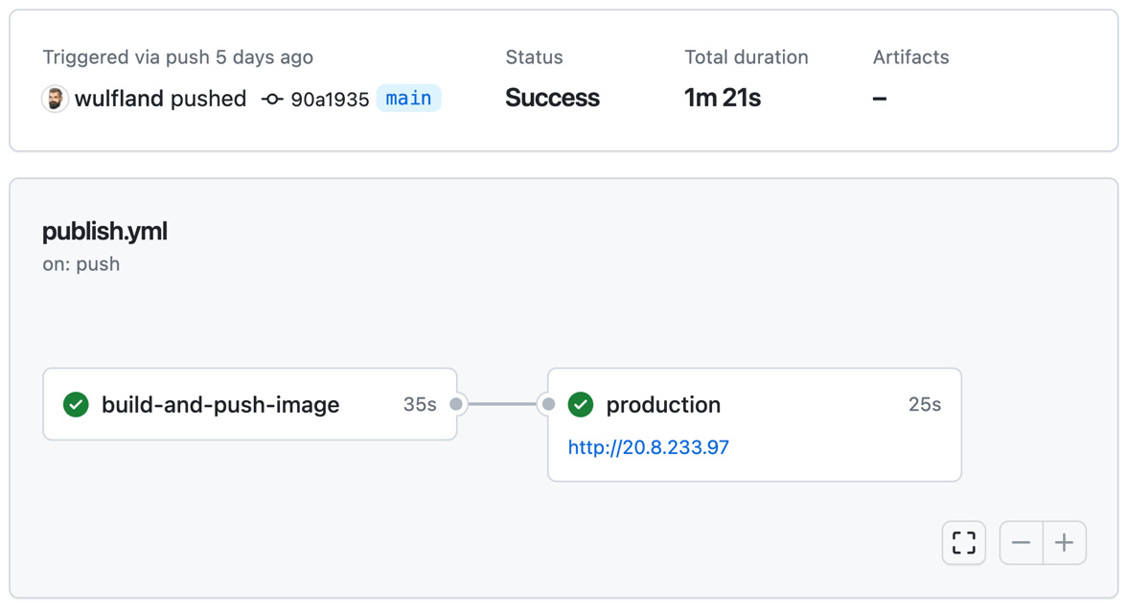
Figure 7.4 – Deploy to dynamic environments
- It will display the Hello World application from your container.

How it works…
The Azure Login action will authenticate to Azure using the OIDC identity. This identity can then be granted fine-grained access to Azure resources. As we limited access to the Production environment in our repository, only this job can use the application to authenticate to Azure. You could also use branches, tags, or pull requests for that.
We then use the aks-set-context action to configure access to AKS using kubectl. This will allow us to deploy the actual application to Kubernetes.

There’s more…
Kubernetes can get very complex very fast. In the real world, you are going to add DNS and SSL to the cluster and use namespaces to manage multiple containers running in parallel. This is a nice way to deploy every pull request to a dynamic environment. However, this is outside the scope of this book.
If you want to use other cloud providers instead of Azure to release the container, you’ll find a hands-on for deploying to AWS Elastic Container Service (ECS) here: https://github.com/wulfland/AccelerateDevOps/blob/main/ch9_release/Deploy_to_AWS_ECS.md, or another on how to deploy to Google Kubernetes Engine (GKE) here: https://github.com/wulfland/AccelerateDevOps/blob/main/ch9_release/Deploy_to_GKE.md.

Automating the update of your dependencies
Now that we have an end-to-end workflow from our package repo into the release repo and, from there, into production, I want to show you how you can use dependabot together with GitHub Actions to automate the update process of your dependencies.

Getting ready…
In the repository, navigate to Settings | Code security and analysis and make sure that Dependency graph is enabled (see Figure 7.4):
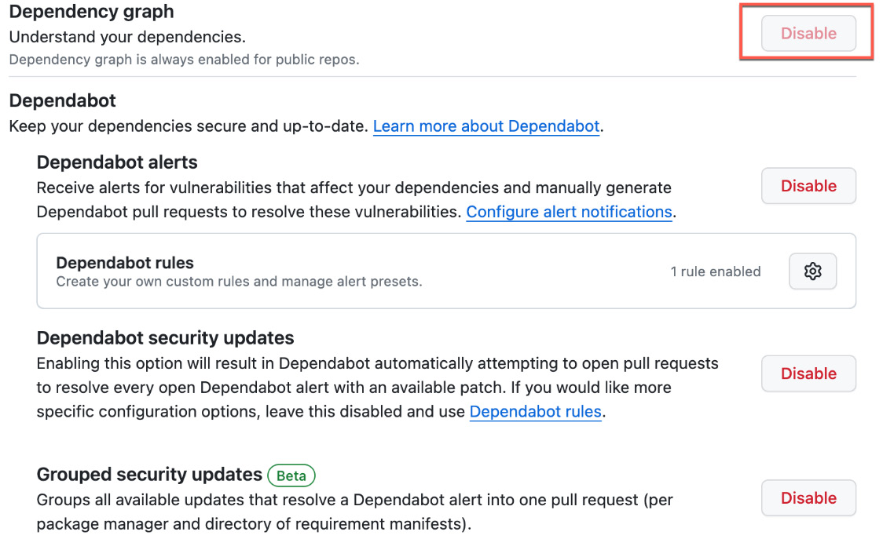
Figure 7.5 – Enabling the dependency graph and optional dependabot alerts
This will analyze your repository and detect all dependencies that you can inspect under Insights | Dependency graph. You can also enable Dependabot alerts. In this case, dependabot will notify you when there are known vulnerabilities in one of your dependencies. Dependabot security updates go one step further, and dependabot will generate a pull request with a version update to a nonvulnerable version for you. To reduce the number of pull requests, you can group the updates together (this feature is still in beta).

How to do it…
- Create a new dependabot secret called PAT and set it with the value of the PAT token with read access to packages:
$ gh secret set
PAT
--app dependabot
- Create a new file: .github/dependabot.yml. It always starts with version:2:
version: 2
- Configure a new npm-registry using PAT, pointing to https://npm.pkg.github.com:
registries:
npm-pkg
:
type: npm-registry
url: https://npm.pkg.github.com
token: ${{ secrets.PAT }}
replaces-base: true
- The version updates are configured under updates. Add the ecosystem npm and point it to the name of the registry you created:
updates:
- package-ecosystem: "npm"
directory: "/"
schedule:
interval: "weekly"
registries:
-
npm-pkg
This will check for weekly updates of npm packages, including those in the private registry.
- Optionally, add updates for GitHub actions:
- package-ecosystem: "github-actions"
directory: "/"
schedule:
interval: "weekly"
This will check the GitHub actions for updated versions.
- You can also add Docker as an ecosystem:
- package-ecosystem: "docker"
directory: "/"
schedule:
interval: "weekly"
This also works with Kubernetes manifest files, and dependabot will check for updates in image tags inside the manifest file. However, in our case, we use environment variables to directly deploy the new version.
- Commit and push the file. Then, head over to Insights | Dependency graph | Dependabot. There is an entry for every ecosystem configured, and you can inspect the logfile by clicking on the link on the right side (see Figure 7.6):
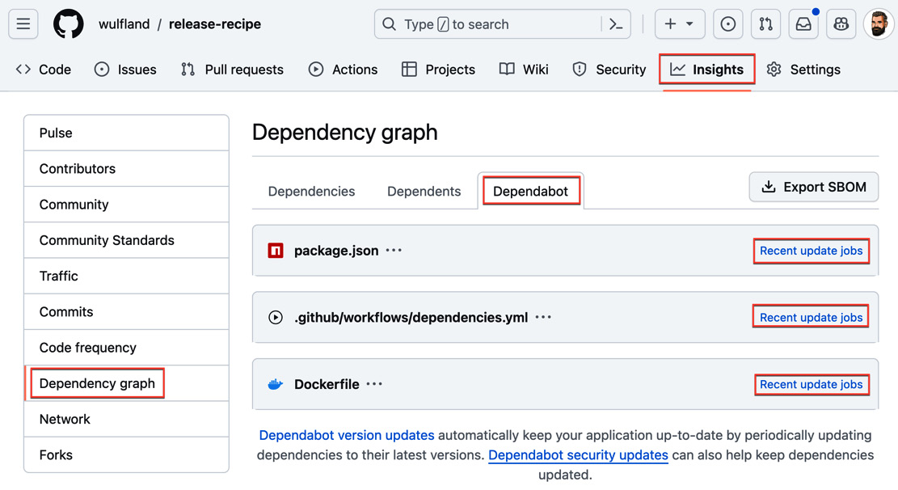
Figure 7.6 – Inspecting the logs for dependabot version updates
Check that there are no errors in the logs.
- Now, go to the package-recipe repository and create a new release with a new patch version. Once the new package version is published, head over to Insights | Dependency graph | Dependabot and click on the link in the package.json line. Hit Check for updates to enforce dependabot to now check for updates (see Figure 7.7):
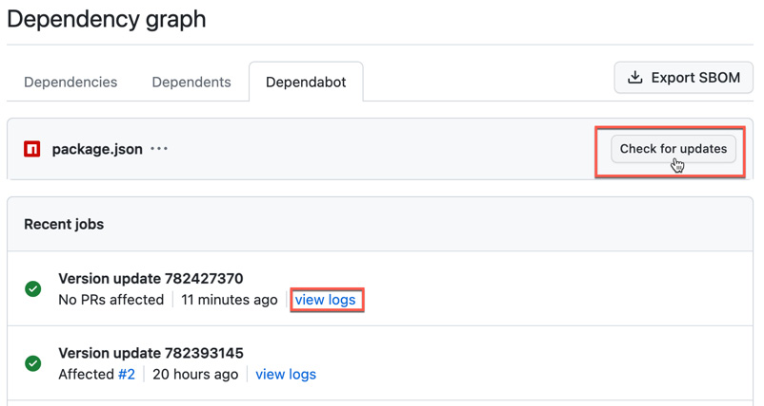
Figure 7.7 – Have dependabot now check for updates
- Dependabot will create a new pull request with a version update to the new version (see Figure 7.8):
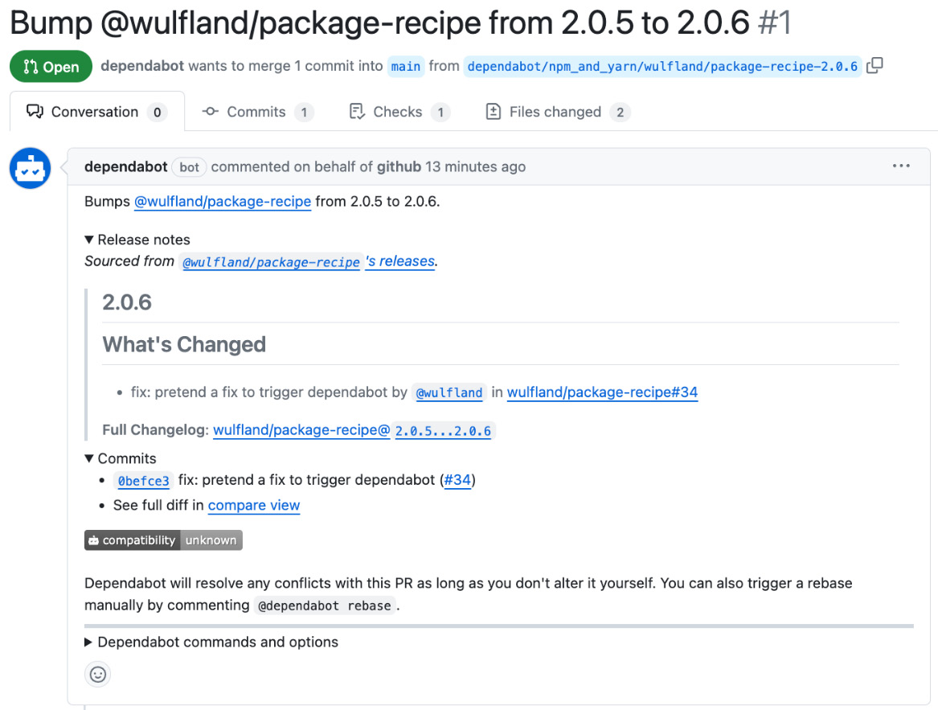
Figure 7.8 – A pull request created by dependabot version updates
Merge the pull request or have dependabot do it by commenting @dependabot squash and merge on the pull request.
- As we trust the owner of the package, we can automate this last step and just merge every pull request for specific versions after all checks are successful. Create a new file: .github/workflows/dependencies.yml. The workflow will run on pull_request_target, and it will need write permissions for the pull requests:
name: Dependabot auto-merge
on: [ pull_request_target ]
permissions:
pull-requests: write
contents: write
- Only run the job if the author of the pull request is dependabot:
jobs:
dependabot:
runs-on: ubuntu-latest
if: ${{ github.actor == 'dependabot[bot]' }}
steps:
- The first step is to fetch dependabot metadata:
- name: Dependabot metadata
id:
metadata
uses: dependabot/fetch-metadata@v1
with:
github-token: "${{ secrets.GITHUB_TOKEN }}"
- Next, add a step that runs on the following conditions based on the metadata: if the dependency name contains your package (replace {OWNER} with your user name) and the version update is a patch version. Merge the pull request if all checks have succeeded using gh merge --auto:
- name: Enable auto-merge for all patch versions
if: ${{contains(steps.
metadata
.outputs.dependency-names, '
@{OWNER}/package-recipe
') && steps.metadata.outputs.update-type == 'version-update:semver-patch'}}
run: gh pr merge --auto --merge "$PR_URL"
env:
PR_URL: ${{github.event.pull_request.html_url}}
GITHUB_TOKEN: ${{secrets.GITHUB_TOKEN}}
Please note that this workflow will not trigger the publish.yml workflow listening for the push trigger for main. This is because merge is carried out using GITHUB_TOKEN. You can either use a PAT token, as in the last step, or you can move the publish logic to a reusable workflow and call it from this workflow directly.
- Now, go back the package-recipe repository and create a new release with a new patch version. Once the new package version is published, head over to Insights | Dependency graph | Dependabot and click on the link in the package.json line. Hit Check for updates to enforce dependabot to now check for updates (see Figure 7.7). Dependabot will create a pull request, trigger the workflow, and the pull request will automatically be merged.

How it works…
Dependabot can help you to keep your dependencies up to date with less effort. You can use it to automate the update process and to keep up with the latest releases of all your dependencies.
There are many ecosystems supported by this:
- Bundler
- Cargo
- Composer
- Dev containers (including GitHub Codespaces)
- Docker
- Hex
- Elm-packages
- Git submodules
- GitHub Actions
- Go modules
- Maven and Gradle
- npm
- NuGet
- pip, pipenv, and pip-compile
- pnpm
- poetry
- pub
- Swift
- Terraform
- yarn
For a complete list, see the following link: https://docs.github.com/en/code-security/dependabot/dependabot-version-updates/about-dependabot-version-updates.
Dependabot will create pull requests for each version update of each dependency. You can use @Dependabot commands on the pull request to interact with dependabot and to tell it certain things, such as ignoring versions or rebasing changes.
The dependabot.yml file has many options. You can specify what kind of updates are allowed, customize the commit message, group updates together, ignore certain dependencies, and add reviewers, labels, or assignees. For a complete list of configuration options, see the following link: https://docs.github.com/en/code-security/dependabot/dependabot-version-updates/configuration-options-for-the-dependabot.yml-file. In combination with workflows and the dependabot/fetch metadata actions, this a very powerful tool to automate your supply chain across many repositories and teams. If you look at Chapters 6 and 7, we use Conventional Commits with GitVersion to automate the semantic versioning based on a conventional commit message completely. We can then leverage dependabot to fully automate the update of downstream dependents.

There’s more…
In our example, we directly build the container and push the deployment to Kubernetes. However, you can also use dependabot to update Kubernetes manifest files by adding an entry to the Docker package-ecosystem element of your dependabot.yml file for each directory containing a manifest, which references Docker image tags. Kubernetes manifests can be normal Kubernetes deployment files, and Helm charts are also supported. For more information about configuring your dependabot.yml file for Kubernetes, see the following link: https://docs.github.com/en/code-security/dependabot/dependabot-version-updates/configuration-options-for-the-dependabot.yml-file#docker.

Clean up
Please don’t forget to delete your cluster when you are done with the recipes so that no unnecessary costs will occur. You can use the script destroy-azure.sh in the repo and run it locally or just run the following command in the Azure Cloud Shell (https://shell.azure.com):
$ az group delete --resource-group
AKSCluster
--yes
Just check that you did not change the name of the resource group when setting everything up.

Summary
Congratulations on making it to the end of the book. I hope the practical, hands-on, focused recipes helped you to build a foundation for automating all kinds of tasks in your day-to-day work and helped increase the productivity in your engineering teams. I tried to include all the aspects of GitHub Actions that are relevant, balancing simplicity and real-world applicability. GitHub is a platform that is evolving very fast, with changes being released multiple times a day. If you consider the partners and actions from the open source community, the GitHub ecosystem is huge and changes all the time. If you have encountered changes during the hands-on labs in this book, please reach out to me on GitHub by creating an issue or submitting a pull request, and I will try to incorporate the changes in the repository. I hope you enjoyed the book, and I hope you will enjoy GitHub Actions as I do; it is the best automation platform I’ve ever used.
Index
As this ebook edition doesn't have fixed pagination, the page numbers below are hyperlinked for reference only, based on the printed edition of this book.
A
act
reference link 59
actionlint
reference link 52
actions
sharing, to marketplace 88-94
Actions Runner Controller (ARC) 112, 115
reference link 5
Amazon Web Services (AWS) 197
Anchore SBOM Action 192
app registration 203
authentication 143
auto-scaling
self-hosted runners 97-112
AWS Elastic Container Service (ECS) 210
Azure Boards 2
Azure CLI
reference link 202
Azure Cloud Shell
URL 202
Azure Key Vault 205
Azure Kubernetes Service (AKS) 197
container application, releasing to 206-209
Azure portal 197
B
billing, for GitHub Actions
reference link 6
branch 18
workflows, developing in 44-50
branch protection 161, 162
reference link 53
C
cache
managing 196
cache action
reference link 195, 196
caching
using, in workflows 193-195
Check dist 79
Checkmarx 3, 177
checkout action 159, 160
Checkov 178
CI build 79
Cloud Shell 197
code
building 156-158
testing 156-158
code coverage results
displaying 168
codeowners
reference link 54
CodeQL 3
reference link 177
used, for finding security vulnerabilities 174
working 175-177
composite action 68, 83, 148
creating 83-85
github-script, using to add comment to issue 85, 87
Conan 192
concurrency groups 172
reference link 172
conditional execution 73
reference link 75
configuration token 103
container
building 198-201
publishing 198-201
container application
releasing, to AKS 206-209
contexts
reference link 16
Continuous Deployment (CD) 1, 197
Continuous Integration (CI) 1, 64, 155
Conventional Commits 94, 187, 188
reference link 187
custom deployment protection rules 35
CycloneDX (CDX) 192
URL 192
D
debug logging
enabling 58, 59
decentralized git version control system (VCS) 2
Dependabot 3, 210, 211, 215, 216
dependencies
update, automating of 210-215
deployment branch 35
devops-actions 50
devops-actions/actionlint
reference link 52
Docker 38, 197
Docker container action 64, 68
creating 66, 67
Docker Desktop for Mac
URL 38
Docker Desktop for Windows
URL 38
Docker Docs 38
Docker Engine
URL 38
Dockerfile
reference link 100
Docker meta-action
reference link 202
E
Eclipse 2
Elastic Container Services (ECSs) 197
environment files 71, 135
reference link 72
environments 28, 35, 142, 143
approval checks 205, 206
creating 28-30
reference link 143
using 31-34
using, for approvals and checks 136-141
ESLint 177
Express
URL 201
expressions 16, 73
reference link 16, 75
F
form parser 135
FOSSology 192
G
gh auth login
reference link 49
Git branches 184
Git flow
reference link 186
GitHub 1, 192
ecosystem 2, 3
hosting 4
pricing model 4, 5
GitHub Actions 2, 3
pricing 5, 6
using 18, 23
GitHub Action workflows 11
GitHub Advanced Security 3
GitHub App 136
GitHub CLI 197
URL 49
used, for commenting on issues 136
using, to access resources 131-134
GitHub Codespaces 3, 197
URL 43
GitHub Copilot 3
GitHub.dev 43
GitHub Discussions 2
GitHub Enterprise Cloud (GHEC) 5
GitHub Enterprise Server (GHES) 5, 116
GitHub flow
reference link 186
GitHub form schema
reference link 130
GitHub-hosted runners 121-123
creating 119, 120
GitHub Marketplace 6-9, 93
URL 6
GitHub Package Registry 203
GitHub Packages 3
GitHub Pages 168, 171
GitHub Projects 2, 144-148
GitHub releases 93, 183
reference link 183
github-script 88
reference link 87
using to add comment to issue, in composite action 85, 87
GITHUB_TOKEN 134
using, to access resources 131-134
workflow permissions 134, 135
GitReleaseManager
reference link 191
git tags 93
Git tags 183, 184
GitTools 191
GitVersion 184, 202
reference link 186
Go 192
Google Cloud Platform (GCP) 197
Google Kubernetes Engine (GKE) 197, 210
H
Harden-Runner action
reference link 116
HashiCorp Vault 205
Helm charts 216
I
identity provider (IdP) 2
infrastructure as code (IaC) 178
IssueOps 125
issues 143
issue template 125, 130
creating 126-129
issue templates, configuring for repositories
reference link 131
J
Java 192
JavaScript actions 68
Jest 156
Jira 2
jobs 23
outputs 135
jobs, running in containers
reference link 62
job summaries 72
reference link 72
using 68-71
JSON web token 205
JWT (JSON Web Token) 103
K
Kubernetes 112
L
Large File Storage (LFS) 159
log
messages, writing to 54-58
long polling 104
M
manual triggers 22
marketplace 17
actions, sharing to 88-94
matrix
features 165
reference link 166
used, for building software versions 164, 165
Maven 192
messages
writing, to log 54-58
Microsoft Defender for DevOps 177
Microsoft Entra 203
Microsoft System Center 193
minute multipliers 5
monitoring and troubleshooting
reference link 59
N
National Telecommunications and Information Administration (NTIA) 191
.NET 192
networking, for hosted compute products
reference link 6
NodeJS 60, 192
O
OIDC trust 205
Open Container Initiative (OCI) 192
Open ID Connect (OIDC) 3, 197
used, for securely deploying cloud 202-205
Open Worldwide Application Security Project (OWASP) 192
Organization for the Advancement of Structured Information Standards (OASIS) 178
output parameters
adding 68-71
OWASP Dependency-Track
reference link 193
P
package
publishing, on release creation 179-182
versioning 184-186
personal access token (PAT) 62, 103, 136, 198
PHP 192
port 443 104
problem matchers
reference link 52
pull request template 130
Python 192
R
releases 183
repositories, cloning
reference link 39
reusable workflows 148
and composite actions 149-153
reference link 153
rulesets 162, 163
advantages 163
reference link 53, 163
runner groups 116
multiple runner groups, creating 116-119
runners 116
S
scheduled triggers 22
secrets 24-28
using 24-26
Secret Scanning 3
Security Assertion Markup Language (SAML) 4
security vulnerabilities
finding, with CodeQL 174
self-hosted runner
authentication to GitHub 103
auto-scaling 105-112
cleaning up 104
installing, on macOS 105
network communication 104
running, as service 104
scaling, with Kubernetes using ARC 112-116
setting up 96-102
updating 104
working 102
semantic versioning 94, 183
major version 183
minor version 183
patch version 183
pre-version 183
semantic versions
reference link 94
Serverless Application Model (SAM) 178
ServiceNow IT Operations Management (ITOM) 193
service principle 203
setup actions 160
SHA 18
short-lived access token 205
single sign-on (SSO) 4
Slack 2
Snow
URL 193
Snyk 3, 177
Software-as-a-Service (SaaS) 4
software asset management (SAM) 193
software bills of materials (SBOMs) 155
generating 188-192
using 188-192
Software Identification (SWID) tags 192, 193
Software Package Data Exchange (SPDX) 189, 191
SonarCloud 172
reference link 174
SonarQube 172
Static Analysis Results Interchange Format (SARIF) 178
step
outputs 135
super-linter 161
syft 192
syntax, for issue forms
reference link 130
System for Cross-domain Identity Management (SCIM) 4
T
tag 18
tag protection rule
reference link 94
tag rules 35
Teams 2
template picker form
configuring 130, 131
test results 166
pull requests and workflow summaries decorating 167-170
Trello 2
triggers
reference link 22
TypeScript action 75
creating 75-82
V
validation workflow 160
branch protection 161, 162
rulesets 162, 163
super-linter 161
variables 24-28
using 24, 25, 26
Veracode 3
Visual Studio 2
Visual Studio Code (VS Code) 2, 38
URL 37
used, for authoring workflows 38-43
W
webhook triggers 22
workflow editor
used, for writing workflows 10-21
workflow job
functions, to check status 75
workflows
authoring, with Visual Studio Code 38-43
caching, using in 193-195
developing, in branches 44-50
linting 50-53
running, locally 59-62
workflow status badge
adding 171
Y
YAML Ain’t Markup Language
basics 21
collection types 21

packtpub.com
Subscribe to our online digital library for full access to over 7,000 books and videos, as well as industry leading tools to help you plan your personal development and advance your career. For more information, please visit our website.

Why subscribe?
- Spend less time learning and more time coding with practical eBooks and Videos from over 4,000 industry professionals
- Improve your learning with Skill Plans built especially for you
- Get a free eBook or video every month
- Fully searchable for easy access to vital information
- Copy and paste, print, and bookmark content
Did you know that Packt offers eBook versions of every book published, with PDF and ePub files available? You can upgrade to the eBook version at packtpub.com and as a print book customer, you are entitled to a discount on the eBook copy. Get in touch with us at customercare@packtpub.com for more details.
At www.packtpub.com, you can also read a collection of free technical articles, sign up for a range of free newsletters, and receive exclusive discounts and offers on Packt books and eBooks.

Other Books You May Enjoy
If you enjoyed this book, you may be interested in these other books by Packt:



Mastering GitHub Actions
Eric Chapman
ISBN: 978-1-80512-862-5
- Explore GitHub Actions' features for team and business settings
- Create reusable workflows, templates, and standardized processes to reduce overhead
- Get to grips with CI/CD integrations, code quality tools, and communication
- Understand self-hosted runners for greater control of resources and settings
- Discover tools to optimize GitHub Actions and manage resources efficiently
- Work through examples to enhance projects, teamwork, and productivity

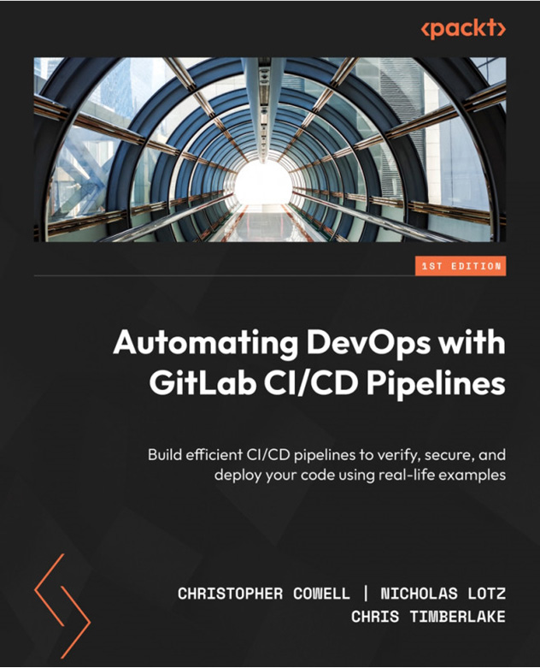

Automating DevOps with GitLab CI/CD Pipelines
Christopher Cowell, Nicholas Lotz, Chris Timberlake
ISBN: 9781803233000
- Gain insights into the essentials of Git, GitLab, and DevOps
- Understand how to create, view, and run GitLab CI/CD pipelines
- Explore how to verify, secure, and deploy code with GitLab CI/CD pipelines
- Configure and use GitLab Runners to execute CI/CD pipelines
- Explore advanced GitLab CI/CD pipeline features like DAGs and conditional logic
- Follow best practices and troubleshooting methods of GitLab CI/CD pipelines
- Implement end-to-end software development lifecycle workflows using examples

Packt is searching for authors like you
If you’re interested in becoming an author for Packt, please visit authors.packtpub.com and apply today. We have worked with thousands of developers and tech professionals, just like you, to help them share their insight with the global tech community. You can make a general application, apply for a specific hot topic that we are recruiting an author for, or submit your own idea.

Share your thoughts
Now you’ve finished GitHub Actions Cookbook, we’d love to hear your thoughts! If you purchased the book from Amazon, please click here to go straight to the Amazon review page for this book and share your feedback or leave a review on the site that you purchased it from.
Your review is important to us and the tech community and will help us make sure we’re delivering excellent quality content.

Download a free PDF copy of this book
Thanks for purchasing this book!
Do you like to read on the go but are unable to carry your print books everywhere?
Is your eBook purchase not compatible with the device of your choice?
Don’t worry, now with every Packt book you get a DRM-free PDF version of that book at no cost.
Read anywhere, any place, on any device. Search, copy, and paste code from your favorite technical books directly into your application.
The perks don’t stop there, you can get exclusive access to discounts, newsletters, and great free content in your inbox daily
Follow these simple steps to get the benefits:
- Scan the QR code or visit the link below


https://packt.link/free-ebook/9781835468944
2. Submit your proof of purchase
3. That’s it! We’ll send your free PDF and other benefits to your email directly

